LABORATORY WORK REPORT
Lab 3 — Logical Design: University Database
Database Management Systems
Laboratory work: | Lab 3 — Logical Design (University database, individual work)
Student full name: | Doe John
Group: | SISCCO-2502NS
Course: | Database Management Systems

1. From the Conceptual to the Logical Model
The logical model is based on the conceptual ER diagram from Lab work 2 (9 entities, 13 relationships, two of them many-to-many). Normalization led to three changes:
1. Students – Courses (M:N) was transformed into the associative table Enrollments (enrollment_id, student_id, course_id, semester_id, grade). The relationship attributes "semester" and "grade" became columns of this table, and "semester" became a foreign key to Semesters, which adds the 1:M relationship Semesters – Enrollments.
2. Teachers – Courses (M:N) was transformed into the associative table Course_Teachers with the composite primary key (teacher_id, course_id) and the attribute assigned_since.
3. Schedule was corrected. In the conceptual model a lesson referred to Teachers and to Courses separately, so the timetable could pair a teacher with a course that he or she does not teach. Now the pair (teacher_id, course_id) of a lesson is one composite foreign key to Course_Teachers, so every scheduled lesson is guaranteed to match a real teaching assignment.
As a result the logical model has 11 tables and only 1:1 and 1:M relationships.

2. Complete ER Diagram (3NF)
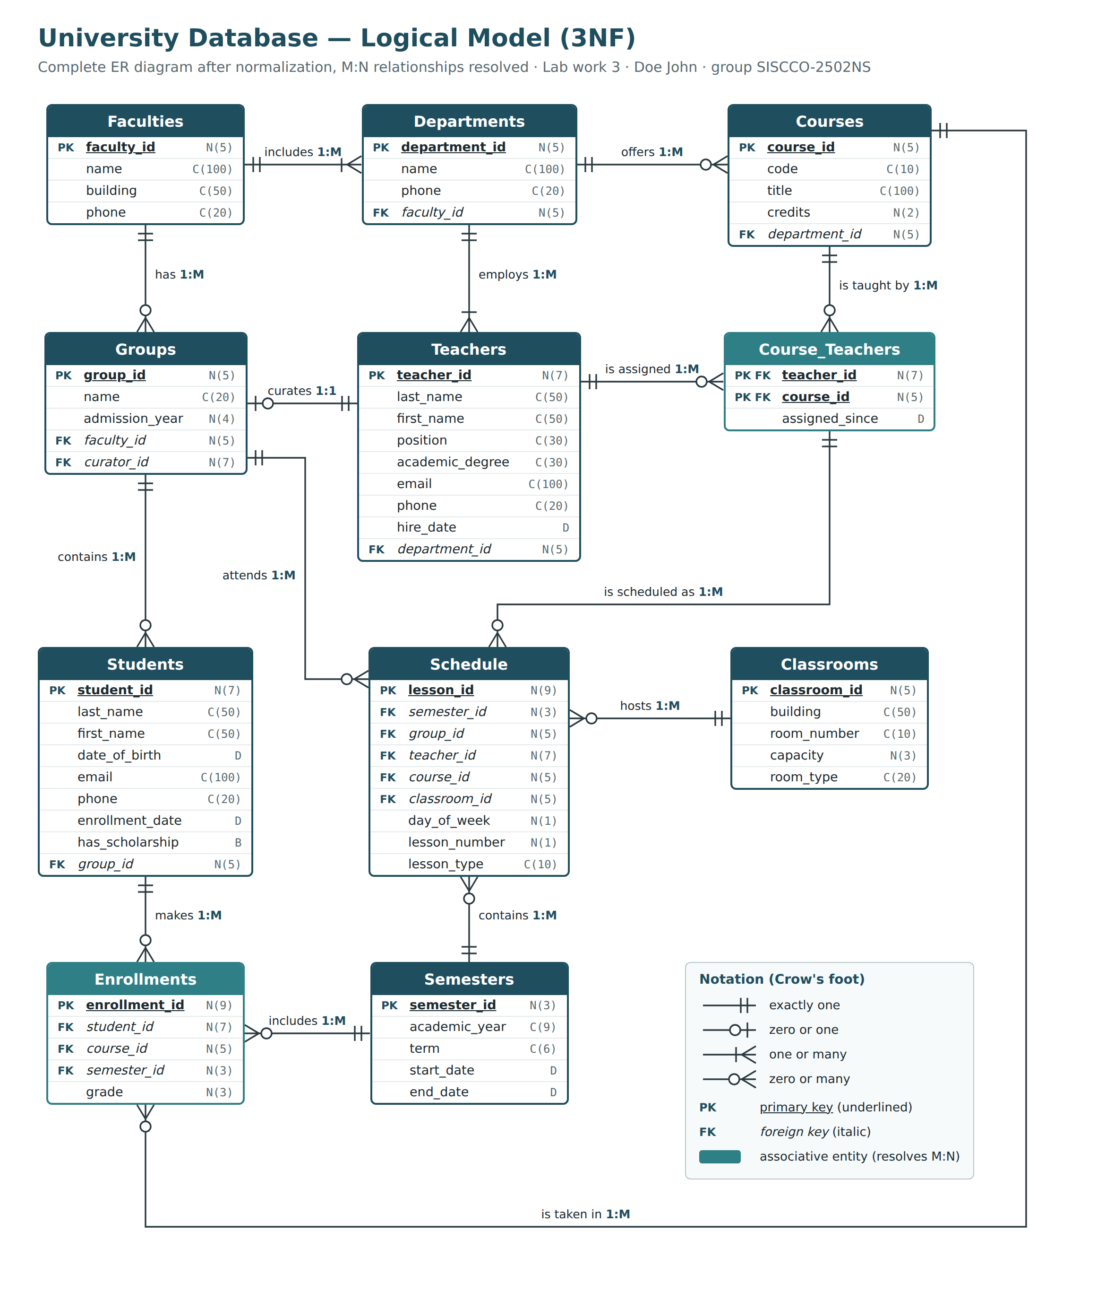
Figure 1. Logical model of the University database in 3NF (Crow's foot notation). Associative entities that resolve M:N relationships are shown in a lighter color.

3. Normalization Check
First normal form (1NF). Every table has a primary key, and every attribute holds a single atomic value: there are no repeating groups or lists inside a cell. For example, the courses of a teacher are not stored as a list inside Teachers but as separate rows of Course_Teachers, and a student's grades are separate rows of Enrollments.
Second normal form (2NF). There is no partial dependency of a non-key attribute on a part of a composite key. Only Course_Teachers has a composite primary key, and its only non-key attribute, assigned_since, depends on the whole pair (teacher_id, course_id). In Enrollments the grade depends on the whole combination (student_id, course_id, semester_id), not on any part of it. All other tables have a single-attribute primary key, so they are in 2NF automatically.
Third normal form (3NF). There is no transitive dependency: no non-key attribute determines another non-key attribute. For example, Students stores group_id but not the faculty — the faculty is reached through Groups. Storing faculty_id in Students would create the transitive dependency student_id -> group_id -> faculty_id. In the same way Teachers stores department_id but not the faculty. Attributes that determine other attributes (Faculties.name, Teachers.email, Courses.code, Groups.name and Groups.curator_id, Classrooms (building, room_number), Semesters (academic_year, term)) are candidate keys protected by UNIQUE constraints, so they do not break 3NF — every table is in fact also in BCNF.
Table | Primary key | Candidate keys (UNIQUE) | 1NF | 2NF | 3NF
Faculties | faculty_id | name | ✓ | ✓ | ✓
Departments | department_id | (faculty_id, name) | ✓ | ✓ | ✓
Teachers | teacher_id | email | ✓ | ✓ | ✓
Groups | group_id | name; curator_id | ✓ | ✓ | ✓
Students | student_id | — | ✓ | ✓ | ✓
Courses | course_id | code | ✓ | ✓ | ✓
Semesters | semester_id | (academic_year, term) | ✓ | ✓ | ✓
Classrooms | classroom_id | (building, room_number) | ✓ | ✓ | ✓
Course_Teachers | teacher_id, course_id | — | ✓ | ✓ | ✓
Enrollments | enrollment_id | (student_id, course_id, semester_id) | ✓ | ✓ | ✓
Schedule | lesson_id | (semester_id, group_id, day_of_week, lesson_number) | ✓ | ✓ | ✓

4. Functional Dependencies
Normalized tables have only full functional dependencies on their keys. For every table the full FDs are:
Table Faculties – Full FD:
{faculty_id} -> {name, building, phone}
{name} -> {faculty_id, building, phone} (name is a candidate key)

Table Departments – Full FD:
{department_id} -> {name, phone, faculty_id}
{faculty_id, name} -> {department_id, phone} (candidate key)

Table Teachers – Full FD:
{teacher_id} -> {last_name, first_name, position, academic_degree, email, phone, hire_date, department_id}
{email} -> {teacher_id, ...} (e-mail is a candidate key)

Table Groups – Full FD:
{group_id} -> {name, admission_year, faculty_id, curator_id}
{name} -> {group_id, admission_year, faculty_id, curator_id} (candidate key)
{curator_id} -> {group_id, name, admission_year, faculty_id} (candidate key, 1:1 relationship)

Table Students – Full FD:
{student_id} -> {last_name, first_name, date_of_birth, email, phone, enrollment_date, has_scholarship, group_id}

Table Courses – Full FD:
{course_id} -> {code, title, credits, department_id}
{code} -> {course_id, title, credits, department_id} (candidate key)

Table Semesters – Full FD:
{semester_id} -> {academic_year, term, start_date, end_date}
{academic_year, term} -> {semester_id, start_date, end_date} (candidate key)

Table Classrooms – Full FD:
{classroom_id} -> {building, room_number, capacity, room_type}
{building, room_number} -> {classroom_id, capacity, room_type} (candidate key)

Table Course_Teachers – Full FD:
{teacher_id, course_id} -> {assigned_since}

Table Enrollments – Full FD:
{enrollment_id} -> {student_id, course_id, semester_id, grade}
{student_id, course_id, semester_id} -> {enrollment_id, grade} (candidate key)

Table Schedule – Full FD:
{lesson_id} -> {semester_id, group_id, teacher_id, course_id, classroom_id, day_of_week, lesson_number, lesson_type}
{semester_id, group_id, day_of_week, lesson_number} -> {lesson_id, teacher_id, course_id, classroom_id, lesson_type} (candidate key: a group cannot have two lessons at the same time)

5. Description of the Tables
Type, length: N – numeric, C – character, D – date, B – boolean.

Table 1. Faculties
Stores faculties of the university.
Field's name | Field's content | Type, length | Note (constraints)
faculty_id | Faculty ID | N(5) | Primary Key
name | Faculty name | C(100) | NOT NULL, UNIQUE
building | Main building of the faculty | C(50) | NOT NULL
phone | Dean's office phone | C(20)

Table 2. Departments
Stores departments (chairs) inside each faculty.
Field's name | Field's content | Type, length | Note (constraints)
department_id | Department ID | N(5) | Primary Key
name | Department name | C(100) | NOT NULL; UNIQUE together with faculty_id
phone | Department phone | C(20)
faculty_id | Faculty the department belongs to | N(5) | NOT NULL, Foreign Key to Faculties

Table 3. Teachers
Stores teaching staff.
Field's name | Field's content | Type, length | Note (constraints)
teacher_id | Teacher ID | N(7) | Primary Key
last_name | Last name | C(50) | NOT NULL
first_name | First name | C(50) | NOT NULL
position | Academic position | C(30) | NOT NULL; one of: Assistant, Senior Lecturer, Associate Professor, Professor
academic_degree | Academic degree | C(30) | one of: Master, PhD, Doctor of Sciences (may be empty)
email | University e-mail | C(100) | NOT NULL, UNIQUE
phone | Phone number | C(20)
hire_date | Date of employment | D | NOT NULL
department_id | Department where the teacher works | N(5) | NOT NULL, Foreign Key to Departments

Table 4. Groups
Stores study groups of students.
Field's name | Field's content | Type, length | Note (constraints)
group_id | Group ID | N(5) | Primary Key
name | Group name, e.g. SISCCO-2502NS | C(20) | NOT NULL, UNIQUE
admission_year | Year of admission | N(4) | NOT NULL; between 2000 and 2100
faculty_id | Faculty of the group | N(5) | NOT NULL, Foreign Key to Faculties
curator_id | Curator (advisor) of the group | N(7) | NOT NULL, UNIQUE, Foreign Key to Teachers

Table 5. Students
Stores students and their personal data.
Field's name | Field's content | Type, length | Note (constraints)
student_id | Student ID | N(7) | Primary Key
last_name | Last name | C(50) | NOT NULL
first_name | First name | C(50) | NOT NULL
date_of_birth | Date of birth | D | NOT NULL; later than 01.01.1980
email | E-mail | C(100) | UNIQUE
phone | Phone number | C(20)
enrollment_date | Date of enrollment at the university | D | NOT NULL; later than date_of_birth
has_scholarship | Whether the student receives a scholarship | B | NOT NULL; default FALSE
group_id | Study group of the student | N(5) | NOT NULL, Foreign Key to Groups

Table 6. Courses
Stores academic courses (disciplines).
Field's name | Field's content | Type, length | Note (constraints)
course_id | Course ID | N(5) | Primary Key
code | Course code, e.g. DBMS2101 | C(10) | NOT NULL, UNIQUE
title | Course title | C(100) | NOT NULL
credits | Number of credits | N(2) | NOT NULL; from 1 to 10
department_id | Department responsible for the course | N(5) | NOT NULL, Foreign Key to Departments

Table 7. Semesters
Stores academic semesters.
Field's name | Field's content | Type, length | Note (constraints)
semester_id | Semester ID | N(3) | Primary Key
academic_year | Academic year, e.g. 2025-2026 | C(9) | NOT NULL; format YYYY-YYYY
term | Term | C(6) | NOT NULL; Fall, Spring or Summer; UNIQUE together with academic_year
start_date | First day of the semester | D | NOT NULL
end_date | Last day of the semester | D | NOT NULL; later than start_date

Table 8. Classrooms
Stores classrooms and laboratories.
Field's name | Field's content | Type, length | Note (constraints)
classroom_id | Classroom ID | N(5) | Primary Key
building | Building | C(50) | NOT NULL
room_number | Room number | C(10) | NOT NULL; UNIQUE together with building
capacity | Number of seats | N(3) | NOT NULL; greater than 0
room_type | Type of room | C(20) | NOT NULL; Lecture hall, Computer lab, Seminar room or Laboratory

Table 9. Course_Teachers
Stores which teachers teach which courses (resolves Teachers M:N Courses).
Field's name | Field's content | Type, length | Note (constraints)
teacher_id | Teacher | N(7) | Primary Key (together with course_id), Foreign Key to Teachers
course_id | Course | N(5) | Primary Key (together with teacher_id), Foreign Key to Courses
assigned_since | Date since the teacher teaches the course | D | NOT NULL

Table 10. Enrollments
Stores which student took which course in which semester, and the grade (resolves Students M:N Courses).
Field's name | Field's content | Type, length | Note (constraints)
enrollment_id | Enrollment ID | N(9) | Primary Key
student_id | Student | N(7) | NOT NULL, Foreign Key to Students
course_id | Course | N(5) | NOT NULL, Foreign Key to Courses
semester_id | Semester in which the course is taken | N(3) | NOT NULL, Foreign Key to Semesters; (student_id, course_id, semester_id) UNIQUE
grade | Final grade | N(3) | from 0 to 100 (empty until graded)

Table 11. Schedule
Stores the weekly timetable of lessons.
Field's name | Field's content | Type, length | Note (constraints)
lesson_id | Lesson ID | N(9) | Primary Key
semester_id | Semester | N(3) | NOT NULL, Foreign Key to Semesters
group_id | Group that attends the lesson | N(5) | NOT NULL, Foreign Key to Groups
teacher_id | Teacher who conducts the lesson | N(7) | NOT NULL; Foreign Key (with course_id) to Course_Teachers
course_id | Course of the lesson | N(5) | NOT NULL; Foreign Key (with teacher_id) to Course_Teachers
classroom_id | Classroom | N(5) | NOT NULL, Foreign Key to Classrooms
day_of_week | Day of week (1 = Monday ... 6 = Saturday) | N(1) | NOT NULL; from 1 to 6
lesson_number | Lesson period of the day | N(1) | NOT NULL; from 1 to 7
lesson_type | Type of lesson | C(10) | NOT NULL; Lecture, Practice or Lab

6. Conclusion
The conceptual model from Lab work 2 was translated into a logical model in third normal form. Both many-to-many relationships were replaced by associative tables (Enrollments and Course_Teachers), the Schedule table was corrected to reference real teaching assignments, and every table was checked for 1NF, 2NF and 3NF through its functional dependencies. The resulting 11 tables, with their types and constraints, are the basis for the SQL implementation in Lab work 4.

