LABORATORY WORK REPORT
Lab 10 — Views and CTE on the University Database
Database Management Systems
Laboratory work: | Lab 10 — Views (University database, individual work)
Student full name: | Doe John
Group: | SISCCO-2502NS
Course: | Database Management Systems

Preparation
DBMS: PostgreSQL 16. The database is the University database from the handout (“Lab work 8.sql”), in the state after Lab work 9: the handout data, the rows added in Lab 8 and Lab 9, and the changes made by the INSERT, DELETE and UPDATE queries of Lab 9 (Tasks 8–10). The tasks were run in order, so every task sees the changes of the previous ones (for example, the new teacher from Task 5 is in the view in Task 6).
Every result is the real output of PostgreSQL. For the statements that do not return a table (CREATE VIEW, INSERT) the result is the message returned by the server, as on the Messages tab of pgAdmin.

Tasks

Task 1
Choose any query from the LW9 (implemented before with subquery) and remake them using CTE.
This is LW9 Task 1 (last names of all students whose major is CSSE). In LW9 the two subqueries were nested inside each other; here each of them is written once, at the top, as a named CTE (Common Table Expression) after the keyword WITH. The first CTE csse_major finds the major CSSE, the second CTE csse_groups uses the first one and finds the groups of this major, and the main query takes the students of these groups. The query is read from top to bottom, step by step. The result is the same as in LW9: 8 students; Bekova from RET-131 is not shown.
WITH csse_major AS (
SELECT major_id
FROM majors
WHERE major_name = 'CSSE'
),
csse_groups AS (
SELECT group_id
FROM groups
WHERE major_id IN (SELECT major_id FROM csse_major)
)
SELECT lname
FROM students
WHERE group_id IN (SELECT group_id FROM csse_groups);
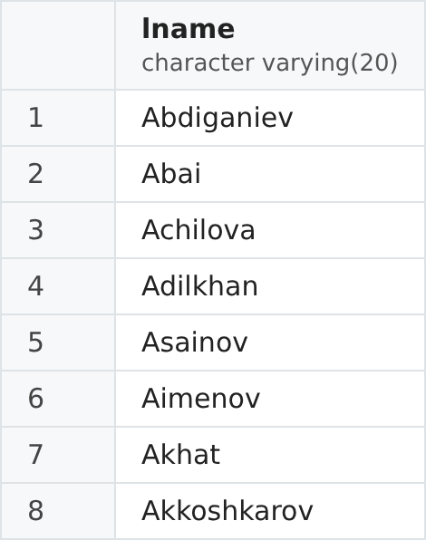
Figure 1. Result of Task 1.

Task 2
Choose any other query from the LW9 (implemented before with subquery) and also remake them using CTE.
This is LW9 Task 7, where the per-student averages were calculated in a subquery in the FROM clause. Now the same subquery is moved into the CTE student_avg, and the main query simply reads FROM student_avg like from a normal table. The result is the same as in LW9: 7 students have grades, the best average is 93.50, the worst is 51.00 and the average of the averages is 78.36.
WITH student_avg AS (
SELECT stud_id, AVG(final) AS avg_final
FROM progress
GROUP BY stud_id
)
SELECT COUNT(*) AS students,
ROUND(MAX(avg_final), 2) AS best_average,
ROUND(MIN(avg_final), 2) AS worst_average,
ROUND(AVG(avg_final), 2) AS average_of_averages
FROM student_avg;
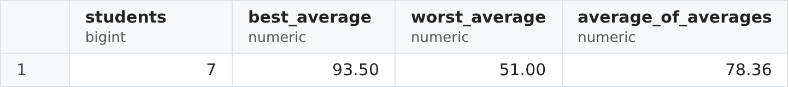
Figure 2. Result of Task 2.

Task 3
The Teachers table contains some columns with private information. Create a view Teacher_info to hide them and to show only first, last names and id.
The Teachers table also stores the phone number (phnum), the e-mail and the department of every teacher. The view Teacher_info shows only the identifier, the first name and the last name. A view does not store data: it is a saved SELECT query with a name, and every time the view is used, the query runs on the current data of Teachers. Users can be given access to the view instead of the table, so they cannot see the private columns. PostgreSQL answers with the message CREATE VIEW.
CREATE VIEW Teacher_info AS
SELECT teach_id, fname, lname
FROM teachers;
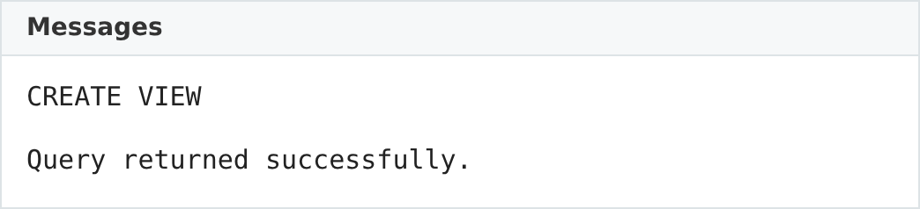
Figure 3. Result of Task 3.

Task 4
Show all rows from the view Teacher_info (from the #3) with SELECT statement.
A view is used in SELECT like a table. The result shows all 6 teachers, but only the three columns of the view: teach_id, fname and lname. The phone numbers and e-mails are hidden.
SELECT *
FROM Teacher_info;
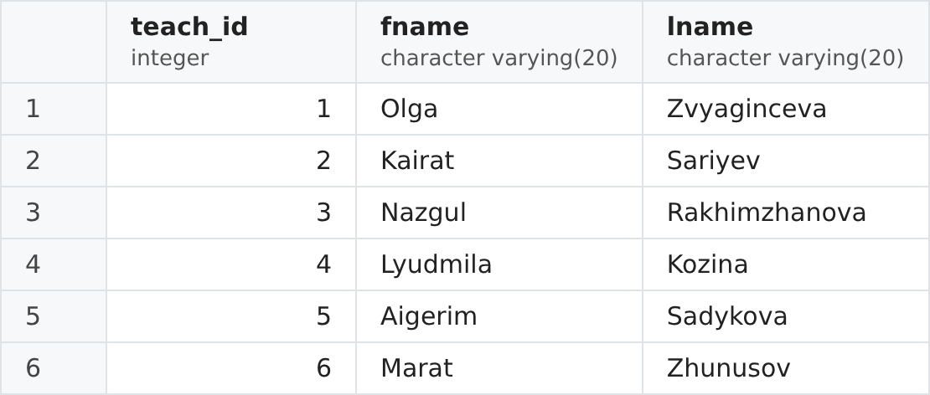
Figure 4. Result of Task 4.

Task 5
Add a new row into the Teachers table.
A new teacher, Daniyar Omarov, assistant in the IS department, is added to the table Teachers (not to the view). The message INSERT 0 1 means that 1 row was inserted (0 is the object identifier, which PostgreSQL no longer uses for tables).
INSERT INTO teachers
VALUES (7, 'Daniyar', 'Omarov', 1234567, 'omarov@gmail.com', 'Assistant', 2);
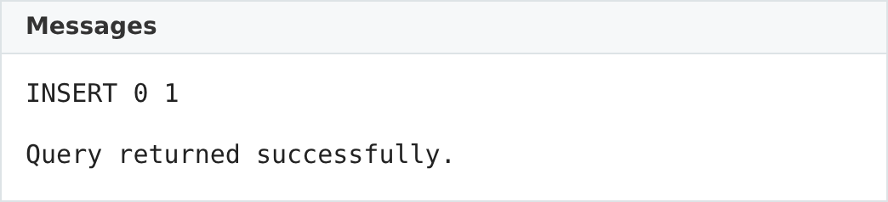
Figure 5. Result of Task 5.

Task 6
Check with SELECT if the Teacher_info view contains this new information or not.
Yes, the view contains the new teacher: Omarov is the 7th row. The view was created before this row was added, but a view keeps only the query, not the data, so the query runs again on the current table every time. Any change in Teachers is visible in the view at once.
SELECT *
FROM Teacher_info;
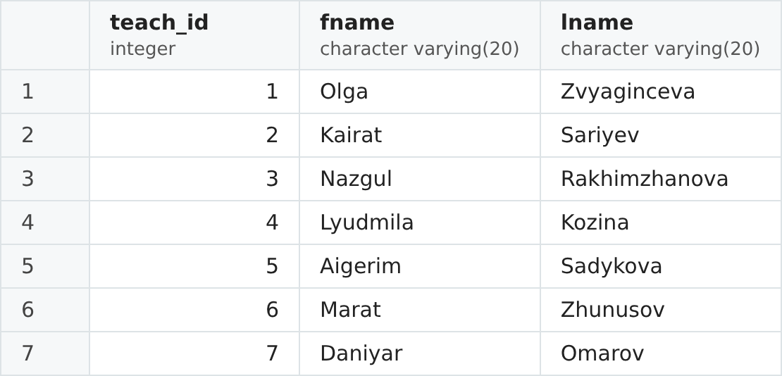
Figure 6. Result of Task 6.

Task 7
Change the structure of the Teacher_info view to include another one column from the Teachers table.
CREATE OR REPLACE VIEW replaces the query of the existing view with a new one. The column positions (the teacher's position) is added; it is not private information. In PostgreSQL CREATE OR REPLACE can only add new columns at the end of the view; the existing columns must keep their names, order and types (otherwise the view has to be dropped with DROP VIEW and created again).
CREATE OR REPLACE VIEW Teacher_info AS
SELECT teach_id, fname, lname, positions
FROM teachers;
Figure 7. Result of Task 7.

Task 8
Show with SELECT a result of the renewed view Teacher_info.
The renewed view shows the same 7 teachers, now with the fourth column positions: senior lecturers, an associate professor (Zhunusov) and an assistant (Omarov). The phone numbers and e-mails are still hidden.
SELECT *
FROM Teacher_info;
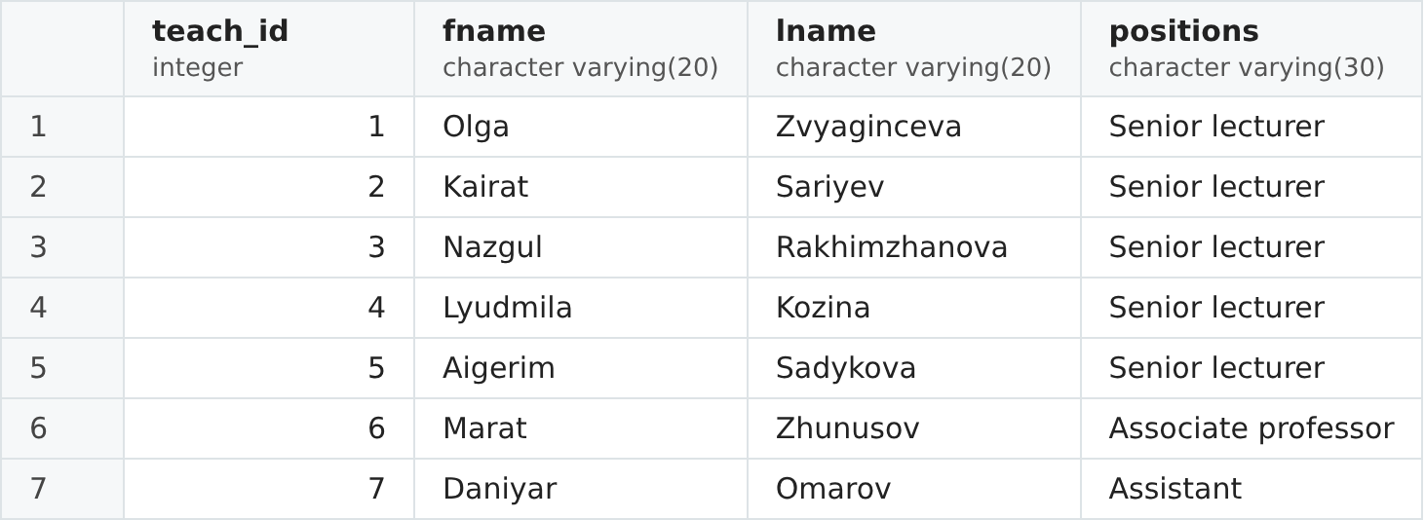
Figure 8. Result of Task 8.

Task 9
Create a new view with joining of two or more tables, an aggregation function or a subquery.
The view Student_gpa joins three tables (Students, Groups and Progress) and uses the aggregate functions COUNT and AVG with GROUP BY. For every student it gives the full name, the group, the number of subjects with a grade and the average final grade (like a GPA). LEFT JOIN keeps the students who have no grades yet. Now this report can be received with a short SELECT from the view instead of writing the join every time.
CREATE VIEW Student_gpa AS
SELECT st.stud_id,
st.fname || ' ' || st.lname AS full_name,
g.group_name,
COUNT(p.final) AS subjects,
ROUND(AVG(p.final), 2) AS avg_final
FROM students st
JOIN groups g ON st.group_id = g.group_id
LEFT JOIN progress p ON p.stud_id = st.stud_id
GROUP BY st.stud_id, st.fname, st.lname, g.group_name;
Figure 9. Result of Task 9.

Task 10
Show with SELECT a result of the view from the #9.
The view returns all 9 students, sorted from the best average final grade to the lowest: Asainov has the best average, 93.50, and Akhat the lowest, 51.00. Bekova and Akkoshkarov have no grades, so their number of subjects is 0 and their average is NULL; NULLS LAST puts them at the end. ORDER BY is written in the SELECT, not in the view.
SELECT *
FROM Student_gpa
ORDER BY avg_final DESC NULLS LAST;
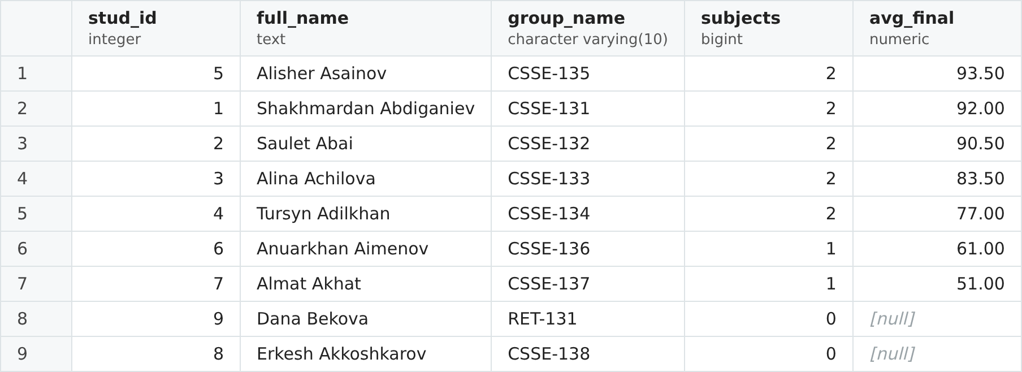
Figure 10. Result of Task 10.

