LABORATORY WORK REPORT
Lab 6 — Relational Algebra: SELECT Queries
Database Management Systems
Laboratory work: | Lab 6 — Relational algebra (University database, individual work)
Student full name: | Doe John
Group: | SISCCO-2502NS
Course: | Database Management Systems

Preparation
A new database was created in PostgreSQL 16 with the SQL code given in the assignment. Every query below was run against it, and each result shows the real output with its column names and types.
CREATE TABLE Students(
stud_id int PRIMARY KEY,
fname varchar(20),
lname varchar(20)
);

CREATE TABLE Departments(
dep_id int PRIMARY KEY,
name varchar(10)
);

CREATE TABLE Teachers(
teach_id int PRIMARY KEY,
fname varchar(20),
lname varchar(20),
dep_id int REFERENCES Departments(dep_id)
);

INSERT INTO Students VALUES (1,'A','A'), (2,'B','B');
INSERT INTO Departments VALUES (1,'AAA'), (2,'BBB');
INSERT INTO Teachers VALUES (1,'B','B', 2), (2,'C','C', 2);

Tasks

Task 1
Show all information about all teachers.
Relational algebra (the whole relation, no operation): Teachers
SELECT *
FROM Teachers;

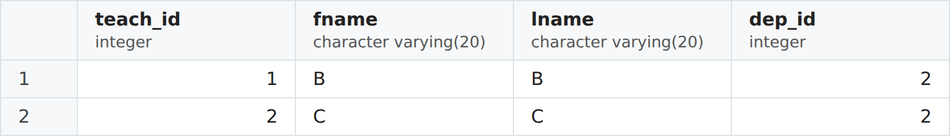
Figure 1. Result of Task 1.

Task 2
Show last names of all students (only last names, not all columns).
Relational algebra (projection): π lname (Students)
SELECT lname
FROM Students;

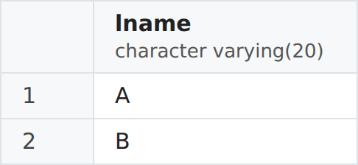
Figure 2. Result of Task 2.

Task 3
Show last names of teachers whose first names = "B".
Relational algebra (selection, then projection): π lname (σ fname = 'B' (Teachers))
SELECT lname
FROM Teachers
WHERE fname = 'B';


Figure 3. Result of Task 3.

Task 4
Show information about all teachers and all students in the one table (with 2 columns: first name, last name).
Relational algebra (union): π fname, lname (Students) ∪ π fname, lname (Teachers)
SELECT fname, lname
FROM Students
UNION
SELECT fname, lname
FROM Teachers;

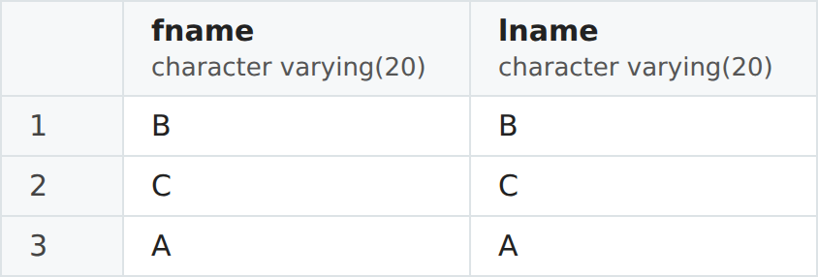
Figure 4. Result of Task 4.
Note. UNION removes duplicates, so B B — a student and a teacher at the same time — appears only once.

Task 5
Show information about students, but without persons who are students and teachers at the same time (in the table with 2 columns: first name, last name).
Relational algebra (difference): π fname, lname (Students) − π fname, lname (Teachers)
SELECT fname, lname
FROM Students
EXCEPT
SELECT fname, lname
FROM Teachers;


Figure 5. Result of Task 5.

Task 6
Show information only about persons who are students and teachers at the same time (in the table with 2 columns: first name, last name).
Relational algebra (intersection): π fname, lname (Students) ∩ π fname, lname (Teachers)
SELECT fname, lname
FROM Students
INTERSECT
SELECT fname, lname
FROM Teachers;


Figure 6. Result of Task 6.

Task 7
Show teachers and their departments in the following table: teachers' last name, department name. Include only teachers which have departments and departments which have teachers.
Relational algebra (inner join): π T.lname, D.name (Teachers T ⋈ T.dep_id = D.dep_id Departments D)
SELECT T.lname, D.name
FROM Teachers T
INNER JOIN Departments D ON T.dep_id = D.dep_id;

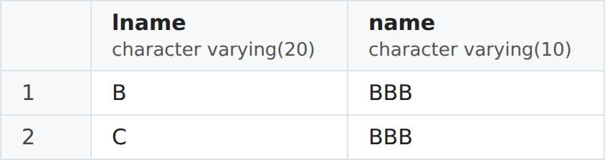
Figure 7. Result of Task 7.

Task 8
Show teachers and their departments in the following table: teachers' last name, department name. In this task include also teachers which at this moment have not any department.
Relational algebra (left outer join): π T.lname, D.name (Teachers T ⟕ T.dep_id = D.dep_id Departments D)
SELECT T.lname, D.name
FROM Teachers T
LEFT JOIN Departments D ON T.dep_id = D.dep_id;

Figure 8. Result of Task 8.
Note. With the given data every teacher has a department, so the result equals Task 7. A teacher with dep_id = NULL would appear here with an empty (NULL) department name.

Task 9
Show teachers and their departments in the following table: teachers' last name, department name. In this task include also departments which at this moment have not any teachers.
Relational algebra (right outer join): π T.lname, D.name (Teachers T ⟖ T.dep_id = D.dep_id Departments D)
SELECT T.lname, D.name
FROM Teachers T
RIGHT JOIN Departments D ON T.dep_id = D.dep_id;

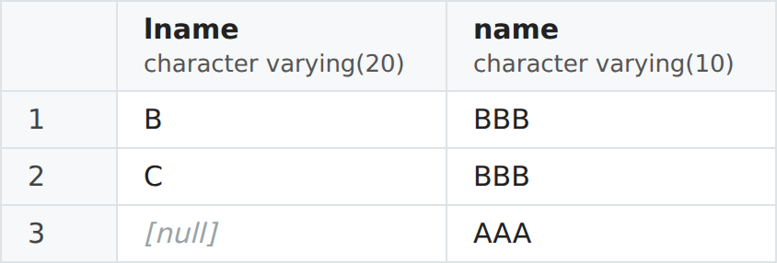
Figure 9. Result of Task 9.
Note. Department AAA has no teachers, so it appears with a NULL teacher's last name.

Task 10
Show teachers and their departments in the following table: teachers' last name, department name. In this task include also teachers which at this moment have not any department as well as departments which at this moment have not any teachers.
Relational algebra (full outer join): π T.lname, D.name (Teachers T ⟗ T.dep_id = D.dep_id Departments D)
SELECT T.lname, D.name
FROM Teachers T
FULL JOIN Departments D ON T.dep_id = D.dep_id;

Figure 10. Result of Task 10.
Note. Keeps unmatched rows from both sides. With the given data only department AAA is unmatched, so the result equals Task 9.

Conclusion
Each task was solved with a single SELECT query that implements one operation of relational algebra: projection (Task 2), selection with projection (Task 3), the set operations union, difference and intersection on union-compatible relations (Tasks 4–6, via UNION, EXCEPT and INTERSECT), and the join family — inner join (Task 7) and left, right and full outer joins (Tasks 8–10), which differ only in which unmatched rows they keep.

