LABORATORY WORK REPORT
Lab 7 — Queries: SELECT Basics on the University Database
Database Management Systems
Laboratory work: | Lab 7 — Queries (University database, individual work)
Student full name: | Doe John
Group: | SISCCO-2502NS
Course: | Database Management Systems

University Database ER Diagram
All queries run on the University database created in Lab works 4 and 5 (11 tables, filled with the Lab 5 data). DBMS: PostgreSQL 16. Every result below is the real output of the query, with column names and types as returned by PostgreSQL.
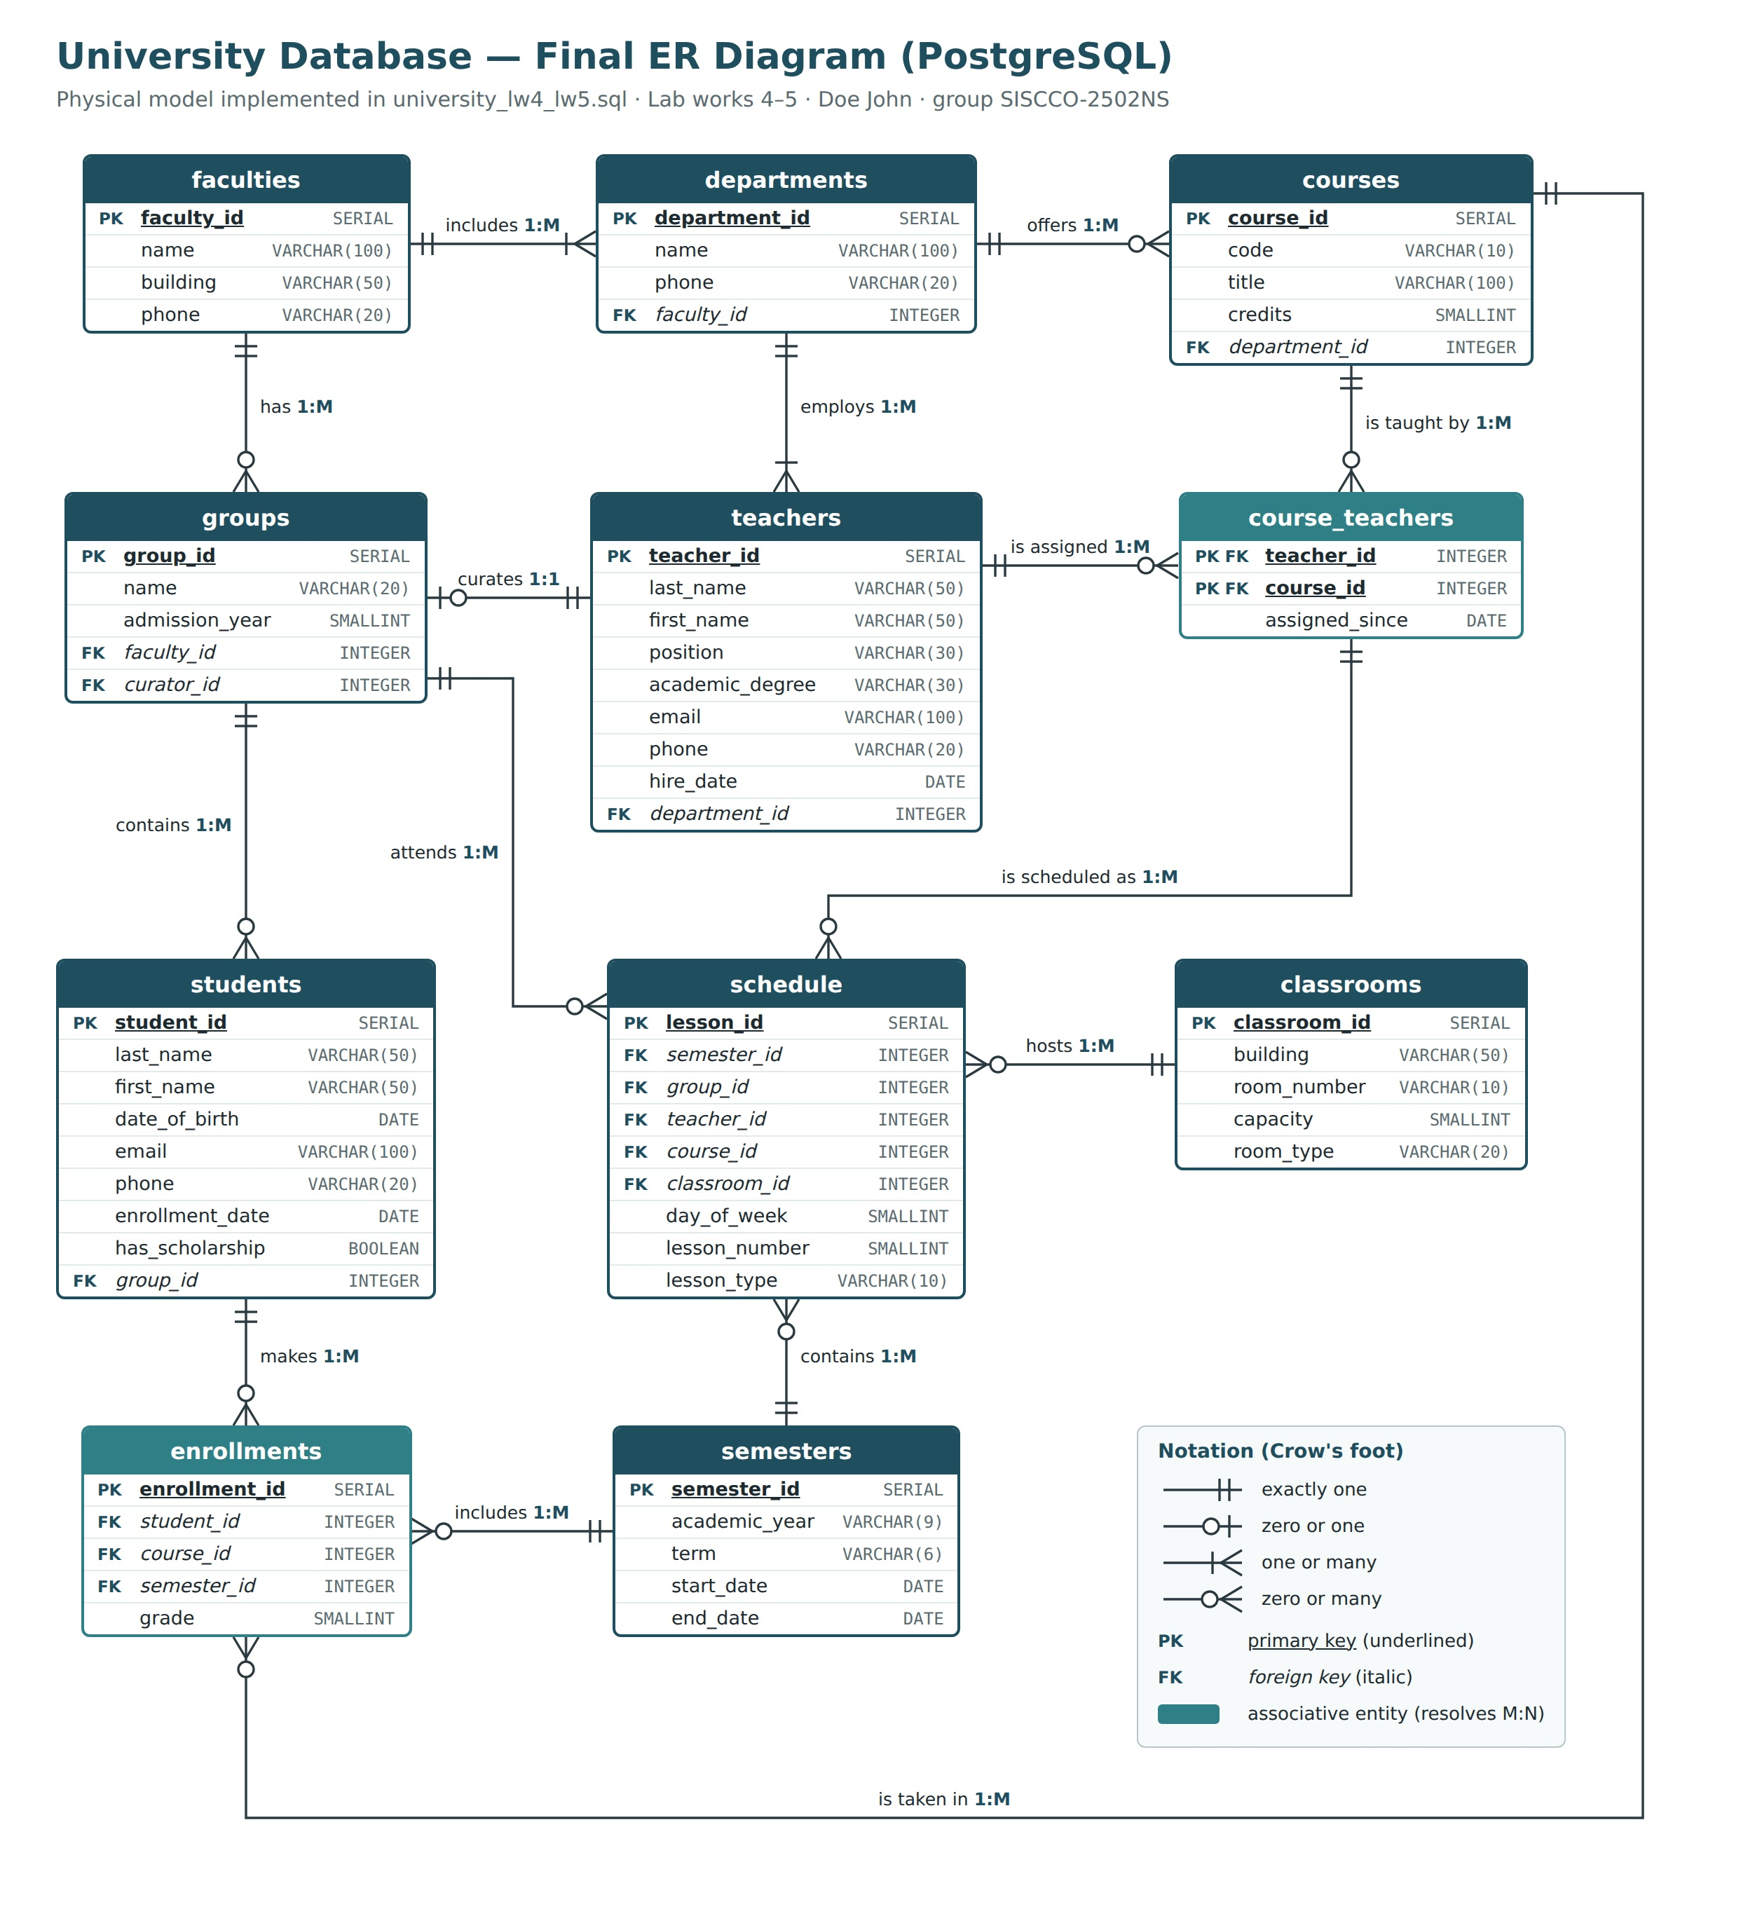
Figure 1. ER diagram of the University database (Lab works 4–5).

Tasks

Task 1
Use SELECT statement for any table with aliasing a result column.
The query shows all courses; every result column gets a new, more readable name with AS.
SELECT code AS course_code,
title AS course_title,
credits AS ects_credits
FROM courses;
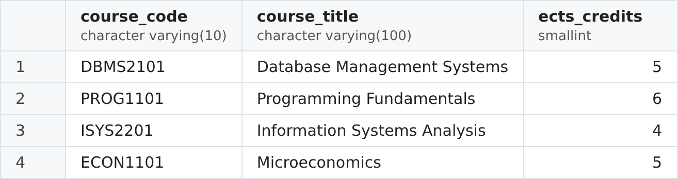
Figure 2. Result of Task 1.

Task 2
Use aliasing of tables in a SELECT statement with several tables (with join operation).
The query shows every student with the name of his or her group. The tables students and groups get the short aliases s and g, which are used to qualify the columns in SELECT and in the join condition.
SELECT s.last_name, s.first_name, g.name AS group_name
FROM students s
JOIN groups g ON s.group_id = g.group_id;
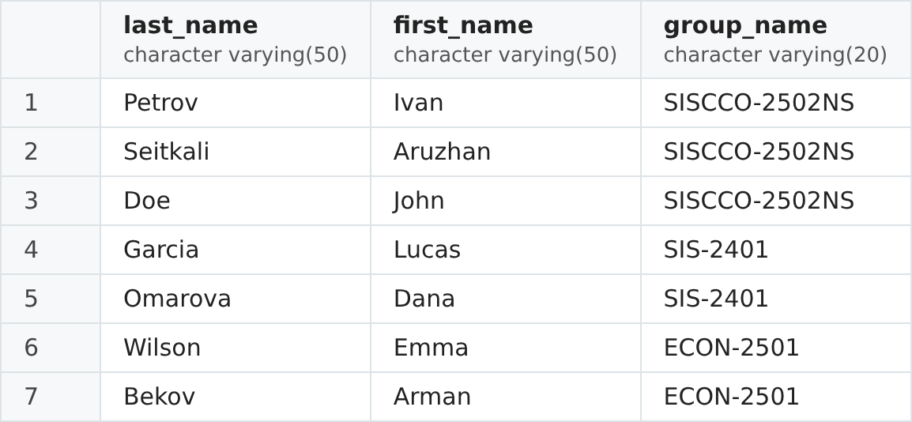
Figure 3. Result of Task 2.

Task 3
Select data from any table and represent two different attributes in one column in the result table.
The query joins the last name and the first name of every teacher into one column full_name with the concatenation operator ||.
SELECT last_name || ' ' || first_name AS full_name,
position
FROM teachers;
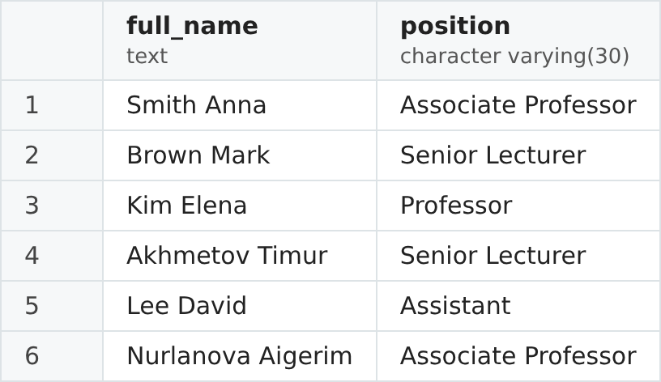
Figure 4. Result of Task 3.

Task 4
Write a SELECT query to get data from any table's attribute without duplicates values.
Six teachers hold only four different positions; DISTINCT removes the repeated values.
SELECT DISTINCT position
FROM teachers;
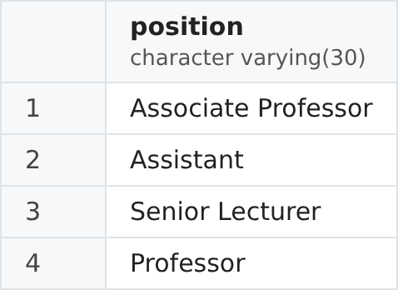
Figure 5. Result of Task 4.

Task 5
Select only null or not null values of any table's attribute.
The query shows the students who have no phone number in the database (the phone is NULL).
SELECT last_name, first_name, phone
FROM students
WHERE phone IS NULL;
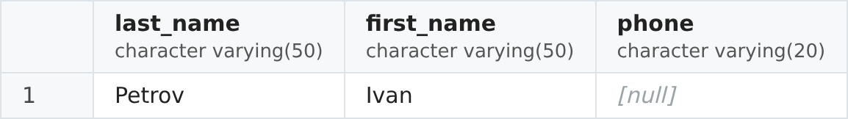
Figure 6. Result of Task 5.

Task 6
Use SELECT statement to get rows from any table with filtering values in a column between two values (using the <,<=,> and >= operators).
The query shows the enrollments with a grade from 70 to 90 inclusive, written with the comparison operators >= and <=.
SELECT student_id, course_id, semester_id, grade
FROM enrollments
WHERE grade >= 70 AND grade <= 90;
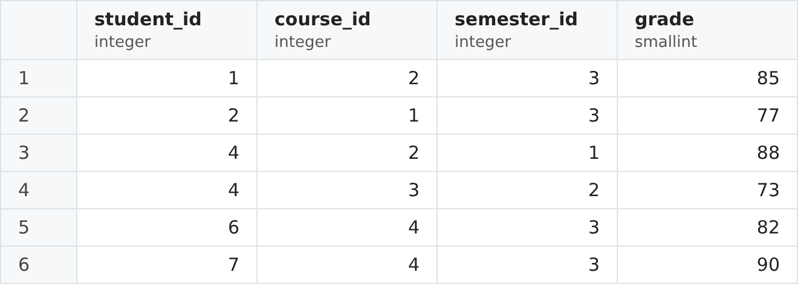
Figure 7. Result of Task 6.

Task 7
Use SELECT statement to get rows from any table with filtering values in a column between two values (using the BETWEEN operator).
The query shows the students born in 2006. BETWEEN includes both boundary values.
SELECT last_name, first_name, date_of_birth
FROM students
WHERE date_of_birth BETWEEN '2006-01-01' AND '2006-12-31';
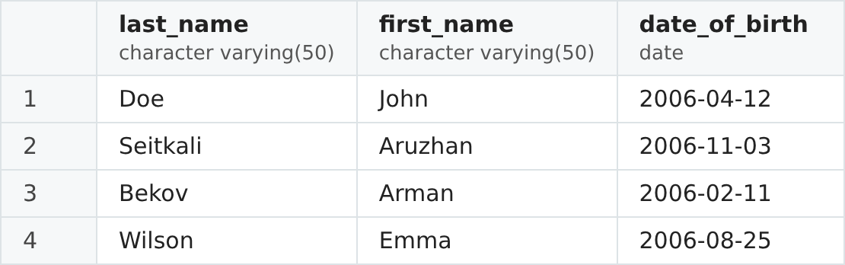
Figure 8. Result of Task 7.

Task 8
Use % with LIKE operator to find some values.
The % wildcard matches any number of characters, so the query finds all courses whose title contains the word "Systems" anywhere.
SELECT code, title
FROM courses
WHERE title LIKE '%Systems%';
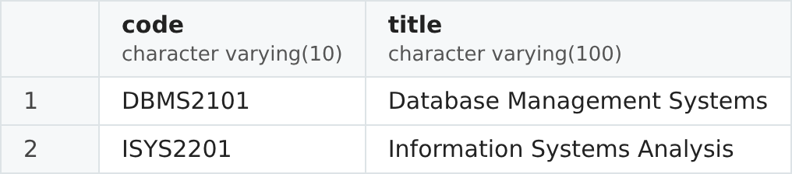
Figure 9. Result of Task 8.

Task 9
Use _ with LIKE operator to find some values.
The _ wildcard matches exactly one character. The pattern 'SIS-____' finds groups whose name is "SIS-" followed by exactly four characters, so SIS-2401 matches but SISCCO-2502NS does not.
SELECT name, admission_year
FROM groups
WHERE name LIKE 'SIS-____';
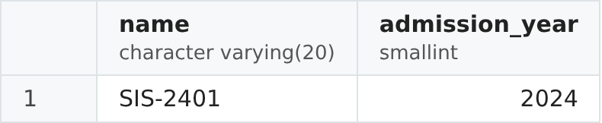
Figure 10. Result of Task 9.

Task 10
Write a SELECT query with CAST or :: operators.
The query converts the SMALLINT column credits in two ways: with the :: operator to a decimal number, and with CAST to text, so that it can be joined with the word "credits".
SELECT code,
credits::NUMERIC(4,1) AS credits_decimal,
CAST(credits AS VARCHAR) || ' credits' AS credits_text
FROM courses;
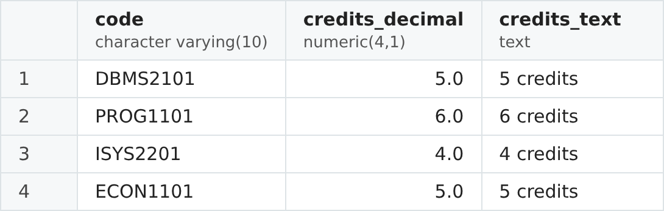
Figure 11. Result of Task 10.

