LABORATORY WORK REPORT
Lab 9 — Nested Queries on the University Database
Database Management Systems
Laboratory work: | Lab 9 — Nested queries (University database, individual work)
Student full name: | Doe John
Group: | SISCCO-2502NS
Course: | Database Management Systems

Preparation
DBMS: PostgreSQL 16. The database is the University database from the handout (“Lab work 8.sql”), in the state after Lab work 8: the handout data plus the rows added to Ed_process and Progress in Lab 8, Task 7.
With this data some tasks would show nothing interesting: all students study CSSE, all teachers work in CSSE&T, and nobody has an exam grade below 50. So a few rows were added before the tasks:
-- A group and a student of another major (RET), so that Task 1 filters something
INSERT INTO Groups VALUES (9,'RET-131',NULL,2);
INSERT INTO Students VALUES (9,'Dana','Bekova',NULL,1234567,'bekova@gmail.com',9);

-- Teachers of the IS and EM departments, so that Task 3 filters something
INSERT INTO Teachers VALUES (5,'Aigerim','Sadykova',1234567,'sadykova@gmail.com','Senior lecturer',2),
(6,'Marat','Zhunusov',1234567,'zhunusov@gmail.com','Associate professor',3);

-- A failed exam (below 50) for Task 4: Database Design for group CSSE-137
INSERT INTO Ed_process VALUES (12,7,1,4);
INSERT INTO Progress VALUES (12,12,7,55,61,58,40,51);
Every query below contains at least one subquery. Every result is the real output of the query, with column names and types as returned by PostgreSQL. Tasks 8–10 change the data, so they use RETURNING to show the inserted, deleted or updated rows.

Tasks

Task 1
Show last names of all students whose major is “CSSE”.
Students do not store their major, only their group, and the group stores the major. So there are two nested subqueries. The innermost one finds the identifier of the major CSSE (1). The middle one returns the list of groups of this major (CSSE-131 … CSSE-138), and the outer query shows the students whose group is IN this list. 8 students are shown; Bekova is not, because her group RET-131 belongs to the major RET.
SELECT lname
FROM students
WHERE group_id IN (SELECT group_id
FROM groups
WHERE major_id = (SELECT major_id
FROM majors
WHERE major_name = 'CSSE'));
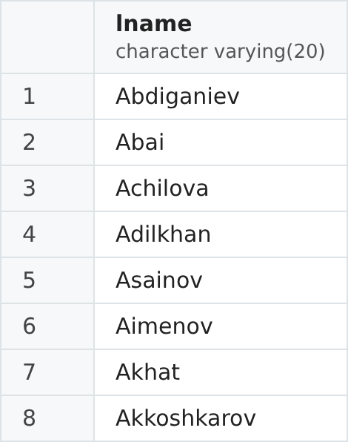
Figure 1. Result of Task 1.

Task 2
Show the identifiers of all students whose "final" grade is greater than the average "final" grade of all students.
The subquery returns one value, the average of all final grades: 985 / 12 = 82.08. The outer query compares every final grade with this value and keeps the grades above it. A student can have several such grades (for example student 1 has 90 and 94), so DISTINCT shows each identifier only once. Students 1–5 have at least one final grade above 82.08; students 6 (61) and 7 (51) do not.
SELECT DISTINCT stud_id
FROM progress
WHERE final > (SELECT AVG(final)
FROM progress)
ORDER BY stud_id;
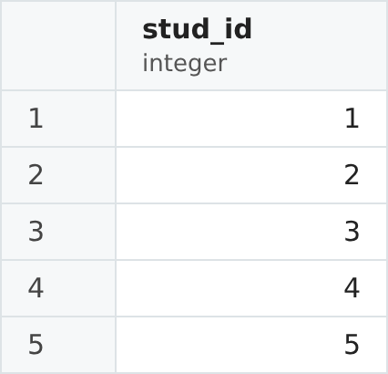
Figure 2. Result of Task 2.

Task 3
Show last names of all the teachers who work in departments CSSE&T and IS.
The subquery finds the identifiers of the departments CSSE&T and IS (1 and 2). The outer query shows the teachers whose dep_id is in this list: the four teachers of CSSE&T and Sadykova from IS. Zhunusov is not shown, because he works in the EM department.
SELECT lname
FROM teachers
WHERE dep_id IN (SELECT dep_id
FROM departments
WHERE dep_name IN ('CSSE&T', 'IS'));
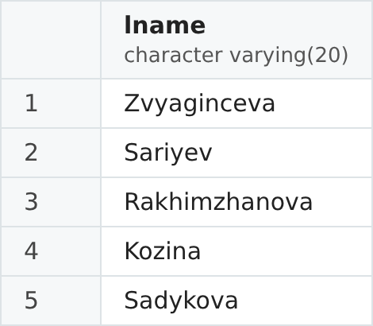
Figure 3. Result of Task 3.

Task 4
If at least one student has an "exam" grade below 50%, show a list of the last names of all university students with their "exam" grades (i.e. all students with any grades).
EXISTS is true if the subquery returns at least one row. The subquery does not depend on the outer query, so the condition is the same for every row: it is true here, because Akhat has 40 for the exam. Therefore the list of all students with their exam grades is shown (12 grade records). If nobody had an exam grade below 50, EXISTS would be false and the result would be empty.
SELECT st.lname, p.exam
FROM students st
JOIN progress p ON p.stud_id = st.stud_id
WHERE EXISTS (SELECT *
FROM progress
WHERE exam < 50)
ORDER BY st.lname, p.exam;
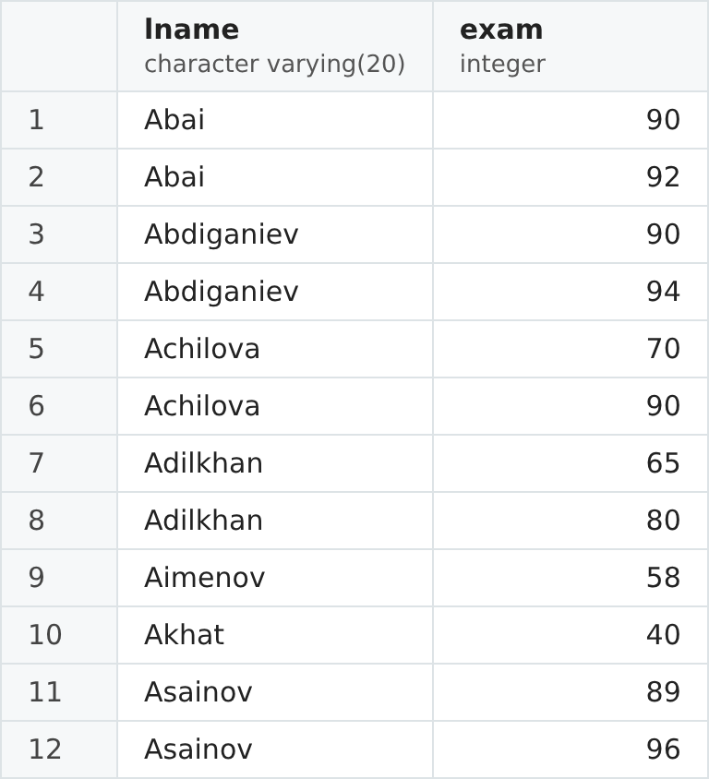
Figure 4. Result of Task 4.

Task 5
Write a query with ANY keyword and a subquery. Explain the query result.
The query shows the Database Design final grades that are greater than at least one (ANY) Physics final grade. The subquery returns the Physics grades 94, 91, 77, 70 and 90. "> ANY" is true when the value is greater than at least one of them, which is the same as greater than the smallest one (70). So 5 grades remain; Aimenov (61) and Akhat (51) are not greater than any Physics grade.
SELECT st.lname, s.subj_name, p.final
FROM progress p
JOIN students st ON p.stud_id = st.stud_id
JOIN ed_process e ON p.proc_id = e.proc_id
JOIN subjects s ON e.subj_id = s.subj_id
WHERE s.subj_name = 'Database Design'
AND p.final > ANY (SELECT p2.final
FROM progress p2
JOIN ed_process e2 ON p2.proc_id = e2.proc_id
JOIN subjects s2 ON e2.subj_id = s2.subj_id
WHERE s2.subj_name = 'Physics')
ORDER BY p.final DESC;
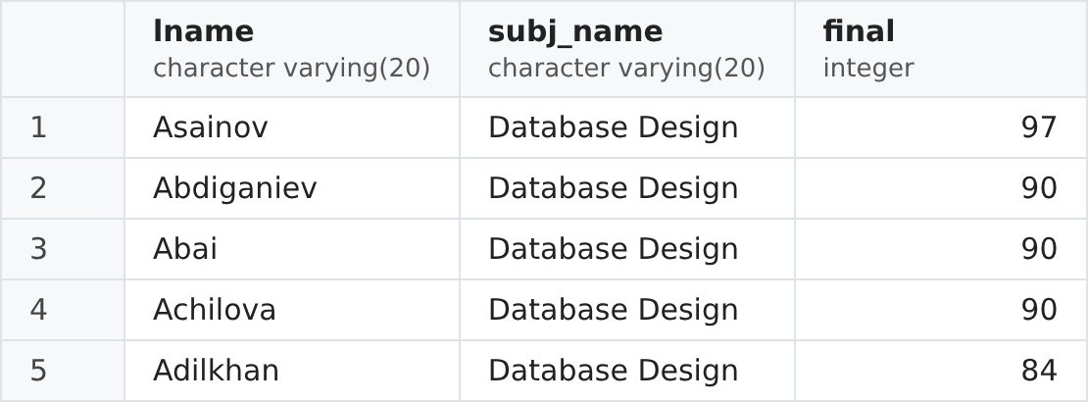
Figure 5. Result of Task 5.

Task 6
Write a query with ALL keyword and a subquery. Explain the query result.
The same query as in Task 5, but with ALL instead of ANY. "> ALL" is true only when the value is greater than every value of the subquery, which is the same as greater than the largest one (94). Only one Database Design grade is higher than all Physics grades: Asainov with 97.
SELECT st.lname, s.subj_name, p.final
FROM progress p
JOIN students st ON p.stud_id = st.stud_id
JOIN ed_process e ON p.proc_id = e.proc_id
JOIN subjects s ON e.subj_id = s.subj_id
WHERE s.subj_name = 'Database Design'
AND p.final > ALL (SELECT p2.final
FROM progress p2
JOIN ed_process e2 ON p2.proc_id = e2.proc_id
JOIN subjects s2 ON e2.subj_id = s2.subj_id
WHERE s2.subj_name = 'Physics')
ORDER BY p.final DESC;
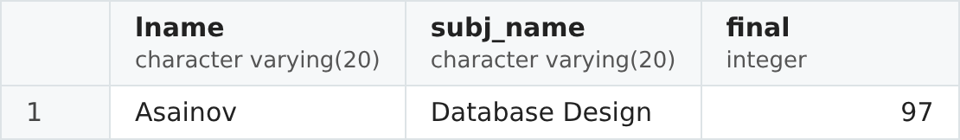
Figure 6. Result of Task 6.

Task 7
Write a query with a subquery in FROM clause. Explain the query result.
The subquery in FROM works as a temporary table student_avg with one row per student: the student's identifier and average final grade (92, 90.5, 83.5, 77, 93.5, 61, 51). The outer query aggregates this table once more: 7 students have grades, the best average is 93.50, the worst is 51.00 and the average of all student averages is 78.36. Such a query needs a subquery in FROM, because aggregate functions cannot be nested directly: MAX(AVG(final)) gives an error. A subquery in FROM must have an alias (AS student_avg).
SELECT COUNT(*) AS students,
ROUND(MAX(avg_final), 2) AS best_average,
ROUND(MIN(avg_final), 2) AS worst_average,
ROUND(AVG(avg_final), 2) AS average_of_averages
FROM (SELECT stud_id, AVG(final) AS avg_final
FROM progress
GROUP BY stud_id) AS student_avg;
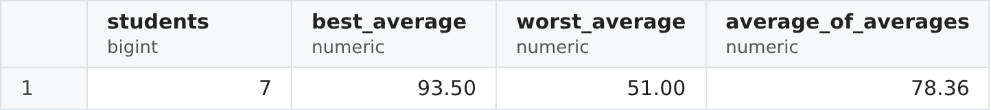
Figure 7. Result of Task 7.

Task 8
Write a query with a subquery in INSERT statement. Explain the query result.
The query adds a Physics lecture for group CSSE-131 to the schedule: on Tuesday at 13:00 in room 410, teacher Sariyev. The Schedule table stores only identifiers, so they are found by names with subqueries: the next free sch_id (MAX + 1 = 3), the course of the group in Ed_process (proc_id 7), the class type "lecture" (1) and the teacher Sariyev (2). Each subquery returns exactly one value. RETURNING * shows the inserted row.
INSERT INTO schedule
VALUES ((SELECT MAX(sch_id) + 1 FROM schedule),
(SELECT e.proc_id
FROM ed_process e
JOIN groups g ON e.group_id = g.group_id
JOIN subjects s ON e.subj_id = s.subj_id
WHERE g.group_name = 'CSSE-131' AND s.subj_name = 'Physics'),
(SELECT class_id FROM classes WHERE class_type = 'lecture'),
(SELECT teach_id FROM teachers WHERE lname = 'Sariyev'),
410, '13:00', 'tue')
RETURNING *;
Figure 8. Result of Task 8.

Task 9
Write a query with a subquery in DELETE statement. Explain the query result.
The query deletes the courses from Ed_process that have no grades. The subquery returns the proc_id of all records in Progress, and NOT IN keeps only the courses that are not in this list. Only one course has no grades: Database Design of group CSSE-133 (proc_id 3), and it has no classes in the schedule either, so it can be deleted. RETURNING * shows the deleted row.
DELETE FROM ed_process
WHERE proc_id NOT IN (SELECT proc_id
FROM progress)
RETURNING *;
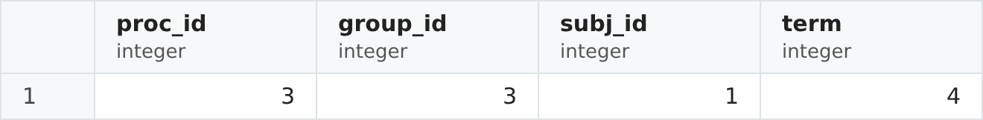
Figure 9. Result of Task 9.

Task 10
Write a query with a subquery in UPDATE statement. Explain the query result.
In the handout data no department has a head (headteach_id is NULL). The query assigns a head to every department: the teacher of that department with the smallest identifier. This is a correlated subquery: it uses d.dep_id from the outer UPDATE, so it is calculated again for every department. CSSE&T gets teacher 1 (Zvyaginceva), IS gets teacher 5 (Sadykova) and EM gets teacher 6 (Zhunusov). RETURNING shows the updated rows.
UPDATE departments d
SET headteach_id = (SELECT MIN(t.teach_id)
FROM teachers t
WHERE t.dep_id = d.dep_id)
WHERE headteach_id IS NULL
RETURNING dep_id, dep_name, headteach_id;
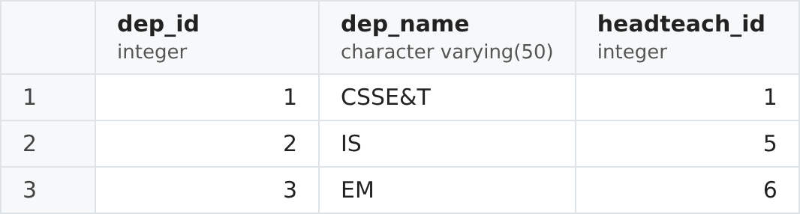
Figure 10. Result of Task 10.

