LABORATORY WORK REPORT
Lab 1 — Number Systems: Conversion and Arithmetic
Database Management Systems
Laboratory work: | Lab 1 — Number systems. Transfer numbers from one number system to another. Arithmetic in the number systems.
Student full name: | Doe John
Group: | SISCCO-2502NS
Course: | Database Management Systems

1. Objective
To acquire the skills of operations in different number systems: converting a number between the decimal, binary, octal and hexadecimal systems by the division/multiplication-by-base method, and by the shortcut methods of grouping binary digits by 3 (octal) and by 4 (hexadecimal).

2. Task (Variant 6)
Complete the table by converting each of the four given numbers into the remaining number systems:
№ | Decimal | Binary | Octal | Hexadecimal
1 | 654.27 | — | — | —
2 | — | 1100001010101 | — | —
3 | — | — | 632 | —
4 | — | — | — | 5AD

3. Solution

3.1 Number 654.27(10)
Integer part, division-by-base method:
Division | Quotient | Remainder
654 : 2 | 327 | 0
327 : 2 | 163 | 1
163 : 2 | 81 | 1
81 : 2 | 40 | 1
40 : 2 | 20 | 0
20 : 2 | 10 | 0
10 : 2 | 5 | 0
5 : 2 | 2 | 1
2 : 2 | 1 | 0
1 : 2 | 0 | 1
654(10) = 1010001110(2) — remainders read bottom to top.
Fractional part, multiplication-by-base method: 0.27 × 2 = 0.54 → 0; 0.54 × 2 = 1.08 → 1; 0.08 × 2 = 0.16 → 0; 0.16 × 2 = 0.32 → 0; 0.32 × 2 = 0.64 → 0; 0.64 × 2 = 1.28 → 1; 0.28 × 2 = 0.56 → 0; 0.56 × 2 = 1.12 → 1; 0.12 × 2 = 0.24 → 0; 0.24 × 2 = 0.48 → 0.
0.27(10) ≈ 0.0100010100(2), so 654.27(10) = 1010001110.0100010100(2)
Octal (division/multiplication by 8): 654 : 8 = 81 r6; 81 : 8 = 10 r1; 10 : 8 = 1 r2; 1 : 8 = 0 r1 → 654(10) = 1216(8). 0.27×8=2.16→2; 0.16×8=1.28→1; 0.28×8=2.24→2; 0.24×8=1.92→1 → 0.27(10) ≈ 0.2121(8).
654.27(10) = 1216.2121(8)
Hexadecimal (division/multiplication by 16): 654 : 16 = 40 r14(E); 40 : 16 = 2 r8; 2 : 16 = 0 r2 → 654(10) = 28E(16). 0.27×16=4.32→4; 0.32×16=5.12→5; 0.12×16=1.92→1; 0.92×16=14.72→E → 0.27(10) ≈ 0.451E(16).
654.27(10) = 28E.451E(16)

3.2 Number 1100001010101(2)
Decimal (positional summation): 1·2¹²+1·2¹¹+1·2⁶+1·2⁴+1·2²+1·2⁰ = 4096+2048+64+16+4+1 = 6229(10).
Octal (group into 3 bits from the right, zero-padded): 001 100 001 010 101 → 1 4 1 2 5 → 14125(8). Check: 1·8⁴+4·8³+1·8²+2·8+5 = 6229 ✓
Hexadecimal (group into 4 bits from the right): 0001 1000 0101 0101 → 1 8 5 5 → 1855(16). Check: 1·16³+8·16²+5·16+5 = 6229 ✓

3.3 Number 632(8)
Decimal: 632(8) = 6·8²+3·8¹+2·8⁰ = 384+24+2 = 410(10).
Binary (each octal digit → 3 bits): 6=110, 3=011, 2=010 → 110011010(2). Check: 256+128+16+8+2 = 410 ✓
Hexadecimal (group the binary code into 4 bits): 0001 1001 1010 → 1 9 A → 19A(16). Check: 256+144+10 = 410 ✓

3.4 Number 5AD(16)
Decimal: 5AD(16) = 5·16²+10·16¹+13·16⁰ = 1280+160+13 = 1453(10).
Binary (each hex digit → 4 bits): 5=0101, A=1010, D=1101 → 0101 1010 1101 → 10110101101(2) (leading zero dropped). Check: 1024+256+128+32+8+4+1 = 1453 ✓
Octal (group the binary code into 3 bits): 010 110 101 101 → 2 6 5 5 → 2655(8). Check: 2·512+6·64+5·8+5 = 1453 ✓

4. Verification
All four conversions were additionally cross-checked with a short Python script implementing the same division/multiplication algorithms, confirming every value in the final table below.
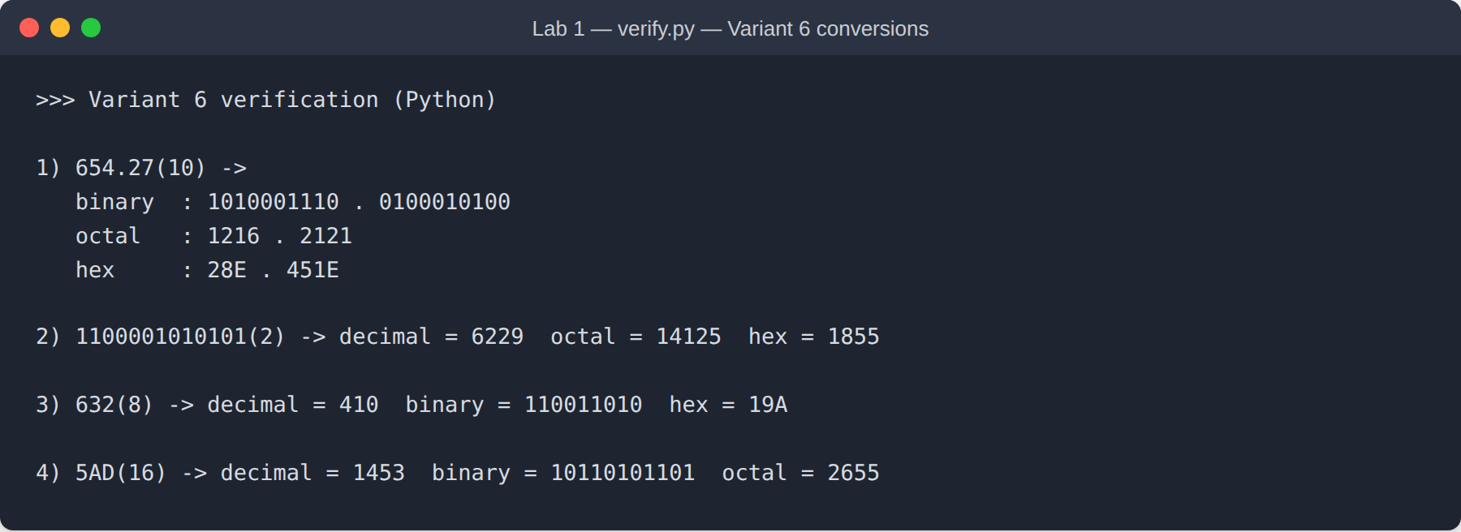
Figure 1. Console output — verifying the variant 6 conversions with Python.

5. Final Table (Variant 6)
№ | Decimal | Binary | Octal | Hexadecimal
1 | 654.27 | 1010001110.0100010100 | 1216.2121 | 28E.451E
2 | 6229 | 1100001010101 | 14125 | 1855
3 | 410 | 110011010 | 632 | 19A
4 | 1453 | 10110101101 | 2655 | 5AD

6. Conclusion
This laboratory work reinforced the skills of converting numbers between the decimal, binary, octal, and hexadecimal number systems: using the division/multiplication-by-base method, as well as the "shortcut" methods of grouping binary digits by 3 (for octal) and by 4 (for hexadecimal). All four variant-6 conversions were solved step by step and independently verified with a Python script, and every result was consistent across both methods.

