LABORATORY WORK REPORT
Lab 2 — MS-DOS: Files and Directories
Database Management Systems
Laboratory work: | Lab 2 — Determination of properties of an operating system. Operation with files and directories.
Student full name: | Doe John
Group: | SISCCO-2502NS
Course: | Database Management Systems

1. Objective
Acquisition of the main skills of operation in the environment of the MS-DOS operating system: navigating disks and directories, working with files, and building a multi-level directory structure from the command line.

2. MS-DOS Commands Used

Service and navigation commands
Command | Purpose
VER / CLS / DATE / TIME | Show MS-DOS version / clear screen / show date / show time
DriveName: | Change the current drive (e.g. D:)
CD DirectoryPath | Change to the specified directory
CD .. | Move to the parent directory
CD \ | Move to the root directory of the current drive

File and directory commands
Command | Purpose
COPY CON FileName | Create a text file from the keyboard (finish with F6 / Ctrl+Z)
TYPE / EDIT / REN / DEL | View / edit / rename / delete a file
MD DirectoryName | Create a new directory
RD DirectoryName | Delete an empty directory (move out of it first)
DIR [Path] [/P] [/S] | List directory contents (/P page by page, /S recursively)

3. Task (Variant 6)
Create the following hierarchical file system inside the STUDENT directory, where each directory D1–D8 contains a text file of the same name (d1.txt–d8.txt):
C:\STUDENT
+-- D1 (d1.txt)
| +-- D2 (d2.txt)
| +-- D3 (d3.txt)
| +-- D4 (d4.txt)
| +-- D5 (d5.txt)
+-- D6 (d6.txt)
+-- D7 (d7.txt)
+-- D8 (d8.txt)

D1 and D6 are two independent subdirectories of STUDENT. D1 contains only D2, which in turn contains D3, D4, D5. The D6 branch is a chain of nested directories: D6 → D7 → D8 — each next directory is nested inside the previous one, not a "sibling" of it.

4. Solution — Sequence of MS-DOS Commands
C:\>MD STUDENT
C:\>CD STUDENT

C:\STUDENT>MD D1
C:\STUDENT>CD D1
C:\STUDENT\D1>COPY CON d1.txt (type text, then F6/Ctrl+Z)

C:\STUDENT\D1>MD D2
C:\STUDENT\D1>CD D2
C:\STUDENT\D1\D2>COPY CON d2.txt

C:\STUDENT\D1\D2>MD D3
C:\STUDENT\D1\D2>CD D3
C:\STUDENT\D1\D2\D3>COPY CON d3.txt
C:\STUDENT\D1\D2\D3>CD ..

C:\STUDENT\D1\D2>MD D4
C:\STUDENT\D1\D2>CD D4
C:\STUDENT\D1\D2\D4>COPY CON d4.txt
C:\STUDENT\D1\D2\D4>CD ..

C:\STUDENT\D1\D2>MD D5
C:\STUDENT\D1\D2>CD D5
C:\STUDENT\D1\D2\D5>COPY CON d5.txt
C:\STUDENT\D1\D2\D5>CD ..
C:\STUDENT\D1\D2>CD ..
C:\STUDENT\D1>CD ..

C:\STUDENT>MD D6
C:\STUDENT>CD D6
C:\STUDENT\D6>COPY CON d6.txt

C:\STUDENT\D6>MD D7
C:\STUDENT\D6>CD D7
C:\STUDENT\D6\D7>COPY CON d7.txt

C:\STUDENT\D6\D7>MD D8
C:\STUDENT\D6\D7>CD D8
C:\STUDENT\D6\D7\D8>COPY CON d8.txt

C:\STUDENT\D6\D7\D8>CD \

5. Verification
The finished structure was reviewed page by page with a recursive directory listing:
C:\>CD STUDENT
C:\STUDENT>DIR /S /P

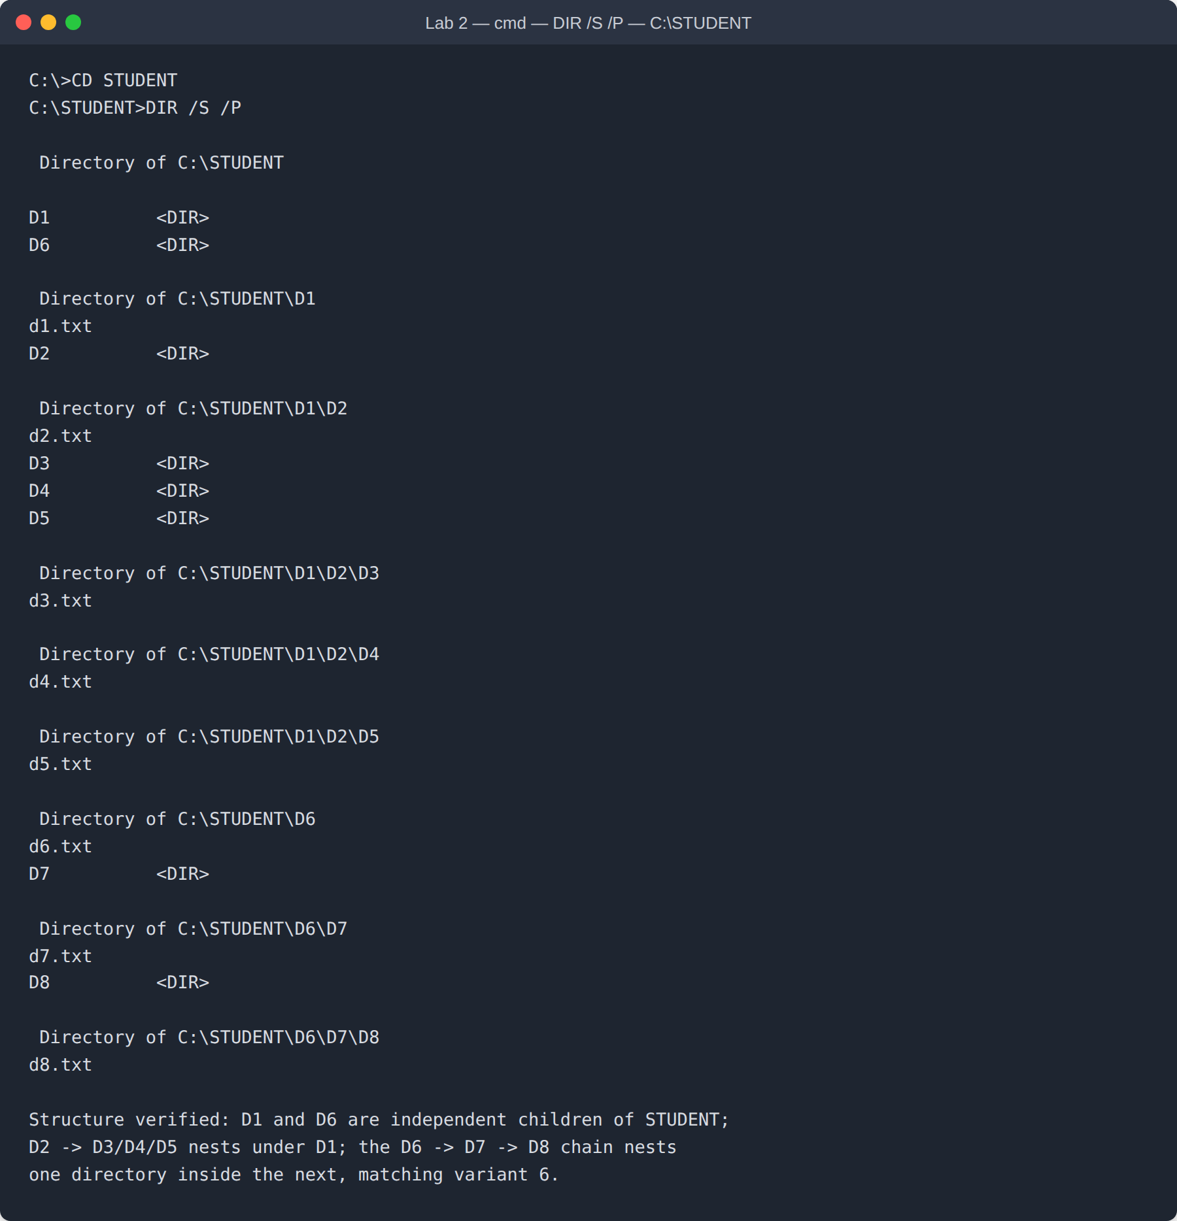
Figure 1. Recursive directory listing of C:\STUDENT, confirming the variant 6 structure and all eight text files.

6. Conclusion
This laboratory work covered the core MS-DOS commands: service commands (VER, CLS, DATE, TIME), navigation commands (CD, drive switching), file commands (COPY CON, TYPE, REN, DEL, MOVE), and directory commands (MD, RD, DIR). These were used to build and verify the hierarchical file structure of the STUDENT directory assigned for variant 6, where D1 and D6 are independent branches and D6 → D7 → D8 forms a chain of nested subdirectories.

