LABORATORY WORK REPORT
Lab 3 — HTML: Formatting, Images and Hyperlinks
Database Management Systems
Laboratory work: | Lab 3 — Creation of the elementary HTML document (3-a); insertion of figures, bookmarks and hyperlinks (3-b).
Student full name: | Doe John
Group: | SISCCO-2502NS
Course: | Database Management Systems

1. Objective
- learn to create the elementary hypertext document by means of the Notepad text editor;
- learn to use font- and paragraph-formatting tags;
- learn to insert pictures into an HTML document;
- learn to create bookmarks and hyperlinks.
This laboratory work has no variants — the task is the same for every student; personal data is substituted into the document individually. It produces four linked files: 1_Doe.htm, 2_Doe.htm, 3_Doe.htm, 4_Doe.htm.

2. Part 3-a, Steps 1–5 — Headings and Font Formatting (1_Doe.htm)
The base document was created with the standard html/head/title/body structure, a signature added with <br>, and the three lines re-styled with heading tags (final: h2 / h5 / h3):
<h2>I welcome you on my first web page!</h2>
<h5>Student of the SISCCO-2502NS group</h5>
<h3><font size="+2"><i>Doe John</i></font></h3>

A Russian sample phrase from the assignment was added and formatted per the required sample — strikethrough, per-letter colored bold italic, underlined small text, and a two-color word split — with a bookmark named "Morning" placed just before it (used later from 3_Doe.htm):
<a name="Morning"></a>
<p>
<s>Нас</s>
<b><i><font color="red">у</font><font color="green">т</font><font color="blue">р</font><font color="purple">о</font></i></b>
<u><small>встречает</small></u>
про<i><font color="red">хлад</font></i><font color="blue">ой</font>
</p>

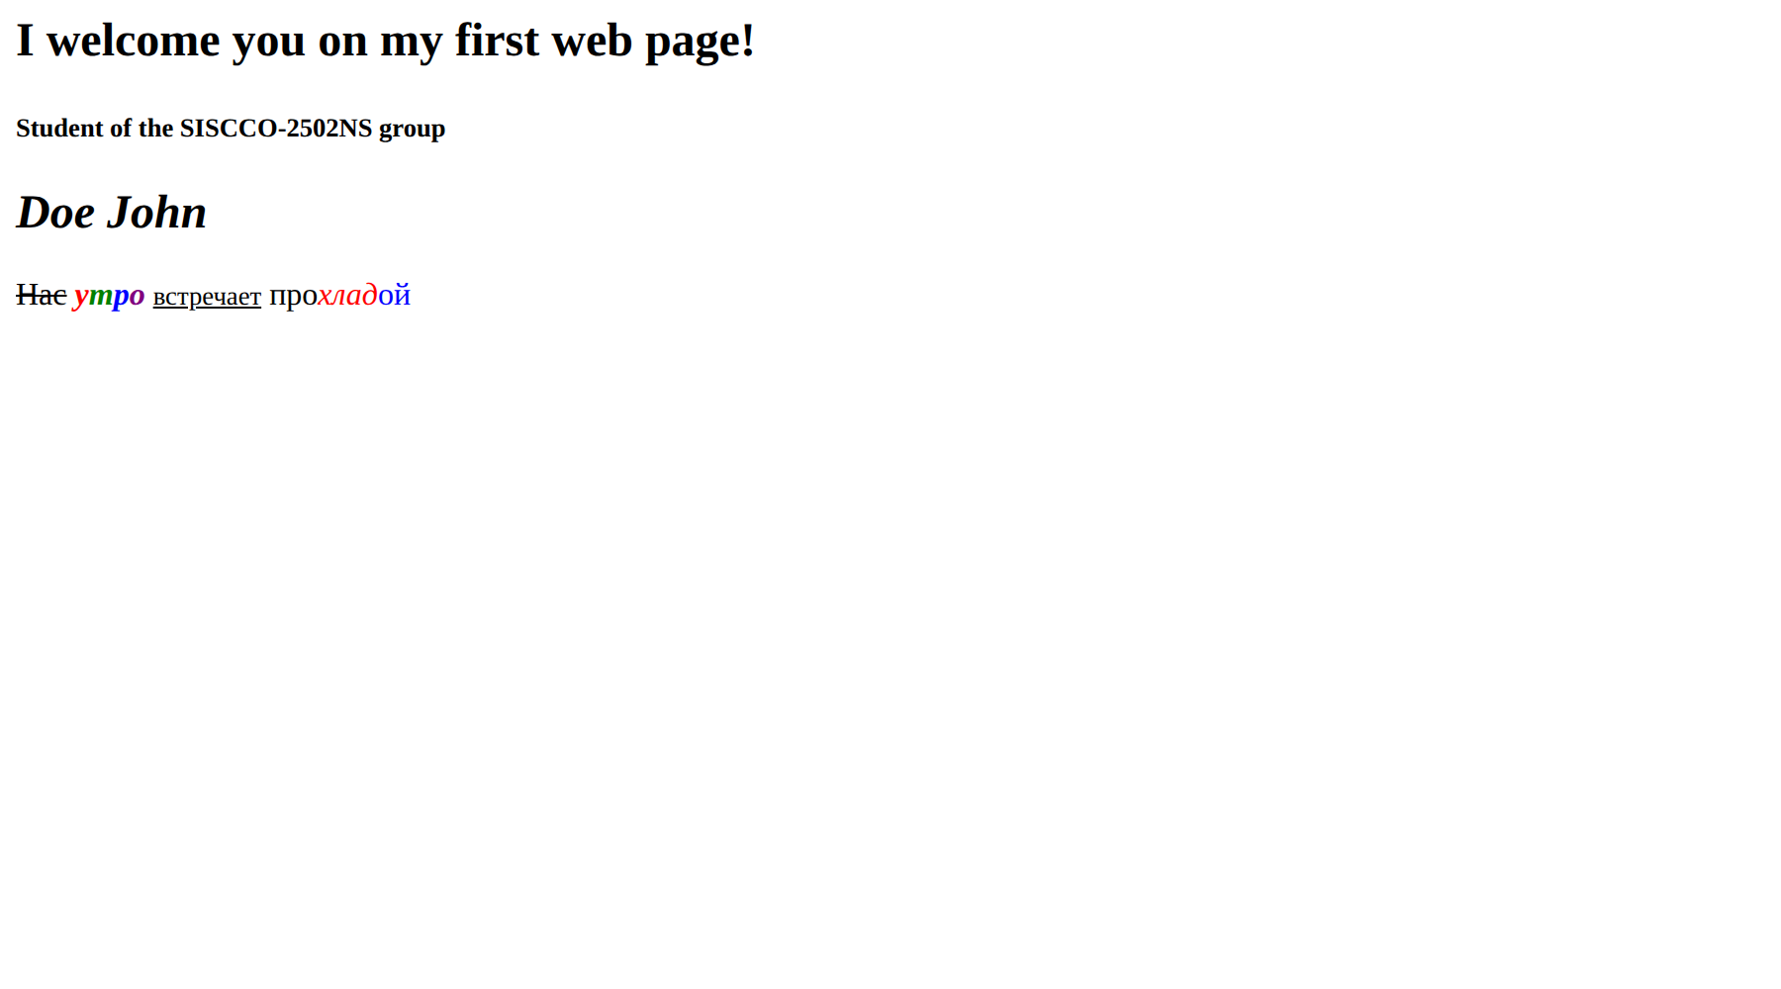
Figure 1. 1_Doe.htm rendered in the browser — headings and per-letter font formatting.

3. Part 3-a, Step 6 — Paragraph Formatting (2_Doe.htm)
A second document center-aligns its greeting line, then formats a sample paragraph two ways: justified and bounded by horizontal rules, then duplicated and split into centered lines with <br> (a layout that survives window resizing, unlike the justified version). A bookmark "Mono" marks the start of the sample text. The methodical guide's original sample text here was replaced with the classic Lorem Ipsum filler text, since the exercise is about paragraph formatting, not the specific wording:
<p align="center">
Приветствую Вас на моей второй web-странице! <br>
Lorem Ipsum
</p>

<a name="Mono"></a>
<hr size="2">
<p align="justify"> ... Lorem ipsum dolor sit amet ... </p>
<hr size="2">

<p align="center">
Lorem ipsum dolor sit amet, consectetur adipiscing elit, <br>
sed do eiusmod tempor incididunt ut labore et dolore magna aliqua. <br>
... <br>
Duis aute irure dolor in reprehenderit in voluptate velit esse cillum.
</p>

4. Part 3-a, Step 7 — Lists (3_Doe.htm)
A third document builds an unordered "Fonts / Titles / Paragraphs" list (first ordered, then changed to bulleted per the assignment), plus a "mixed" list: an outer ordered list with nested unordered sub-lists:
<ol>
<li>Fonts
<ul><li>Size</li><li>Color</li><li>To a set</li><li>Indexes</li></ul>
</li>
<li>Headings
<ul><li>From 1st to the 6th level</li></ul>
</li>
<li>Paragraphs
<ul><li>Alignment</li><li>A rupture of lines in the paragraph</li><li>With reformatting use.</li></ul>
</li>
</ol>

5. Part 3-b — Images, Bookmarks and Hyperlinks (4_Doe.htm)
A blue arrow image (50×50, right-aligned, tooltip "to Return") was added at the top of a copy of 2_Doe.htm, itself a hyperlink back to 3_Doe.htm; a green arrow image (100×100, tooltip "Figure 2") was added at the end. The original assignment specified .wmf sample graphics; these were replaced with SVG, since browsers no longer render WMF:
<a href="3_Doe.htm">
<img src="images/arrow1.svg" width="50" height="50" align="right" alt="to Return">
</a>
...
<img src="images/arrow2.svg" width="100" height="100" align="left" alt="Figure 2">

Bookmarks and hyperlinks tie all four documents together:
Word / element | Link target
"Fonts" (3_Doe.htm) | 1_Doe.htm#Morning
"Titles" (3_Doe.htm) | #Hello (top of 3_Doe.htm itself)
"Paragraphs" (3_Doe.htm) | 2_Doe.htm
"reformatting" (3_Doe.htm) | 2_Doe.htm#Mono
Arrow image (4_Doe.htm) | 3_Doe.htm
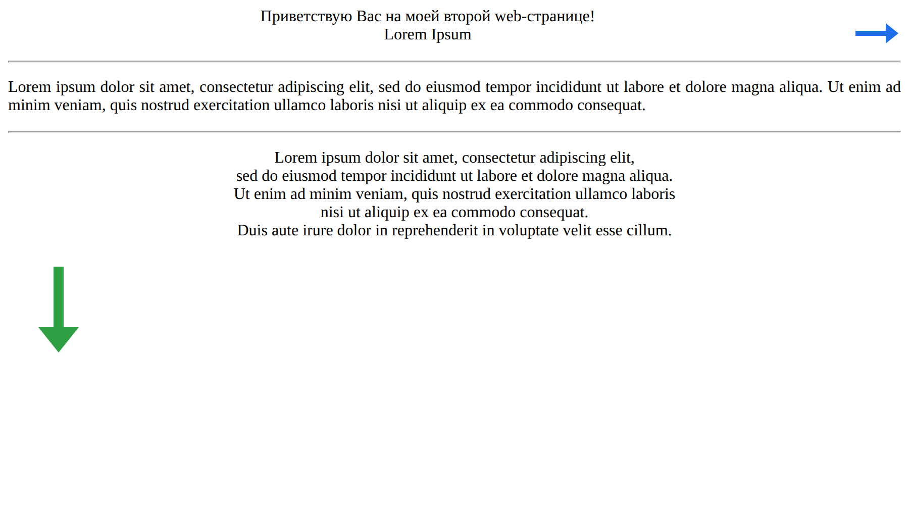
Figure 2. 4_Doe.htm rendered in the browser — the sized/aligned arrow images with tooltips and a hyperlink back to 3_Doe.htm.
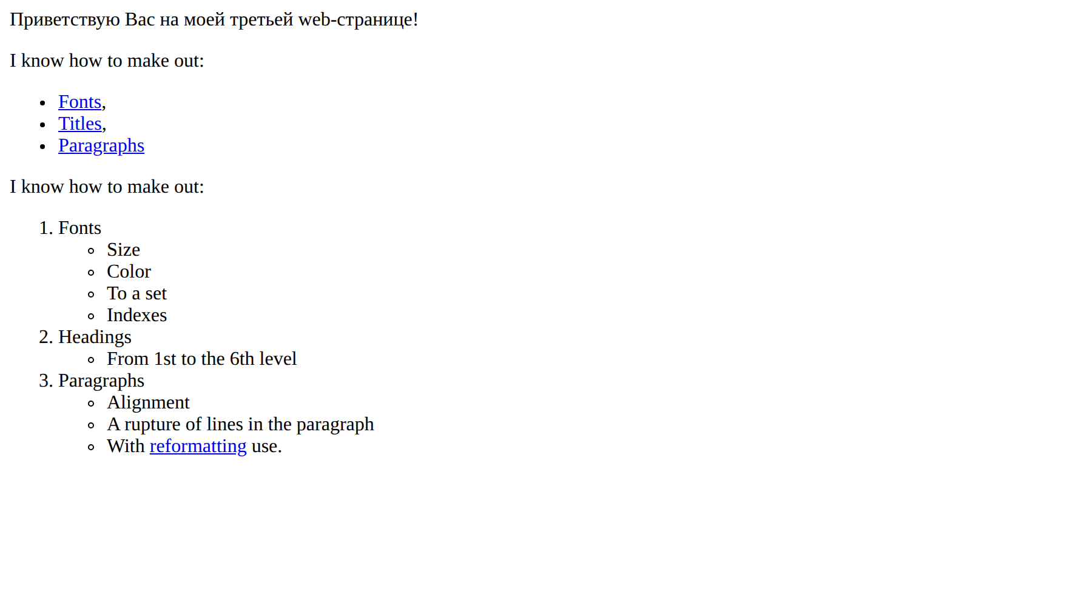
Figure 3. 3_Doe.htm rendered in the browser — the bulleted list (with hyperlinks) and the nested mixed list.

6. Reference Tables (Main Tags Used)
Purpose | Tag
Heading, paragraph, line break | h1..h6 / p / br
Paragraph alignment | p align="left|center|right|justify"
Horizontal rule | hr size="?"
Bold / italic / underline / strike | b / i / u / s
Font size / color | font size="?" / font color="..."
Ordered / unordered list | ol / ul with li items
Insert an image | img src="file" width="w" height="h" align="..." alt="..."
Link to a page / bookmark | a href="page" / a href="page#bookmark" / a href="#bookmark"
Define a bookmark | a name="bookmark_name"

7. Verification
All four documents were opened in a headless Chromium browser and every hyperlink was followed to confirm the bookmarks resolve correctly, the images render at the requested size and alignment, and the per-letter/per-word font formatting displays as specified.

8. Conclusion
This laboratory work covered creating simple HTML documents: document structure, font formatting (bold, italic, underline, strikethrough, color, size), paragraph formatting (alignment, horizontal rules, line breaks), ordered/unordered/nested lists, image insertion with size, alignment and tooltip, and bookmarks and hyperlinks both within and between documents. The four resulting pages (1_Doe.htm–4_Doe.htm) render and cross-link correctly, as confirmed by direct browser testing.

