LABORATORY WORK REPORT
Lab 4 — Relational Databases: Tables, Relationships and Queries
Database Management Systems
Laboratory work: | Lab 4 — Creating a simple database in Microsoft Access 2010: entering/sorting records, a two-table database with relationships, and select queries.
Student full name: | Doe John
Group: | SISCCO-2502NS
Course: | Database Management Systems

1. Objective
- learn how to create a table with the help of templates and the Table Designer;
- ensure correct data entry into a table and learn how to sort records;
- design a two-table database with a one-to-many relationship and cascade update/delete;
- learn how to build simple and complex selection queries.
This laboratory work has no variants — the task, sample tables and their data are the same for every student.

2. Environment Note
This lab is written around the Microsoft Access 2010 desktop GUI, which is not available in this environment. To make the work reproducible and verifiable, every table, relationship and query below was rebuilt as an equivalent SQLite database and plain SQL — the same relational operations Access performs under its ribbon menus (a "data scheme" relationship with cascade options is a FOREIGN KEY ... ON UPDATE/DELETE CASCADE; the Query Builder's select query is a SELECT statement). All data and results were generated by actually running these scripts.

3. Practical Work 1 — Tables "Employee" and "Student"

Task 1: Employee (built from a template)
Fields renamed per the assignment (ID/State/Country or Region -> Code/Republic/Country), unused template fields removed, then sorted alphabetically by Organization:
Code | Organization | Last name | First name | Position | City
1 | Растр | Иванов | Сергей | инженер | Лениногорск
2 | Иволга | Сидоров | Дмитрий | электрик | Лениногорск
3 | Голден | Петров | Иван | прораб | Лениногорск
4 | Лайма | Никитина | Элина | бухгалтер | Лениногорск
5 | Рубин | Сергеева | Мария | директор | Лениногорск
(Contact details — email, phones, fax, street address, postal code, country — are carried in full in the underlying table; only the identifying columns are shown here for readability.)

Task 2: Student (built with the Table Designer, CodeStudent autonumber key)
Code | Last name | First name | Patronymic | Address | Phone | Specialty
1 | Иванов | Сергей | Александрович | г. Новороссийск | 457896 | технолог
2 | Петров | Сергей | Петрович | г. Москва | 7458962 | технолог
3 | Гаврелеева | Ольга | Ивановна | г. Москва | 3698521 | бухгалтер
4 | Соколова | Инна | Олеговна | г. Новороссийск | 852967 | бухгалтер
5 | Мухина | Олеся | Петровна | г. Москва | 8625471 | технолог
6 | Апареева | Анна | Романовна | г. Люберцы | 748596 | технолог
7 | Глинкина | Дина | Евгеньевна | г. Люберцы | 919597 | технолог
8 | Сорина | Ольга | Сергеевна | г. Москва | 9191954 | бухгалтер
Both tables live together in employees.db, the SQL equivalent of the single "workers"/"Database of employees" file used across Practical work 1 and 3.

4. Practical Work 2 — Two-Table Database with a Relationship
Tables Groups (Study Group as the key) and List (Code as the key; Study Group is a lookup/combo-box column referencing Groups) were built with the Table Designer, then linked in the data scheme with a one-to-many relationship, referential integrity enforced, and both cascade update and cascade delete enabled:
CREATE TABLE Groups (StudyGroup INTEGER PRIMARY KEY, Teacher TEXT);
CREATE TABLE List (
Code INTEGER PRIMARY KEY AUTOINCREMENT, LastName TEXT, ..., StudyGroup INTEGER,
FOREIGN KEY (StudyGroup) REFERENCES Groups (StudyGroup)
ON UPDATE CASCADE ON DELETE CASCADE
);

Groups was filled with five study groups (101–105, one teacher each) and List with five students, each pointing at a group. Task 7 then renumbered every group from 10x to 20x — cascade update automatically rewrote the matching Study Group values in List. Task 8 deleted group 201 — cascade delete automatically removed every List row that had referenced it (Чернова and Архипов, originally group 101):
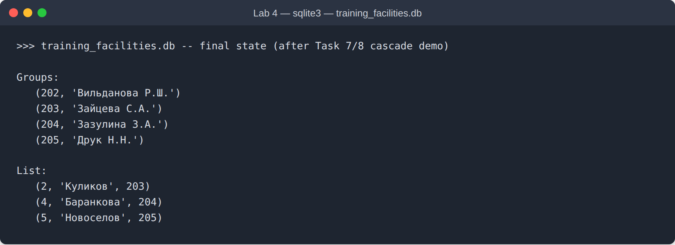
Figure 1. training_facilities.db — final state after the Task 7 cascade update and Task 8 cascade delete: group 201 is gone, and so are the two students who were in it.

5. Practical Work 3 — Select Queries
Built against employees.db (Employee and Student). The Query Builder's two required queries — a "phone book" of students whose surname starts with a given letter, and a selection by city — translate directly to SQL:
SELECT CodeStudent, LastName, FirstName, Patronymic, PhoneNumber
FROM Student WHERE LastName LIKE 'С%'; -- -> Соколова, Сорина

SELECT CodeStudent, LastName, FirstName, Address FROM Student
WHERE Address LIKE '%Москва%' OR Address LIKE '%Люберцы%';
-- -> 6 students

The four "separate task" queries and their verified results:
# | Query | Result
1 | Students named Olga | Гаврелеева, Сорина
2 | Employees whose organization starts with Р | Растр (Иванов), Рубин (Сергеева)
3 | Students trained as технолог | Иванов, Петров, Мухина, Апареева, Глинкина
4 | Employees: engineer or accountant | Иванов (инженер), Никитина (бухгалтер)
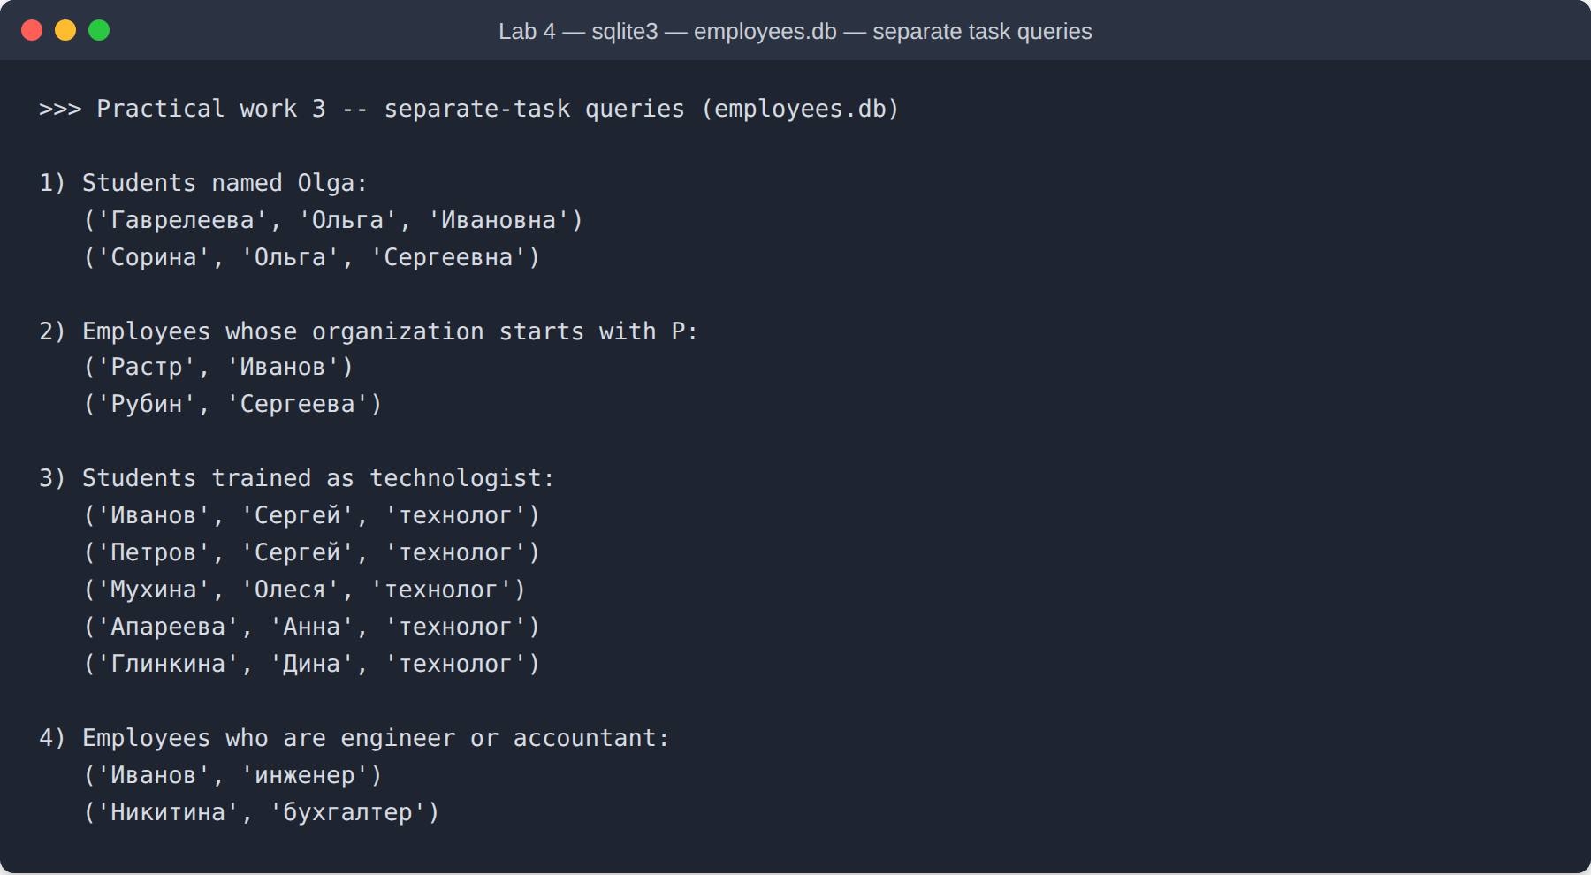
Figure 2. sqlite3 console output for the four "separate task" queries against employees.db.

6. Conclusion
This laboratory work covered building Access-style relational databases end to end: creating a table from an application-part template, creating a table by hand with the Table Designer (including an autonumber key), entering and sorting records, designing a two-table schema with a one-to-many relationship enforced by referential integrity and cascading updates/deletes, and building selection queries with text and set-membership criteria. Since the Access GUI itself was not available in this environment, every step was additionally reproduced and verified as an equivalent, runnable SQLite database and SQL script.

