LABORATORY WORK REPORT
IoT Botnet Traffic Classifier — Improved Version
Lab 3 Project: hybrid detection, honest evaluation, and a comparison with the original Lab 3
Laboratory work: | Lab 3 Project — Improved IoT Botnet Traffic Classifier (Topic 4)
Team member 1: | [ENTER NAME 1]
Team member 2: | [ENTER NAME 2]
Group: | [ENTER YOUR GROUP]
Course: | Cybersecurity & Machine Learning
Dataset used: | CICIDS2017 (Friday-afternoon DDoS capture, 225,745 flows)
Date: | [ENTER SUBMISSION DATE]
Note: replace the bracketed fields above with your own information before submission, formatted per your instructor's requirements.

1. Purpose of This Work
Lab 3 built a Random Forest that classified network flows as Safe or Threat, a Streamlit dashboard for it, and a live self-attack test. The self-attack exposed a serious weakness: a hand-crafted low-and-slow (Slowloris-style) attack passed through completely undetected (0 of 40 flows caught).
This project (folder lab3_project/) takes the improvement ideas listed at the end of Lab 3, implements them, and measures whether they actually help. The new version is compared with the original Lab 3 model under identical conditions throughout the report.
Main results at a glance:
- Lab 3's own evasion attack: 0/40 detected by the old model, 40/40 detected by the new one.
- Time-based test (train on earlier traffic, test on later traffic): false alarms 115 → 14, missed attacks 79 → 53.
- A stronger follow-up attack (v2) that spreads the slow connections across 4 servers is only partly caught: 0 flows Threat, 38/40 Suspicious.

2. Weaknesses Found in the Original Lab 3
# | Weakness | Evidence / consequence
1 | Each flow judged in isolation | The low-and-slow log: 0/40 detected. One slow connection really does look like idle traffic.
2 | Only a random 70/30 split | The same 20-minute attack is on both sides of the split, so F1 ≈ 1.000 overstates real performance.
3 | Only two outcomes (Safe / Threat) | No borderline level, so near-misses are invisible to the analyst.
4 | No explanation for a verdict | The analyst cannot tell why a flow was flagged.
5 | Flow-level view only | No answer to "which server is under attack?"
6 | No tests; model saved without metadata | Hard to verify or reproduce the results.

3. Suggested Improvements

3.1 Implemented in this project
- Context features: for every (destination server, minute) the model also sees the number of distinct clients, the number and share of long, near-idle connections, and the median connection length. IP addresses are only used to group flows and are never model inputs.
- Derived per-flow features: duration in seconds, bytes per packet, and an is_long_quiet flag (connection longer than 60 s with under 10 bytes/s).
- Synthetic slow-attack augmentation (training only): 351 synthetic slow-DoS flows are added to training minutes only. Their parameters deliberately differ from the held-out attack files, so the test is not memorised.
- Sparse-view augmentation: 2,000 training flows are re-cut into small pseudo-logs (30–600 flows) so the model also works on small sampled uploads (Section 7.2).
- Calibrated rule layer (hybrid detection): flag a connection that is long and near-idle when its server has at least 23 such connections in the same minute. 23 is one more than the highest value normal training traffic ever reached (22).
- Three verdicts with reasons: Threat / Suspicious / Safe, each flow with a plain-English explanation.
- Honest evaluation: random split, time split, small sampled logs, and two held-out attack files.
- Per-server summary in the dashboard, 11 unit tests (pytest), and a model bundle that stores its metrics, rule threshold and library versions.

3.2 Further ideas (not implemented)
- Retrain on a real IoT botnet dataset (N-BaIoT, Bot-IoT, CICIoT2023); CICIDS2017 is enterprise traffic.
- Measure true connection concurrency from second-level timestamps instead of one-minute windows.
- Calibrate probabilities (Platt / isotonic), add SHAP explanations, and feed analyst-reviewed Suspicious flows back into training.
- Add a per-source view to catch scanners and single bots.

4. Architecture of the New Version
File | Role
src/config.py | Paths, feature lists, thresholds, split time
src/data.py | Downloads (once) and loads the CICIDS2017 CSV
src/features.py | Cleaning, derived features, per-server-minute context features
src/augment.py | Synthetic slow-attack bursts (training only)
src/detector.py | Hybrid detector: model score + rule, verdicts, reasons, server summary
src/train.py | Trains old and new model, runs all evaluations, draws charts
scripts/make_evasion_v2.py | Generates the stronger v2 attack log
app.py | Streamlit dashboard
tests/ | 11 pytest unit tests

Decision logic for each flow (the most severe outcome wins):
- Threat: the slow-flood rule fired, or model probability ≥ 0.5.
- Suspicious: model probability between 0.2 and 0.5.
- Safe: everything else.
Both models use the same algorithm (Random Forest, 200 trees) and the same real training rows. The only differences are the features, the augmentation and the rule layer. Any change in the results therefore comes from the improvements, not from a different classifier.

5. Training and Evaluation Output
Running python -m src.train trains the original Lab 3 model (baseline) and the new model side by side and evaluates both:
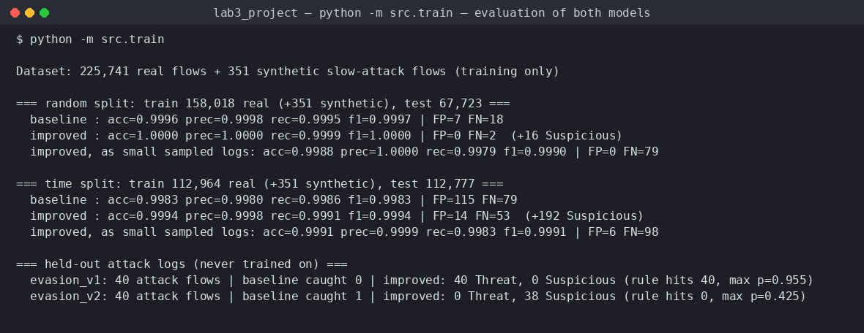
Figure 1. Console output — both models under the random split, the time split, small sampled logs and the two held-out attack logs.
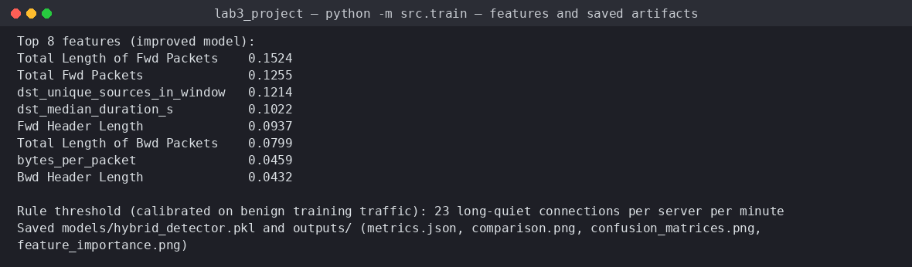
Figure 2. Console output — most important features of the new model, calibrated rule threshold, saved files.
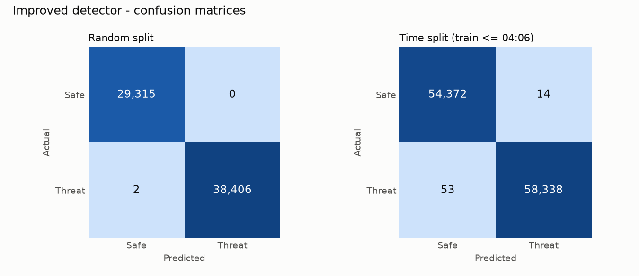
Figure 3. Confusion matrices of the new detector (random split and time split).
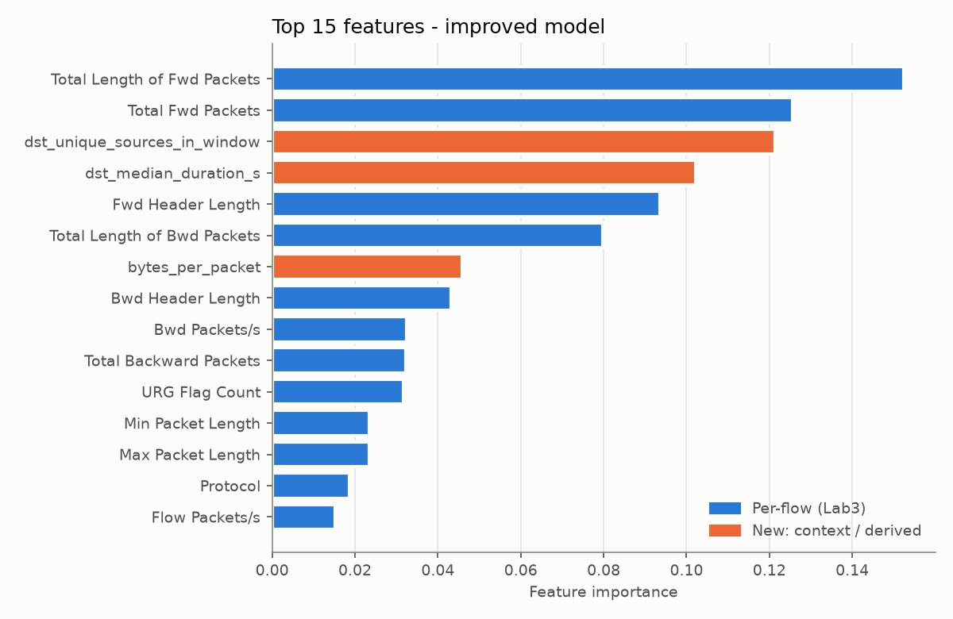
Figure 4. Top 15 features of the new model. Orange bars are new features that did not exist in Lab 3.
Two of the four most important features are new context features: dst_unique_sources_in_window and dst_median_duration_s. The model really uses the server-level picture that Lab 3 could not see.

6. Comparison: Original Lab 3 vs. New Version

6.1 Metrics
Evaluation | Lab 3 (old) | Lab 3 Project (new)
Random split — accuracy | 0.9996 | 1.0000
Random split — F1 | 0.9997 | 1.0000
Random split — false positives / false negatives | 7 / 18 | 0 / 2
Time split — accuracy | 0.9983 | 0.9994
Time split — F1 | 0.9983 | 0.9994
Time split — false positives / false negatives | 115 / 79 | 14 / 53
Time split as small sampled logs — FP / FN | 115 / 79 | 6 / 98
v1 low-and-slow attack (1 server) | 0 / 40 detected | 40 / 40 Threat
v2 slow attack spread over 4 servers | 1 / 40 detected | 0 Threat, 38 / 40 Suspicious
Demo sample log (30 DDoS + 30 benign) | 30 Threat, 30 Safe | 30 Threat, 30 Safe

The old model is per-flow only, so cutting the time-split test into small logs does not change its result. That is why the same numbers appear in both of its time-split rows.
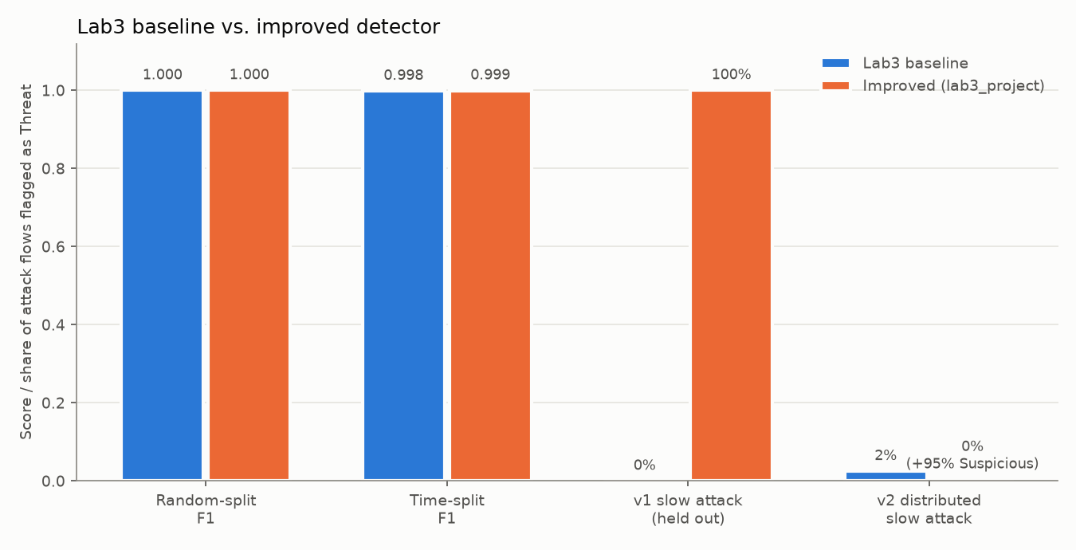
Figure 5. Old (blue) vs. new (orange): F1 on both splits and share of each held-out attack flagged as Threat.
How to read the comparison:
- Random split: both models look almost perfect. This split is inflated for both, because the same attack appears on both sides.
- Time split, the honest test: the new version raises far fewer false alarms (115 → 14, about 8× fewer) and misses fewer attacks (79 → 53). It also marks 192 borderline flows as Suspicious for review.
- v1 attack: the main goal. It goes from completely invisible to fully detected, and every flow carries a reason naming the slow-connection flood.
- v2 attack: neither version flags it as Threat. The new version at least marks 95% of it as Suspicious; the old one ignores it.

6.2 Features and design
Aspect | Lab 3 (old) | Lab 3 Project (new)
Model inputs | 26 per-flow features | 26 per-flow + 3 derived + 4 context features
Training data | Real flows only | Real flows + 351 synthetic slow attacks + 2,000 sparse-view flows
Detection | Random Forest only | Random Forest + calibrated slow-flood rule
Verdicts | Safe / Threat | Safe / Suspicious / Threat, with a reason
Evaluation | Random split | Random split, time split, sampled logs, 2 held-out attacks
Dashboard | Per-flow table, two charts | Demo-log buttons, per-server summary, per-flow reasons, model card
Tests | None | 11 unit tests

6.3 The same attack in both dashboards
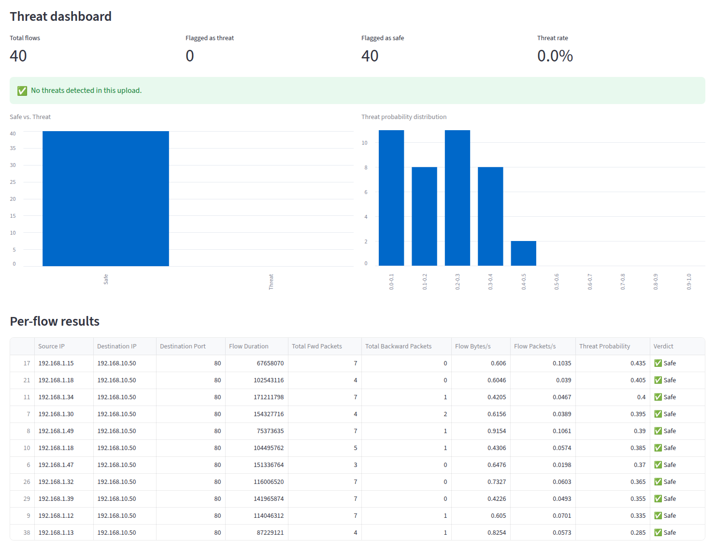
Figure 6. OLD (Lab 3): the low-and-slow attack log. 0 of 40 flows flagged; every verdict is Safe.
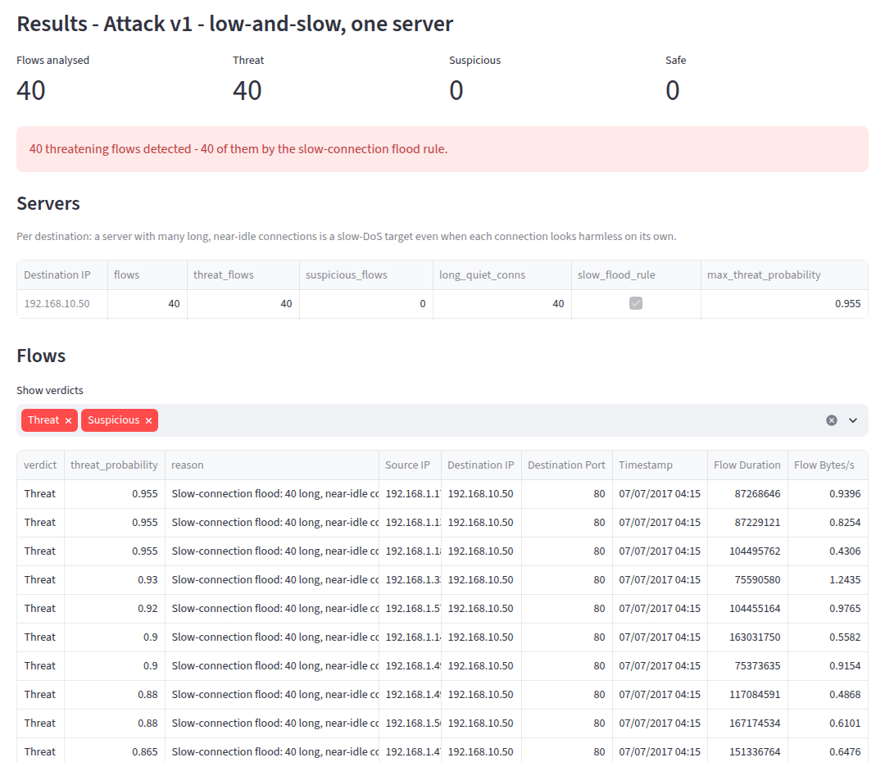
Figure 7. NEW (Lab 3 Project): the same attack log. 40 of 40 flows are Threat, all caught by the slow-connection flood rule. The server table points to 192.168.10.50 as the target.
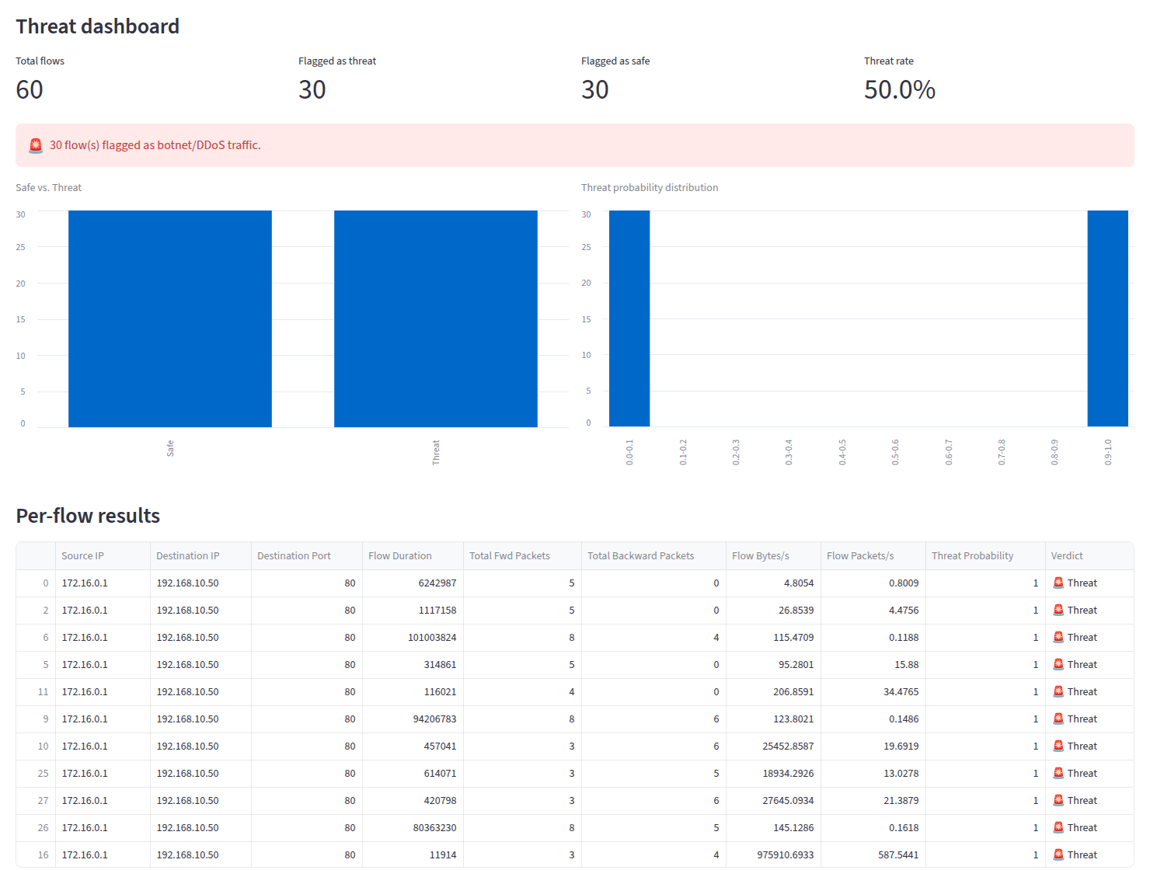
Figure 8. OLD (Lab 3): the 60-flow sample log (30 real DDoS + 30 benign).
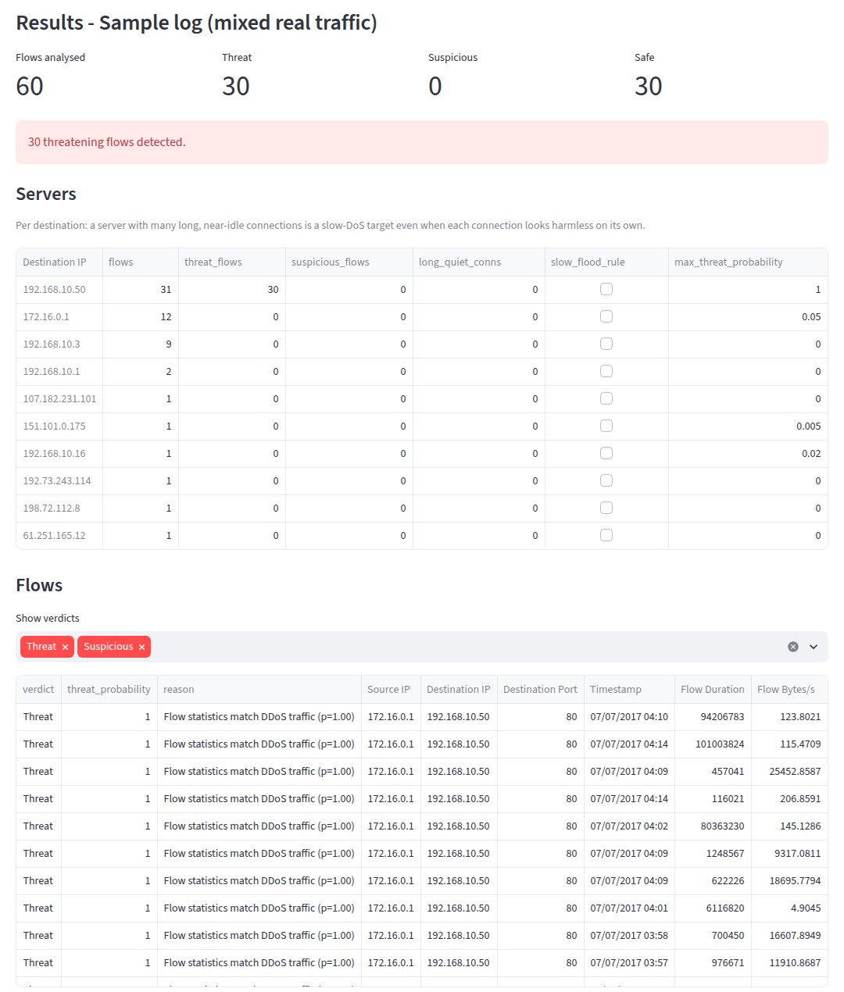
Figure 9. NEW (Lab 3 Project): the same sample log. Still 30 Threat / 30 Safe. Each flow has a reason, and the server table shows all attack flows going to 192.168.10.50.

7. Problems Found During Development
Three problems were found while building the new version. Each was measured and fixed, and each is a useful lesson.

7.1 Shortcut learning
The first version also used raw volume counters (number of flows per server and per client per minute). Under the time split the model learned a shortcut: an attack sends at least ~2,000 flows per minute. In its last minute the DDoS faded to about 1,350 flows per minute, and the model missed 1,348 attack flows. The old Lab 3 model missed only 79. Removing the volume counters fixed it (53 misses). The remaining context features describe the shape of the traffic, not how loud it is.

7.2 Context features assumed a complete capture
Context is computed inside the uploaded log. A small sample has about one flow per server per minute, so every server looks quiet. Before the fix the new model rated 0 of 30 real DDoS flows in the demo sample as Threat. On the time-split test cut into small logs, it missed 55,274 attack flows. The fix was sparse-view augmentation. The amount was chosen with a sweep:
Sparse-view rows | Full capture FP / FN | Sampled logs FP / FN | Demo DDoS → Threat
0 | 6 / 53 | 5 / 55,274 | 0 / 30
2,000 (chosen) | 14 / 53 | 6 / 98 | 30 / 30
5,000 | 23 / 54 | 15 / 86 | 30 / 30
15,000 | 112 / 56 | 110 / 69 | 30 / 30

More sparse data makes the model rely on per-flow features again, and false alarms grow back toward Lab 3's 115. 2,000 rows keeps most of the benefit of both.

7.3 The arms race: v1 → v2
The new version catches v1 because 40 slow connections hit one server in one minute, a level normal traffic never reaches. The v2 attack (scripts/make_evasion_v2.py) keeps exactly the same slow connections but spreads them over 4 servers and 10 minutes, with at most one per server per minute. The rule no longer fires, and the model only rates the flows Suspicious. This is a partial bypass.
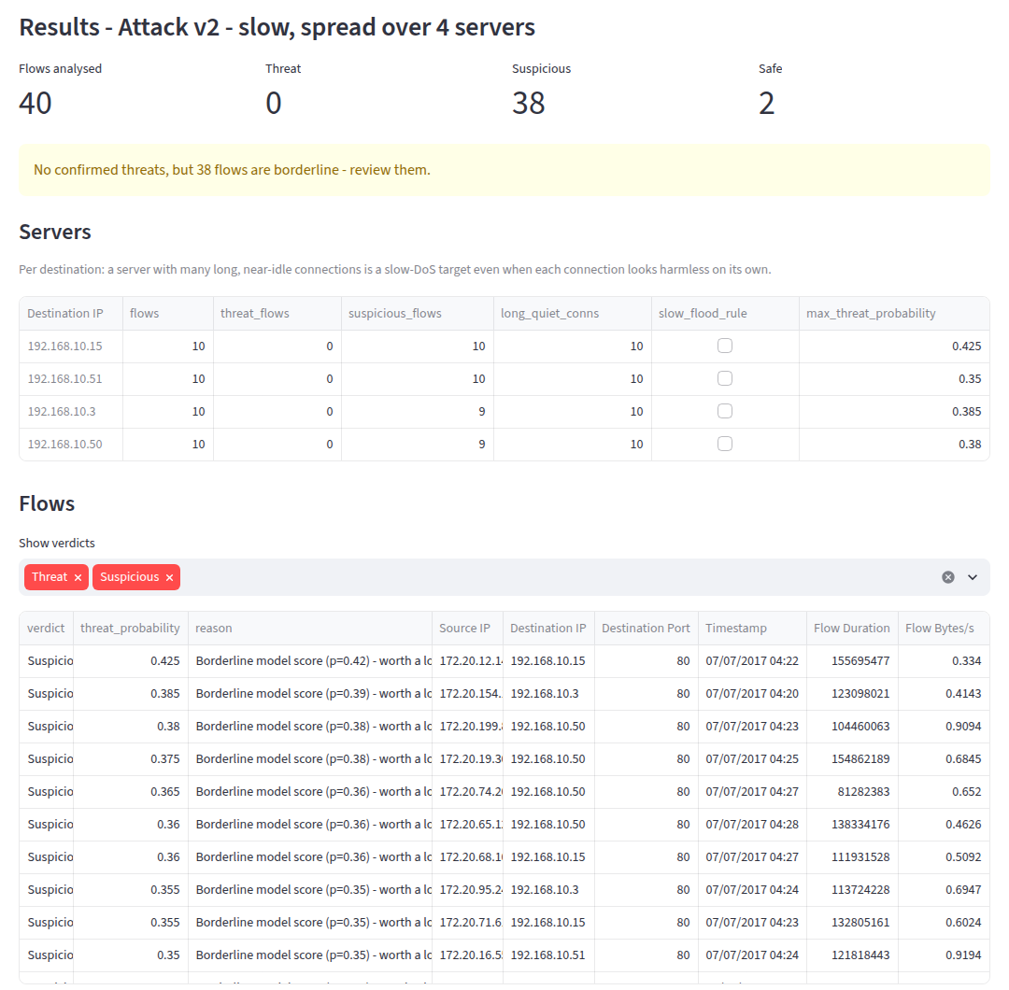
Figure 10. NEW: the v2 attack. 0 Threat, 38 Suspicious, 2 Safe. The dashboard warns the analyst to review the borderline flows.
The trade-off for the attacker: a slow-connection DoS works by filling up one server's connection pool. Spread this thin, each server carries only 1 extra slow connection per minute, which does almost no damage. The defence has not made the attack impossible, but it has forced the attacker into a much weaker one.

8. Web Application and Tests
The dashboard (streamlit run app.py) has three one-click demo logs (sample, v1, v2) plus a CSV uploader (up to 500 MB). For every upload it shows the Threat / Suspicious / Safe counts, a status banner, a per-server summary table, and a per-flow table with verdict, probability and reason. The sidebar is a model card with the evaluation results. All verdicts can be downloaded as CSV.
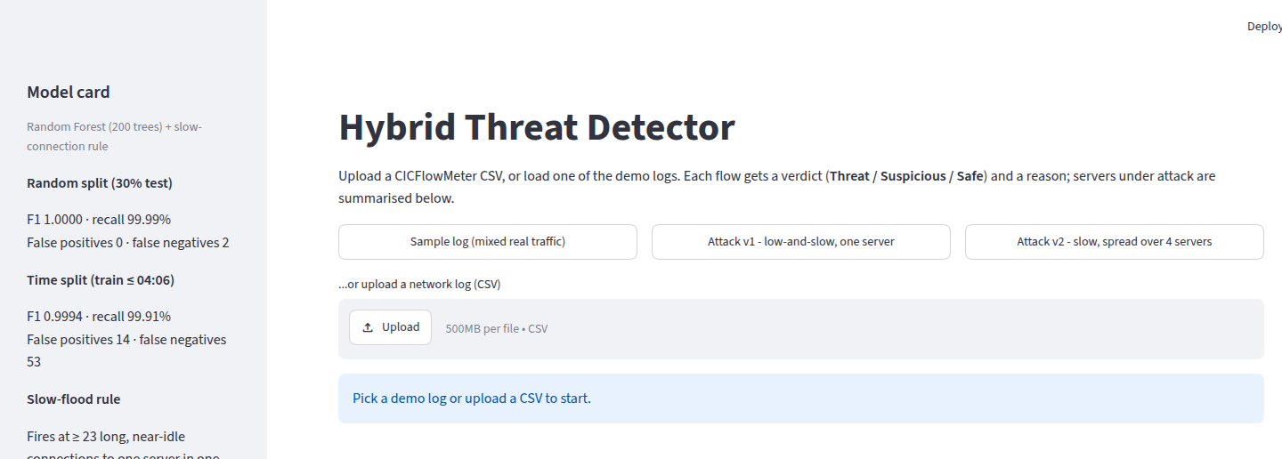
Figure 11. The new dashboard before any log is loaded: model card in the sidebar, demo buttons and uploader.
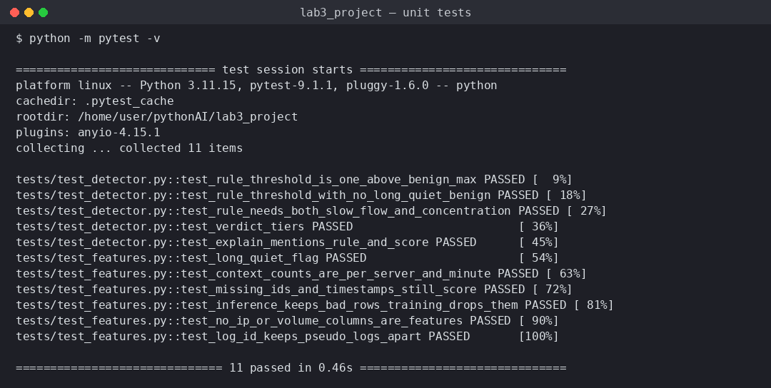
Figure 12. All 11 unit tests pass (feature pipeline, rule calibration, verdict tiers, explanations).

9. How to Run
- pip install -r requirements.txt
- python -m src.train — downloads the 35 MB dataset if missing, trains both models, writes models/ and outputs/
- streamlit run app.py — opens the dashboard
- pytest — runs the unit tests
- python scripts/make_evasion_v2.py — regenerates the v2 attack log (already included)

10. Conclusion
The improved version fixes the main weakness found in Lab 3. The low-and-slow attack that went completely undetected is now caught in full (0/40 → 40/40). Accuracy on normal traffic also improved: under the honest time-based test, false alarms fell from 115 to 14 and missed attacks from 79 to 53. The key idea is simple: some attacks are only visible when you look at many connections together, so the model must see context, not only single flows.
The project also showed that improvements need careful testing. Two of the first changes made things worse in ways the random split could not reveal: shortcut learning on traffic volume, and failure on small sampled logs. Only the time split and the sampled-log test exposed them. Finally, the v2 attack shows that every defence invites a counter-move. The detector does not stop it fully, but it forces the attacker into a far less damaging attack and still flags almost every flow for review.

11. Presentation / Defense Prep
Q: What is the single most important change compared to Lab 3?
A: Context features: the model sees what is happening to the whole server in the same minute, not only the single flow. A slow attack is invisible per flow but obvious per server.
Q: Why is the time split more honest than the random split?
A: With a random split, flows from the same attack minutes are in both training and test, so the model is partly tested on traffic it has effectively already seen. Training on earlier traffic and testing on later traffic is how a deployed detector really works.
Q: Why add a rule if you already have a model?
A: The rule covers the attack pattern with almost no real training examples, and its threshold is set from normal traffic, so it raises no false alarms on the training data. It is also easy to explain to an analyst.
Q: Does the new version stop every attack?
A: No. The v2 attack, spread thinly over several servers, is only marked Suspicious. But spreading it that thin removes most of the attack's power, so the attacker gains very little.
Q: What would you do next?
A: Train on real IoT botnet data, measure true connection concurrency with second-level timestamps, calibrate the probabilities, and add an analyst feedback loop so reviewed Suspicious flows become new training data.

