Cultivating Change: SFFI’s SDG Innovation Award for Sustainable Aquaculture

Recognizing the grassroots innovators helping shape a more sustainable, inclusive, and resilient future for aquaculture in Nepal.

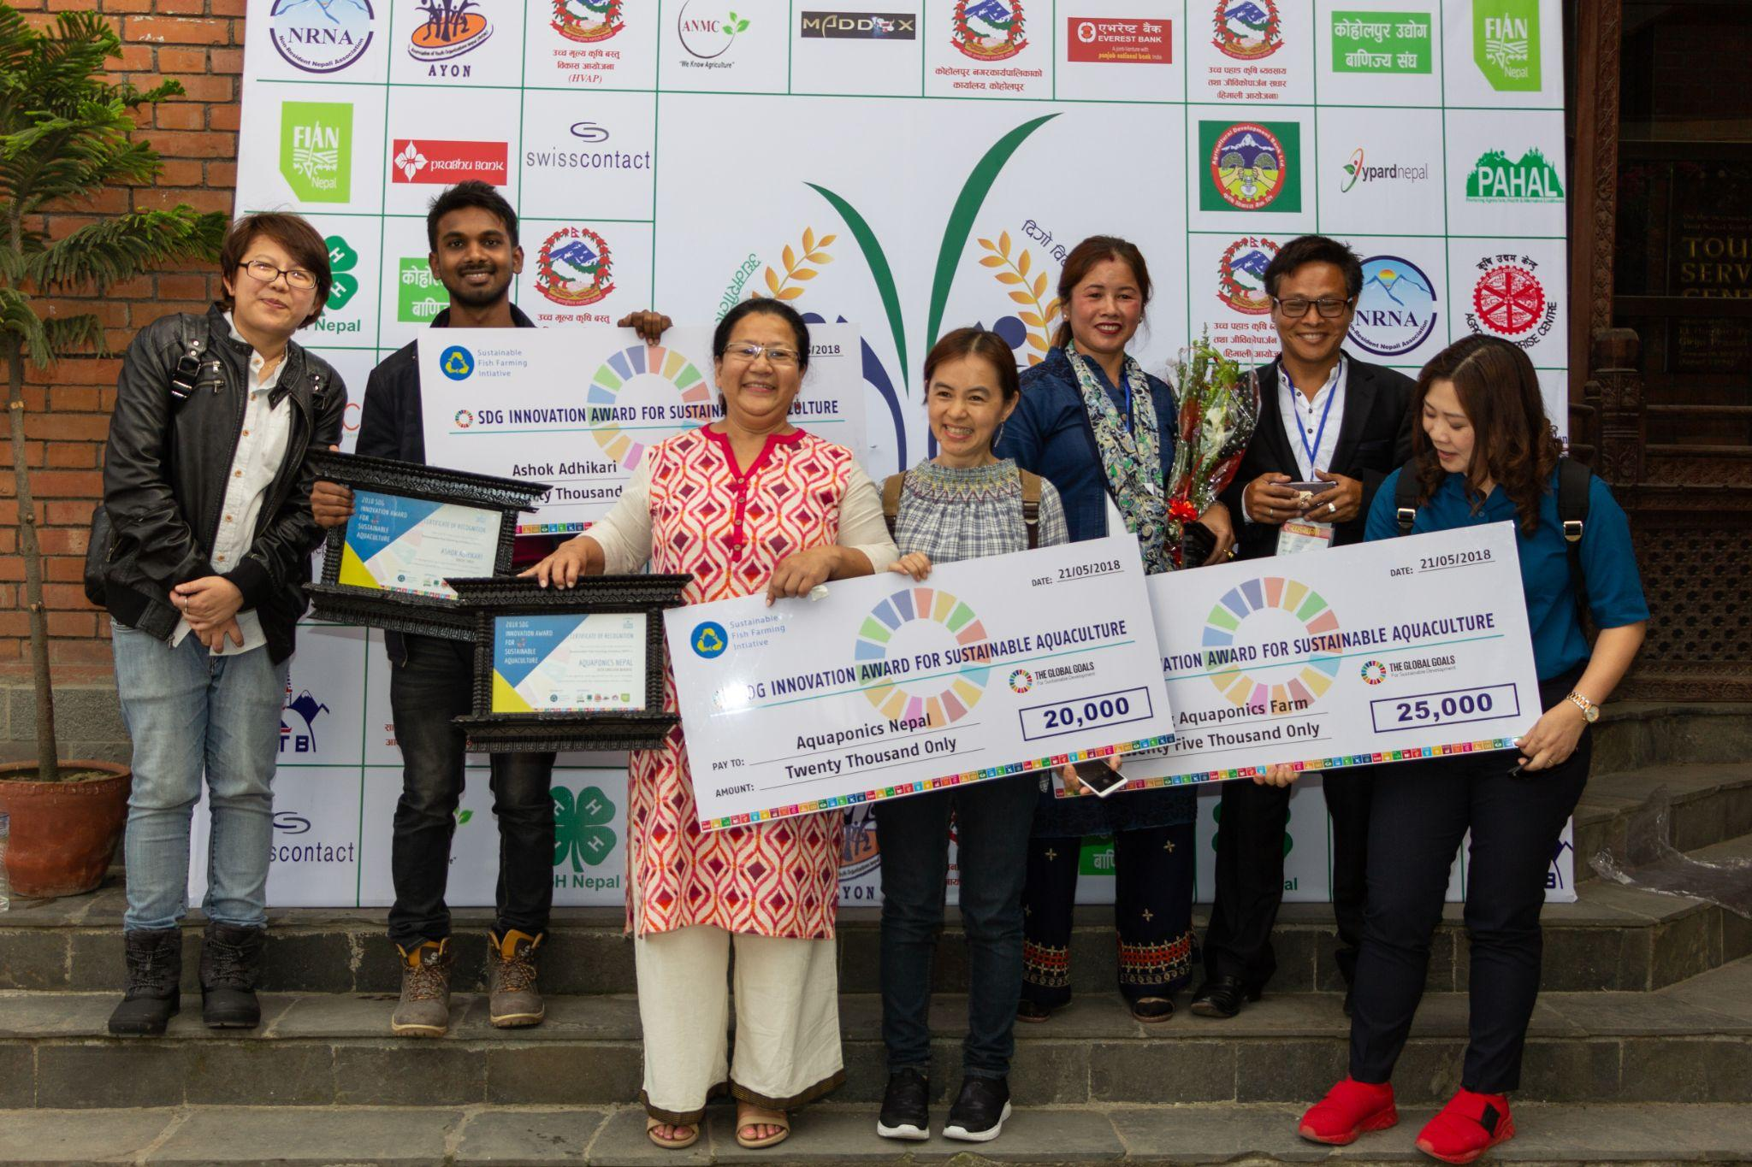
The Sustainable Fish Farming Initiative (SFFI) SDG Innovation Award for Sustainable Aquaculture was created to do more than recognize promising ideas. It was designed to spotlight grassroots innovators whose work was advancing sustainable aquaculture, strengthening rural livelihoods, and opening new pathways for youth-led innovation in Nepal.
At its heart, the award reflected a simple but important belief: local innovation mattered. Across Nepal, some of the most practical and inspiring solutions were emerging not from large institutions, but from entrepreneurs, farmers, and community-rooted changemakers responding directly to the challenges around them.
“The award was not only about recognition. It was about creating visibility, momentum, and support for ideas with real community impact.”
By honoring fellows each year, SFFI helped bring wider attention to innovations that might otherwise have remained local. The award also created space for connection across agriculture, aquaculture, entrepreneurship, and youth leadership—showing how sustainable fish farming could contribute to wider development goals, from food security to inclusive economic opportunity.

Why the award mattered
Nepal’s agricultural future depended not only on policy and investment, but also on the people testing new ideas on the ground. Yet many grassroots innovators faced a familiar challenge: they had strong solutions, but limited access to public recognition, networks, and platforms that could help them grow.
SFFI’s yearly award responded to that gap. It recognized leadership in sustainable aquaculture, encouraged practical and environmentally responsible innovation, and supported young changemakers working to improve food production, resource efficiency, and livelihoods in their communities.
In this sense, the award was as much about building a culture of innovation as it was about celebrating individual achievement.
“Sustainable aquaculture becomes more powerful when local innovators are seen, supported, and connected.”

The winners
One of the most notable editions of the award came in 2018, when SFFI recognized a cohort of Nepali innovators whose work combined technical creativity with strong social purpose.
The fellowship award was presented during the 2nd Youth Agriculture Entrepreneurship Symposium, hosted by 4-H Nepal in collaboration with SFFI, Ayon Nepal, National Youth Council Nepal, Youth Action Nepal, and FIAN Nepal, among others. The symposium brought together nearly 200 young Nepali agriculture enthusiasts and concluded with a 15-point declaration, reflecting the energy of a new generation of agricultural leadership.

Rita Shrestha Bhadra – Aquaponics Nepal
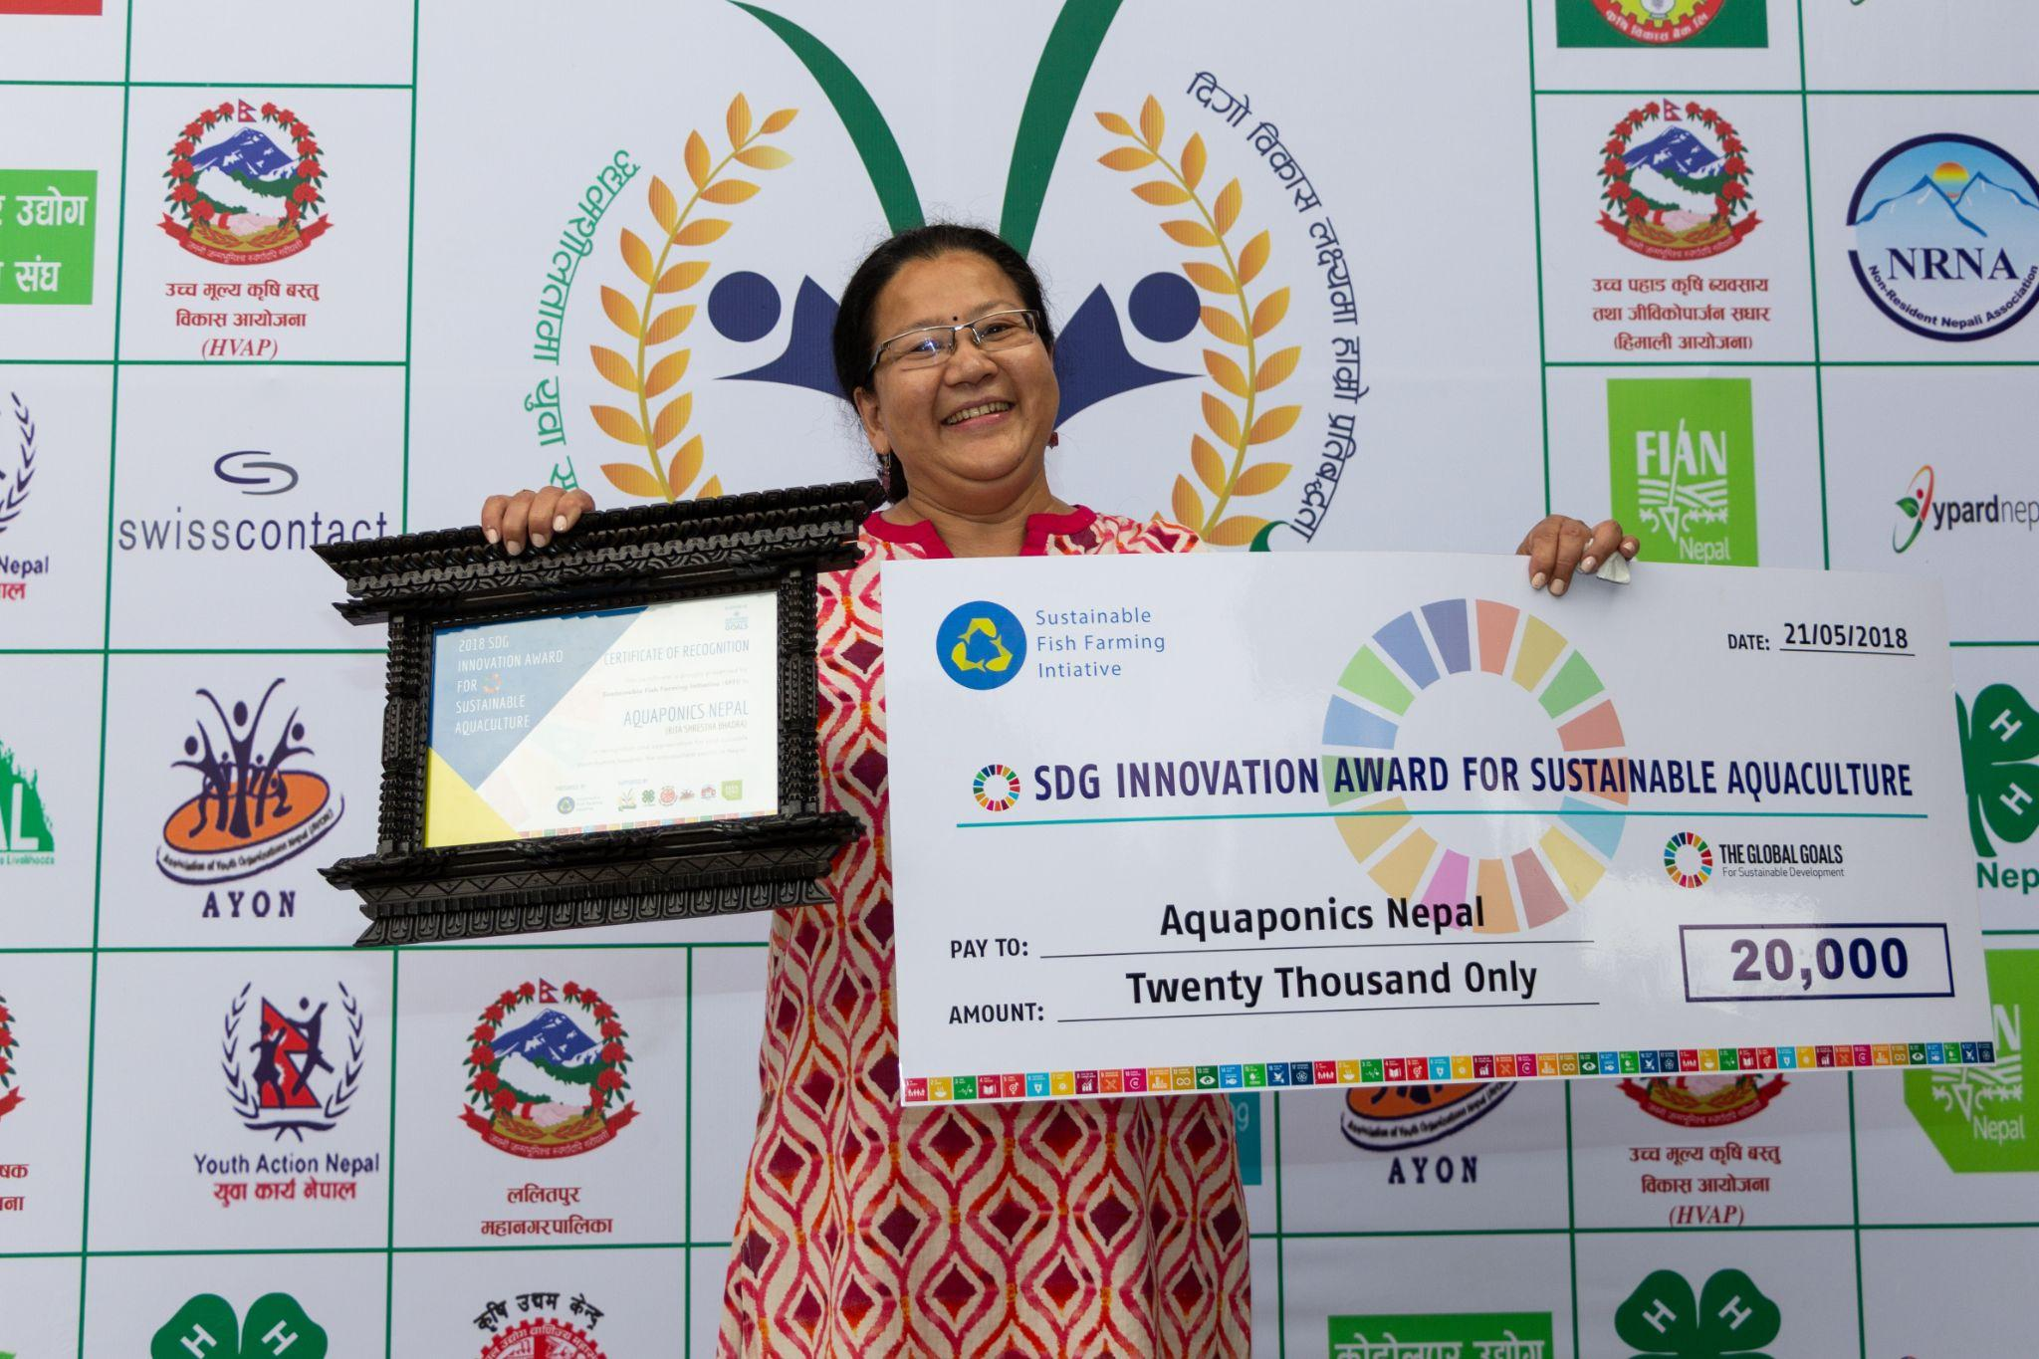
Rita Shrestha Bhadra, founder of Aquaponics Nepal, was honored for pioneering aquaponics as a sustainable farming solution in Kathmandu.

Her work introduced an innovative model of year-round food production that used significantly less water than conventional farming while integrating fish production with plant cultivation. She also extended her impact through training, including work with 80 women participants from Budhanilkantha Ward 9, and brought a strong commitment to expanding women’s participation in aquaculture.

Ashok Adhikari – Krishi Guru
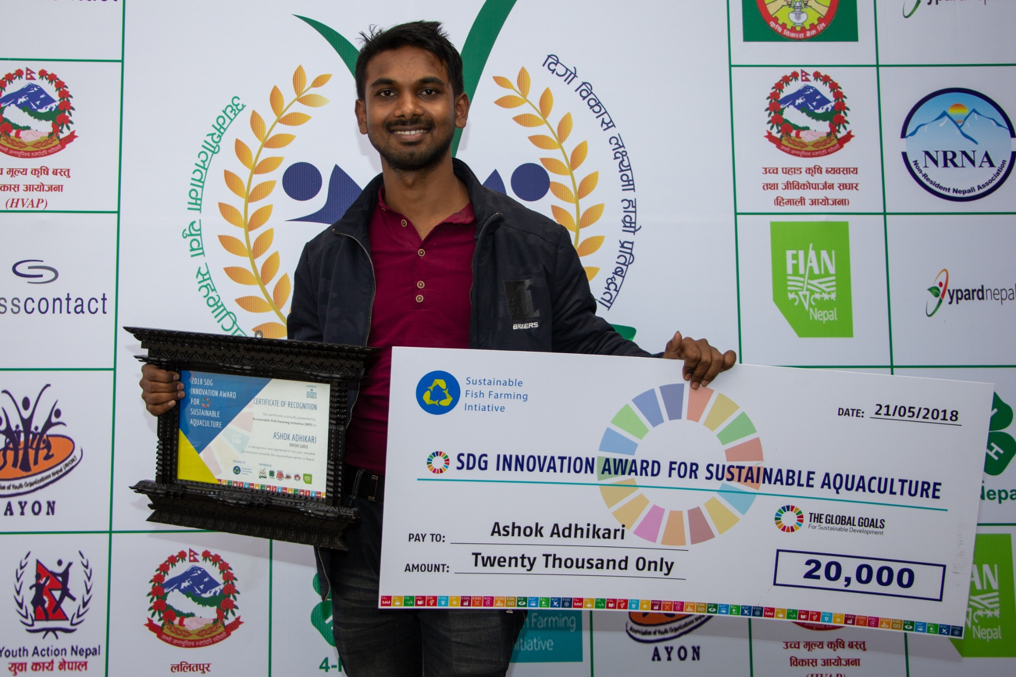

Ashok Adhikari was recognized for his long-standing commitment to Nepal’s aquaculture sector and his efforts to use digital tools to improve the livelihoods of fish farmers.
Through his association with Krishi Guru, a mobile-based agriculture knowledge-sharing platform, he helped connect farmers to extension agencies, input suppliers, agro-entrepreneurs, and market traders. His work demonstrated how technology, knowledge, and better access to information could support more productive and profitable aquaculture systems.

Om Thapa and Tara Thapa – Galyang Aquaponics Farm
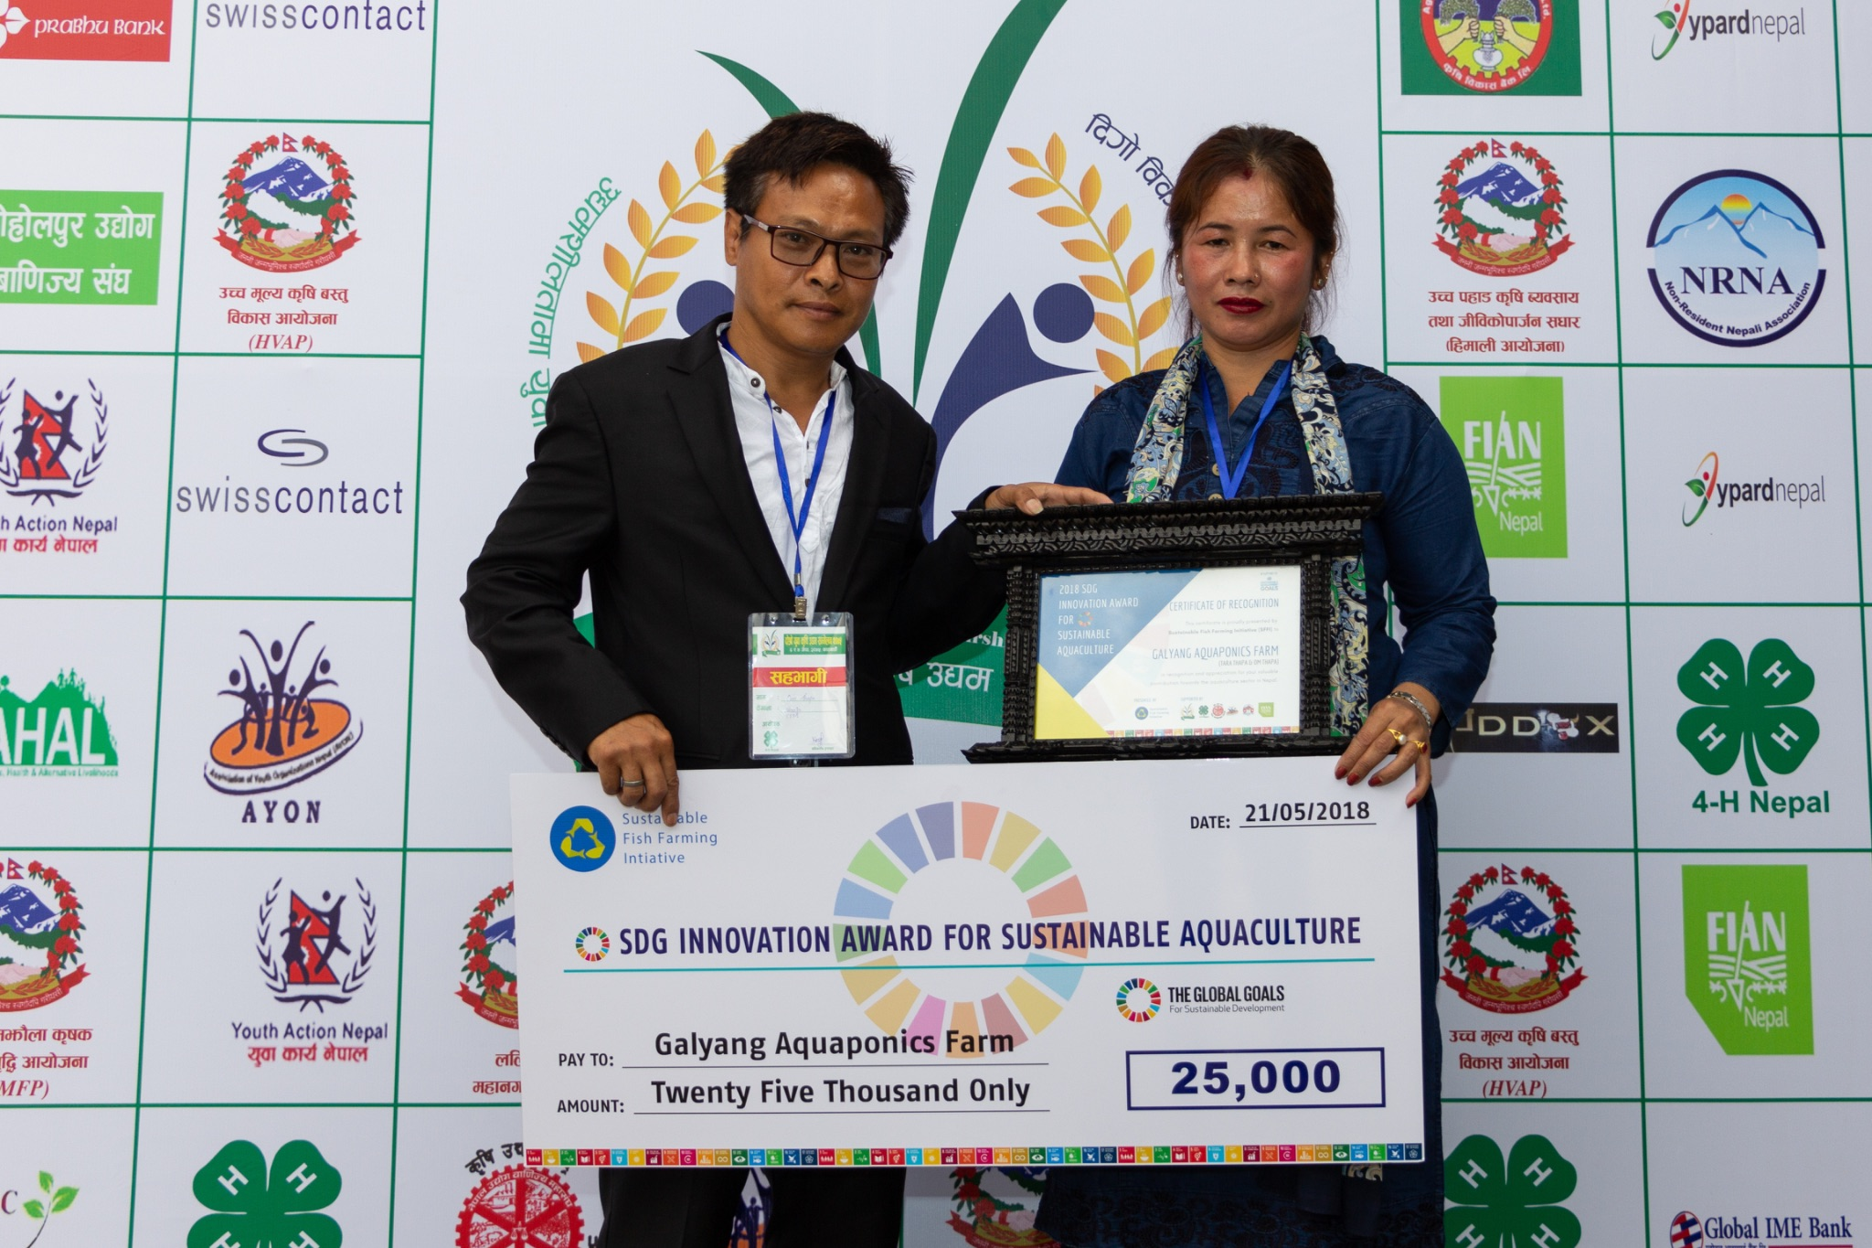
Om Thapa and Tara Thapa, co-founders of Galyang Aquaponics Farm in Syangja, were recognized for building an innovative aquaponics system that combined fish farming with vegetable production.
Their work offered a practical example of how resource-efficient farming could respond to land constraints, food needs, and the growing importance of sustainable local production. By adapting new techniques to local conditions, they showed how innovation could thrive at community level.

More than an award
Taken together, the 2018 winners reflected the wide range of change SFFI sought to support: digital extension, women-led entrepreneurship, aquaponics innovation, and community-based food system transformation.
The SDG Innovation Award for Sustainable Aquaculture stood for more than celebration. It affirmed that sustainable aquaculture in Nepal would be shaped not only by institutions, but by the vision, determination, and creativity of local innovators.
“When grassroots innovators are recognized and supported, their ideas travel farther and their impact grows deeper.”
That remained the reason behind the award each year: to identify promising leaders, amplify their work, and help build a stronger future for sustainable aquaculture in Nepal.

