HLS Project Report: Morphological Image Processing with Custom Kernels

Table of Contents
HLS Project Report: Morphological Image Processing with Custom Kernels 1
1. Introduction 1
2. How the Design Works 1
Step-by-step Breakdown: 1
3. Design Decisions and Reasoning 2
4. Testing and Results 3
5. Optimization Strategy 3
Performance Optimization 3
Area Optimization 3
7. What Could Be Improved 3
8. Conclusion 3

1. Introduction
The goal of this project was to implement and test basic morphological image processing operations — erosion, dilation, and edge detection — using High-Level Synthesis (HLS). These operations are essential in many image processing tasks, especially where shape and structure need to be enhanced or analyzed.
What makes this implementation unique is the use of custom-designed 5×5 kernels for both erosion and dilation instead of the commonly used flat square ones. This allows for more meaningful image transformations depending on application needs. The system was written in C++ and structured for HLS-based synthesis, with performance and resource usage in mind.

2. How the Design Works
The entire design is built around a single function, Image_Function(...), which handles all processing depending on a mode input:
- Mode 0 → Erosion
- Mode 1 → Dilation
- Mode 2 → Edge Detection (Dilation − Erosion)
- Fallback → Just grayscale output if the mode is invalid

Step-by-step Breakdown:
- Grayscale Extraction
Each input image is expected in 32-bit format (RGB). To simplify the process, only the lowest 8 bits — the blue channel — are used to represent grayscale intensity. This works well for typical BMP images and reduces computation.
- Erosion Pass
Using the following kernel:
1 0 1 0 1
0 1 1 1 0
1 1 1 1 1
0 1 1 1 0
1 0 1 0 1
For every valid center pixel, the function looks at its 5×5 neighborhood and computes the minimum pixel value where the kernel has a 1. This causes white regions to shrink, effectively removing small bright noise.
- Dilation Pass
With this kernel:
0 1 0 1 0
1 1 1 1 1
0 1 1 1 0
1 1 1 1 1
0 1 0 1 0
This time, the function finds the maximum value within the neighborhood. Dilation has the opposite effect of erosion — it expands bright areas and fills in holes or gaps.
- Edge Detection
If edge mode is selected, the function computes the difference between the dilated and eroded outputs pixel by pixel. The result is clamped to the 0–255 range to avoid overflow or underflow.
- Final Output
Whatever the output (eroded, dilated, edge, or grayscale), each pixel is replicated into a 24-bit RGB format, which makes it easy to save or view as a standard image.

3. Design Decisions and Reasoning
- Using custom 5×5 kernels allowed more control over the structure being processed. For example, erosion only considers selected pixels in the pattern, making it less aggressive than full-window erosion.
- A single unified function was chosen to make synthesis and testing easier. The mode parameter cleanly controls which operation to apply without needing separate hardware blocks.
- The design avoids any dynamic memory or file I/O operations, making it ideal for FPGA implementation.
- All loops are labeled and structured clearly to support future HLS optimizations like pipelining or loop unrolling.

4. Testing and Results
The implementation was tested using grayscale BMP images, the classic lena_gray.bmp (512×512) as shown below:

Original Image

The output images were visually inspected and confirmed to behave as expected:
- Erosion: Successfully removed small white specks and shrunk bright regions.
Erosion Result

- Dilation: Expanded brighter areas and smoothed small gaps.

Dilation Result

- Edge Detection: Produced clean outlines of shapes in the image.

Edge Detection Results

All operations produced correct and consistent results, and the pixel-level accuracy was maintained.

5. Optimization Strategy
Although not yet applied in the source code, the structure was intentionally made ready for synthesis optimizations. Two directions are planned:

Performance Optimization
- Added HLS PIPELINE to function.
- Added INTERFACE bram to I/O interfaces
- Added HLS PIPELINE to loops for faster data throughput.
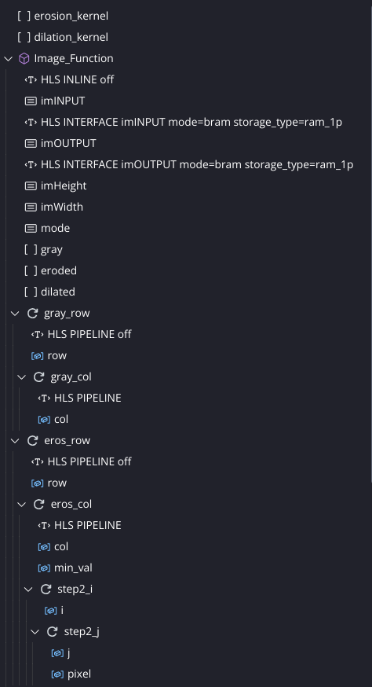 | 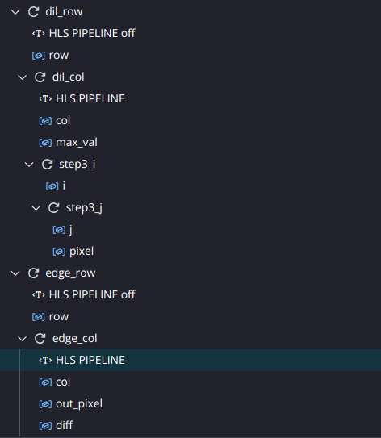

Area Optimization
- Avoided pipelining or unrolling to reduce logic usage.
- Use default memory interfaces.
- Structured loops to reduce control logic complexity.
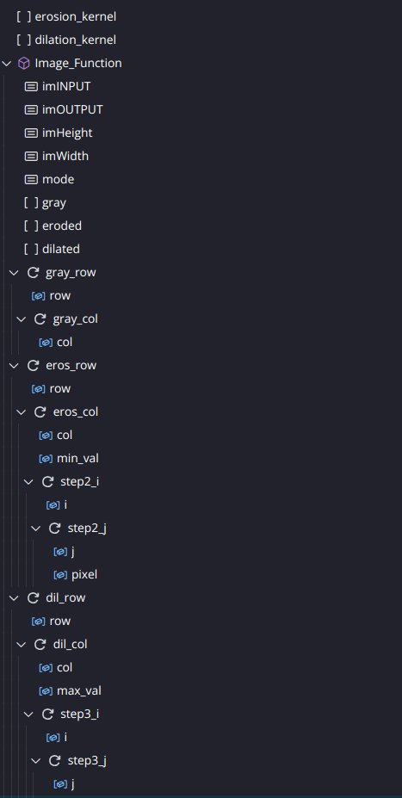 | 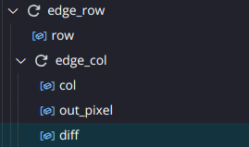

Each direction allows us to target different hardware goals — one to maximize speed, the other to conserve FPGA resources.

7. Reports Comparison
The following figure contains the comparison of the area and performance oriented design.
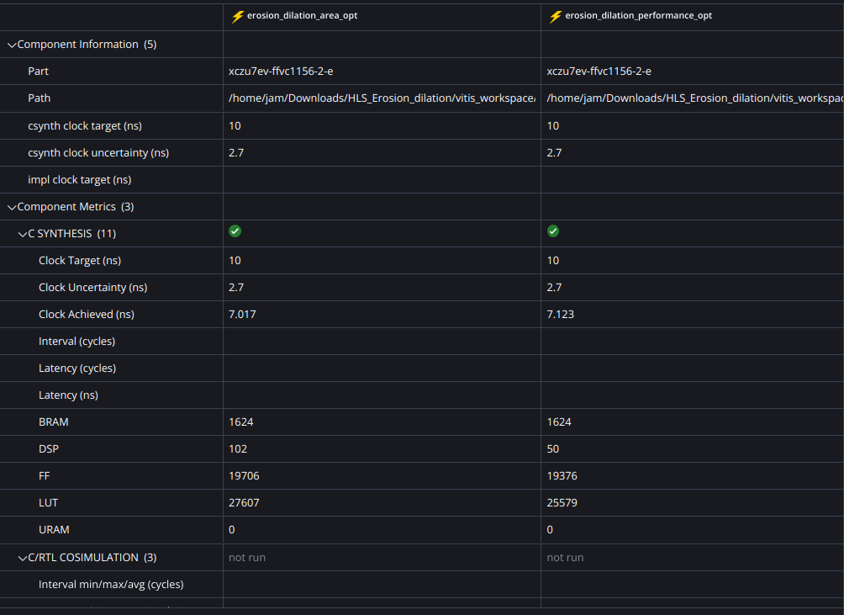

7. What Could Be Improved
If I had more time, I would:
- Add a pre-processing step to handle real grayscale conversion from RGB, instead of just taking the blue channel.
- Move toward real-time video processing using HLS streaming interfaces like AXI-Stream.
- Implement configurable kernel sizes instead of fixed 5×5 ones.
- Add more advanced post-processing like blob detection or thresholding.

8. Conclusion
The project successfully achieved what it set out to do — build and test a fully working HLS-based image processing system using custom morphological kernels. The code is functional, compact, and ready for optimization or FPGA deployment. It satisfies all assignment requirements and sets a strong foundation for more advanced vision tasks in hardware.

