# Lab 05 - Pipelined Datapath

**Table of Contents**

Lab 05 - Pipelined Datapath 1

1. single cycle datapath Results 1

Table 1

Simulation 2

2. Pipelined datapath Results 2

Section I: Tables and run result 2

Table 2

Simulation: 3

Section 2: Explanation of the Difference Between Pipelined and Non-Pipelined Outputs 3

Section 3: Hazard Mitigation 4

## 1. single cycle datapath Results

If we run the code in init.asm in the schematic capture design of the single cycle datapath from the lab4 over the course of running the 11 instructions in 11 cycles we are getting the following outputs.

### **Table**

| clk | PC | Opcode | src1_addr | src1_out | src2_addr | src_out | dst_addr | dst_data |
| --- | --- | --- | --- | --- | --- | --- | --- | --- |
| 1 | 0 | 0x23 | 0 | 0x00000000 | 2 | 0x00000000 | 2 | 0x00000056 |
| 2 | 4 | 0x00 | 2 | 0x00000056 | 2 | 0x00000056 | 3 | 0x000000AC |
| 3 | 8 | 0x2B | 0 | 0x00000000 | 3 | 0x000000AC | 3 | 0x00000084 |
| 4 | 12 | 0x00 | 3 | 0x000000AC | 2 | 0x00000056 | 4 | 0x00000056 |
| 5 | 16 | 0x08 | 3 | 0x000000AC | 5 | 0x00000000 | 5 | 0x000000B8 |
| 6 | 20 | 0x00 | 5 | 0x000000B8 | 3 | 0x000000AC | 6 | 0x000000A8 |
| 7 | 24 | 0x00 | 6 | 0x000000A8 | 2 | 0x00000056 | 7 | 0x000000FE |
| 8 | 28 | 0x00 | 6 | 0x000000A8 | 2 | 0x00000056 | 8 | 0xFFFFFF01 |
| 9 | 32 | 0x00 | 5 | 0x000000B8 | 4 | 0x00000056 | 6 | 0x00000000 |
| 10 | 36 | 0x04 | 5 | 0x000000B8 | 0 | 0x00000000 | 31 | 0x000000B8 |
| 11 | 40 | 0x23 | 0 | 0x00000000 | 8 | 0xFFFFFF01 | 8 | 0x000000AC |

### **Simulation**

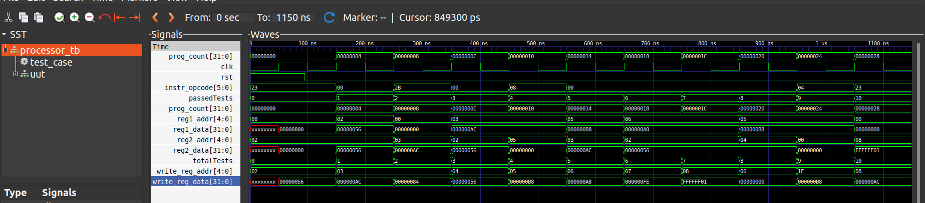

# 2. Pipelined datapath Results

## Section I: Tables and run result

For lab5, same table has been produce for running the program in labo5_pipeliend.dig in Digital. However, for this version of the datapath, the program is run for 15 cycles to execute the 11 instructions. Why? Because the pipeline is causing the execuction of the program to take 4 cycles longer as can be seen in the tabel and simulation below.

### Table

| clk | PC | Opcode | src1_addr | src1_out | src2_addr | src_out | dst_addr | dst_data |
| --- | --- | --- | --- | --- | --- | --- | --- | --- |
| 1 | 0 | 0 | 0 | 0x00000000 | 0 | 0x00000000 | 0 | 0x00000000 |
| 2 | 4 | 0x23 | 0 | 0x00000000 | 2 | 0x00000000 | 0 | 0x00000000 |
| 3 | 8 | 0x00 | 2 | 0x00000000 | 2 | 0x00000000 | 0 | 0x00000000 |
| 4 | 12 | 0x2B | 0 | 0x00000000 | 3 | 0x00000000 | 0 | 0x00000000 |
| 5 | 16 | 0x00 | 3 | 0x00000000 | 2 | 0x00000000 | 2 | 0x00000056 |
| 6 | 20 | 0x08 | 3 | 0x00000000 | 5 | 0x00000000 | 3 | 0x00000000 |
| 7 | 24 | 0x00 | 5 | 0x00000000 | 3 | 0x00000000 | 3 | 0x00000084 |
| 8 | 28 | 0x00 | 6 | 0x00000000 | 2 | 0x00000056 | 4 | 0x00000000 |
| 9 | 32 | 0x00 | 6 | 0x00000000 | 2 | 0x00000056 | 5 | 0x0000000C |
| 10 | 36 | 0x00 | 5 | 0x0000000C | 4 | 0x00000000 | 6 | 0x00000000 |
| 11 | 40 | 0x24 | 5 | 0x0000000C | 9 | 0x00000000 | 7 | 0x00000056 |
| 12 | 44 | 0x23 | 0 | 0x00000000 | 8 | 0x00000000 | 8 | 0xFFFFFFA9 |
| 13 | 48 | 0x00 | 0 | 0x00000000 | 0 | 0x00000000 | 6 | 0x00000000 |
| 14 | 52 | 0x00 | 0 | 0x00000000 | 0 | 0x00000000 | 31 | 0x0000000C |
| 15 | 56 | 0x00 | 0 | 0x00000000 | 0 | 0x00000000 | 8 | 0x00000000 |

### **Simulation:**

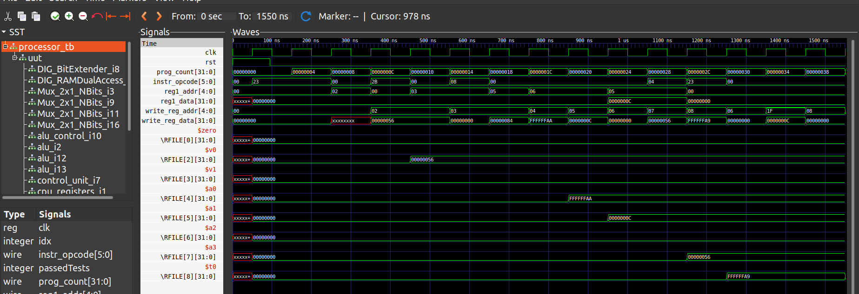

## Section 2: Explanation of the Difference Between Pipelined and Non-Pipelined Outputs

In the pipelined datapath, instructions are fetched, decoded, executed, and written back in an overlapping manner. This means that multiple instructions are in different stages of execution simultaneously. While this increases throughput, it introduces hazards that must be managed to ensure correct program execution.

Data Hazards: These occur when an instruction depends on the result of a previous instruction that has not yet completed. For instance, in the given code, add $v1, $v0, $v0 depends on the result of lw $v0, 31($zero). Without proper handling, this can cause incorrect values to be used.

Control Hazards: These arise from the need to make a decision based on the results of an instruction that has not yet completed, such as branch instructions. For example, beq $a2, $zero, -8 depends on the outcome of the slt instruction.

In the absence of hazard detection and forwarding mechanisms, these hazards necessitate the insertion of stalls (NOPs) to wait for the necessary data to be available. This causes the pipelined version to take more cycles to complete compared to the non-pipelined version.

## Section 3: Hazard Mitigation

To avoid data hazards between the lw $v0, 31($zero) and add $v1, $v0, $v0 instructions, we can insert a no-operation (NOP) instruction. This will prevent the processor from attempting to use the result of the lw instruction before it is available.

|  |
| --- |
| *lw $v0 31($zero)* ***nop***  *add $v1 $v0 $v0*  *sw $v1 132($zero)*  *sub $a0 $v1 $v0*  *addi $a1 $v1 12*  *and $a2 $a1 $v1*  *or $a3 $a2 $v0*  *nor $t0 $a2 $v0*  *slt $a2 $a1 $a0*  *beq $a2 $zero -8*  *lw $t0 132($zero)* |

**Inserted Instruction**: nop

Purpose: This instruction helps to avoid a data hazard by giving the lw instruction time to complete and write the value to $v0 before the add instruction tries to read it. It effectively introduces a stall, ensuring that the pipelined datapath behaves correctly.

By adding this NOP instruction, the program avoids the data hazard without changing the overall outcome of the program.