Project Solutions
1. The issue is in the arch of the pulse design. Because, cnt+1 never reaches to N_Pulse, therefore, desired result is not being achieved. This can be solved with a simple trick by replacing cnt+1=N_PULSE with cnt+1=N_PULSE-1 in the ARCH_2 code line number 72.

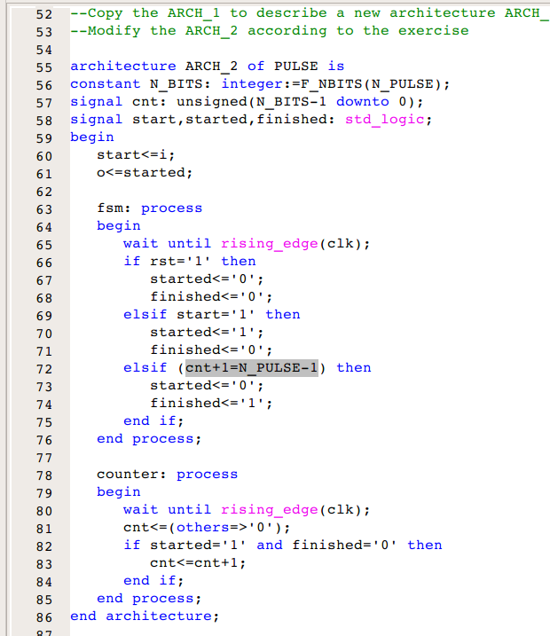

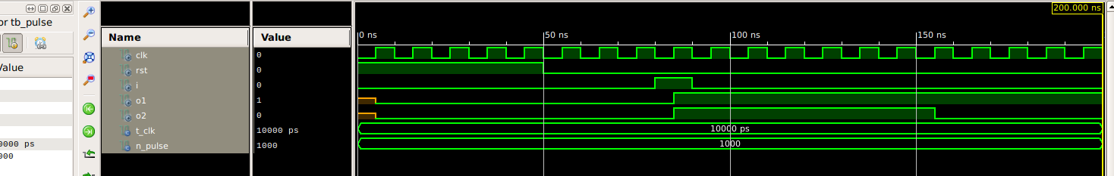

We can see in the simulation that correct ARCH_2 output o2 is as required but arch_1 output o1 is wrong.

2. To achieve the double click, following code lines of the test bench has been modified.

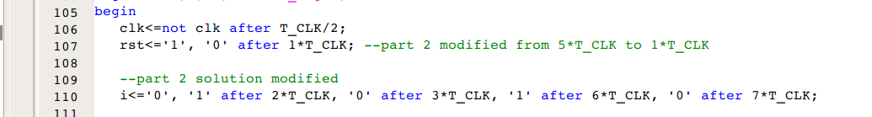
This makes sure start is pressed twice after 2*T_CLK and 6*T_CLK.
Next, line 72 of arch_1 is also changed to make it work.
Now, to make sure arch_2 output is enlarged as required, its counter (cnt) is being reset every time a start is pressed.
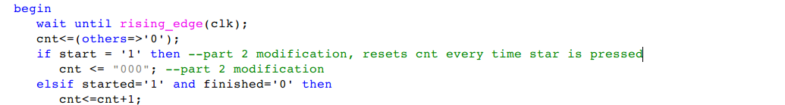
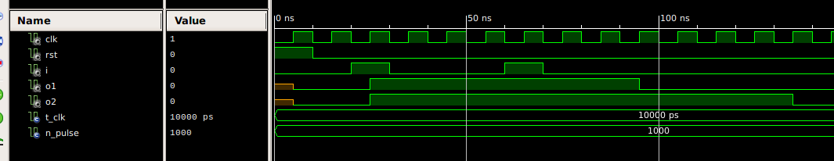
The commented line makes sure, arch_2 is enlarged than arch_1 output. Simulation result below shows the achieved result.
3. In order to activate arche_2 output o2 at the start and end of pulse, we only need to assign o2 as 1 when pulse is active or count of arche_2 (cnt+1=N_PULSE-1) has reached required number of pulses. This can be done by modifying 61 of the pulse as shown in the screenshot below.
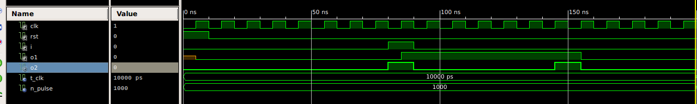
As a result, desired output pulse at o2 is achieved.
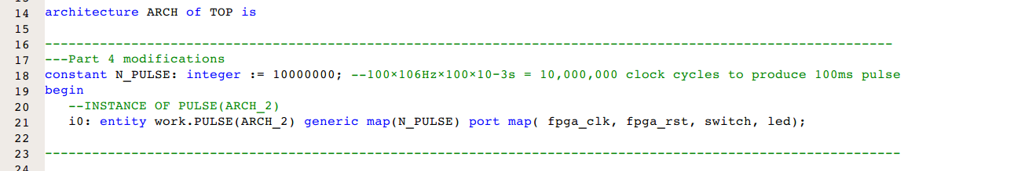
4.
100×106Hz×100×10−3s = 10,000,000 clock cycles to produce 100ms pulse
top level code modified.

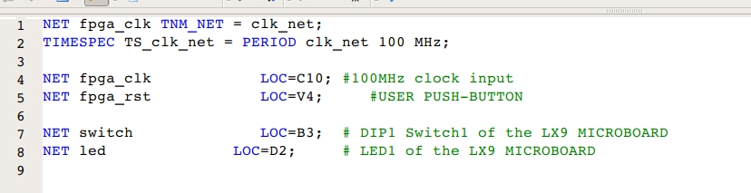

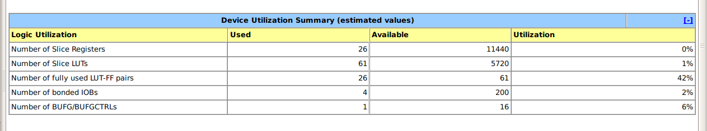
Device utilization summary:
---------------------------

Selected Device : 6slx9csg324-3

Slice Logic Utilization:
Number of Slice Registers: 26 out of 11440 0%
Number of Slice LUTs: 61 out of 5720 1%
Number used as Logic: 61 out of 5720 1%

Slice Logic Distribution:
Number of LUT Flip Flop pairs used: 61
Number with an unused Flip Flop: 35 out of 61 57%
Number with an unused LUT: 0 out of 61 0%
Number of fully used LUT-FF pairs: 26 out of 61 42%
Number of unique control sets: 2

IO Utilization:
Number of IOs: 4
Number of bonded IOBs: 4 out of 200 2%

Specific Feature Utilization:
Number of BUFG/BUFGCTRLs: 1 out of 16 6%

