Documentation for my unit 2 game

Game Requirements:
• Make use of Version Control
• Behaviour implemented through C# Scripts
• User input through keyboard or controller
• At least one object that the player has control over
• At least two objects that can interact with each other
o One of these might be the player-controlled object
• At least one object that is primarily driven through the physics system
o This may also be the player-controlled object
• Music
• Sound Effects
• Use of the inspector to expose variables
• A random element (use of Mathf.Random or equivalent)
• The game is built to an executable
Documentation Requirements:
• How to play the game
• A link to the repository that is accessible to the assessor
• A statement on any assets or code that is not the work of the student
• A statement on AI usage
• A section that highlights how your submission meets each of the criteria listed above –
feel free to use code snippets to evidence your work.
• A discussion of the three most interesting parts of your time developing the game
(approx. 1-2 pages). You should make sensible use of code snippets, pseudocode, or
diagrams to support your discussion.
o This could be an elegant solution to a task
o A complex bug that you fixed
o A feature that you made more efficient through optimisation
o A feature that is well executed within the game
o A lesson learned about game development
• A critical evaluation of the project and your own work. You will discuss the successes of
the work and where it can be improved. You will also discuss your own performance and
lessons learned for any future work. (approx. 0.5-1 page).

How To Play:
Use the mouse cursor to aim and left click to shoot an arrow, defeat all slimes to win the level (Demo currently only contains level 1).

Link to the public repository:
jamboy2209/Unit-2-Game: version control to show development of my game project for CMP112 unit 2 assessment.
I didn’t use any assets or code not developed by myself, everything was made either during the practical’s or in my free time in the university library.

Ai: I did not use any generative ai to develop code for me during this task, all code was discovered through trial and error or through unities lessons on scripting.

Criteria: my submission meets the criteria mostly through a select few objects: the player uses a mouse to aim and fire arrows from a tower, meeting criteria of user input, C# scripts, an object the player controls, and an object driven through physics. The game plays background music and sound effects play whenever the player shoots and arrow or hits a target. The inspector was used so that certain variables can be changed if needed, and a random number generator is used to randomly pick what enemy spawns each time.

During development, one interesting solution I came up with for a task was when I was coding the slimes spawning into the scene, I needed a way to set them up so that only a set amount spawned with a slight delay between spawns, my solution to this was to create a coroutine that spawned a random slime, waited for one second, then added 1 to a counter keeping track of how many slimes were spawned in, and finally an if statement checked if less than 25 slimes had spawned in, if the condition was true the coroutine would run code to run itself again spawning another slime until 25 had been spawned. Here is a snippet of the code to run the coroutine, this code appears both in the start function and at the end of the coroutine itself.
A complex bug I managed to fix in the game was that once the game ended an empty object is created that runs code to find certain other objects activate some and deactivate others, however, I soon realised that .find and .findObjectsWithTag cannot find objects that aren’t active in the scene, my solution was to create an array containing every object containing a transform component, then create a second array that picked out only the inactive objects from the first array, then setting all objects in the second array as active,
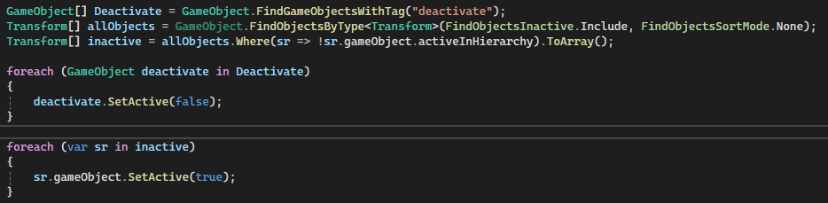
Above is an image of the final code I implemented in the game, this only worked as I needed to access every inactive object in scene, however I know that in future ill need to use a more unique component between the objects I need to activate. Finally, one thing I have learned about game design is that almost everything is about trial and error, and not everything will work first try and will require skill in problem solving to get working together as one large project.

Critical evaluation:
Inn my opinion there are quite a few areas where the game could be improved or optimised, however what I say I did well in this project was how varied my selection of code has been, giving me experience in multiple aspects of scripting and challenging me to find ways to make them all work together as seamlessly as I can, albeit some solutions may need to be changed or improved beyond my current work, area for improvement include trying to optimise code such as removing certain scripts and merging them into similar scripts that contain the same variables (e.g. the slime prefabs). I have learned a lot about game development during this project, namely the focus on problem solving, specifically however information that will prove useful in future projects is to always use a decision to check if an object is doing something before destroying or deactivating it, I learned this during development when I was trying to get a sound effect to play when an enemy died, however in my original code the object was being destroyed as it tried to play the sound, resulting in the sound not playing, my solution, once I had learned this new knowledge mentioned prior, was to make it so that when the enemy is destroyed, a new object is created which plays the sound and after its finished playing the new object is destroyed as well.

