Jacob Ambrose 02/03/2024

Module 5.2 MySQL Functions

1. **Function: DATE_FORMAT();**
   1. Usage: Can be used to standardize the representation of dates in the database
   2. Proper usage: SELECT DATE_FORMAT(*date, format)* different characters in the format section will help developers standardize formatting from days of week, to year formatting.
   3. Example
      1. 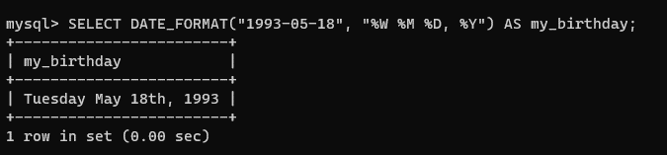
2. **Function: SYSTEM_USER();** 
   1. Usage: Used to identify current active user in the database
   2. Proper usage: SELECT DATE_FORMAT(*)*;
   3. Example
      1. 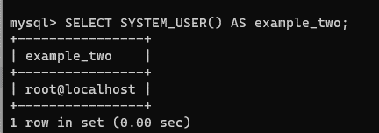
3. **Function: CASE** 
   1. Usage: Similar to if/else statements for example can be used to identify the number of inventory or certain items are stored into the database
   2. Proper usage: CASE  
          WHEN *condition1* THEN *result1*  
          WHEN *conditionN* THEN *resultN*  
          ELSE *result*  
      END;
   3. Example:
      1. 