Jacob Ambrose

Module 6.2- Database and Scripting

02/10/2024

Step 1: Run SQL Script for test script provided:

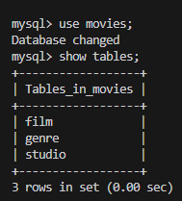

Step 2: Show Tables:

Step 3: Example of Python script running successfully:  
