INDEX :

|  |
| --- |
| **Project Definition** |
| **Design Thinking** |
| • Project Objectives |
| • IoT Sensor Designs |
| • Real-Time Transit |
| • Integration Approach |

**ABSTRACTION**:

Public transportation optimization is the process of improving the efficiency and effectiveness of public transportation systems. This can be done by a variety of means, such as:

Improving vehicle scheduling: Optimizing vehicle schedules can help to reduce waiting times and improve service frequency.

Designing efficient routes: Designing efficient routes can help to reduce travel times and fuel consumption.

Coordinating different modes of transportation: Coordinating different modes of transportation, such as buses and trains, can make it easier for passengers to get around.

Improving infrastructure: Investing in public transportation infrastructure, such as new bus lanes and train stations, can improve the overall quality of service.

Public transportation optimization is a complex problem, as it involves a variety of factors, such as passenger demand, vehicle availability, and budget constraints. However, a number of optimization techniques can be used to find solutions that improve the overall efficiency and effectiveness of public transportation systems.

One common approach to public transportation optimization is to use mathematical models. These models can be used to represent the complex relationships between the different factors involved in public transportation systems. Once a model has been developed, it can be used to evaluate different scenarios and identify the one that produces the best outcome.

**1.Project Objectives**:

Real-time transit information systems provide passengers with instant access to route details and vehicle locations, while arrival time prediction algorithms enhance journey planning. Ridership monitoring helps optimize routes and schedules by analyzing passenger demographics and travel patterns. The overarching aim is to elevate public transportation, including vehicle upgrades and sustainability measures, creating a more accessible, efficient, and eco-friendly transit system for all.

**2. IoT Sensor Design:**

The deployment of IoT sensors in public transportation vehicles involves a strategic plan. Begin with a needs assessment to define objectives, select suitable sensors like GPS and passenger counters, and ensure robust data connectivity. Install sensors securely, establish a central data management platform, and integrate sensor data for route optimization. Implement real-time monitoring for vehicle tracking and passenger communication for enhanced services.

Prioritize data security and maintenance, analyzing collected data for informed decisions and compliance with privacy regulations. Finally, plan for scalability to accommodate future expansion of the sensor network as the transportation system evolves.

**3.Real-Time Transit Information Platform**:

The web-based platform aims to provide passengers with a user-friendly interface for accessing real-time transit information. It integrates data from IoT sensors on public transportation vehicles, including GPS and passenger counters. Key features include interactive route maps, current schedules, estimated arrival times, trip planning tools, and personalized alerts.

The platform prioritizes accessibility for all users, adheres to stringent data security and privacy measures, and may incorporate multi-modal transportation information for seamless journeys. Overall, it aims to enhance the passenger experience and facilitate efficient and informed transit use. 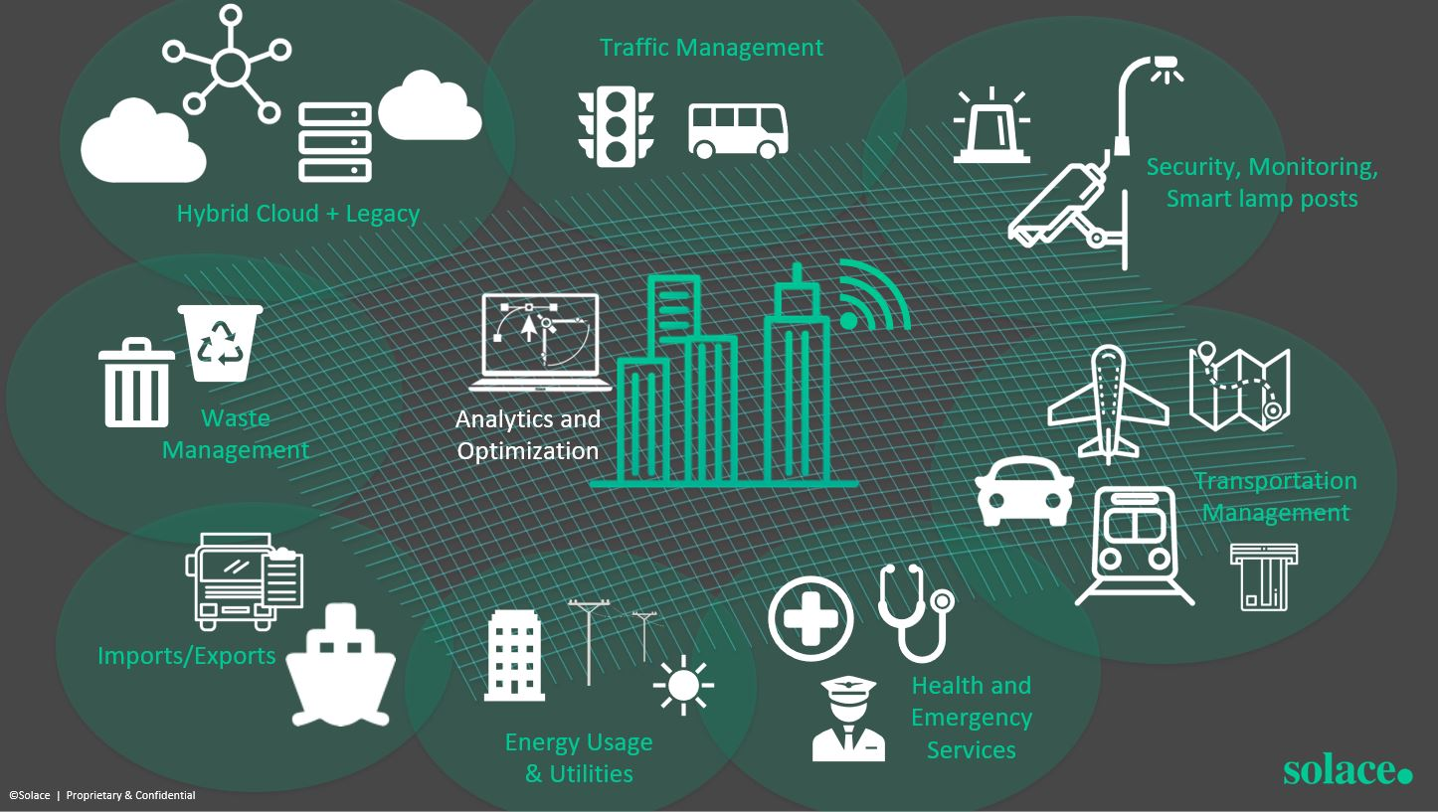

4.Integration Approach:

IoT sensors in public transportation vehicles collect data such as GPS location and passenger counts, which is processed and formatted into structured messages. These sensors utilize wireless communication methods, including cellular networks, Wi-Fi, or specialized protocols like LoRaWAN or satellite, to transmit data to a cloud-based platform.

This platform receives, validates, and stores the data in databases, making it accessible through APIs. The real-time transit information platform then retrieves and displays this data on a user-friendly web interface for passengers, providing up-to-the-minute information about public transportation services.

Another approach to public transportation optimization is to use simulation. Simulation models can be used to create a virtual representation of a public transportation system. This model can then be used to test different optimization strategies and see how they affect the system's performance.

Public transportation optimization is an important area of research, as it can help to improve the quality of life for millions of people who rely on public transportation to get around. By developing and implementing effective optimization strategies, we can make public transportation more efficient, effective, and accessible for everyone.

Here are some examples of how public transportation optimization can be used to improve the performance of public transportation systems:

Reduce travel times: Public transportation optimization can be used to reduce travel times by improving vehicle scheduling, designing efficient routes, and coordinating different modes of transportation.

Improve reliability: Public transportation optimization can be used to improve reliability by reducing waiting times and increasing service frequency.

Increase ridership: Public transportation optimization can be used to increase ridership by making public transportation more convenient, affordable, and accessible.

Reduce costs: Public transportation optimization can be used to reduce costs by improving fuel efficiency and reducing the number of vehicles required to operate the system.

Public transportation optimization is a complex and challenging task, but it is essential for improving the performance of public transportation systems. By developing and implementing effective optimization strategies, we can make public transportation more efficient, effective, and accessible for everyone.

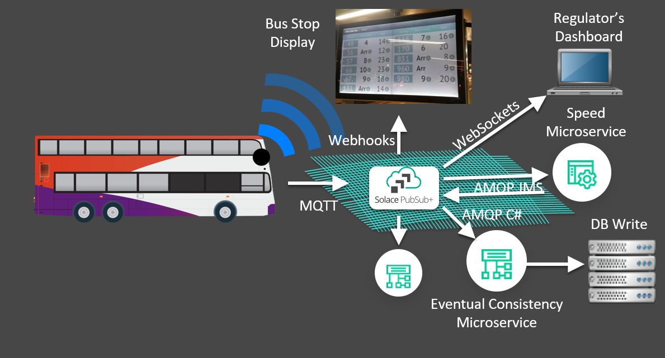

Public transportation optimization in IoT can involve various algorithms and techniques depending on the specific goals and challenges of the transportation system. Here are some commonly used algorithms and methods for optimizing public transportation using IoT:

**Dijkstra's Algorithm**: Dijkstra's algorithm is a widely used algorithm for finding the shortest path between nodes in a graph. In public transportation optimization, this algorithm can be used to find the most efficient routes between bus stops or train stations.

**Algorithm for Public Transportation Optimization on IOT**:

**Step 1**: Data Collection

1.1. Deploy IOT devices on vehicles: Equip public transportation vehicles (buses, trams, trains) with IoT sensors and devices to collect real-time data. These devices can include GPS, accelerometers, temperature sensors, and cameras.

1.2. Install IoT infrastructure: Set up IoT infrastructure like sensors at stops, traffic signals, and other relevant locations to monitor traffic, weather, and passenger counts.

**Step 2**: Data Integration and Processing

2.1. Data Ingestion: Collect and process data from IoT devices, including vehicle location, speed, passenger load, environmental conditions, and traffic information.

2.2. Real-time Data Analysis: Use cloud computing or edge computing to analyze data in real-time to make immediate decisions.

**Step 3**: Route Optimization

3.1. Dynamic Routing: Use algorithms such as Dijkstra's or A* to dynamically optimize vehicle routes based on real-time traffic conditions, passenger demand, and road closures.

3.2. Predictive Analytics: Utilize historical and real-time data to predict future demand and traffic patterns for route planning.

**Step 4**: Passenger Information and Experience Enhancement

4.1. Mobile Apps and Information Displays: Develop mobile applications and information displays at stops and inside vehicles to provide real-time updates on vehicle locations, estimated arrival times, and any disruptions.

4.2. Passenger Load Balancing: Use data on passenger loads to dispatch additional vehicles during peak hours and optimize service frequency.

**Step 5**: Maintenance and Safety

5.1. Predictive Maintenance: Monitor vehicle health and predict maintenance needs using IoT data to prevent breakdowns and improve safety.

5.2. Safety Alerts: Implement safety alerts for drivers and passengers, such as collision warnings and emergency services integration.

**Step 6**: Energy Efficiency

6.1. Energy Monitoring: Monitor vehicle energy consumption using IoT sensors and algorithms to optimize routes and reduce fuel consumption.

6.2. Eco-friendly Alternatives: Suggest eco-friendly routes or public transportation modes like electric buses when possible.

**Step 7**: Environmental Considerations

7.1. Air Quality Monitoring: Use IoT sensors to monitor air quality and provide alternate routes if there are pollution hotspots or environmental hazards.

7.2. Green Initiatives: Promote green transportation options and incentivize their use.

**Step 8**: Feedback Loop and Machine Learning

8.1. Continuous Learning: Implement machine learning models that learn from historical and real-time data to improve the efficiency of public transportation services over time.

**Step 9**: Emergency Management

9.1. Crisis Response: Utilize IoT data to respond to emergencies or natural disasters by rerouting vehicles and ensuring passenger safety.

**Step 10:** Cost Optimization

10.1. Cost Analysis: Monitor and analyze the operational costs of the public transportation system and make adjustments to optimize the budget.

**Step 11:** Reporting and Analytics

11.1. Generate reports and dashboards for transportation authorities to assess the performance of the system, track key metrics, and identify areas for improvement.

**Step 12:** Accessibility and Inclusivity

12.1. Ensure that the system caters to the needs of all passengers, including those with disabilities, by providing real-time accessibility information and adapting services as necessary.

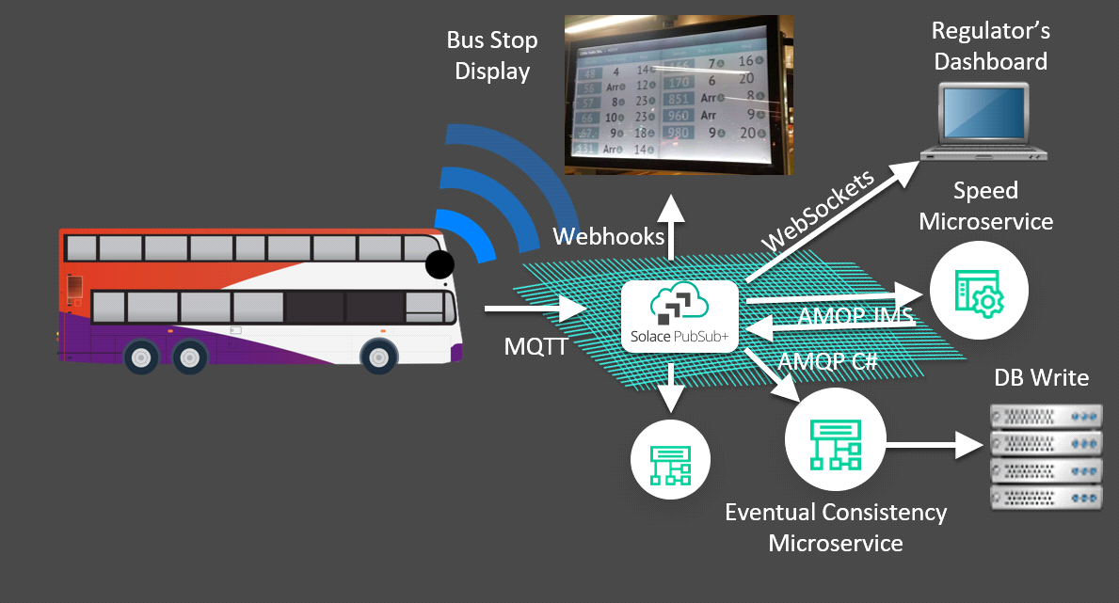**CONCLUSION OF ALGORITHM:**

This algorithm provides a high-level overview of the steps and considerations involved in optimizing public transportation using IOT. Implementing such a system requires collaboration between transportation authorities, technology providers, and data scientists, along with continuous improvement and adaptation based on the gathered data and changing urban dynamics.

I.Project Description:

Improving vehicle scheduling:

Optimizing vehicle schedules can help to reduce waiting times and improve service frequency.

Designing efficient routes:

Designing efficient routes can help to reduce travel times and fuel consumption.

Coordinating different modes of transportation:

Coordinating different modes of transportation, such as buses and trains, can make it easier for passengers to get around.

Improving infrastructure:

Investing in public transportation infrastructure, such as new bus lanes and train stations, can improve the overall quality of service.

Public transportation optimization is a complex problem, as it involves a variety of factors, such as passenger demand, vehicle availability, and budget constraints. However, a number of optimization techniques can be used to find solutions that improve the overall efficiency and effectiveness of public transportation systems.

One common approach to public transportation optimization is to use mathematical models. These models can be used to represent the complex relationships between the different factors involved in public transportation systems. Once a model has been developed, it can be used to evaluate different scenarios and identify the one that produces the best outcome.

II. Project Implementation:

Data Collection and Processing:

Data Sources:

Gather data on passenger demand, routes, stops, and schedules.

Utilize real-time data, historical usage patterns, and geographic information.

1.Data Processing:

Clean and preprocess the collected data.

Create a digital map of routes, stops, and passenger demand.

2.Route Planning and Scheduling:

Optimization Algorithms:

Implement algorithms to optimize routes and schedules.

Consider factors such as traffic conditions, road closures, and passenger preferences.

Frequency and Capacity:

Determine the frequency and capacity of each vehicle on different routes.

Real-Time Monitoring:

GPS and Tracking Systems:

Implement GPS tracking on vehicles.

Continuously monitor vehicle locations in real-time.

Adjustment Mechanism:

Develop a system to adjust routes and schedules based on real-time traffic and demand fluctuations.

Passenger Information System:

Real-Time Information:

Develop a platform to provide real-time information to passengers about routes, schedules, and delays.

Implement mobile apps and digital signage at stops for updates.

Ticketing and Payment:

Electronic Ticketing:

Implement electronic ticketing systems, including contactless payment options.

Safety and Security:

Surveillance and Emergency Systems:

Implement surveillance systems on vehicles and at stops.

Develop emergency response systems for unexpected situations.

Feedback and Improvement:

Passenger Feedback:

Create a mechanism for collecting feedback from passengers and drivers.

Utilize data analytics to identify areas for improvement.

Environmental Considerations:

Eco-Friendly Practices:

Implement practices and technologies to reduce the environmental impact of public transportation.

Cost Management:

Operational Cost Monitoring:

Develop a system to continuously monitor and manage operational costs.

Integration:

System Integration:

Ensure seamless integration with other transportation systems, city infrastructure, and data sources.

Development Platforms and Technologies:

Programming Languages:

Choose appropriate programming languages (e.g., Python, Java) for backend and frontend development.

Database:

Implement a robust database system to store and retrieve data efficiently.

Web and Mobile Development:

Develop web and mobile applications for passenger interfaces.

APIs and Microservices:

Implement APIs and microservices for modular and scalable development.

Testing and Deployment:

Testing:

Conduct thorough testing, including unit testing, integration testing, and user acceptance testing.

Deployment:

Deploy the system in stages, considering scalability and user adoption.

Maintenance and Updates:

Regular Maintenance:Establish a maintenance plan to address issues and ensure system reliability.

Updates and Enhancements:Plan for periodic updates and enhancements based on feedback and technological advancements.

Circuit Diagram:

Working process of public transportation optimization:

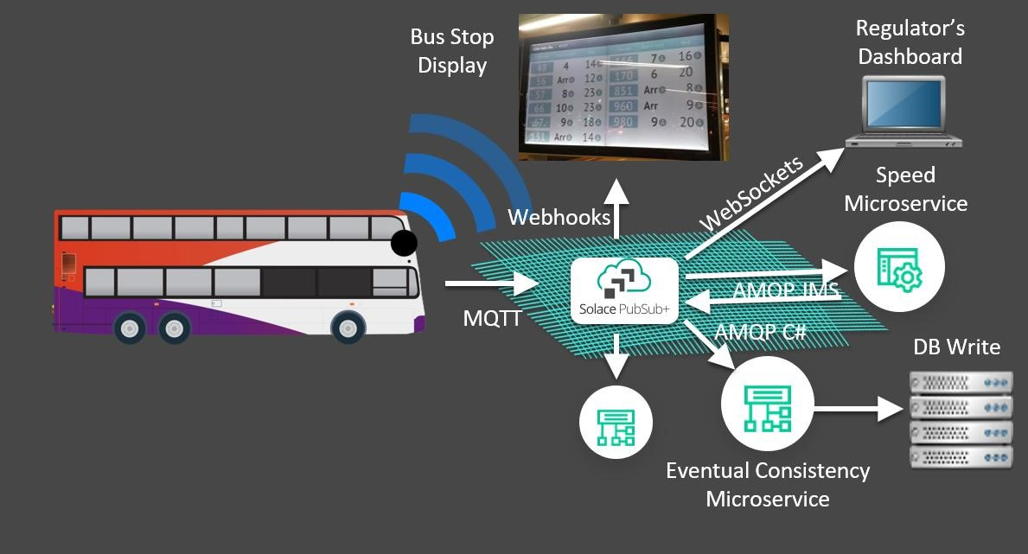

**Real-time example of public transportation optimization:**

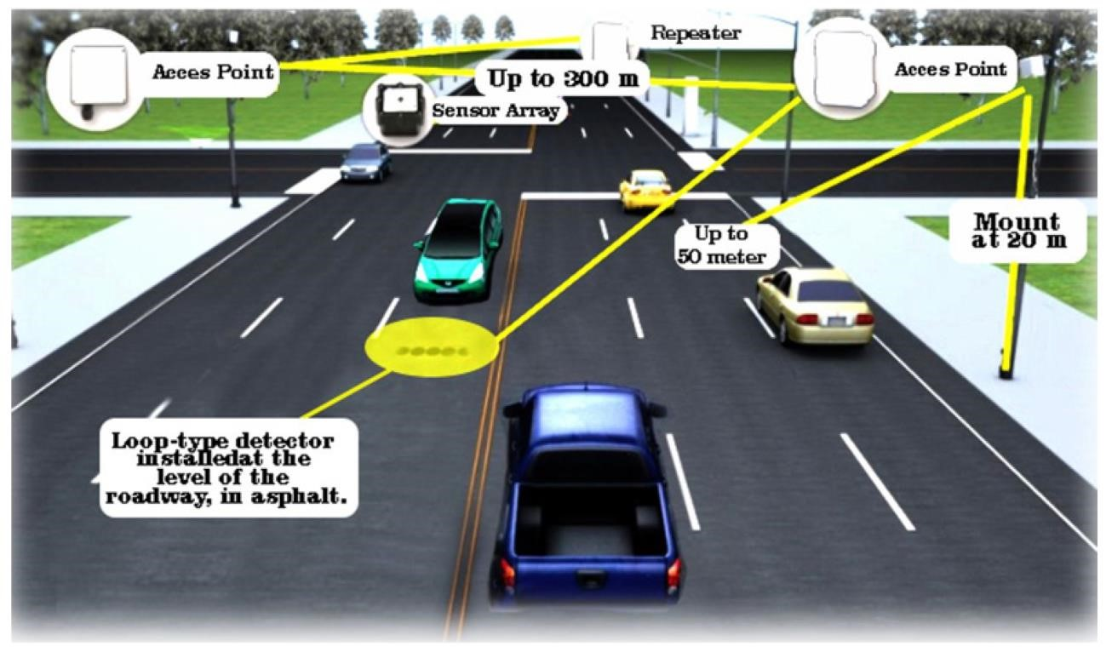

**Vehicle detection to control the public transport :**

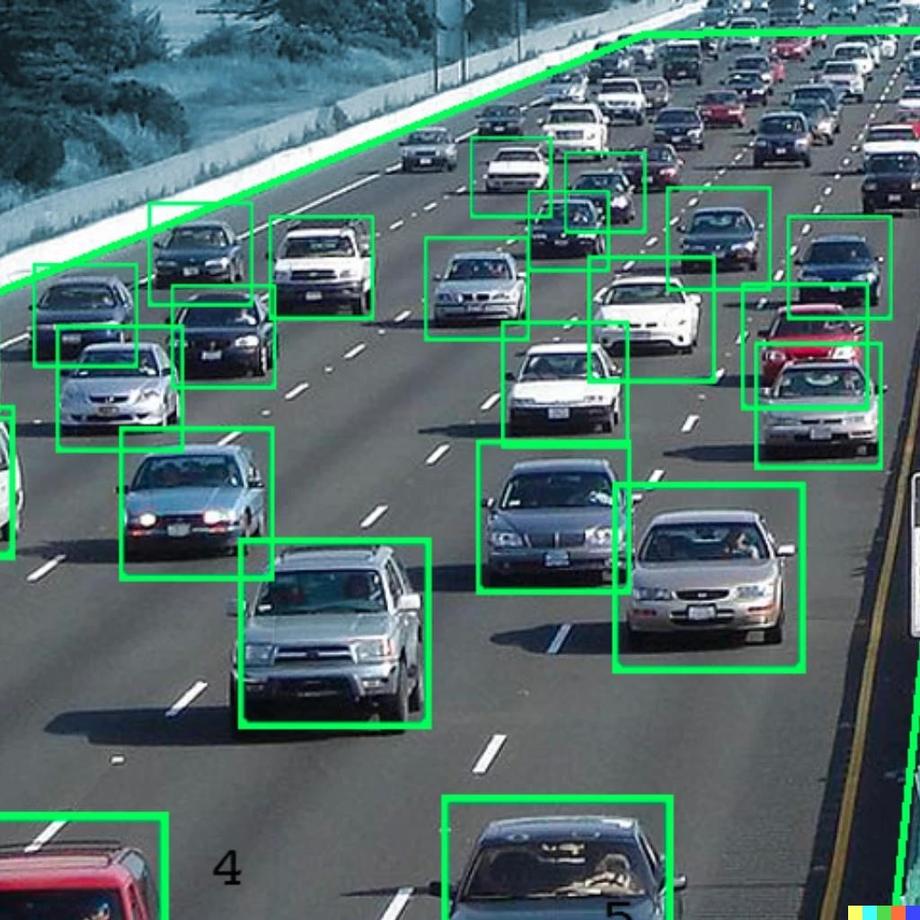

**Public transportation optimization using IoT connected Camera’s:**

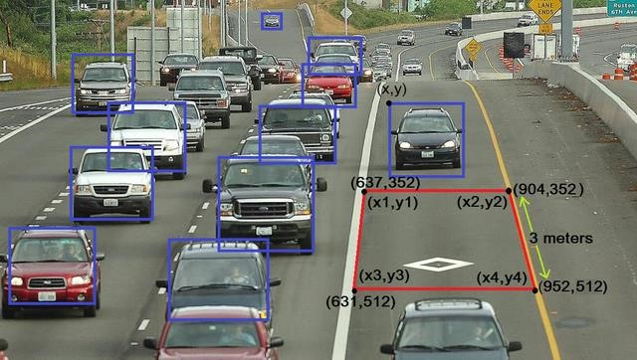

**Source Code:**

**4.1.. Front Code:(Python)**

#define BLYNK_TEMPLATE_ID "TMPL26V4fGv5q"

#define BLYNK_TEMPLATE_NAME "Test"

#define BLYNK_AUTH_TOKEN "XEHxNF_Ur1Nt2p7wB5B20dNI1ZUwj34P"

#include <WiFi.h>

#include <WiFiClient.h>

#include <BlynkSimpleEsp32.h>

int duration1 = 0; int distance1 = 0; int duration2 = 0; int distance2 = 0; int dis1 = 0; int dis2 = 0; int dis_new1 = 0; int dis_new2 = 0; int entered = 0; int left = 0; int inside = 0; #define LED 2

#define PIN_TRIG1 15

#define PIN_ECHO1 14

#define PIN_TRIG2 13

#define PIN_ECHO2 12

BlynkTimer timer;

char auth[] = BLYNK_AUTH_TOKEN; char ssid[] = "Wokwi-GUEST"; // your network SSID (name) char pass[] = "";

#define BLYNK_PRINT Serial

long get_distance1() { // Start a new measurement: digitalWrite(PIN_TRIG1, HIGH); delayMicroseconds(10); digitalWrite(PIN_TRIG1, LOW);

// Read the result:

duration1 = pulseIn(PIN_ECHO1, HIGH); distance1 = duration1 / 58; return distance1;

}

long get_distance2() { // Start a new measurement: digitalWrite(PIN_TRIG2, HIGH); delayMicroseconds(10); digitalWrite(PIN_TRIG2, LOW);

// Read the result:

duration2 = pulseIn(PIN_ECHO2, HIGH); distance2 = duration2 / 58; return distance2;

}

void myTimer() { Serial.println("100"); dis_new1 = get_distance1(); dis_new2 = get_distance2(); if (dis1 != dis_new1 || dis2 != dis_new2){ Serial.println("200"); if (dis1 < dis2){ Serial.println("Enter loop"); entered = entered + 1; inside = inside + 1;

digitalWrite(LED, HIGH);

Blynk.virtualWrite(V0, entered); Blynk.virtualWrite(V2, inside); dis1 = dis_new1; delay(1000); digitalWrite(LED, LOW);

} if (dis1 > dis2){ Serial.println("Leave loop"); left = left + 1; inside = inside - 1;

Blynk.virtualWrite(V1, left); Blynk.virtualWrite(V2, inside); dis2 = dis_new2; delay(1000);

}

}

}

void setup() {

Serial.begin(115200); pinMode(LED, OUTPUT); pinMode(PIN_TRIG1, OUTPUT); pinMode(PIN_ECHO1, INPUT); pinMode(PIN_TRIG2, OUTPUT); pinMode(PIN_ECHO2, INPUT);

Blynk.begin(auth, ssid, pass, "blynk.cloud", 8080); timer.setInterval(1000L, myTimer);

} void loop() { Blynk.run(); timer.run();

}

**4.2.. Backend Code:(Python)**

{

"version": 1,

"author": "MANOJ S",

"editor": "wokwi",

"parts": [

{ "type": "wokwi-esp32-devkit-v1", "id": "esp", "top": -12.8, "left": 180.8, "attrs": {} },

{

"type": "wokwi-hc-sr04",

"id": "ultrasonic1",

"top": -31.94,

"left": -1.1,

"attrs": { "distance": "240" }

},

{

"type": "wokwi-hc-sr04",

"id": "ultrasonic2",

"top": -32.14,

"left": -184.37,

"attrs": { "distance": "104" }

},

{

"type": "wokwi-led",

"id": "led1",

"top": 196.6,

"left": 95.24,

"attrs": { "color": "red" }

}

],

"connections": [

[ "esp:TX0", "$serialMonitor:RX", "", [] ],

[ "esp:RX0", "$serialMonitor:TX", "", [] ],

[ "ultrasonic1:VCC", "esp:VIN", "red", [ "v0" ] ], [ "ultrasonic1:GND", "esp:GND.2", "black", [ "v0" ] ],

[ "ultrasonic1:TRIG", "esp:D13", "green", [ "v0" ] ],

[ "ultrasonic1:ECHO", "esp:D12", "green", [ "v0" ] ],

[ "ultrasonic2:GND", "esp:GND.2", "black", [ "v93.61", "h255.99", "v-19.13", "h1.42" ] ],

[ "ultrasonic2:VCC", "esp:VIN", "red", [ "v111.32", "h288.11", "v-26.93" ] ],

[ "ultrasonic2:ECHO", "esp:D14", "green", [ "v97.15", "h262.44", "v-53.14" ] ],

[ "ultrasonic2:TRIG", "esp:D15", "green", [ "v102.11", "h397.16", "v-36.14" ] ],

[ "led1:C", "esp:GND.1", "black", [ "v7.36", "h195.18", "v-106.29" ] ], [ "led1:A", "esp:D22", "green", [ "v0.98", "h178.81", "v-149.51" ] ]

],

"dependencies": {}

}

**4.3.. Sample Output:**

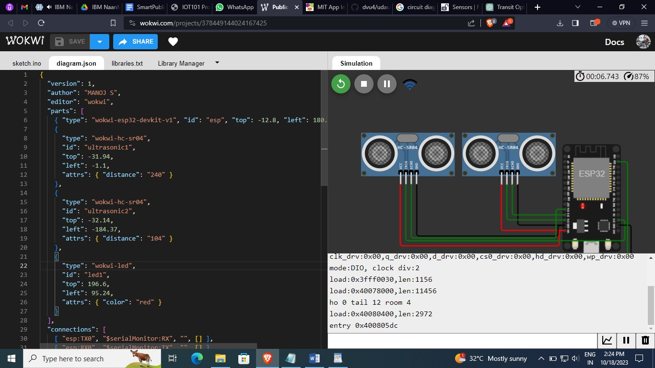

**Fig:** Start the IoT Module



**Fig:** Initializing the IoT Module



**Fig: Started the intialize**

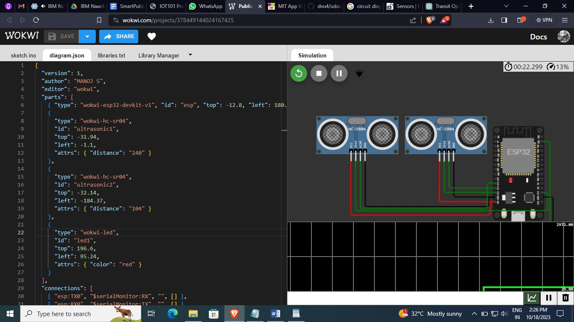

**Fig:Optimal of program**

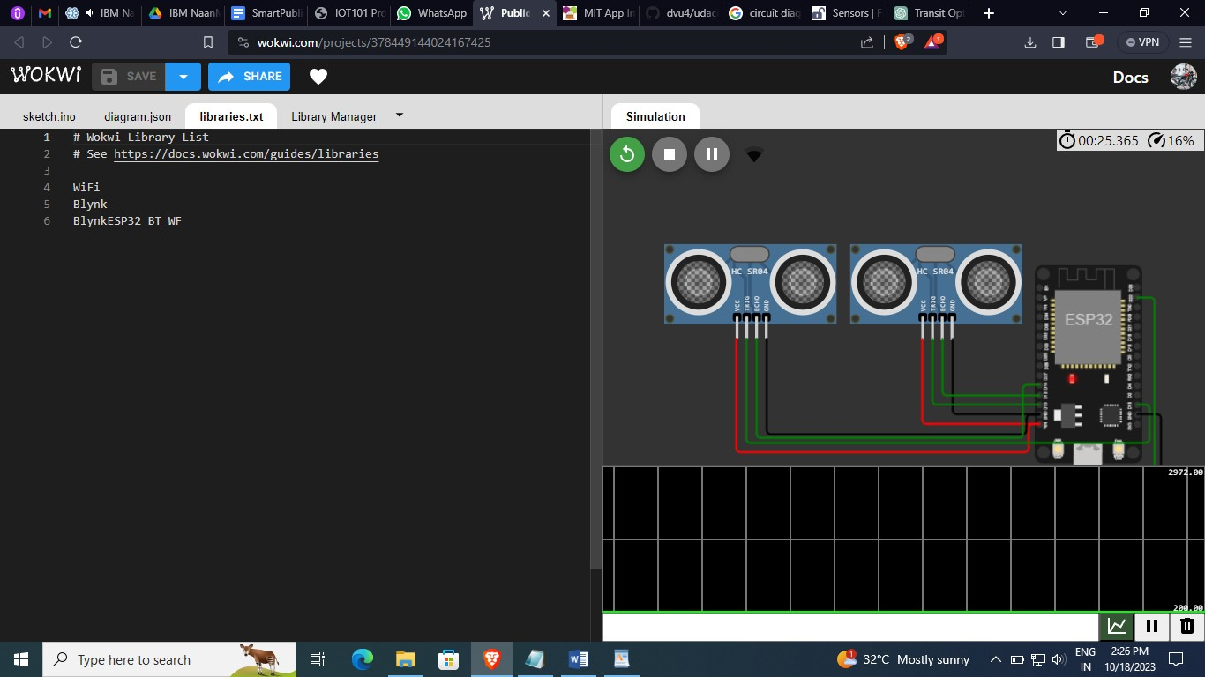

Fig: Initialize the code

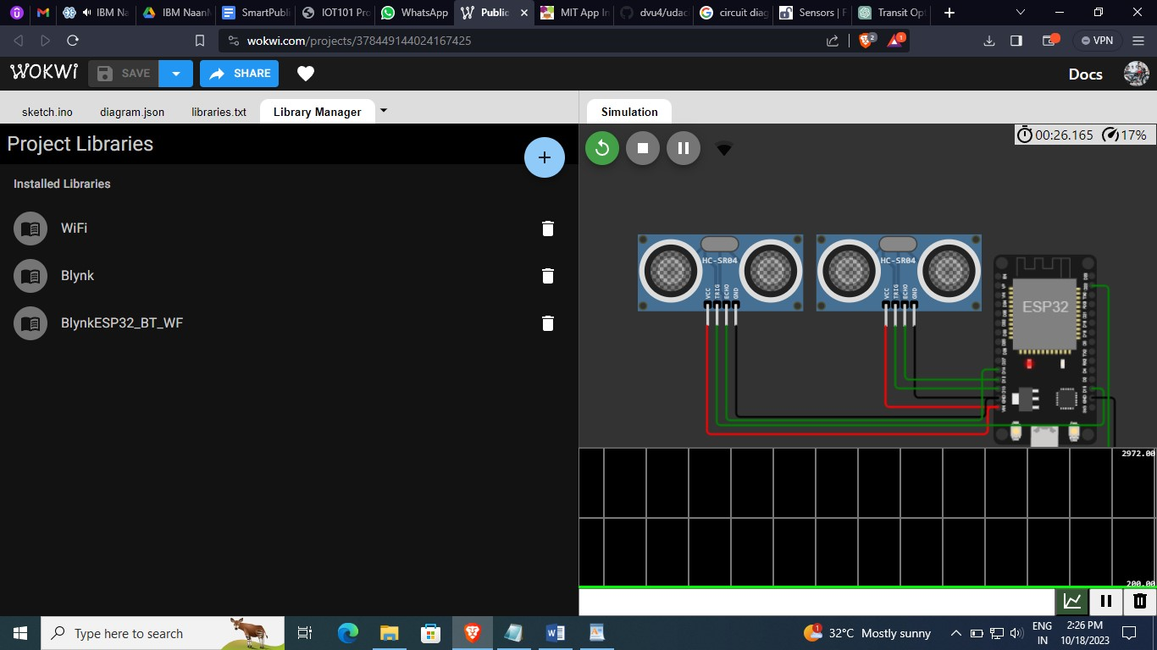

Fig describe the optimization of US Wave

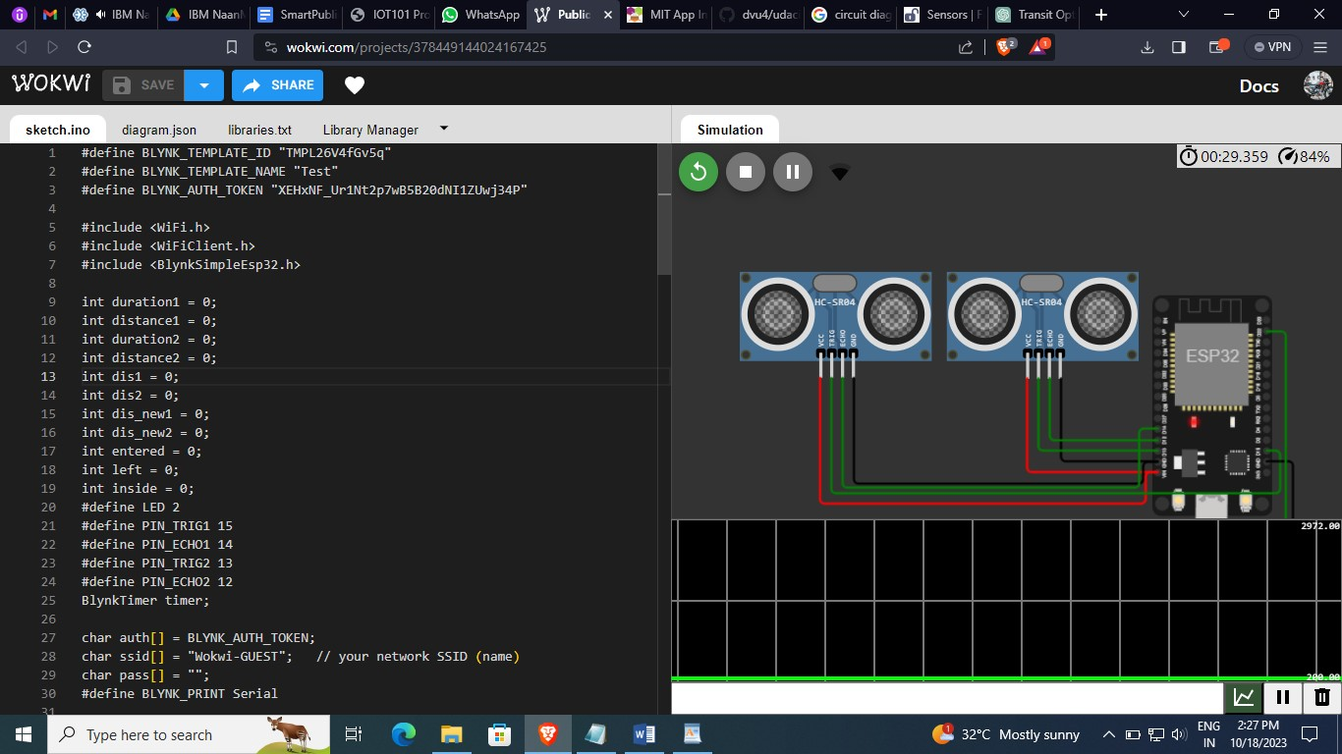



**PUBLIC TRANSPORT OPTIMIZATION:**

**(**Data analysis):

Analyzing the state of public transport in India from 2010 to the present involves an in-depth study, which cannot be fully covered in a text-based response. However, I can provide you with a simplified narrative analysis based on available knowledge up to 2021. Please note that for an up-to-date and comprehensive analysis, you would need access to current data and detailed research.

**Analysis of Public Transport in India (2010-2021):**

1. **Growth of Metro Systems**: India has seen a significant expansion of metro rail systems in major cities like Delhi, Mumbai, Bangalore, and Chennai. These have helped reduce traffic congestion and provided a faster mode of urban transportation.

2. **Expansion of Bus Networks:**Bus transport continues to be a critical mode of public transport. The Jawaharlal Nehru National Urban Renewal Mission (JNNURM) and Smart Cities Mission have played a role in improving bus services in several cities.

3. **High-Speed Rail (HSR):** The Indian government initiated several HSR projects to connect major cities, promising faster, more efficient, and sustainable transportation.

**4. Challenges in Bus Transportation:** While buses are a lifeline for many, challenges such as over-crowding, poor maintenance, and safety issues remain. Improving the quality and coverage of bus services remains a significant challenge.

**5. Railway Infrastructure:** The Indian Railways underwent modernization and electrification efforts, enhancing connectivity and speed. The Dedicated Freight Corridor (DFC) project aims to improve freight transport efficiency.

**6. Impact of Urbanization:** Rapid urbanization has increased the demand for public transportation. However, the growth in vehicle ownership has also led to increased traffic congestion in many urban areas.

**7. Financial Sustainability:** Many public transport systems continue to rely on government subsidies. Finding a sustainable financial model is crucial for long-term viability.

**8. Sustainability and Environmental Impact:** Environmental concerns have led to a greater focus on sustainability and cleaner technologies in public transport.

**9. Digital Transformation:** The advent of smartphone apps for booking tickets, checking schedules, and real-time tracking has made public transport more accessible and convenient.

**10. COVID-19 Impact:**The COVID-19 pandemic disrupted public transport as lockdowns were enforced, and people hesitated to use crowded public transit. Recovery efforts were essential to restore services.

**11. Last-Mile Connectivity:** Improving the connectivity between public transport modes and destinations remains a priority, ensuring ease of use for commuters.

**12. Integration of Transport Modes:** Efforts have been made to integrate various modes of transportation within a city to create a seamless, intermodal system.

**13. Safety and Security:** Ensuring the safety of passengers, particularly women and vulnerable groups, remains a concern.

\*\***Future Prospects:\*\***

The future of public transport in India may see further expansion of metro systems, the success of high-speed rail projects, and a shift towards electric and sustainable transport. The government's policies and investments will play a crucial role in shaping the future of public transportation. Additionally, addressing the environmental impact and improving financial sustainability will be key challenges for the coming years.

Please note that the dynamics of public transport in India may have evolved since my last knowledge update in September 2021. For a more up-to-date and comprehensive analysis, it's important to refer to the latest reports and research in the field.

**Optimized by IoT:**

Performance

Optimization

User

Oriented

Safety

Accessibility

Regularity

Journey Speed

Operator

Oriented

Operating Costs

Staff per Bus Ratio

Load factor

% of Cancelled kilometer

Fleet Utilization

Fig. Hierarchy of performance optimization process

The comparison matrices are:

**Level 1 Goal of the study:** optimize the performance of the public transport.

**Level 2:** The stakeholders of the public transport industry

**Level 3 Decision variables:** The judgement matrix of pairwise comparison of level 2 elements the stakeholders of the based on the AHP rating scale was provided by experts associated with bus transportation and academia using a designed pro forma. Table 3 presents the pairwise comparison of the two elements, viz. operator and users.

Further, the decision variables, divided into user oriented and operator oriented, were analyzed to determine their priorities.

|  |  |  |  |  |  |  |
| --- | --- | --- | --- | --- | --- | --- |
| Decision variable | Reliability | Safety | Accessibility | Journey speed/travel time | | Priority vector |
| Reliability | 1 | 1/9 | 3 | 1 |  | 0.11 |
| Safety | 9 | 1 | 9 | 9 |  | 0.72 |
| Accessibility | 1/3 | 1/9 | 1 | 1/4 |  | 0.05 |
| Journey speed/travel time | 1 | 1/9 | 4 | 1 |  | 0.12 |

**Table: Final weights of decision variables**

In India, rapid urbanization and motorization post independence have led to increased travel demand, triggering a transport crisis that includes congestion, pollution, and other environmental externalities. Mitigation of this transport crisis has become a challenging task in the transport industry. Development of public transport has been identified as a sustainable solution for all major transport problems. Moreover, public transport is the primary and only means of transport for a large section of society in India. The Working Group of Urban Transport [1] has suggested a desirable share of public transport of 60% of motorized trips to reduce energy needs and address the transport crisis. Public transport undertakings are striving to provide efficient and convenient travel. However, they are not providing better travel options due to various challenges in the public transport industry, such as financial instability, incompetence, and unreliability. Excessive operating cost, overstaffing, low productivity, and imprudent use of financial resources are a few of the institutional issues, while inadequate frequency, increased travel time, poor service quality, and overcrowding are a few of the reasons why users are shifting away from public transport. The declining share of public transport has caused the public transport industry to become loss-making.

While the government has a complete monopoly over the rail transport sector, there are many competing players in the road transport industry. In this fiercely competitive environment, state-owned public transport industry cannot operate sustainably, showing mediocre performance. In this respect, a crucial question is to identify which operating practices and administrative regulations could improve the public transport industry. Meanwhile, inefficiencies, bottlenecks, and the potential of public transport should be determined by evaluating the performance in the current scenario. Moreover, to improve the performance and efficiency in the face of reduced budgets, high political expectations, and competition between operators, the performance of the industry must be improved by optimizing the available resources.

In recent years, performance evaluation has become a focus of attention in the public transport industry, as it is viewed as a method to assess the outcomes of the system, which can be further analyzed to decide upon improvement strategies. Since public transport involves multiple stakeholders, optimization procedures must be performed rather than just evaluation. Unfortunately, performance optimization is a largely unexplored area, even though it facilitates efficient and effective use of technological, financial, material, and human resources. According to Perez et al. [2], a truly optimal solution exists only if a single criterion is considered. However, in practical scenarios, several issues must be addressed in the optimization procedure. Firstly, there are multiple decision variables, structured in multilevel hierarchies [3]; For instance, passenger transport assessment solely based on economic criteria may be too narrow, as the final decision-making depends on various types of factors other than monetary ones [4]. Secondly, some level of subjective judgement is involved in the assessment of decision variables, which can result in the use of incorrect information. Finally, the stakeholders in the public transport industry include the users, operators, and community at large [5].

The rationale for this paper is based on the following arguments: Studies on Indian SRTUs have tended to focus on performance evaluation, whereas the area of performance optimization has been left largely unexplored. While the performance evaluation process can acknowledge or assess the outcomes of any system for further analysis to decide upon improvement strategies, performance optimization can be viewed as a process of utilizing technological, financial, material, and human resources efficiently and effectively. This study proposes a performance optimization methodology integrating the analytical hierarchy process (AHP) and goal programming (GP), considering both operators’ and users’ perceptions. The analytical hierarchy process, a multicriteria decision-making tool, is used to evaluate the decision variables and calculate their weights for use as penalties in goal programming.

The objectives of this study are: (1) to identify the decision variables to be used for performance optimization, (2) to calculate their weights using the AHP, and (3) optimize the performance of the Kerala State Road Transport Corporation (KSRTC) considering both users’ and operators’ perceptions by using analytical hierarchy process and goal programming. The remainder of this manuscript is organized as follows: Section 2 reviews a few existing methodologies for performance evaluation and optimization techniques. Section 3 explains the methodology used in the study. Section 4 describes the current scenario of the KSRTC and the application of the methodology for optimization of its performance, followed by concluding remark

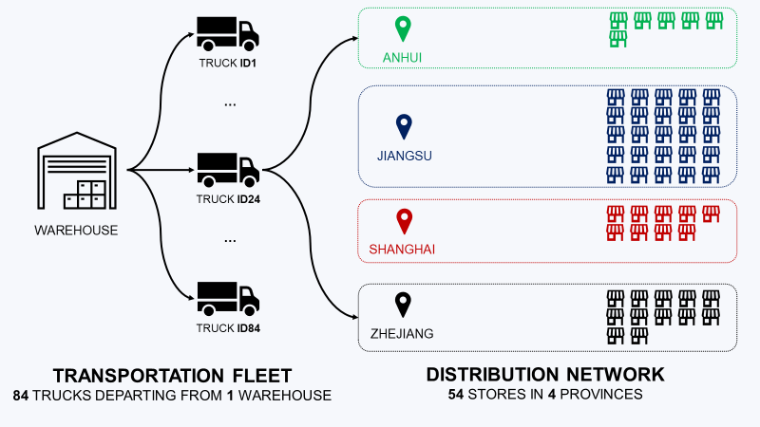

FIG: Optimized Transport

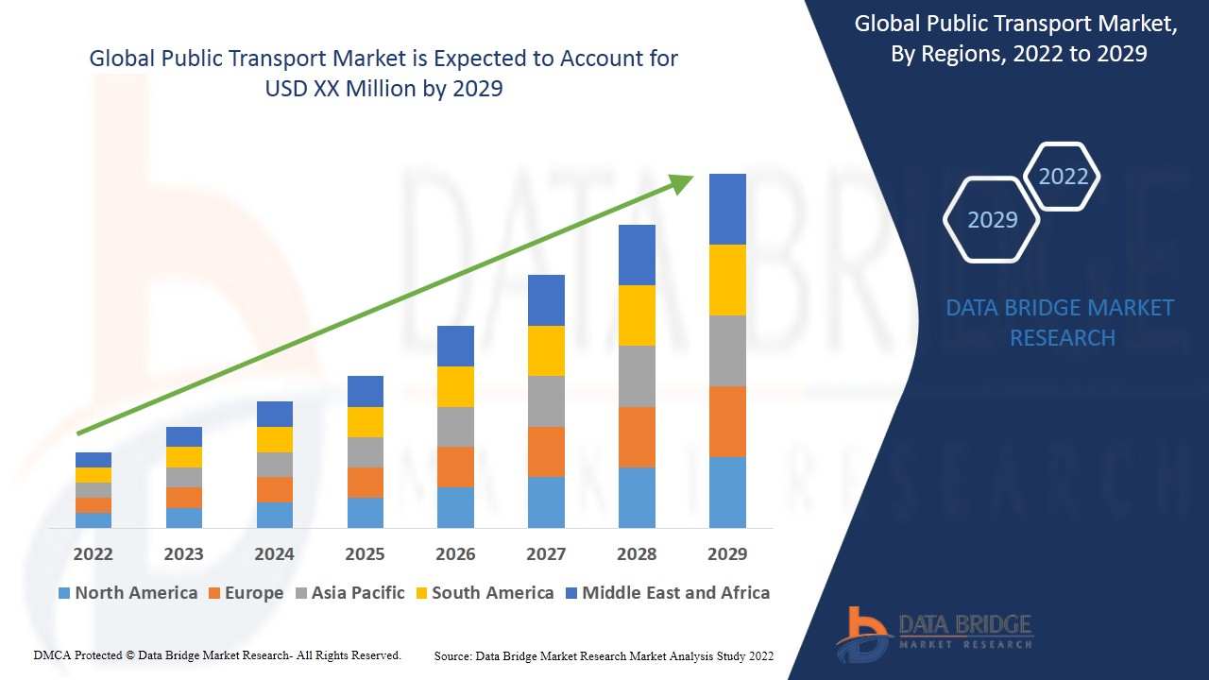

Fig: Public Transport Optimized

CONCLUSION:

Given the increasing need for crowd management systems

in today’s public transport and the paucity of IoT imple-

mentation in the same, this project has demonstrated a

robust, cheap and scalable system to mange crowds in

public transport. The software simulation was carried out

to check feasibility of such a system to work in a real time

environment. The project design was built and tested for

various loads and seating profiles to better estimate the

threshold. The prototype was built and tested in real time

seating environments. The final results show promise for

implementation in the real world. Further work can be

done to account for standing passengers, implementing

addressing schemes to increase scalability and introduce

web development to improve the webpage interface.