**Overview of IT**

1. **What is software? What is software engineering?**

* The software is basically a set of instructions or commands that tell a computer what to do.
* For Example: clock, Microsoft word, calendar.
* Software engineering: The software engineering is a designing, developing, testing and maintaining software system.

1. **Explain type of software.**

* The main is a two software.1) **Application software**

2) **System software**

* 1. Application software:

Application software that’s develops in computer by developer that’s call application software.

e.g. Whatsapp, face book, word, excel.

* 2. System software:

System software is a computer program designed to provide a platform of running application software.

e.g. clock, notepad.

* 3.Embedded software:

Embedded software is hardware device, often controlling and device functionality and behaviour.

* 4. Programming software:

Programming software is high-level programming language into machine code to the execute by computer.

* 5.Middleware software:

Middleware software is line and operating system and the application running.

1. **What is SDLC? Explain each phase of SDLC.**

* The SDLC typically includes such as planning, analysis, design, implementation, testing, developer, and maintenance.
* Software Development Life Cycle:

1. Planning:

The fest phase of the SDLC is the project planning stage where are gathering

Business requirement your client.

1. Analysis:

The second phase of the SDLC is the project scope, objective, requirement, and constraints are the defined.

1. Designing:

The third phase of the SDLC is the system architecture and detail design are create base on the requirements in the previous.

1. Implementation:

The implementation translating the design specification in to actual code. Developer by the test code according to the design document and coding.

1. Testing:

The testing phase is dedicated to verifying that the software meets the specified requirements and works as intended.

1. Maintenance:

Maintenance that the software remains functional and up-to-date throughout its lifecycle.

1. **What is DFD? Create a DFD diagram on Flipkart.**

* A data-flow diagram is a way of representing a flow of data through a process or a system.
* FLIPKART-DFD:

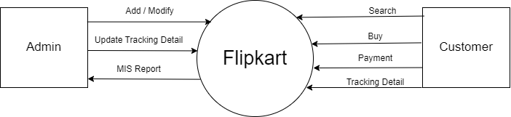

**Level 0 DFD diagram of flip cart**

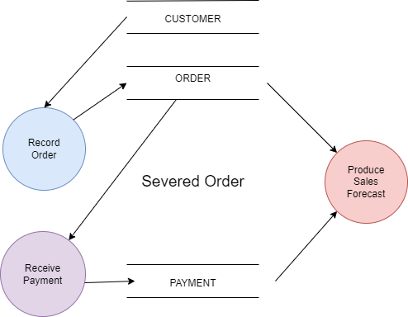

**Level 1 DFD diagram of flip cart**

1. **What is Flow Chart? Create a flowchart to make addition of two numbers.**

* A flowchart is a diagram that the show the step and sequence of process or workflow.
* Create a flowchart if a 35+ 64

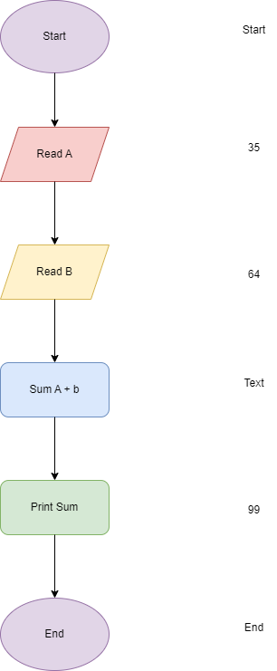

1. **What is Use case Diagram? Create a use-case on bill payment on paytm.**

* A use case diagram is a graphical representation of the functional requirement of a system or software application.

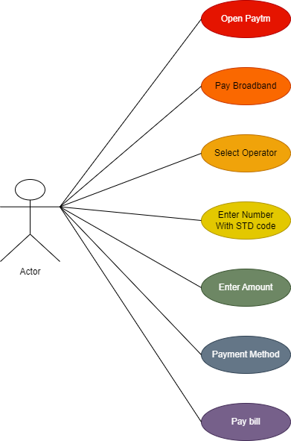

**Fig: Use-case in Pay Broadband**