**TITLE:** CodTech IT Solutions Internship

**INTERN INFORMATION:**

**Name:** Vishal Jambukiya

**ID:** ICOD5637

(1) SIMPLE CALCULATOR WITH ADVANCE FEATURES

Overview

1. This Python program implements a simple calculator with advanced features. It allows users to perform basic arithmetic operations such as addition, subtraction, multiplication, and division, as well as exponentiation. Additionally, users have the option to quit the program.

Features

* Addition (+): Allows users to add two numbers.
* Subtraction (-): Allows users to subtract one number from another.
* Multiplication (*): Allows users to multiply two numbers.
* Division (/): Allows users to divide one number by another.
* Exponentiation (^): Allows users to raise a number to a power.
* Quit (q): Allows users to exit the program.

Program Execution

* The program prompts the user to choose an operation or to quit.
* Depending on the user's choice, the program either performs the selected operation or exits.
* If the user selects an arithmetic operation, the program prompts the user to enter two numbers.
* After receiving the input, the program performs the operation and displays the result.
* The program then returns to the main menu, allowing the user to choose another operation or to quit How to Use
* Run the Python script task_1.py.
* Follow the on-screen instructions to perform arithmetic operations or to quit the program.

Output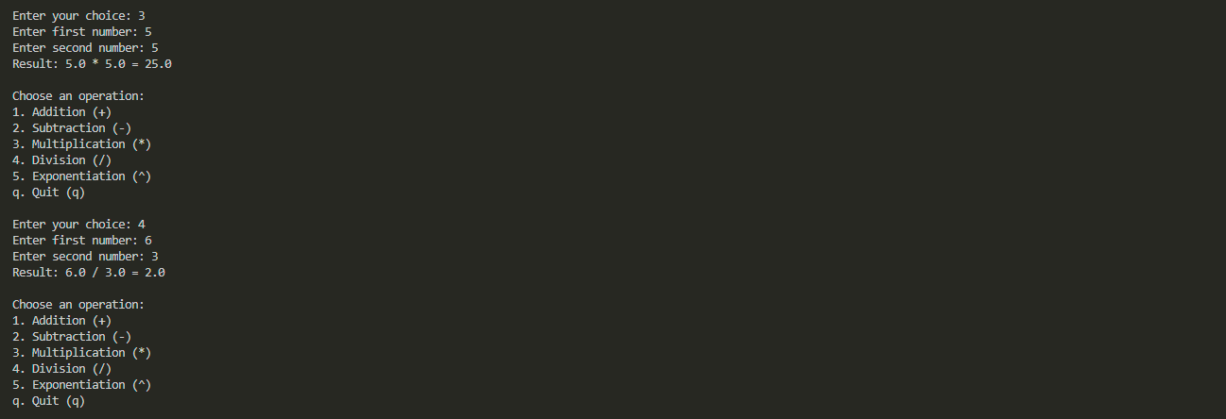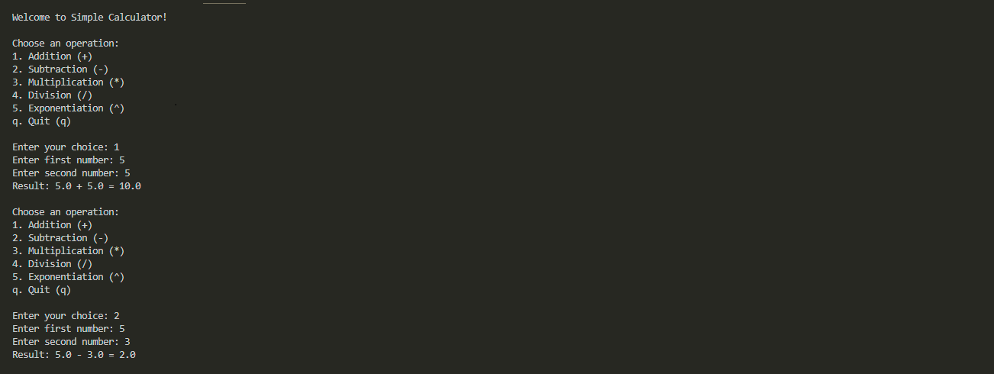

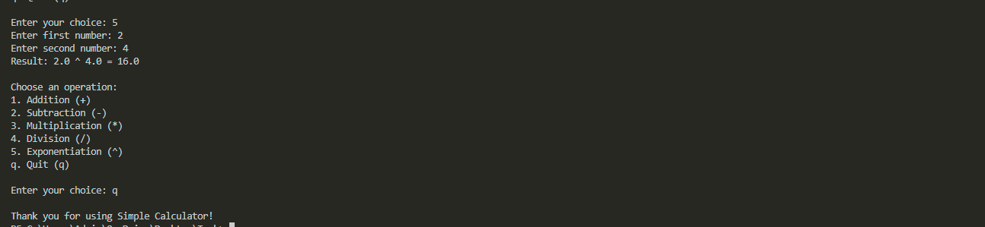

(2) SIMPLE PYTHON CHATBOT

Introduction:

The Python Chatbot is an interactive conversational agent designed to engage in dialogue with users, providing assistance and information based on natural language input. Leveraging the Natural Language Toolkit (NLTK), the chatbot employs pattern matching and reflection techniques to understand user queries and generate appropriate responses.

This program serves as a basic framework for building chatbots capable of handling a variety of conversational scenarios. With a predefined set of patterns and responses, users can interact with the chatbot on topics such as greetings, personal information, general inquiries, and expressions of gratitude.

Installation:

* Install Python: Ensure you have Python installed on your system. You can download and install Python from the official website: python.org.
* Install NLTK: NLTK (Natural Language Toolkit) is a library for natural language processing in Python. You can install NLTK using pip, the Python package manager. Open a terminal or command prompt and run the following command:
* Pip Install nltk
* After Installation NLTK Than run task_2.py file. And Enjoy Bot

User Interactions:

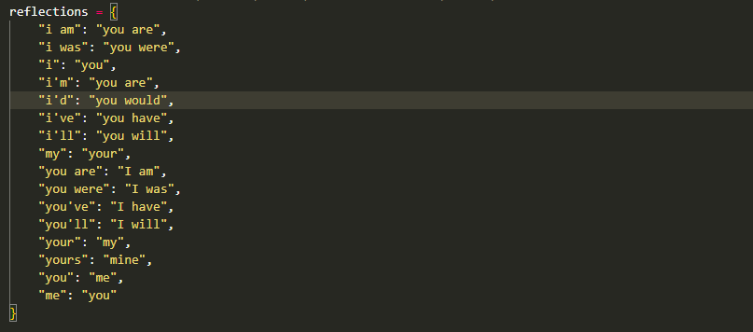

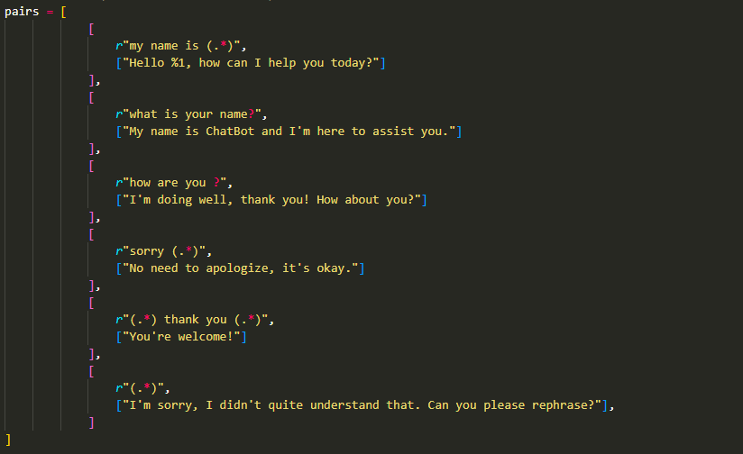

In Above Code Some Sentence but We Can Add New as We Want.

Output:

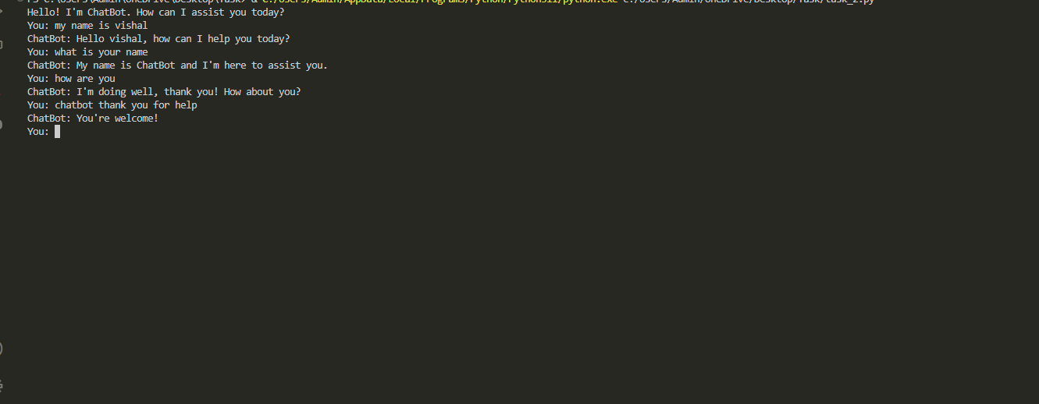

When some other sentence Enter by user so Chatbot Give Default Sentence Like this.

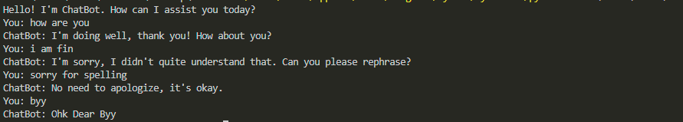

Conclusion:

In conclusion, the Python Chatbot provides a versatile platform for creating interactive conversational agents using natural language processing techniques. Through the utilization of NLTK and pattern matching algorithms, the chatbot can understand user queries and generate contextually relevant responses, facilitating engaging interactions with users.