JAMBY G. REYES INFORMATION MANAGEMENT
BSIT 2F2

Exercise #13:
- Which command displays the MySQL version?
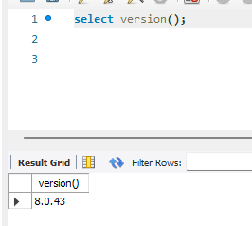

- Use the SELECT command to evaluate 4 X 4 X 4 and name the column Cube of 4.
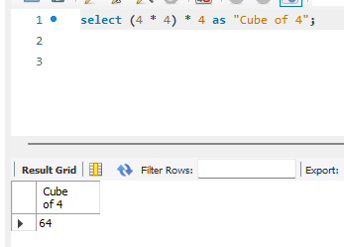

- Display your name with SELECT.
