Username: eulette.miranda@motolite.com

Password: J#236455025349oq

R@mcar0959

pid.ojt@motolite.com

Password:

H(073454161430om

song:

ba bye na - ba bye narin ba sa ting ala ala

Disney land wish kay ginie

kay tagal kitang hinintay

--------------------------------------------------------------------------------------------------------------------------------------------------------------------------

qa acc:

40001110

12345

initiator acc:

6034294

12345

final process - QA HEAD - manager

40000197

12345

supervisor -

40000781

12345

JA25-KF034

match the table size thru colspan - Inspection Request

accept - pending - pass - For approval[completion(qa head)] -

there's date completed if (QA approved it)

Filtering for completed - VIEWED & NOT VIEWED

-------------------------------------------------------------------------------------------------------------------------------------------------------------------------

7-17-2025

PPIC - approval,

- request result

PPIC and PO - INSPECTION Request

kdskszlnwxkdxggh - password ng office365

NCR - July 21 - August 1 = (10days)

MRB - August 4 - August 15 = (10days)

RCPA - August 18 - August 29 = (10days)

REQUEST FOR DISTRIBUTION - Sept 1 - Sept 12 = (10days)

(40days)

--------------------------------------------------------------------------------------------------------------------------------------------------------------------------

7-17-2025

sending emails -

notifications - (NOTIFICATIONS JUST NEED FILTERING FOR VIEWED AND NOT VIEWED)

the sidebar not hiding when clicking outside sidebar -

editing the table - colspan

--------------------------------------------------------

7-18-2025

sending emails - DONE

notifications (NOTIFICATIONS JUST NEED FILTERING FOR VIEWED AND NOT VIEWED) - done

the sidebar not hiding when clicking outside sidebar -

editing the table - colspan -

edited the

-------------------------------------------------------------------

7-21-2025

edited the file structure for js and css

inspection-qa-completed-table-.php

ins[ection-qa-task-failed.js - nahinto sa pag hanap ng (.php)

../php/ncr/

../php/inspection/

../../../../css/inspection-table.html

a href="php/inspection/inspection-dashboard-department-head.php

include 'css/inspection-dashboard.html';

include 'css/inspection-dashboard-modal.html';

include 'css/inspection-history.html';

include '../../../../css/inspection-table.html';

include 'css/custom-elements.html';

include '../css/remarks-modal.html';

-----------------------------------------------------------------------------------------

7-22-2025

view button not working - styles or js

sending email not working

in completed when view the not viewed it will immediately mark as viewed eventhough the modal is not showed

abstract background not working

ending - view button gumagana and email hindi pa pero ang problem is no record found in view button dashboard

------------------------------------------------------------------------------------------

7-24-2025

PROBLEMS

- view button now showing data (no record found)

- sending email not working

- creating request (initiator POV) not working

inspection-initiator-insert.php

inspection-request-insert-initiator.php

inspection-request-insert-final-sub.php

__________________________________________________________________________________________

7-25-2025

ncr no., wbs, description, requestor, assignee, date of request, status, action, history

table

problem: outgoing - painting -

------------------------------------------------------------------------------------------

7-26-2025

problem solved

- date for outgoing painting

- sending emails

- distinction of between rti and ssd

SIR SANDY PROBLEM

- 7-26-2025 - DISTINCTION of rti and ssd

- 7-29-2025 - notifications with viewed and unviewed filtering

- 7-30-2025 - attachment for rejection

- 7-30-2025 - showing the rejected remarks for dashboard, rejected

- 7-31-2025 - required attachment in requesting - dimensional

- 8-1-2025 - attachment for dimensional

- 8-1-2025 - remarks for completion

- 8-4-2025 - required attachment in requesting - material analysis

- 8-4-2025 - no attachment in view for passed with failed complted

- 8-6-2025 -

___________________________________________________________

7-28-2025

problem solved

- date filtering

new problem

- PPIC must see all the completed, failed, rejected and cancelled

sql:

CREATE TABLE inspection_rejected_notification (

notification_id INT AUTO_INCREMENT PRIMARY KEY,

inspection_no INT(9)

);

CREATE TABLE inspection_failed_notification (

notification_id INT AUTO_INCREMENT PRIMARY KEY,

inspection_no INT(9)

);

CREATE TABLE inspection_cancelled_notification (

notification_id INT AUTO_INCREMENT PRIMARY KEY,

inspection_no INT(9)

);

update the

- inspection-update-reject

- inspection-notification-rejected.php

- inspection-data-retrive-history.js

- inspection-data-retrive-remarks.js

- inspection-table-qa-reject.php

- inspection-table-qa-pending.php

- inspection-rable-qa-rescheduled.php

- inspection-table-qa-for-rescheduling.php

- inspection-table-qa-for-reschedule.php

- inspection-table-qa-cancelled.php

- inspection-table-qa-for-completion.php

- inspection-table-qa-for-failure.php

- inspection-table-qa-failed.php

- inspection-table-qa-request.php

- inspection-data-retrieve-reject.php

- inspection-qa-task-rejected.js

- inspection-request-delete-rejected-notification.php

- inspection-filter-table-rejected.js

__________________________________

7-29-2025

fix the notification and the view buttons

-------------------------------------------------------------------------------------------

7/30/2025

inspection-modal-reject.php

inspection-modal-reject.js

inspection-update-status.js

inspection-update-reject.php

inspection-qa-task-rejected.js

inspection-seciton-rejected.php

CREATE TABLE inspection_rejected_attachments (

id INT AUTO_INCREMENT PRIMARY KEY,

attachment VARCHAR(255) NOT NULL,

inspection_no INT NOT NULL,

uploaded_at DATETIME DEFAULT CURRENT_TIMESTAMP

);

make a inspection-get-rejected-attachments.php

make a inspection-get-rejected-remarks.php

make a inspection-get-rejected-attachment-initiator.php

edit the inspection-data-retrieve.js

inspection-create-initiator.php

edit inspection-dashboard.js

inspection-dashboard-qa-head.php

inspection-dashboard-qa.php

inspection-dashboard-initiator.php

-----------------------------------------------------------------

inspection-completed-attachments

PROBLEM:

no attachm,ent founbd in this inspection number

inspection-completed-attachments-insert.php

inspection-request-insert-completed-attachments.php

------------------------------------------------------------------------

----------------------------------------------------------------------------

7-31-2025

- create table inspection_dimensional_attachment

-

-

---------------------------------------------------------------

create - inspection-get-dimensional-attachments.php

inspection-data-retrieve.js

-----------------------------------------------------------------------

8-1-2025

ALTER TABLE `system_users` ADD COLUMN `login_token` VARCHAR(64) NULL AFTER `department`;

edit the - login-retrieve.php, logout-.php

then add this every page

require_once 'connection.php'; // ADD THIS LINE to get DB connection

session_start();

// ---- Persistent login restore logic ----

if (empty($_SESSION['user']) && !empty($_COOKIE['persistent_login'])) {

list($employee_id, $token) = explode(':', $_COOKIE['persistent_login'], 2);

$stmt = $conn->prepare("SELECT employee_name, employee_privilege, department FROM system_users WHERE employee_id = ? AND login_token = ?");

$stmt->bind_param("is", $employee_id, $token);

$stmt->execute();

$result = $stmt->get_result();

if ($result && $result->num_rows === 1) {

$user = $result->fetch_assoc();

$_SESSION['user'] = [

'name' => $user['employee_name'],

'privilege' => $user['employee_privilege'],

'id' => $employee_id,

'department' => $user['department'],

];

// Refresh the cookie expiry:

setcookie('persistent_login', "$employee_id:$token", time() + 60 * 60 * 24 * 365, "/", "", false, true);

} else {

// Invalid token, remove the cookie

setcookie('persistent_login', '', time() - 3600, '/');

}

$stmt->close();

}

----------------------------------------------

inspection modal view.php

cancelled notif not adding when cancel

section na okay nayung dimentional attachment:

request

received

pending

for reschedule

-----------------------

NOTE: I PAKITA ANG REMARKS FOR COMPLETION

_________________________________________________________________________________________

8-4-2025

required file for material analysis

1.)create a db named

CREATE TABLE `inspection_material_attachments` (

`id` int(11) NOT NULL,

`attachment` varchar(255) NOT NULL,

`inspection_no` int(11) NOT NULL,

`uploaded_at` timestamp NOT NULL DEFAULT current_timestamp()

) ENGINE=InnoDB DEFAULT CHARSET=utf8mb4 COLLATE=utf8mb4_general_ci;

2.)inspection-create-initiator.php

inspection-data-insert.js

inspection-request-insert-material.php

3.) view it in the view btn

inspection-completed-attachments-insert.php

inspection-request-insert-completed.php

-----------------------------------------------------------------------------------------------

papalitan cookie:

login.php

login-retrieve.php

logout.php

homepage-dashboard

inspection-dashboard

inspection-tasks-qa-head.php

inspection-tasks-qa.php

inspection-request-insert-completed-attachments.php

inspection-request-insert-rejected-attachments.php

inspection-create-initiator.php

inspection-section-

inspection-update-for-completion

inspection-table-ssd

inspection-table-rti

inspection-table-qa-reject.php

inspection-table-qa-for-reschedule.php

inspection-table-qa-failed.php

inspection-table-qa-cancelled.php

inspection-table-ppic.php

inspection-table-dashboard.php

inspection-section-for-reschedule-qa-head.php

inspection-section-for-approval.php

inspection-section-completed-qa-head.php

inspection-rescheduled.php

inspection-rescheduled-update.php

inspection-request-update-initiator.php

inspection-request-update-history.php

inspection-request-insert-remarks.php

inspection-request-insert-reject.php

inspection-request-insert-initiator.php

inspection-request-insert-history.php

inspection-remarks-insert.php

inspection-remarks-insert_1.php

inspection-request-insert-initiator.php

inspection-final-sub-insert.php

inspection-qa-task-completed.php

______________________________________________________________________________________________

8-6-2025-

adding - material analysis file and dimensional file cannot view in dashboard

update - inspection-update-cancel.php

update - inspection-filter-table-dashboard.js

FOR PE CALIBRATION:

update - inspection-section-received.php

- inspection-qa-task-received.js

- inspection-filter-table-received.js

- inspection-table-qa-request.php

- inspection-notification-received.php

added - inspection-update-pe-calibration.php

------------------------------------------------------------------------------

8-7-2025

ALTER TABLE `system_users`

ADD COLUMN `email` varchar(255) NULL AFTER `employee_name`;

--------------------------------------------------------------------0

8/8/2025

now what I want is that it will email also the initiator to email the initiator

check the $inspectionNo in the table named 'inspection_request'

CREATE TABLE `inspection_request` (

`inspection_no` int(9) NOT NULL,

`company` varchar(255) NOT NULL,

`wbs` varchar(255) NOT NULL,

`description` varchar(255) NOT NULL,

`request` varchar(255) NOT NULL,

`status` varchar(255) NOT NULL,

`remarks` varchar(255) NOT NULL,

`requestor` varchar(255) NOT NULL,

`date_time` varchar(255) NOT NULL,

`approval` varchar(255) NOT NULL

) ENGINE=InnoDB DEFAULT CHARSET=utf8mb4 COLLATE=utf8mb4_general_ci;

after selecting the inspection_no check the column 'requestor' get that then go to table system_users

CREATE TABLE `system_users` (

`employee_id` int(8) NOT NULL,

`employee_name` varchar(255) NOT NULL,

`email` varchar(255) DEFAULT NULL,

`employee_password` char(255) NOT NULL,

`employee_privilege` varchar(255) NOT NULL,

`department` varchar(255) NOT NULL

) ENGINE=InnoDB DEFAULT CHARSET=utf8mb4 COLLATE=utf8mb4_general_ci;

the request column that comes from inspection_request scan the match "employee_name" if you find that then email also the what value of email "column"

ALTER TABLE inspection_incoming_wbs

ADD COLUMN quantity INT UNSIGNED NULL AFTER description;

ALTER TABLE inspection_incoming_wbs

MODIFY COLUMN quantity VARCHAR(50) NULL AFTER description;

update -inspection-data-insert.js

-inspection-request-insert-incoming-wbs.php

-inspection-css.js

-inspection-create-initiator.php

-inspection-modal-view.php

-inspection-populate-elemets.js

-inspection-request-retrieve-incoming-wbs.php

-inspection-request-insert-incoming-wbs.php

________________________________________________________________________________

CREATE TABLE IF NOT EXISTS inspection_outgoing_item (

id INT AUTO_INCREMENT PRIMARY KEY,

inspection_no INT NOT NULL,

item VARCHAR(255) NOT NULL,

quantity VARCHAR(255) NOT NULL,

created_at TIMESTAMP DEFAULT CURRENT_TIMESTAMP,

INDEX (inspection_no)

);

ALTER TABLE inspection_outgoing_item

MODIFY quantity VARCHAR(255) NOT NULL;

2:36pm - 8-8-2025

update -inspection-create-initiator

-inspection-css.js

-inspetion-data-insert.js

-inspection-request-insert-incoming.php

-inspection-populate-elements.js

-inspection-request-retrieve-incoming.php

-----------------------------------------------------------------

8-9-2025

update -inspection-filter-table-received.php

update 2 - inspection-create-initiator.php

- inspection-css.js

- inspection-data-insert.js

- inspection-request-insert-incoming-wbs.php

- inspection-populate-elements.js

- inspection-request-retrieve-incoming-wbs.php

- inspection-section-received.php

- inspection-modal-view.php

- inspection-section-completed.php

- inspection-section-failed.php

- inspection-section-for-approval-completion.php

- inspection-section-for-approval-reschedule.php

- inspection-section-for-approval-failure.php

- inspection-section-rejected.php

- inspection-section-cancelled.php

- then update the js version

inspection-qa-task-for-rescheduling.php:

function fetchInspectionRequest(inspectionNo) {

const formData = new FormData();

formData.append('inspection_no', inspectionNo);

// ⬇️ return the promise so callers can await it

return fetch('inspection-request-retrieve-initiator.php', {

method: 'POST',

body: formData

})

.then(response => {

if (!response.ok) throw new Error('Network response was not ok');

return response.json();

})

.then(data => {

if (data.status === 'success') {

populateInspectionRequest(data.data, inspectionNo);

document.getElementById('inspection-completed-attachments').style.display = 'none';

// ⬇️ set both globals used by fetchIncomingWBS

privilege = data.privilege ?? privilege;

// adjust the path below to whatever your payload uses

requestStatus = (data.data?.request_status ?? data.request_status ?? data.data?.status ?? requestStatus);

// let caller chain/await and know we're done

return { privilege, requestStatus };

}

throw new Error(data.message || 'Failed to load inspection data');

})

.catch(error => {

console.error('Fetch error:', error);

Swal.fire({ icon: 'error', title: 'Error', text: 'Failed to load inspection data' });

throw error; // rethrow so the caller can handle it

});

}

inspection-qa-task-for-failure.php:

function fetchInspectionRequest(inspectionNo) {

const formData = new FormData();

formData.append('inspection_no', inspectionNo);

return fetch('inspection-request-retrieve-initiator.php', { // <-- return the promise

method: 'POST',

body: formData

})

.then(response => {

if (!response.ok) throw new Error('Network response was not ok');

return response.json();

})

.then(data => {

if (data.status === 'success') {

populateInspectionRequest(data.data, inspectionNo);

fetchInspectionRejectedAttachments(inspectionNo);

privilege = data.privilege;

requestStatus = data.request_status; // if you have it; otherwise set it elsewhere

// make sure incoming WBS gets populated after privilege/status are known

fetchIncomingWBS(inspectionNo);

} else {

Swal.fire({ icon: 'error', title: 'Error', text: data.message });

}

})

.catch(error => {

console.error('Fetch error:', error);

Swal.fire({ icon: 'error', title: 'Error', text: 'Failed to load inspection data' });

});

}

UI NG OUTOGING OKAY NA PERO SA INSERTING HINDI PA

<?php

session_start();

include 'connection.php';

header('Content-Type: application/json');

if ($_SERVER['REQUEST_METHOD'] !== 'POST') {

echo json_encode(['status' => 'error', 'message' => 'Invalid request method.']);

exit;

}

if (!isset($_POST['inspection-no']) || $_POST['inspection-no'] === '') {

echo json_encode(['status' => 'error', 'message' => 'Session error: Inspection number not set.']);

exit;

}

$inspection_no = (int)$_POST['inspection-no'];

$quantity = trim($_POST['detail-quantity'] ?? '');

$scope = trim($_POST['detail-scope'] ?? '');

$inspection_type = trim($_POST['inspection-type'] ?? '');

$location_of_item = trim($_POST['incoming-location-of-item'] ?? '');

// If your UI uses name="outgoing-options" value="painting"

$painting = (isset($_POST['outgoing-options']) && $_POST['outgoing-options'] === 'painting') ? 'y' : null;

// Incoming-only

$type_of_incoming_inspection = $_POST['incoming-options'] ?? 'none';

$vendor = $_POST['vendor'] ?? 'none';

$po = $_POST['po'] ?? 'none';

$dr = $_POST['dr'] ?? 'none';

if ($quantity === '' || $scope === '' || $inspection_type === '' || $location_of_item === '') {

echo json_encode(['status' => 'error', 'message' => 'All required fields are missing.']);

exit;

}

try {

// Start transaction

if (method_exists($conn, 'begin_transaction')) {

$conn->begin_transaction();

} else {

$conn->autocommit(FALSE);

}

// Insert main record

$stmt = $conn->prepare("INSERT INTO inspection_incoming_outgoing

(type_of_inspection, type_of_incoming_inspection, painting, quantity, scope, vendor, po_no, dr_no, location_of_item, inspection_no)

VALUES (?, ?, ?, ?, ?, ?, ?, ?, ?, ?)");

$stmt->bind_param(

'sssssssssi',

$inspection_type,

$type_of_incoming_inspection,

$painting,

$quantity,

$scope,

$vendor,

$po,

$dr,

$location_of_item,

$inspection_no

);

if (!$stmt->execute()) {

throw new Exception('Error inserting data: ' . $stmt->error);

}

$stmt->close();

// If outgoing, insert rows into inspection_outgoing_item

if ($inspection_type === 'outgoing') {

$items = $_POST['outgoing-item'] ?? []; // note: hyphenated keys are fine in $_POST

$qtys = $_POST['outgoing-quantity'] ?? [];

// Collect valid rows (skip completely empty ones)

$rows = [];

foreach ($items as $i => $it) {

$item = trim((string)$it);

$qty = isset($qtys[$i]) ? trim((string)$qtys[$i]) : '';

if ($item === '' && $qty === '') {

continue;

}

$rows[] = [$inspection_no, $item, $qty];

}

if (!empty($rows)) {

$stmt2 = $conn->prepare("INSERT INTO inspection_outgoing_item (inspection_no, item, quantity) VALUES (?, ?, ?)");

foreach ($rows as [$insNo, $item, $qty]) {

$stmt2->bind_param('iss', $insNo, $item, $qty);

if (!$stmt2->execute()) {

throw new Exception('Error inserting outgoing item: ' . $stmt2->error);

}

}

$stmt2->close();

}

}

// Commit

if (method_exists($conn, 'commit')) {

$conn->commit();

} else {

$conn->autocommit(TRUE);

}

echo json_encode(['status' => 'success', 'message' => 'Data inserted successfully']);

} catch (Throwable $e) {

if (method_exists($conn, 'rollback')) {

$conn->rollback();

} else {

$conn->autocommit(TRUE);

}

echo json_encode(['status' => 'error', 'message' => $e->getMessage()]);

} finally {

$conn->close();

}

update inspection-create-initiator.php and inspection-css.js

okay na insertion eto a update

update - inspection-create-initiator.php

- inspection-css.js

- inspection-date-insert.js

- inspection-request-insert-incoming.php

-------------------------------------------------------

8-11-2025 view nalang need for outgoing

update -inspection-data-retrieve.js

-inspection-create-initiator.php

-inspection-section-received.php

-inspection-qa-task-received.js

completed 2919

rejected 2918

testing 7 - cancelled

4:18pm edited the inspection-filter-table-received.js

---------------------------------------------------------

Without manual input in Incoming Inspection for passed and failed

the only manual is the pass w/ fail

8-12-2025

updated - inspection-section-pending.php

- inspection-qa-task-pending.js

- inspection-request-retrieve-incoming-wbs.php

- inspection-create-initiator.php

- inspection-css.js

I make the notif realtime thru insterval

updated - inspection-filter-table-received.js

--------------------------

8-13-2025

add column in system_users = role

add table = rcpa_request

------------------------------------------

8-18-2025

also the supervisor and manager of the initiator will receive the email and the

failed, rejected, for reschedule, completion will received email

update - inspection-update-for-completion.php

- inspection-update-for-failure.php

- inspection-qa-task-for-failure.js - new version

- inspection-update-for-rescheduling.php

- inspection-qa-task-for-rescheduling.js - new version

- inspection-update-status.js [UpdateStatusToRejected()] - new version

- inspection-update-reject.php

HINDI KOPA INA UPDATE KASI WALA PANG TICKET

-----------------------------------------------------

8-18-2025

view completion button fixed bug

update - inspection-qa-task-completed.js - update version

---------------------------------------------------------------

8-19-2025

gagawin list

- history time with like (5 days ago | 16 hours ago)

- ASSIGNEE CHECKING TO ASSIGNEE PENDING

- UPDATE ALSO THE TIME IN TABLES

- 5 days reply assignee

--------------------------------------------------------

ADDED: FILTER DEPARTMENT 8-19-2025

PLAN GAGAWIN BUKAS:

1.) ASSIGNEE PENDING SECTION - dapat si assignee nalang ang makakakita ng table dito

2.) ASSIGNEE PENDING SECTION - dapat mag update yung status kapag valid and not valid

- valid = 'ASSIGNEE PENDING VALID'

= "ASSIGNEE REPLED"

- not valid = 'ASSIGNEE REPLIED APPROVAL'

= 'ASSIGNEE REPLIED'

3.) ASSIGNEE PENDING SECTION - INSERT HISTORY

QMS CHECKING

status

- REQUEST

- FOR CLOSING APPROVAL

- NOT VALID APPROVAL

---------------------------------------------------------------

8-20-2025

---------------------------------------------------------------

8-21-2025

FIX THE ACTION BUTTON CAN ONLY SEE IN THE ASSIGNEE PENDING

UNDER QMS TASkS - NOTVALID AND CLOSING NOTIF WALA

---------------------------------------------------------------

8-22-2025

LIST GAGAWIN:

- REQUEST IDENTIFICATION FOR RTI OR SSD

- INDICATION OF ROWS BETWEEN RTI AND SSD (BLUE RTI | GRAY SSD)

- ADDING COLUMN IN TABLE 'rcpa_request' = adding column - {HIT REPLY, HIT CLOSING, DEPARTMENT, COMPANY(RTI SSD)}

TANONG: - KAPAG NIREJECT NI SUPERVISOR YUNG APPROVAL - SAN MAPUPUNTA? BABALIK BA SA ASSIGNEE PENDING?

- SINO NAG CCLOSE? for not valid and for valid

- BAKIT MAY FORM NA BOTH MAY FINDINGS VALID AND FINDINGS NOT VALID

- ASK ABOUT FISHBONE KUNG PANO GINAGAWA

- PINAG KAIBA NG (ON GOING CLOSE and CLOSE

- STATUS CLARIFICATION KAY SIR JOJO NAKAKALITO

- KELAN NAPIPIRMAHAN YUNG MGA PIRMA

- ORIGINATOR APPROVAL ba muna bago mag corrective checking

---------------------------------------------------------------------

8-23-2025

NAISIP NA PLAN:

- adding column

CHANGE FILE NAME:

rcpa-task-assignee-approval-closing

VALID STATUS:

FOR APPROVAL MANAGER/SUPERVISOR

QMS CHECKING

ASSIGNEE PENDING

VALID APPROVAL

VALIDATION REPLY

VALIDATION REPLY APPROVAL (removed) (replaced with approval of originator) status (REPLY CHECKING - ORIGINATOR)

ASSIGNEE CORRECTIVE (FOR CLOSING)

ASSIGNEE CORRECTIVE APPROVAL (FOR CLOSING APPROVAL)

CORRECTIVE CHECKING (EVIDENCE CHECKING) - (with remarks and attachfile)

ORIGINATOR (EVIDENCE CHECKING - ORIGINATOR) - (with remarks accept [without file] and reject)

CORRECTIVE APPROVAL (EVIDENCE APPROVAL)

CLOSED

IN-VALID STATUS:

FOR APPROVAL MANAGER/SUPERVISOR

QMS CHECKING

ASSIGNEE PENDING

INVALID APPROVAL

IN-VALIDATIION REPLY

IN-VALIDATION REPLY APPROVAL

ORIGINATOR (IF ACCEPT = INVALID CLOSED (WITH ATTACH FILE) - REJECTED = PEDE MAG ATTACH FILE THEN BALIK KAY QMS (REPLIED INVALID))

- (IN-VALID APPROVAL - ORIGINATOR)

IF ACCEPT NI ORIGINATOR = CLOSED INVALID NA SYA

IF HINDI ACCEPT NI ORIGINATOR = BALIK QA/QMS (QMS CHECKING) tas mapupunta kay assignee uli

CLOSED INVALID

closed 2 types invalid and valid

(calendar Monday to Saturday(default) - set nlng ng not working)

-

RESUBMIT

rcpa-valid-approval - reject - babalik assignee pending

babalik uli kay assignee - supervisor - tas papakita yung evidence for corrective actions

-

--------------------------------------------------------

may option na hindi na dadaan kay manager

-----------------------------------------------

FOR ASSIGNEE APPROVAL

- REPLY APPROVAL

- CORRECTIVE APPROVAL

FOR

----------------------------------------------

8-25-2025

- rejected remarks to all status implemented

- ALTER TABLE `rcpa_reject_remarks` ADD COLUMN `reject_type` VARCHAR(50) NULL AFTER `rcpa_no`;

- RENAME TABLE rcpa_reject_remarks TO rcpa_disapprove_remarks;

ALTER TABLE rcpa_disapprove_remarks

CHANGE COLUMN reject_type disapprove_type VARCHAR(50) DEFAULT NULL;

- ALTER TABLE rcpa_disapprove_remarks

ADD COLUMN attachments TEXT NULL AFTER remarks;

- the process all must complete

- the column disapprove_type changed from varchar 55 into varchar 255

- fix the notifications

- in request hindi nakikita yung valid or invalid

- pending assignee hindi kita ung findings valid or findings invalid

task:

the viewing of disapprove remarks

adding reject remarks when..

-------------------------------------------------------------

why- why analysis in - assignee pending (description of findings ng originator)

rcpa_why_analysis

id, rcpa_no, analysis_type, why_occur, answer

analysis_type:

man

method

material

machine

environment

root cause attach move to corrective textarea

qms/qa reply approval - removed

gagawin list:

removed the validation reply approval in the process - done

finilized the process - checked (for valid only) and (not valid) - done

SHOWING THE NOT VALID VALIDATION IN REQUEST section - done

evidence checking accept must have a remarks - (pending pa ito [NEED CONFIRMATION NI MAM RAZZEL])

remove the pirma pirma

dapat update nalang yung sa valid katulad nung sa not valid update kapag existed na(assignee pending) - DONE

why why analysis - done

file naming fix

notification fix

calendar - done

dashboard

question: filtering sa dashboard, remarks for closing

----------------------------------------------------------------------------

1-09-2025:

send the rcpa-accept-qms-checking.php

I want you to update also the rcpa_request.close_due_date here in send the rcpa-not-working-calendar.php.

the rcpa-not-working i will update tomorrow regardless the status

-------------------------------------------------------------------------------

02-09-2025:

gagawin list:

rcpa dashboard - close due date showing

SECTION:

DESIGN

PPIC

QA

WAREHOUSE

PRODUCTION

tatanggalin ung mga pirma

gawain list:

- tatanggaln yung mga pirma - done

- showing the disapproval remarks if only have (ALL SECTION) - done

- showing of the 'rcpa_evidence_checking_remarks' - done

- adding a follow up sa closed - done

- setting no. of days (closing), actual date of closing and due date of 30 days closing -done

- notification - now

-tasks - done

-tabs - done

- qms tasks - done

- assignee pending - done

- assignee approval - done

-sidebar tasks - done

-sidebar reques - done

showing rows - done all

- fix the row showing of row when assignee - done

- fix he hindi makikita ang row kapag hindi assignee - done

- fix the action button 'for closing' & 'evidence checking' - done

- fix yung after action yung notif mag change -

- QMS TASKS - DONE

- Assignee asks - DONE

- assignee approval - done

- in closed tab, the user can add a add follow up for effectiveness if the department is qa or qms - done

- dashboard and the login add a section in the ssd -

- dashboard -

- grade modal -

- showing the disapproval remarks if only have - done

- adding a view button for dashboard - done

- login add a ssd dept and role - done

-

logic of notif (makikita notif and data kapag assignee ka pero kapg qa ka lahat kita mo) - done

-------------------------------------------------------------------------------------------------------------

RCPA – LAST TAKS

-----------------------------------------------------------------------

REPLY- 3,4,5 EMAIL  
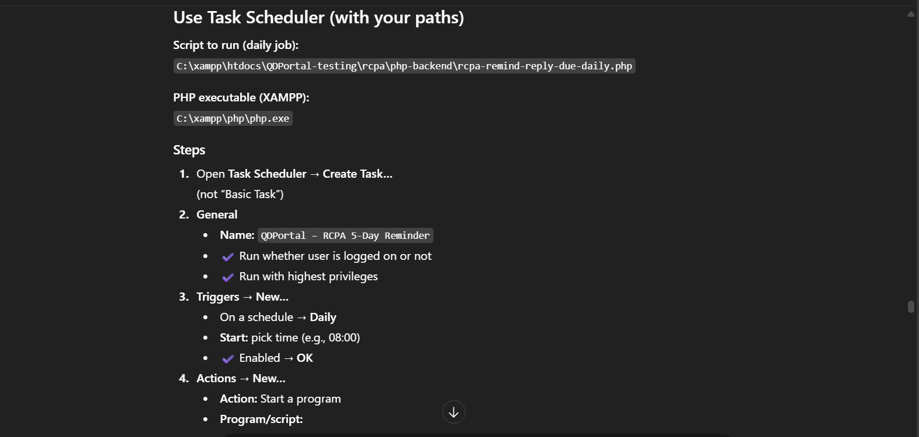

Program/script:  
C:\xampp\php\php.exe  
  
Add arguments:  
-f "C:\xampp\htdocs\QDPortal-testing\rcpa\php-backend\rcpa-remind-reply-due-daily.php"  
  
Start in (optional but good):  
C:\xampp\htdocs\QDPortal-testing\rcpa\php-backend  
  
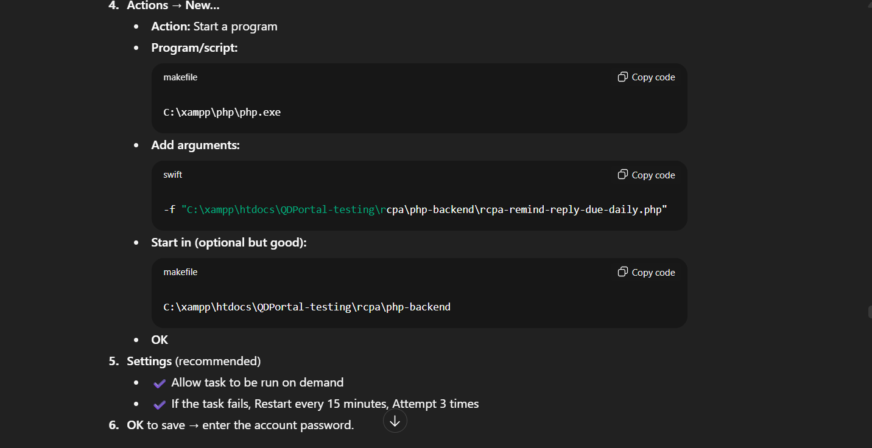

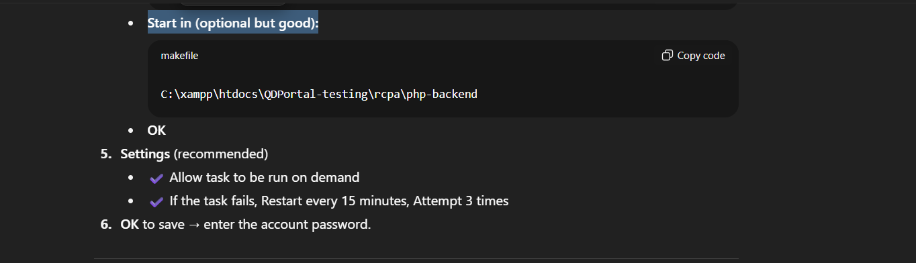

**TEST:**  
UPDATE rcpa_request

SET reply_due_date = CURDATE() + INTERVAL 5 DAY

WHERE id = 22;  
  
**RUN CMD:**  
"C:\xampp\php\php.exe" -f "C:\xampp\htdocs\QDPortal-testing\rcpa\php-backend\rcpa-remind-reply-due-daily.php"  
  
CHECK:  
SELECT * FROM rcpa_request_history

WHERE rcpa_no = 22 AND activity = 'Reminder: Reply due in 5 days'

ORDER BY date_time DESC;

**RE-TEST:  
step 1:**UPDATE rcpa_request

SET reply_due_date = CURDATE() + INTERVAL 3 DAY,

status = 'ASSIGNEE PENDING'

WHERE id = 22; -- your test id  
  
**step2:**  
DELETE FROM rcpa_request_history

WHERE rcpa_no = 22

AND activity IN ('Reminder: Reply due in 5 days',

'Reminder: Reply due in 3 days',

'Reminder: Reply due in 1 day')

AND DATE(date_time) = CURDATE();  
  
**step 3:**  
"C:\xampp\php\php.exe" -f "C:\xampp\htdocs\QDPortal-testing\rcpa\php-backend\rcpa-remind-reply-due-daily.php"

closing - every week email:

CREATE ALSO A TASK SCHEDULER FOR CLOSING:

Program/script:  
C:\xampp\php\php.exe  
  
Add arguments:  
-f "C:\xampp\htdocs\QDPortal-testing\rcpa\php-backend\rcpa-remind-close-due-daily.php"  
  
Start in (optional but good):  
C:\xampp\htdocs\QDPortal-testing\rcpa\php-backend

**TEST:  
step 1:**  
UPDATE rcpa_request

SET close_due_date = CURDATE() + INTERVAL 7 DAY

WHERE id = 22; -- Your test record ID

**step2:**  
DELETE FROM rcpa_request_history

WHERE rcpa_no = 22

AND activity IN ('Reminder: Close due in 7 days')

AND DATE(date_time) = CURDATE();  
  
  
**step 2:**  
"C:\xampp\php\php.exe" -f "C:\xampp\htdocs\QDPortal-testing\rcpa\php-backend\rcpa-remind-close-due-daily.php"

assignee approval - dapat hindi na ma approve ng lahat ng manager only in the assignee- done

send and receive -qms and assignee email - done

blinking after request - done

notif sidebar -

rootcause automatic - data - done

target date - required - date completed - not required - done

30 days closing in corrective action - done

approve remarks - assignee super/manag – KAY INVALIDATION REPLY APPROVAL DON LANG MERON KASI AYUN ACCEPT KAY SIR SANDY

QMS TASKS AND QMS APPROVAL HIDE FOR ASSIGNEE - done

required attachment corrective evidence - done

adding history if the qms changed the std - done

action done checkbox remove - done

evidence checking - originator - removed - done

follow up - only qms can see

grade downloadable - pdf or excel

showing data in grade

assignee - originator - required attachment

kapag ssd prod - ssd prod lang ang makakakita assignee hindi lahaht ng ssd

ERROR ENCOUNTER:

must have a attachment 'FOR CLOSING' fix the message it looked error

valid - having error not identified

nakikita ung valid field Kahit walang data in dashboard - done