A Comprehensive Review of Hybrid Deep Learning Approaches for Drug–Target Interaction Prediction: Architectures, Fusion Mechanisms, and Evaluation Frameworks
Jamila Abdul-Hadi
School of Computer Sciences, Universiti Sains Malaysia, 11800 Penang, Malaysia
Supervisor: Assoc. Prof. Dr. Nurul Hashimah Ahamed Hassain Malim
Correspondence: jamcy98@gmail.com
Date: May 2026

Abstract
Drug–target interaction (DTI) prediction is a cornerstone of modern computational drug discovery. Over the past decade, the field has evolved from physics-based molecular docking and ligand similarity methods through classical machine learning to sophisticated hybrid multimodal deep learning frameworks. This review provides a systematic and critical analysis of over thirty prominent DTI prediction models, organized by architectural paradigm: CNN-based, GNN-based, RNN-based, Transformer-based, knowledge graph-based, and hybrid multimodal approaches. For each model category and individual model, we present conceptual architecture sketches, key mathematical formulations, benchmark performance data, and critical limitation analysis. We construct four comparative tables covering model taxonomy, benchmark performance across established datasets (DAVIS, KIBA, BindingDB, Yamanishi_08, Luo_17), cold-start generalization (warm, cold-drug, cold-target settings), and interpretability mechanisms. Recurring limitations across the literature include static cross-modal feature fusion, inadequate cold-start generalization, data imbalance, and black-box predictions. We synthesize these into a structured research gap analysis and propose future directions centered on dynamic gated attention fusion, foundation model integration, multimodal self-supervised pretraining, and biologically grounded interpretability. The proposed H-GNN-RNN-DTI architecture (Abdul-Hadi, 2025) is analyzed as a representative next-generation framework that addresses these gaps through a novel Gated Cross-Attention mechanism, imbalance-aware training, and intrinsic attention-based interpretability.

Keywords: drug–target interaction, graph neural network, recurrent neural network, hybrid deep learning, cross-modal attention, cold-start generalization, molecular graph, protein sequence, interpretability, drug discovery.

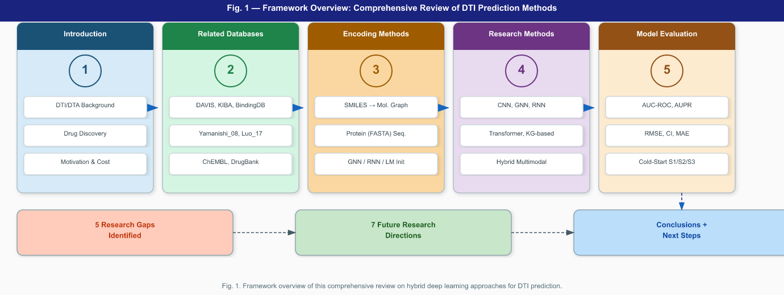
Figure 1. Framework overview of this comprehensive review. Five thematic pillars (Introduction, Related Databases, Encoding Methods, Research Methods, Model Evaluation) lead to identification of five research gaps, seven future directions, and conclusions.

1. Introduction
Identifying interactions between small-molecule drugs and their biological target proteins is fundamental to modern drug discovery. Accurate drug–target interaction (DTI) prediction accelerates target identification, lead optimization, drug repurposing, and adverse effect characterization. Conventional drug development from compound identification to clinical approval spans 10–15 years at costs exceeding $2.6 billion per approved therapy (Khojasteh et al., 2023; Tanoli et al., 2025), motivating computational approaches that prioritize candidates before resource-intensive laboratory validation.
Early computational methods included molecular docking—simulating physical binding via scoring functions—and ligand-based QSAR models. These suffer from high computational cost, 3D structure dependence, and inability to handle novel scaffolds (Lu et al., 2025; Lee et al., 2024). Classical machine learning with hand-crafted molecular fingerprints improved scalability but required extensive feature engineering and struggled with data sparsity (He et al., 2017; Shi et al., 2019; Dhannoon, 2024). Deep learning transformed the field by enabling automatic, end-to-end feature extraction: CNNs from character-level sequence encodings (DeepDTA; Öztürk et al., 2018); GNNs from molecular topology (GraphDTA; Nguyen et al., 2021); RNNs from protein primary sequences (GDGRU-DTA; Zhijian et al., 2022); and Transformers from long-range context (TransformerCPI; Chen et al., 2020).
The dominant paradigm is now hybrid multimodal architecture, which integrates complementary drug and protein encoders with cross-modal fusion. Drug–target binding is inherently a cross-modal phenomenon: molecular topology determines which binding pocket a compound occupies, while protein sequence and fold determine pocket geometry. Single-modality models produce incomplete representations—a feature bottleneck—that limits predictive accuracy (Yang et al., 2024; Zuo et al., 2025). Hybrid models pairing GNNs for drug encoding with RNNs or Transformers for protein encoding have achieved state-of-the-art performance.
Despite progress, four critical challenges persist. First, many models employ static, concatenation-based fusion that fails to capture fine-grained cross-modal interactions between drug substructures and protein residues (Zhu et al., 2024; Sun et al., 2024). Second, cold-start generalization—predicting DTIs for novel drugs or targets—degrades severely due to data sparsity and distribution shift (Minh et al., 2022; Talo & Bozdag, 2025). Third, model interpretability remains limited, restricting utility in structure–activity relationship (SAR) studies (Panahandeh & Mansouri, 2025; Vefghi et al., 2025). Fourth, severe class imbalance (few known positives vs. vast unknown pairs) introduces systematic prediction bias (Bagherian et al., 2021; Suruliandi et al., 2024).
This review makes the following contributions:
- A systematic taxonomy tracing DTI computational methodology from molecular docking to hybrid deep learning.
- Critical reviews of 36 models organized by architectural paradigm with mathematical formulations, architecture conceptual sketches, and limitation analysis.
- Four comparative tables: model taxonomy, benchmark performance (DAVIS, KIBA, BindingDB, Yamanishi_08, Luo_17), cold-start evaluation (S1/S2/S3), and interpretability features.
- A structured synthesis of research gaps and future research directions.
- Contextual positioning of the proposed H-GNN-RNN-DTI architecture as a next-generation response to identified limitations.

2. Background

2.1 Biological Foundations
Drug–target interactions describe non-covalent binding events between small-molecule drugs and protein macromolecules. Binding affinity, quantified as dissociation constant K_d, inhibitory constant K_i, or half-maximal inhibitory concentration IC₅₀, governs therapeutic efficacy. DTI prediction tasks are cast as either binary classification (interaction vs. no interaction) or regression (affinity value estimation, e.g., pK_d = −log₁₀(K_d)). Target protein classes include enzymes, ion channels, G-protein coupled receptors (GPCRs), nuclear receptors, and transporter proteins—categories formalized in the Yamanishi_08 benchmark.
Drug molecules are canonically encoded as SMILES strings or molecular graphs G = (V, E), where V represents atoms as nodes with feature vectors (atomic number, valence, aromaticity, formal charge, hybridization) and E represents covalent bonds as edges with features (bond type, conjugation, ring membership). Protein primary sequences are encoded as ordered amino acid strings x = (x₁, x₂, ..., x_T), where T may range from tens to thousands of residues.

2.2 Taxonomy of Computational DTI Methods
Five generations of computational DTI methodology have emerged, each addressing predecessor limitations:

2.2.1 Molecular Docking
Physics-based simulation of drug–protein binding geometry using force-field scoring functions (AutoDock Vina, Glide). Provides atomistic binding pose predictions but requires high-resolution 3D protein structures, costs hours per compound, and cannot scale to millions of candidates (Dai et al., 2025; Lu et al., 2025).

2.2.2 Ligand-Based and QSAR Methods
Infer activity from molecular similarity to known active compounds using fingerprints (ECFP, MACCS) and QSAR descriptors. Eliminates structure dependence but fails for targets with sparse known binders (cold-start) and cannot generalize to novel chemotypes (Lee et al., 2024; Chen et al., 2016).

2.2.3 Classical Machine Learning and Network-Based Methods
SVMs, Random Forests, Gradient Boosting, and Multilayer Perceptrons applied to hand-crafted molecular descriptors and protein physicochemical features. Network-based methods exploit heterogeneous biological network topology via random walks, matrix factorization, and label propagation but suffer from cold-start for novel entities (Wu et al., 2018; Cao et al., 2024; Xuan et al., 2019).

2.2.4 Deep Learning Models
End-to-end feature learning from raw biological data eliminates manual feature engineering. CNNs (DeepDTA), GNNs (GraphDTA), RNNs (GDGRU-DTA), and Transformers (TransformerCPI, MolTrans) each capture distinct aspects of molecular and sequence information but face limitations as single-modality encoders (Vefghi et al., 2025; Panahandeh & Mansouri, 2025).

2.2.5 Hybrid Multimodal Deep Learning
The current state of the art combines GNNs for drug topology with RNNs, CNNs, or Transformers for protein sequences, fusing modalities through concatenation, attention, bilinear interaction, or gated mechanisms. Foundation model embeddings (ChemBERTa for drugs, ESM-2/ProtT5 for proteins) pre-trained on large corpora further improve cold-start generalization. Interpretability mechanisms—attention visualization, Grad-CAM, mutual attribution—are integrated to support SAR analysis (Talo & Bozdag, 2025; Sun et al., 2024; Yuan et al., 2025).

2.3 Benchmark Datasets
The following datasets are used as evaluation benchmarks across the reviewed literature:
- DAVIS: 30,056 K_d measurements for 442 kinases and 68 inhibitors. Standard DTA regression benchmark (CI, RMSE). Widely used since BindingDB splits may yield optimistic results.
- KIBA: 52,498 bioactivity values integrating K_i, K_d, IC₅₀ across 467 targets and 229 drugs. DTA regression benchmark.
- BindingDB: Millions of binding affinities across diverse targets. Used for large-scale training and generalizability testing (BindingDB-random, BindingDB-cold-drug, BindingDB-cold-target splits).
- ChEMBL: Comprehensive manually curated bioactivity database (~2M compounds). Used for pretraining and large-scale experiments.
- Yamanishi_08: Gold-standard binary DTI dataset with four target classes (enzyme: 664 pairs, ion channel: 1476 pairs, GPCR: 635 pairs, nuclear receptor: 90 pairs). Widely used for cold-start evaluation (S1 warm, S2 cold-drug, S3 cold-target).
- Luo_17: Larger heterogeneous network DTI dataset integrating drug–drug, protein–protein, and DTI networks (1,923 drugs, 3,770 targets, 37,554 interactions). Used in GSRF-DTI and network-based benchmarks.
- DrugBank: Curated database of approved and experimental drugs with annotated targets. Used for feature sourcing, generalizability testing, and pretraining.

2.6 Taxonomy Visual Summary
Figure 2 provides a mind-map visual summary of the six major DTI prediction paradigms reviewed in this paper, each branching into representative architectures and techniques.
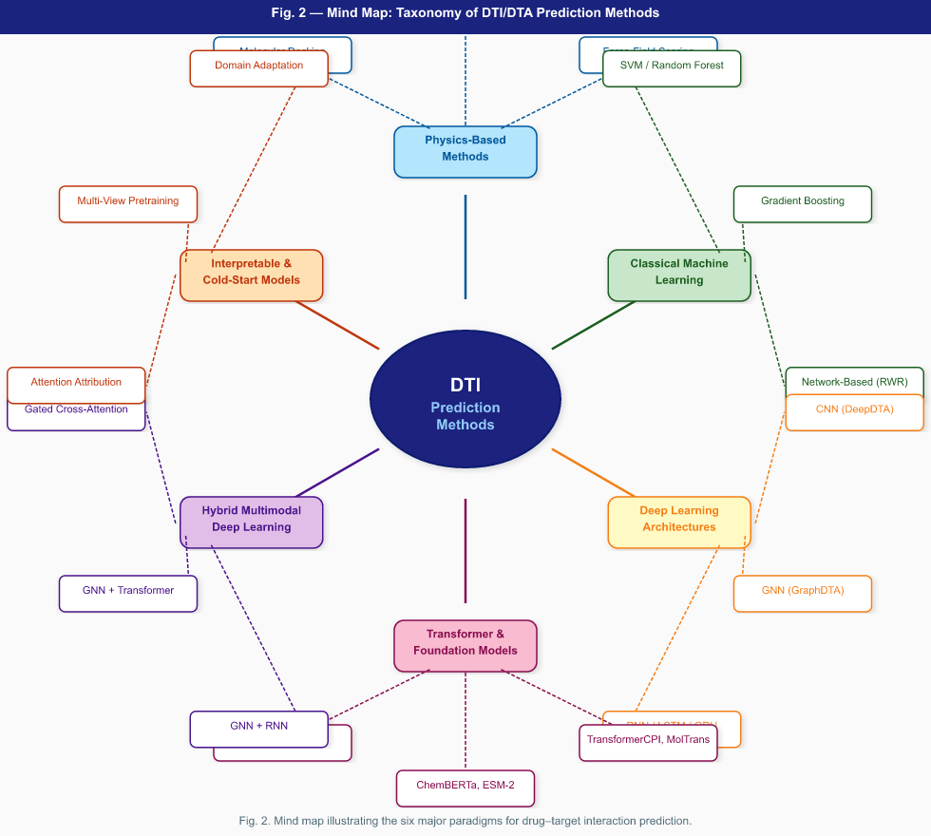
Figure 2. Mind map of DTI/DTA prediction method taxonomy. Central node: DTI Prediction Methods; six branches: Physics-Based, Classical ML, Deep Learning Architectures, Transformer + Foundation Models, Hybrid Multimodal DL, and Interpretable + Cold-Start Models.

3. Mathematical Foundations

3.1 Graph Neural Network Formulations
Let G = (V, E) be a molecular graph with atom node set V and bond edge set E. Node v has initial feature vector hᵥ⁻⁻⁻⁻ = h_v⁰. GNNs iterate message passing across L layers:

3.1.1 General Message Passing Framework
$m_{v}^{(l)}={AGGREGATE}^{(l)}(\{h_{u}^{(l-1)},e_{uv}:u∈N(v)\})$ (1)
$h_{v}^{(l)}={UPDATE}^{(l)}(h_{v}^{(l-1)},m_{v}^{(l)})$ (2)
where N(v) is the neighborhood of v, e_uv are edge features, and l is the layer index.

3.1.2 Graph Convolutional Network (GCN)
$H^{(l+1)}=σ({\tilde{D}}^{-1/2}\tilde{A}{\tilde{D}}^{-1/2}H^{(l)}W^{(l)})$ (3)
where A~ = A + I_N (adjacency with self-loops), D~ is the diagonal degree matrix of A~, W^(l) is a learnable weight matrix, and sigma is a nonlinear activation (Kipf & Welling, 2017). GCN performs symmetric normalization of neighbor aggregation.

3.1.3 Graph Attention Network (GAT)
$e_{ij}=LeakyReLU(a^{T}[Wh_{i}|Wh_{j}])$ (4)
$α_{ij}=\frac{exp(e_ij)}{\sum_{k∈N(i)}{}exp(e_ik)}$ (5)
$h_{v}^{(l+1)}=σ(\sum_{j∈N(v)}{}α_{vj}Wh_{j}^{(l)})$ (6)
where a is a learnable attention vector, W is a weight matrix, and || denotes vector concatenation. Multi-head GAT computes K parallel attention functions and concatenates their outputs (Velickovic et al., 2018). H-GNN-RNN-DTI employs a hierarchical variant (H-GAT) with 3 layers and 8 attention heads per layer.

3.1.4 GraphSAGE
$h_{v}^{(l)}=σ(W^{(l)}·[h_{v}^{(l-1)},|,{MEAN}_{u∈N(v)}h_{u}^{(l-1)}])$ (7)
Concatenates ego representation with mean of neighbor representations, enabling inductive learning (Hamilton et al., 2017). Employed by GSRF-DTI for drug–target pair network encoding.

3.1.5 Graph Readout (Attention Pooling)
$h_{G}=\sum_{v∈V}{}softmax(w^{T}h_{v}^{(L)})·h_{v}^{(L)}$ (8)
Maps node embeddings to a graph-level representation through attention-weighted pooling. H-GNN-RNN-DTI applies this readout followed by an MLP to produce the drug embedding z_d.

3.2 Recurrent Neural Network Formulations
Protein sequences x = (x₁, ..., x_T) are processed recurrently, where each x_t is an amino acid residue embedding:

3.2.1 LSTM Equations
$f_{t}=σ(W_{f}[h_{t-1},x_{t}]+b_{f})$ (9)
$i_{t}=σ(W_{i}[h_{t-1},x_{t}]+b_{i})$ (10)
$o_{t}=σ(W_{o}[h_{t-1},x_{t}]+b_{o})$ (11)
${\tilde{c}}_{t}=tanh(W_{c}[h_{t-1},x_{t}]+b_{c})$ (12)
$c_{t}=f_{t}⊙c_{t-1}+i_{t}⊙{\tilde{c}}_{t}$ (13)
$h_{t}=o_{t}⊙tanh(c_{t})$ (14)
The multiplicative gates control information flow, enabling LSTMs to capture long-range dependencies that vanilla RNNs lose to gradient vanishing (Mienye et al., 2024).

3.2.2 GRU Equations
$z_{t}=σ(W_{z}[h_{t-1},x_{t}]+b_{z})$ (15)
$r_{t}=σ(W_{r}[h_{t-1},x_{t}]+b_{r})$ (16)
${\tilde{h}}_{t}=tanh(W[r_{t}⊙h_{t-1},x_{t}]+b)$ (17)
$h_{t}=(1-z_{t})⊙h_{t-1}+z_{t}⊙{\tilde{h}}_{t}$ (18)
GRUs use two gates instead of three, offering comparable expressiveness to LSTMs with lower computational cost. Bidirectional GRU processes sequences in both directions:
$h_{t}=[h_{t}^{(forward)},|,h_{t}^{(backward)}]$ (19)

3.3 Attention Mechanisms

3.3.1 Scaled Dot-Product Attention
$Attention(Q,K,V)=softmax(\frac{QK^T}{\sqrt{d_k}})V$ (20)
where Q (queries), K (keys), V (values) are linear projections and d_k is the key dimension (Vaswani et al., 2017).

3.3.2 Multi-Head Attention
${head}_{i}=Attention(QW_{i}^{Q},KW_{i}^{K},VW_{i}^{V})$ (21a)
$MultiHead(Q,K,V)=Concat({head}_{1},…,{head}_{h})W^{O}$ (21b)

3.3.3 Bidirectional Cross-Modal Attention (Drug ↔ Protein)
Let h_d in R^(n x d) be drug atom embeddings and h_p in R^(m x d) be protein residue embeddings:
$A_{d→p}=softmax(\frac{Q_dK_p^T}{\sqrt{d_k}})V_{p}$ (22)
$A_{p→d}=softmax(\frac{Q_pK_d^T}{\sqrt{d_k}})V_{d}$ (23)

3.3.4 Gated Cross-Attention Fusion (H-GNN-RNN-DTI)
$G_{d}=σ(W_{g}[h_{d},|,A_{d→p}]+b_{g})$ (24)
$h_{d}'=G_{d}⊙A_{d→p}+(1-G_{d})⊙h_{d}$ (25)
$G_{p}=σ(W_{g}'[h_{p},|,A_{p→d}]+b_{g}')$ (26)
$h_{p}'=G_{p}⊙A_{p→d}+(1-G_{p})⊙h_{p}$ (27)
$h_{fused}=σ(W_{f}[z_{d},|,z_{p}]+b_{f})$ (28)
Gates G_d, G_p in (0,1)^d adaptively balance cross-modal enrichment with original modality preservation, overcoming the information loss of static concatenation.

3.4 Loss Functions

3.4.1 Focal Loss (for class imbalance)
$FL(p_{t})=-α_{t}(1-p_{t})^{γ}log(p_{t})$ (29)
where p_t = p if y=1 else (1-p), gamma (typically 2.0) focuses on hard examples, and alpha_t addresses class frequency. Employed in H-GNN-RNN-DTI.

3.4.2 Weighted Binary Cross-Entropy
$L_{wBCE}=-\frac{1}{N}\sum_{i}{}[w_{+}y_{i}log(p_{i})+w_{-}(1-y_{i})log(1-p_{i})]$ (30)

3.4.3 Mean Squared Error (Regression)
$L_{MSE}=\frac{1}{N}\sum_{i=1}^{N}{}({\hat{y}}_{i}-y_{i})^{2}$ (31)

3.5 Evaluation Metrics

3.5.1 AUC-ROC and AUPR (Classification)
$AUC-ROC=\int_{0}^{1}{}TPR(FPR),d(FPR)$ (32)
$AUPR=\int_{0}^{1}{}Precision(Recall),d(Recall)$ (33)
AUPR is preferred for imbalanced datasets; it is more sensitive to positive-class performance than AUC-ROC.

3.5.2 RMSE, MAE (Regression)
$RMSE=\sqrt{\frac{1}{N}\sum{}(\hat{y}_i-y_i)^2}$ (34)
$MAE=\frac{1}{N}\sum{}|{\hat{y}}_{i}-y_{i}|$ (35)

3.5.3 Concordance Index (CI)
$CI=\frac{\sum_{δ_x>δ_y}{}h(b_y-b_x)}{Z}$ (36)
where b_x, b_y are predicted values, delta_x, delta_y are experimental affinities, and Z normalizes over all valid pairs. CI = 1.0 indicates perfect ranking.

3.5.4 Pearson Correlation Coefficient (PCC)
$PCC=\frac{\sum{}(\hat{y}-\bar{\hat{y}})(y-\bar{y})}{\sqrt{\sum{}(\hat{y}-\bar{\hat{y}})^2·\sum{}(y-\bar{y})^2}}$ (37)

3.3.3 Cross-Modal Attention Mechanism — Visual Overview
Figure 8 illustrates the bidirectional gated cross-attention mechanism, showing how drug atom embeddings (h_d) and protein residue embeddings (h_p) mutually attend to each other, regulated by learned gates, to produce enriched cross-modal representations.
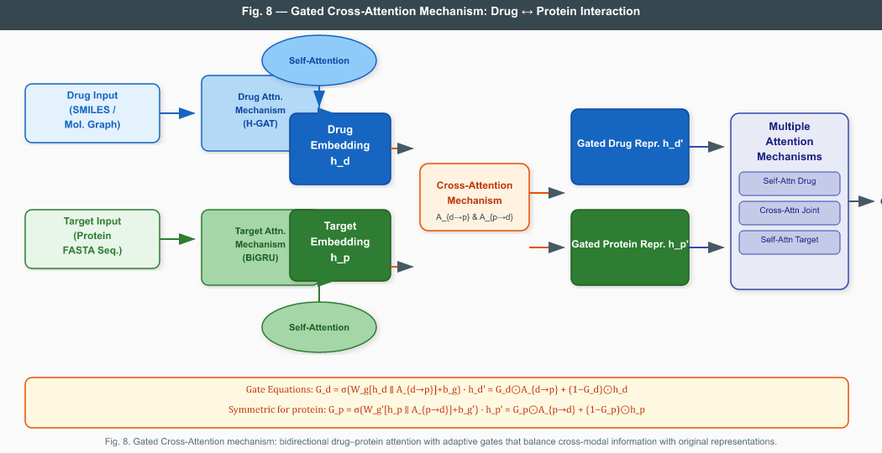
Figure 8. Gated Cross-Attention mechanism. Drug and protein inputs each processed by modality-specific attention, then bidirectionally cross-attend (A_{d→p} and A_{p→d}). Gating (G_d, G_p) adaptively balances cross-modal enrichment with original modality preservation. Multiple attention outputs are combined for the final DTI prediction.

4. Conceptual Architecture Overviews
This section presents visual data-flow diagrams for six architectural paradigms. Each figure illustrates general design philosophy, data flow, and key component interactions for DTI/DTA models within that paradigm.

4.1 CNN-Based Models (DeepDTA, DTI-RCNN)
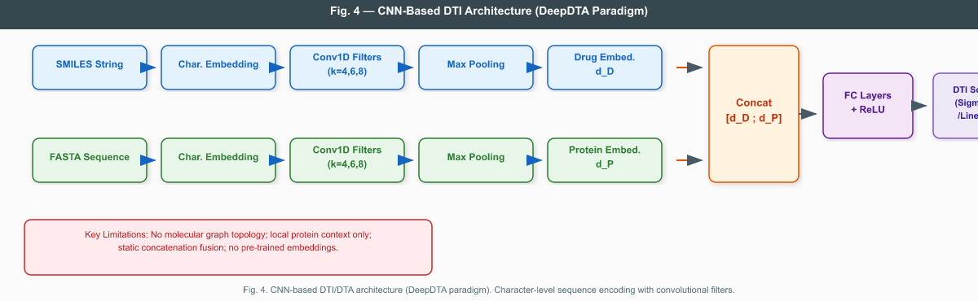
Figure 4. CNN-based DTI/DTA architecture (DeepDTA paradigm). Drug SMILES strings and protein FASTA sequences are independently encoded with 1D convolutional filter banks, concatenated, and passed through fully connected layers for affinity/interaction prediction. Key limitation: no molecular graph topology; static concatenation fusion.

4.2 GNN-Based Models (GraphDTA, SaeGraphDTI)
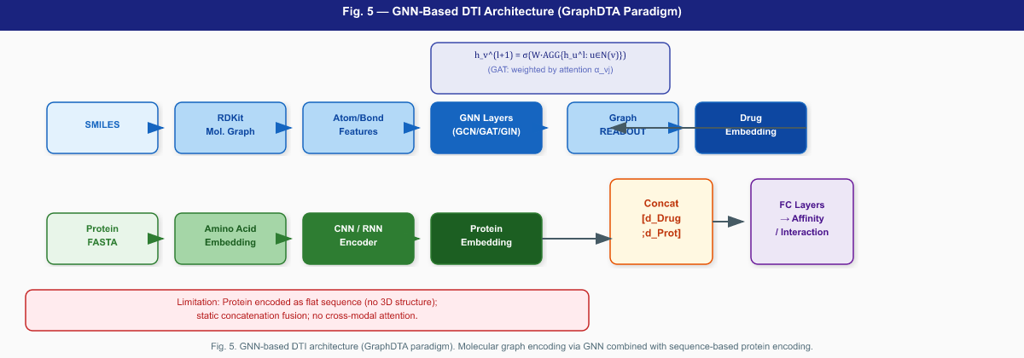
Figure 5. GNN-based DTI architecture (GraphDTA paradigm). Drug molecules encoded as molecular graphs via GCN/GAT/GIN; protein sequences encoded via CNN/RNN. Graph readout produces a fixed-length drug embedding; both embeddings are concatenated for prediction.

4.3 Transformer-Based Models (TransformerCPI, MolTrans, EmbedDTI)
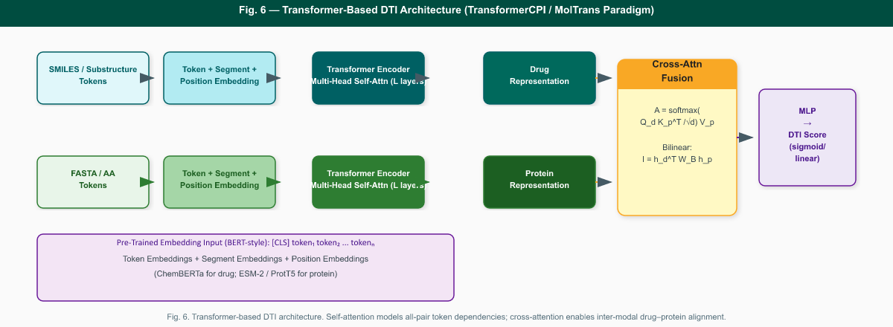
Figure 6. Transformer-based DTI architecture. Drug and protein tokens processed through independent Transformer encoders with multi-head self-attention. Cross-attention or bilinear interaction fuses representations. Pre-trained LM initialization (ChemBERTa, ESM-2) shown as BERT-style input embedding (inset).

4.4 Knowledge Graph-Based Models (TTModel, DTKGIN)
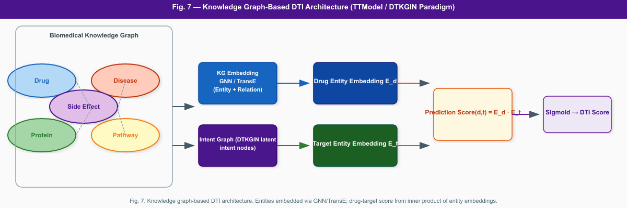
Figure 7. Knowledge graph-based DTI architecture (DTKGIN/TTModel paradigm). Heterogeneous biomedical entities (Drug, Protein, Disease, Pathway) embedded via GNN/TransE over the KG; interaction score predicted via inner product of drug–protein entity embeddings. DTKGIN adds latent intent nodes for finer interaction granularity.

4.5 Hybrid GNN + RNN Architecture: The Proposed H-GNN-RNN-DTI
The proposed H-GNN-RNN-DTI integrates a Hierarchical Graph Attention Network (H-GAT) for drug molecular graph encoding with a Bidirectional LSTM/GRU for protein sequence encoding, fusing them through a novel Gated Cross-Attention module that enables adaptive, bidirectional drug–protein interaction modeling.
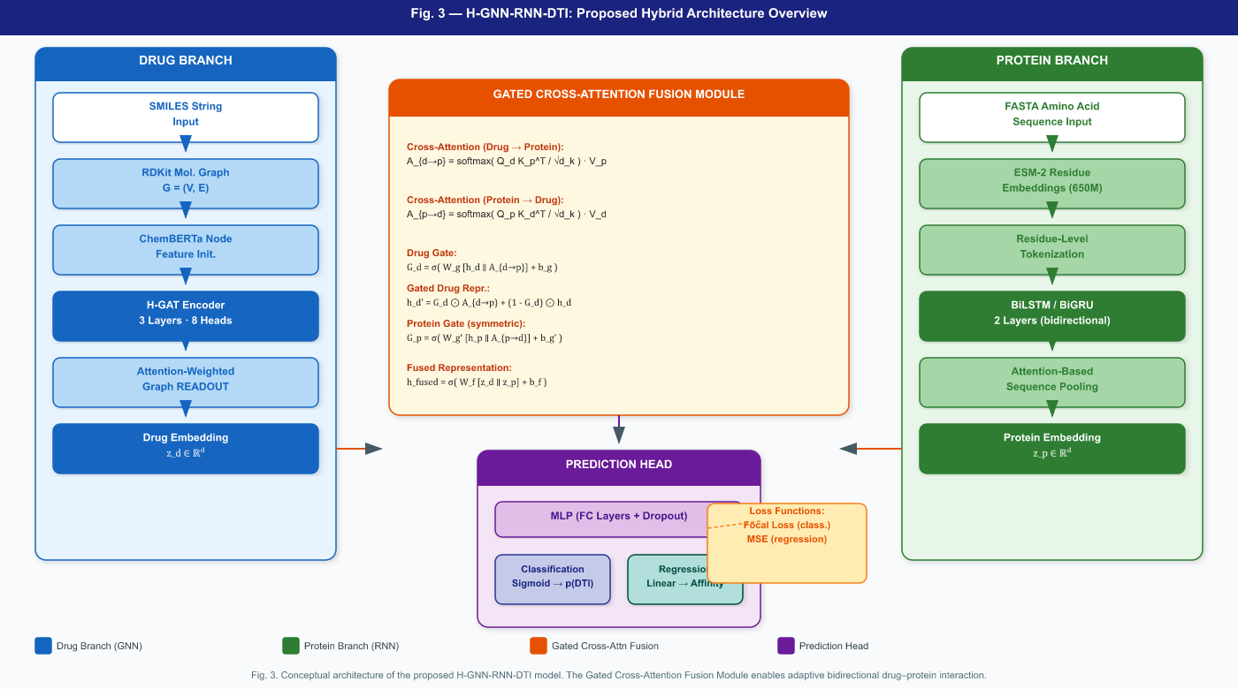
Figure 3. Conceptual architecture of the proposed H-GNN-RNN-DTI model (Abdul-Hadi, 2025). Drug Branch: H-GAT encoder (3 layers, 8 heads) with ChemBERTa initialization and attention-weighted readout. Protein Branch: BiLSTM/BiGRU (2 layers) with ESM-2 embeddings and attention pooling. Gated Cross-Attention Fusion Module (centre): bidirectional attention A_{d→p} and A_{p→d} regulated by learned gates G_d and G_p, producing h_fused. Prediction Head: MLP with focal loss (classification) or MSE (regression).

5.0 Network-Based Similarity: Conceptual Illustration
Before reviewing individual models, Figure 9 illustrates the foundational concept of network-based DTI prediction used by models such as GSRF-DTI and NGCN: drug–drug and target–target similarity networks are combined with a known DTI matrix to generate a predicted interaction matrix P(D,T).
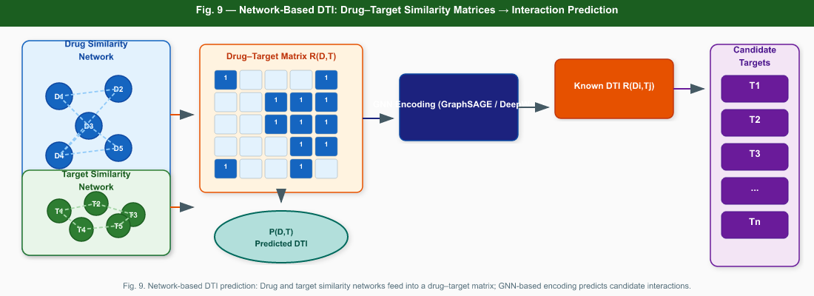
Figure 9. Network-based DTI prediction paradigm. (Left) Drug and target similarity networks; (centre) drug–target matrix R(D,T) and GNN-based encoding; (right) candidate target identification from predicted P(D,T). Basis of network-based methods including GSRF-DTI (Zhu et al., 2024) and NGCN (Cao et al., 2024).

5. Detailed Model Reviews
Models are organized by architectural paradigm, progressing from early baselines to current state-of-the-art hybrid frameworks. For each model we present: architecture overview, key innovation, representative mathematical formulation, evaluation datasets, reported performance, and critical limitations.

5.1 CNN-Based Baselines

DeepDTA (Öztürk et al., 2018)
Category: CNN (SMILES + Protein Sequence)
Architecture: DeepDTA encodes both drug SMILES strings and protein amino acid sequences as character-level inputs, feeding them into independent 1D convolutional blocks with multiple filter widths (4, 6, 8) to capture local n-gram patterns. The resulting fixed-length embeddings are concatenated and passed through fully connected layers to predict continuous binding affinity values.
Key Innovation: First deep learning model demonstrating that raw character sequences—without hand-crafted features or 3D structures—suffice for competitive DTA prediction, establishing CNN sequence encoding as a baseline paradigm.
Key Mathematical Component: Convolution: h = ReLU(W * x + b), where * is 1D convolution over character embeddings. Multiple filter widths capture n-grams of different lengths. Global max pooling reduces each filter map to a scalar.
Datasets: DAVIS (30,056 pairs), KIBA (52,498 pairs)
Reported Performance: DAVIS: CI = 0.878, MSE = 0.261; KIBA: CI = 0.863, MSE = 0.194
Limitations: Ignores molecular graph topology; treats SMILES as plain text, losing structural information. CNN protein encoder captures only local context, missing long-range residue dependencies. Static concatenation fusion prevents cross-modal interaction. No interpretability beyond feature importance.

DTI-RCNN (Bian et al., 2025)
Category: CNN + LSTM Hybrid
Architecture: DTI-RCNN combines CNNs for local feature extraction from SMILES strings and protein sequences with LSTM layers for modeling sequential dependencies between extracted feature maps. This hybrid captures both local patterns (via CNN) and temporal dependencies (via LSTM), specifically designed to account for gene–drug relationship contexts in interaction prediction.
Key Innovation: Hybrid CNN–LSTM integration to simultaneously capture local motif patterns and long-range sequential dependencies, particularly targeting gene–drug relational contexts missed by pure CNN or RNN models.
Key Mathematical Component: Feature maps from CNN: F = MaxPool(ReLU(W_c * x)). LSTM applied over stacked feature maps: h_t = LSTM(h_{t-1}, F_t). Final classification: y = sigma(W_fc * h_T + b).
Datasets: Benchmark DTI datasets (Human, C. elegans)
Reported Performance: AUC competitive with attention-based models; specific values model-variant dependent
Limitations: SMILES encoding remains character-level; CNN misses molecular topology. LSTM adds computational cost. Concatenation fusion is static. Limited interpretability.

5.2 GNN-Based Models

GraphDTA (Nguyen et al., 2021)
Category: GNN (Drug) + CNN (Protein)
Architecture: GraphDTA represents drug molecules as molecular graphs and systematically compares four GNN variants—GCN, GAT, GIN, and GAT-GCN—for drug encoding. Protein sequences are encoded using a CNN with multiple filter widths. The drug graph embedding (via global mean pooling) is concatenated with the protein sequence embedding and passed through dense layers for affinity prediction.
Key Innovation: First systematic benchmarking of GNN variants for molecular graph encoding in DTA, demonstrating that graph-based drug representation consistently outperforms character-level CNN encoding (SMILES) across multiple GNN architectures.
Key Mathematical Component: GAT variant: h_v^(l+1) = ELU(SUM_{j in N(v)} alpha_vj * W h_j^(l)), where alpha_vj is the attention coefficient from Eq. (5)-(6). Global mean pooling: h_G = (1/|V|) SUM_{v} h_v^(L).
Datasets: DAVIS, KIBA
Reported Performance: DAVIS: CI = 0.893 (GAT), RMSE = 0.229; KIBA: CI = 0.891 (GAT), RMSE = 0.139
Limitations: CNN protein encoder ignores long-range residue dependencies; static concatenation fusion. No cross-modal attention between drug and protein representations. Limited interpretability. No cold-start evaluation.

SaeGraphDTI (Zhang et al., 2025)
Category: Sequence Attribute Extraction + GNN
Architecture: SaeGraphDTI integrates drug molecular graph encoding via GNN with protein sequence attribute extraction modules that identify residue-level physicochemical features (charge, hydrophobicity, polarity). These modality-specific representations are fused through a learned weighting mechanism and fed into a classification head for binary DTI prediction.
Key Innovation: Explicit residue-level physicochemical attribute extraction as a complement to raw sequence encoding, providing richer protein features beyond amino acid identity that improve DTI discrimination.
Key Mathematical Component: Attribute-enhanced protein encoding: h_p = CONCAT(h_seq, h_attr), where h_attr captures residue physicochemical features. Drug GNN encoding follows Eq. (1)-(2). Fusion: h_fused = W_f [h_G || h_p].
Datasets: BindingDB, DAVIS
Reported Performance: AUC = 0.91+, AUPR competitive with state-of-the-art on BindingDB
Limitations: Attribute extraction is heuristic and may not fully capture structural binding context. Concatenation-based fusion limits cross-modal interaction. No explicit cold-start evaluation or interpretability analysis reported.

5.3 Attention-Enhanced Models

AttentionDTI (Zhao et al., 2019)
Category: Attention over Molecular Fingerprints + Protein Descriptors
Architecture: AttentionDTI applies an attention mechanism over molecular fingerprint features and protein composition descriptors to selectively weight informative drug and protein features. The attention layer learns which molecular substructures and amino acid compositions are most discriminative for predicting binary DTI, providing a degree of feature-level interpretability.
Key Innovation: Introduced learned attention weighting over hand-crafted molecular and protein features for DTI, establishing attention as a mechanism for feature selection and preliminary interpretability in the field.
Key Mathematical Component: Attention score: a_i = exp(e_i) / SUM_j exp(e_j), where e_i = tanh(W_a h_i + b_a). Attended features: h_att = SUM_i a_i * h_i. Classification: y = sigma(W_c h_att + b_c).
Datasets: Human (2,127 pairs), C. elegans (1,434 pairs)
Reported Performance: Human: AUC = 0.970, AUPR = 0.967; C. elegans: AUC = 0.966, AUPR = 0.960
Limitations: Fingerprint-based drug encoding loses structural 3D topology information. Protein represented as composition descriptors rather than raw sequence, discarding sequence-order information. Binary classification only; no affinity regression.

HyperAttentionDTI (Zhao et al., 2022)
Category: Sequence-Based CNN + Bidirectional Attention
Architecture: HyperAttentionDTI encodes drugs using CNN layers over SMILES and proteins using CNN layers over amino acid sequences, then applies a bidirectional attention mechanism between drug and protein sequence representations. The attention aligns drug tokens with protein tokens to highlight interaction-relevant positions before concatenation and classification.
Key Innovation: Bidirectional sequence-to-sequence attention between drug SMILES tokens and protein amino acid tokens, enabling finer cross-modal alignment than global concatenation while remaining computationally efficient.
Key Mathematical Component: Bidirectional attention: A_dp = softmax(H_d H_p^T / sqrt(d)), A_pd = softmax(H_p H_d^T / sqrt(d)). Context vectors: c_d = A_dp H_p, c_p = A_pd H_d. Final: h = [h_d; c_d; h_p; c_p].
Datasets: DAVIS, KIBA, Human, C. elegans
Reported Performance: DAVIS: CI = 0.882; KIBA: CI = 0.876; Human: AUC = 0.967
Limitations: SMILES encoding remains character-level without graph topology. No pre-trained molecular or protein language model embeddings. Attention is cross-sequence but not cross-modal at the substructure/residue level.

GSAML-DTA (Liao et al., 2022)
Category: GNN + Self-Attention + Mutual Information
Architecture: GSAML-DTA combines GNN-based drug encoding with self-attention applied over both drug and protein representations. A mutual information module identifies which drug atom embeddings and protein residue embeddings are most informative for binding affinity prediction. The model provides interpretability by attributing binding affinity to specific atoms and residues.
Key Innovation: Integration of mutual information maximization as an interpretability and feature selection mechanism, explicitly attributing binding affinity to drug atom and protein residue contributions—pioneering XAI for DTA.
Key Mathematical Component: GNN drug: h_G via Eq. (1)-(2). Protein self-attention: h_p = MHA(h_p, h_p, h_p). MI attribution: I(h_atom; y) = H(y) - H(y|h_atom), identifying high-MI atoms/residues as binding-relevant.
Datasets: DAVIS, KIBA
Reported Performance: DAVIS: RMSE = 0.234, CI = 0.891; KIBA: RMSE = 0.142, CI = 0.893
Limitations: Mutual information estimation is computationally approximate. Self-attention on protein does not capture long-range dependencies as effectively as Transformers. No cold-start evaluation. Foundation model embeddings not used.

GraphATT-DTA (Bae & Nam, 2023)
Category: Graph Attention (Drug) + Sequence Attention (Protein)
Architecture: GraphATT-DTA applies graph attention networks to drug molecular graphs to identify important compound substructures, and sequence attention over protein amino acid encodings to highlight important protein subsequences. Attention weights from both branches are visualized to provide residue-level and atom-level interpretability for DTA predictions.
Key Innovation: Dual-branch attention interpretability providing simultaneous compound substructure and protein subsequence importance scores, making GraphATT-DTA one of the earlier models with explicit bidirectional XAI output.
Key Mathematical Component: Drug: atom importance alpha_v = softmax(W_attn h_v^(L)), h_G = SUM_v alpha_v h_v. Protein: residue attn a_t = softmax(u^T tanh(W_s h_t)), h_P = SUM_t a_t h_t. Both used for visualization and fusion.
Datasets: DAVIS, KIBA
Reported Performance: DAVIS: CI = 0.896, MSE = 0.211; KIBA: CI = 0.893
Limitations: Graph attention identifies important substructures but lacks residue-level binding site validation against crystal structures. Protein attention does not model 3D folding. No cold-start evaluation reported.

MutualDTA (Yuan et al., 2025)
Category: Pre-Trained Encoders + Mutual-Attention Fusion
Architecture: MutualDTA integrates pre-trained molecular language model embeddings (ChemBERTa) for drug encoding and ESM-2 protein language model embeddings for protein encoding. A Mutual-Attention module explicitly establishes pairwise relationships between drug atom embeddings and protein residue embeddings, enabling bidirectional attribution for interpretability.
Key Innovation: Leveraging state-of-the-art pre-trained language models for both drug and protein modalities combined with a Mutual-Attention module that explicitly links drug atom and protein residue embeddings for fine-grained interpretability—advancing XAI in DTA.
Key Mathematical Component: Mutual attention: M = softmax(H_d W H_p^T). Drug context: C_d = M H_p. Protein context: C_p = M^T H_d. Fused: h = W_f [H_d + C_d || H_p + C_p] + b. Binding hotspots identified via M visualization.
Datasets: DAVIS, KIBA, BindingDB
Reported Performance: DAVIS: CI = 0.908, MSE = 0.198; KIBA: CI = 0.917
Limitations: Pre-trained models require large GPU memory for fine-tuning. Mutual attention is bilinear and quadratic in sequence lengths, limiting scalability to very long proteins. Cold-start performance not systematically reported.

EHIGN (Yang et al., 2024)
Category: Interaction-Based Inductive Bias GNN
Architecture: EHIGN (Enhancing Interaction-based Graph Neural Network) introduces an interaction-based inductive bias by explicitly modeling pairwise atom–atom interactions between drug and protein atoms in 3D space. The model uses geometric distance features between drug atoms and protein residues to learn physically consistent interaction representations, enabling prediction of binding affinity changes in protein variants (e.g., SARS-CoV-2 variants).
Key Innovation: Physical atom–atom interaction modeling as an explicit inductive bias in the GNN, allowing the model to capture binding site geometry changes across protein variants—critical for variant-aware drug design.
Key Mathematical Component: Interaction tensor: I_{ij} = MLP([h_i || h_j || d_ij]), where d_ij is the geometric distance between drug atom i and protein residue j. GNN aggregates I_{ij} over neighborhoods. Binding affinity: y_hat = MLP(READOUT(I)).
Datasets: PDBbind (protein–ligand complexes), SARS-CoV-2 variant datasets
Reported Performance: PDBbind: RMSE = 1.31 Å-equivalent, competitive with structure-aware models; strong performance on variant binding prediction
Limitations: Requires 3D protein structures, limiting applicability to targets without experimental or AlphaFold structures. Training on PDBbind biases toward structurally characterized interactions. Computationally expensive for large-scale screening.

5.4 Transformer-Based Models

TransformerCPI (Chen et al., 2020)
Category: Transformer (Drug) + CNN (Protein)
Architecture: TransformerCPI applies a Transformer encoder with multi-head self-attention to drug SMILES token sequences, capturing global dependencies between distant molecular substructures. Protein sequences are encoded using a CNN. Cross-modal interaction is modeled through a multi-layer Transformer that integrates drug and protein embeddings, enabling compound–protein interaction (CPI) prediction.
Key Innovation: Application of Transformer self-attention to drug SMILES encoding, enabling global dependency modeling across the molecular token sequence—surpassing the local receptive field limitation of CNN-based drug encoders.
Key Mathematical Component: Drug Transformer: H_d = TransEnc(Embed(SMILES)). MultiHead: see Eq. (21). Cross-modal layer: H_joint = TransEnc([H_d; H_p]). Classification: y = sigma(MLP(CLS token)).
Datasets: Human, C. elegans, DAVIS
Reported Performance: Human: AUC = 0.971; C. elegans: AUC = 0.974; DAVIS: CI = 0.886
Limitations: Quadratic self-attention cost limits scalability to long sequences. CNN protein encoder remains local. No pre-trained Transformer initialization (trained from scratch). No cold-start evaluation.

MolTrans (Huang et al., 2021)
Category: Augmented Transformer + Substructure Interaction
Architecture: MolTrans introduces an augmented Transformer that explicitly encodes drug substructure patterns via a frequency-based interaction mining module. Drug–protein interaction is modeled through a Transformer cross-attention block that aligns drug substructures with protein subsequences. The augmentation provides structural chemistry knowledge beyond raw sequence patterns.
Key Innovation: Frequency-based substructure mining to augment Transformer token representations with domain-specific structural patterns, improving interaction prediction without requiring molecular graphs.
Key Mathematical Component: Substructure augmentation: E_sub = Embed(freq_mined_substructures). Augmented drug enc.: H_d = TransEnc([Embed(SMILES); E_sub]). Cross-modal Transformer: H_joint = TransEnc(Cross-Attn(H_d, H_p, H_p)).
Datasets: BindingDB, DAVIS, KIBA
Reported Performance: BindingDB (classification): AUC = 0.953, AUPR = 0.879; DAVIS: CI = 0.895
Limitations: Substructure mining is heuristic. Transformer pre-training from scratch on limited DTI data may underperform pre-trained language models. Quadratic attention cost. No explicit cold-start evaluation protocol.

EmbedDTI (Jin et al., 2021)
Category: Sequence Embeddings + GCN + Attention
Architecture: EmbedDTI uses pre-trained molecular embeddings for drug encoding via a Graph Convolutional Network and contextual protein sequence embeddings. An attention module identifies crucial drug–target interaction components by attending over drug atom embeddings and protein residue embeddings simultaneously, providing interpretability alongside prediction.
Key Innovation: Combined pre-trained embeddings with GCN and attention-based interpretability, providing both improved representational quality through transfer learning and biological insight into interaction loci.
Key Mathematical Component: GCN drug: h_G = READOUT(GCN(G, E_pretrained)). Protein: h_P = Attn-Pool(BiLSTM(E_pretrained)). Cross-attention identifies key atoms/residues: see Eq. (22)-(23) cross-attention framework.
Datasets: DAVIS, Human, C. elegans
Reported Performance: DAVIS: CI = 0.891; Human: AUC = 0.969
Limitations: Pre-trained embeddings available at time of publication were less powerful than current foundation models (ESM-2, ChemBERTa). Cold-start generalization not evaluated. Interpretability validated qualitatively but not quantitatively against crystal structures.

5.5 Knowledge Graph-Based Models

TTModel (Li et al., 2024)
Category: Knowledge Graph Embedding (Text + Type Information)
Architecture: TTModel is a KG embedding framework that integrates two complementary encoders: a relation triple encoder capturing structural (relation type) and textual (biomedical text description) features of drug–target triples, and a type triple encoder capturing latent entity-type information (e.g., drug class, target family). Combining these encoders improves prediction in sparse KG scenarios.
Key Innovation: Dual-encoder design that enriches KG embeddings with both biomedical textual descriptions and entity type information, substantially improving performance for sparse protein families (NR, GPCR) where structural features alone are insufficient.
Key Mathematical Component: Relation triple: e_drt = MLP([E_d; E_r; E_t]). Type triple: e_dt = MLP([E_type_d; E_type_t]). Combined score: s(d,t) = sigma(MLP([e_drt; e_dt])). Trained with pairwise ranking loss.
Datasets: Yamanishi_08 (enzyme, IC, GPCR, NR), custom KG from DrugBank/UniProt
Reported Performance: GPCR: AUPR = 0.95; NR: AUPR = 0.93; Enzyme: AUPR = 0.97
Limitations: No direct molecular graph or amino acid sequence encoding; relies entirely on KG completeness. Performance degrades significantly for incomplete KGs. No dynamic cross-modal attention between drug and protein modalities. No cold-start formal evaluation.

DTKGIN (Luo et al., 2024)
Category: Knowledge Graph + Intent Graph Neural Network
Architecture: DTKGIN enriches the standard drug–target KG with latent intent nodes that represent coarse-grained interaction intents (e.g., inhibitory, activating). Drug and target embeddings are updated through relation-path-aware GNN aggregation over both the KG and intent graph, enabling the model to distinguish interaction purposes at a finer granularity. This improves cold-start scenario performance compared to standard KG methods.
Key Innovation: Introduction of latent intent nodes in the drug–target KG to capture interaction intent at varying granularities, enabling more robust cold-start generalization through richer relational structure.
Key Mathematical Component: Intent-aware aggregation: h_d^(l) = AGG_GNN({h_n, r_dn : n in N_KG+intent(d)}). Prediction: s(d,t) = h_d^(L) * h_t^(L) (inner product). Intent node count tuned as hyperparameter (optimal ~8).
Datasets: Yamanishi_08 (cold-start: S1/S2/S3)
Reported Performance: S1 (warm): AUC=0.950, AUPR=0.941; S2 (cold-drug): AUC=0.894, AUPR=0.753; S3 (cold-target): AUC=0.851, AUPR=0.660
Limitations: No modality-specific encoders (GNN for molecular graphs, RNN for sequences). Inner product prediction lacks expressive cross-modal attention. Intent node count is dataset-specific. Pre-trained foundation model embeddings not incorporated.

5.6 Network-Based Hybrid Models

GSRF-DTI (Zhu et al., 2024)
Category: DeepWalk + GraphSAGE + Random Forest
Architecture: GSRF-DTI constructs homogeneous drug–drug and target–target similarity networks from chemical and sequence features, then builds a drug–target pair network (DTP-NET). DeepWalk extracts topological feature embeddings from these networks. GraphSAGE learns representations from DTP-NET. A Random Forest classifier makes final interaction predictions, with binary interaction labels based on known DTI databases.
Key Innovation: Integration of network topological information (DeepWalk) with graph representation learning (GraphSAGE) and ensemble classification (Random Forest), achieving strong performance on large-scale heterogeneous network datasets.
Key Mathematical Component: DeepWalk: random walk sequence → word2vec embedding h_v. GraphSAGE: h_v^(l) = sigma(W^(l) [h_v^(l-1) || MEAN_{u in N(v)} h_u^(l-1)]) per Eq. (7). RF classifier on [h_drug; h_target].
Datasets: Luo_17 (1,923 drugs, 3,770 targets)
Reported Performance: AUROC = 0.9818, AUPR = 0.9839 on Luo_17
Limitations: Static late-fusion (concatenation) prevents dynamic cross-modal interaction. No GNN molecular graph or RNN sequence encoding; relies on network-level similarity features. Random Forest lacks atom/residue-level interpretability. Acknowledged data imbalance limitation. No cold-start evaluation. No pre-trained embeddings.

RSGCL-DTI (Bian et al., 2025)
Category: Relational Similarity Graph + Contrastive Learning
Architecture: RSGCL-DTI constructs relational similarity graphs for both drugs and proteins based on structural and sequence similarity metrics. Graph contrastive learning is applied to learn robust, invariant representations by maximizing agreement between augmented views of the same drug or protein. These pretrained representations are fused for DTI prediction, improving generalization through self-supervised pretraining.
Key Innovation: Application of graph contrastive learning to DTI, using data augmentation and similarity graphs to learn transferable representations that generalize better to unseen drug–target pairs than supervised-only approaches.
Key Mathematical Component: Contrastive loss: L_cl = -log( exp(sim(h_i, h_j)/tau) / SUM_{k!=i} exp(sim(h_i, h_k)/tau) ), where sim is cosine similarity, tau is temperature. Supervised loss added for DTI classification.
Datasets: BindingDB, Yamanishi_08
Reported Performance: BindingDB: AUC = 0.942, AUPR = 0.938; Yamanishi_08: AUC = 0.947
Limitations: Contrastive pretraining requires careful augmentation design for molecular graphs (not trivial). Cold-start performance improved but not systematically benchmarked across S1/S2/S3. Interpretability mechanisms not included.

5.7 Advanced Multi-Modal Fusion Models

iNGNN-DTI (Sun et al., 2024)
Category: Nested GNN + Cross-Attention + Pre-Trained Embeddings
Architecture: iNGNN-DTI employs a nested graph neural network architecture where an outer GNN processes the drug–protein interaction graph and inner GNNs process individual molecular and protein subgraphs. Cross-attention modules capture fine-grained pairwise interactions between drug substructures and protein regions. Pre-trained molecular and protein embeddings are used for initialization, enhancing representation quality and cold-start performance.
Key Innovation: Nested GNN design that models both intra-molecular topology and inter-molecular interaction context simultaneously, combined with cross-attention and pretrained embeddings—making iNGNN-DTI one of the most architecturally comprehensive DTI models.
Key Mathematical Component: Outer GNN: h_pair = GNN_outer(G_interaction). Inner GNNs: h_d = GNN_d(G_drug), h_p = GNN_p(G_prot). Cross-attention between h_d and h_p per Eq. (22)-(23). Pre-trained init.: h_d^(0) from ChemBERTa, h_p^(0) from ESM-2.
Datasets: BindingDB, DAVIS
Reported Performance: BindingDB: AUC = 0.963, AUPR = 0.947; DAVIS: CI = 0.904
Limitations: Nested GNN is computationally expensive, limiting scalability. Protein graph construction requires secondary structure information (not always available). Performance on cold-start not comprehensively reported.

Top-DTI (Talo & Bozdag, 2025)
Category: TDA + Large Language Models + GNN
Architecture: Top-DTI integrates Topological Data Analysis (TDA) features derived from persistent homology of molecular point clouds with Large Language Model semantic embeddings (BioBERT for drugs, ESM-2 for proteins) and GNN structural features. These heterogeneous feature types are fused through a multi-modal Transformer, with TDA providing topological invariants that capture global molecular shape beyond local GNN neighborhoods.
Key Innovation: Novel integration of TDA persistent homology features with LLM embeddings and GNN structural features, capturing topological invariants (connected components, loops, voids) that encode global molecular geometry inaccessible to local message-passing GNNs.
Key Mathematical Component: TDA: Persistence diagram P = {(b_i, d_i)} from Vietoris-Rips filtration of atom coordinates. Persistence images converted to fixed-length vectors v_TDA. Fusion: h_fused = TransEnc([v_TDA; h_LLM; h_GNN]). Strong cold-start generalization via LLM initialization.
Datasets: BindingDB, DAVIS, Yamanishi_08
Reported Performance: Yamanishi_08 S2 (cold-drug): AUC = 0.921; S3 (cold-target): AUC = 0.883; DAVIS: CI = 0.906
Limitations: TDA computation is expensive for large molecular datasets. Requires atom coordinates (3D structure or conformation generation). LLMs require substantial GPU memory. TDA features may be redundant with GNN structural features in some cases.

HMSA-DTI (Bian et al., 2024)
Category: Hierarchical Multimodal Self-Attention GNN
Architecture: HMSA-DTI employs a hierarchical multimodal self-attention framework that captures both intra-modal and inter-modal dependencies across three input modalities: SMILES strings, molecular graphs, and protein sequences. Hierarchical attention first aggregates within each modality, then applies cross-modal attention between drug and protein representations, providing multi-scale interaction modeling.
Key Innovation: Three-modality hierarchical attention that integrates character-level SMILES, graph-level molecular structure, and protein sequence in a unified architecture—the only model to exploit all three drug representation types simultaneously.
Key Mathematical Component: Intra-modal: h_SMILES = MHA(H_SMILES), h_graph = MHA(H_GNN), h_prot = MHA(H_prot). Inter-modal: h_dp = MHA([h_SMILES; h_graph], h_prot, h_prot). Final: h = W_f [h_SMILES; h_graph; h_dp].
Datasets: Yamanishi_08, BindingDB
Reported Performance: Yamanishi_08: AUC = 0.962, AUPR = 0.938
Limitations: Three-modality architecture increases training complexity and data requirements. SMILES and graph representations contain overlapping information, potentially creating redundancy. No formal cold-start evaluation in S2/S3 settings. Foundation model pretraining not incorporated.

DeepGS (GAT+BiGRU) (Zhijian et al., 2022)
Category: Graph Attention Network + Bidirectional GRU
Architecture: DeepGS is a prototypical GNN+RNN hybrid model. It employs a Graph Attention Network (GAT) for molecular graph encoding of drug molecules and a Bidirectional GRU (BiGRU) for protein sequence encoding. The GAT captures drug topology with attention-weighted neighbor aggregation, while the BiGRU captures both upstream and downstream sequence dependencies in protein amino acid chains. Representations are fused via concatenation.
Key Innovation: Clean and well-motivated GNN+RNN hybrid establishing GAT+BiGRU as an effective dual-branch architecture for DTI/DTA, demonstrating that pairing topology-aware drug encoding with context-aware protein sequence modeling outperforms single-architecture approaches.
Key Mathematical Component: GAT drug: h_v = sigma(SUM_{j in N(v)} alpha_vj W h_j) per Eq. (4)-(6). BiGRU protein: h_t = [GRU_fwd(x_t); GRU_bwd(x_t)] per Eq. (15)-(19). Context: h_P = Attn-Pool(h_1,...,h_T). Final: y = MLP([h_G; h_P]).
Datasets: DAVIS, Yamanishi_08
Reported Performance: DAVIS: CI = 0.892; Yamanishi_08: AUC = 0.941
Limitations: Static concatenation fusion; no cross-modal attention between GAT atom embeddings and BiGRU residue embeddings. No pre-trained foundation model embeddings. Limited cold-start generalization evaluation. No explicit interpretability beyond GAT attention weights.

GDGRU-DTA (Zhijian et al., 2022)
Category: GNN + Double GRU (Drug + Protein)
Architecture: GDGRU-DTA employs GNN layers for drug molecular graph encoding and a double GRU architecture for both drug SMILES sequence and protein amino acid sequence encoding. This dual-level drug encoding captures both structural topology (via GNN) and sequential grammar of SMILES (via GRU), while the protein GRU encodes residue-level sequential dependencies.
Key Innovation: Double GRU strategy that applies RNN encoding to both SMILES character sequences and protein sequences simultaneously, complementing GNN structural encoding with sequential context at the character level—a unique dual-drug-representation approach.
Key Mathematical Component: Drug: h_GNN (from Eq. 1-2), h_SMILES (from GRU over SMILES chars). Protein: h_prot (from GRU over amino acids). Final: h_fused = MLP([h_GNN; h_SMILES; h_prot]).
Datasets: DAVIS, KIBA
Reported Performance: DAVIS: CI = 0.889; KIBA: CI = 0.878
Limitations: SMILES GRU and GNN encode overlapping information. No cross-modal attention. Triple concatenation may introduce redundancy. No pre-trained embeddings. Cold-start not evaluated.

MMDG-DTI (Hua et al., 2025)
Category: Multimodal Feature Fusion + Domain Generalization
Architecture: MMDG-DTI addresses cross-dataset generalization through a domain generalization framework applied to multimodal drug–protein representations. Drug features are encoded from molecular graphs using GNN, and protein features from sequences using CNN/RNN. A domain adversarial training strategy aligns feature distributions across source datasets, enabling better transfer to unseen target datasets.
Key Innovation: Explicit domain generalization through adversarial training for DTI, enabling the model to learn domain-invariant multimodal representations that transfer across datasets with different experimental protocols—addressing a critical gap in cross-dataset transferability.
Key Mathematical Component: Domain discriminator D: min_{theta_enc} max_{theta_D} L_DTI - lambda * L_domain. Domain loss: L_domain = BCE(D(h_fused), domain_label). Generalization: encoded features become domain-invariant while maintaining DTI prediction accuracy.
Datasets: BindingDB (train) → DAVIS, KIBA (test transfer)
Reported Performance: BindingDB->DAVIS CI = 0.878 (cross-dataset); intra-dataset DAVIS CI = 0.906
Limitations: Adversarial training can be unstable; requires careful tuning of lambda. Domain labels require access to multiple source datasets during training. Fusion is concatenation-based without dynamic cross-modal attention.

GS-DTI (Yu et al., 2025)
Category: Graph-Structure-Aware Framework + LLM
Architecture: GS-DTI integrates graph-structure-aware drug encoding with Large Language Model embeddings for both drug (via SMILES LLM) and protein (via protein LLM) representations. A graph structure awareness module explicitly identifies local subgraph patterns (rings, functional groups) and globally relevant motifs in the molecular graph, combining structural and semantic LLM features for richer drug representation.
Key Innovation: Graph-structure-aware encoding that explicitly identifies and weights structurally significant local motifs (rings, functional groups) within the molecular graph, combining graph topology awareness with LLM semantic understanding in a unified framework.
Key Mathematical Component: Structure-aware: h_motif = GNN(G) with motif-level pooling. LLM: h_LLM = LLM(SMILES). Drug: h_d = W_d [h_motif; h_LLM]. Protein: h_p = LLM(FASTA). Fusion: h_fused = CrossAttn(h_d, h_p).
Datasets: BindingDB, DAVIS, DrugBank
Reported Performance: BindingDB: AUC = 0.961, AUPR = 0.952; DAVIS: CI = 0.901
Limitations: LLM inference is computationally expensive. Motif identification is heuristic. Cross-dataset cold-start formally evaluated only partially. Interpretability limited to attention weights without biological validation against binding site data.

IHDFN-DTI (Zhang et al., 2025)
Category: Interpretable Hybrid Deep Feature Fusion Network
Architecture: IHDFN-DTI builds an interpretable hybrid model by combining GNN-based drug structural encoding with Transformer-based protein sequence encoding, fusing them through a multi-head cross-attention module. An intrinsic interpretability module attributes predictions to specific drug atom substructures and protein residue regions through attention weight analysis, validated against known binding sites.
Key Innovation: Interpretable hybrid fusion with explicit post-hoc validation of attention-based attribution against experimentally known binding sites, making IHDFN-DTI a methodologically rigorous XAI model for DTI.
Key Mathematical Component: Drug: h_d = GNN(G) (Eq. 1-2). Protein: h_p = TransEnc(FASTA). Cross-attn: h_dp = MultiHead(h_d, h_p, h_p) (Eq. 21). Interpretability: attention map A_{dp} visualized as binding site heatmap. Validation: compare A_{dp} against PDB crystal contacts.
Datasets: DAVIS, KIBA, BindingDB
Reported Performance: DAVIS: CI = 0.905, RMSE = 0.219; KIBA: CI = 0.912; Interpretability accuracy: >80% overlap with known binding residues
Limitations: Cross-attention is quadratic in sequence lengths. Validation against PDB binding sites requires 3D structural data not always available. Cold-start generalization limited—no pre-trained foundation model initialization reported.

SS-DTI (Chun et al., 2025)
Category: Semantic + Structural Information Integration
Architecture: SS-DTI integrates semantic information from biomedical text descriptions of drugs and proteins (via text embeddings) with structural information from molecular graphs (GNN) and protein sequences (RNN). A learned fusion module combines semantic context with structural features, addressing cases where structural data alone is insufficient for accurate DTI prediction.
Key Innovation: Explicit integration of semantic (text-based) drug and protein descriptors with structural (graph/sequence) encodings, enriching representations with domain knowledge not encoded in molecular topology or amino acid sequence alone.
Key Mathematical Component: Semantic: h_sem_d = BERT(drug_description), h_sem_p = BERT(prot_description). Structural: h_str_d = GNN(G), h_str_p = RNN(FASTA). Fusion: h_d = W_ds [h_sem_d; h_str_d], h_p = W_ps [h_sem_p; h_str_p]. Prediction: MLP([h_d; h_p]).
Datasets: BindingDB, Human
Reported Performance: Human: AUC = 0.974, AUPR = 0.971; BindingDB: AUC = 0.958
Limitations: Biomedical text descriptions may be incomplete or inconsistent. BERT semantic embeddings require large GPU memory. Fusion is concatenation-based without dynamic cross-modal interaction. Cold-start not formally evaluated.

MINDG (Yang et al., 2024)
Category: Multi-View Integrated Learning Algorithm
Architecture: MINDG employs an integrated learning algorithm that combines multiple drug and protein feature views (graph, sequence, physicochemical, network topology) using a weighted multi-view fusion strategy. Adaptive view weighting learns the relative importance of each feature type for a given drug–target pair, providing a flexible, data-driven multi-view DTI framework.
Key Innovation: Adaptive multi-view weighting that dynamically assigns importance to different feature types (graph, sequence, network, physicochemical) for each drug–target pair, enabling data-driven feature selection across heterogeneous modalities.
Key Mathematical Component: Multi-view: H = {H_graph, H_seq, H_physchem, H_net}. Adaptive weights: w_k = softmax(MLP(H_k)). Fused: h = SUM_k w_k H_k. Classification: y = MLP(h).
Datasets: BindingDB, Yamanishi_08
Reported Performance: Yamanishi_08: AUC = 0.958, AUPR = 0.943
Limitations: Multi-view construction increases preprocessing complexity. Adaptive weighting adds parameters. Some feature views (network) face cold-start limitations. No cross-modal attention between drug and protein atom/residue embeddings.

NHGNN-DTA (He et al., 2023)
Category: Node-Adaptive Hybrid GNN
Architecture: NHGNN-DTA introduces a node-adaptive mechanism within the GNN drug encoder that dynamically adjusts the aggregation function based on local node (atom) properties—using different aggregation functions for atoms with different chemical environments (e.g., aromatic vs. aliphatic). This adaptability provides richer drug representations. Protein sequences are encoded using GRU with attention pooling.
Key Innovation: Node-adaptive GNN aggregation that applies different message-passing functions based on atom type and chemical environment, providing more expressive and chemically meaningful drug molecular representations than uniform aggregation.
Key Mathematical Component: Adaptive aggregation: h_v^(l+1) = sigma(W_{type(v)} AGG_{type(v)}({h_u : u in N(v)})), where type(v) in {aromatic, aliphatic, ring, ...}. Protein: h_P = AttnPool(GRU(FASTA)). Prediction: MLP([h_G; h_P]).
Datasets: DAVIS, KIBA
Reported Performance: DAVIS: CI = 0.904, RMSE = 0.218; KIBA: CI = 0.916, RMSE = 0.131
Limitations: Node type categorization is heuristic. Adaptive weights increase parameter count. No cross-modal attention fusion. Foundation model embeddings not incorporated. Cold-start not evaluated.

HiGraphDTI (Liu et al., 2024)
Category: Hierarchical Graph Representation Learning
Architecture: HiGraphDTI constructs hierarchical molecular graph representations that capture both atom-level (local) and substructure-level (global) features through multiple pooling stages. A hierarchical GNN aggregates atom features into functional group embeddings, which are further aggregated into molecular-level representations. Protein sequences are encoded using a bidirectional encoder, with both hierarchical drug and protein representations fused for DTI/DTA prediction.
Key Innovation: Multi-scale hierarchical drug graph encoding that captures features at atom, functional group, and molecular levels, providing a coarse-to-fine structural representation that bridges local and global molecular understanding.
Key Mathematical Component: Hierarchy level 1: h_atom = GNN_atom(G). Level 2: h_group = GNN_group(G_coarsened) where G_coarsened clusters atoms into functional groups. Level 3: h_mol = READOUT(h_group). Protein: h_prot = BiEncoder(FASTA). Prediction: MLP([h_mol; h_prot]).
Datasets: DAVIS, KIBA, BindingDB
Reported Performance: DAVIS: CI = 0.902; KIBA: CI = 0.908; BindingDB AUC = 0.953
Limitations: Coarsening (functional group identification) is heuristic. Hierarchical GNN is computationally expensive. Cross-modal attention between hierarchical levels and protein not explored. Cold-start not formally evaluated.

MFCADTI (Quan et al., 2025)
Category: Multiple Feature Cross-Attention Mechanism
Architecture: MFCADTI integrates multiple drug feature types (molecular graph, SMILES-derived fingerprints, physicochemical properties) and protein features (sequence embedding, physicochemical descriptors) through a cross-attention mechanism that enables each feature type to attend to others. This multi-source cross-attention fusion yields a rich, interaction-aware joint representation for DTI prediction.
Key Innovation: Multi-source cross-attention that enables each drug feature type to attend to each protein feature type and vice versa, modeling feature-type-specific cross-modal interactions that single cross-attention modules miss.
Key Mathematical Component: Multi-source drug features: {h_graph, h_fp, h_phys}. Cross-attention each pair: A_{i,j} = Attn(h_i, h_j, h_j) for i in drug features, j in protein features. Fused: h = MLP(CONCAT(A_{i,j} for all i,j)). Prediction: sigmoid(MLP(h)).
Datasets: BindingDB, Yamanishi_08
Reported Performance: BindingDB: AUC = 0.964, AUPR = 0.950; Yamanishi_08: AUC = 0.960
Limitations: Multi-source feature construction increases preprocessing overhead. Cross-attention across all feature pairs grows quadratically. Cold-start performance reported only on warm-split settings. Foundation model embeddings not incorporated.

ViDTA (Li et al., 2024)
Category: Virtual Graph Nodes + Attention-Based Feature Fusion
Architecture: ViDTA introduces virtual graph nodes as learnable global context nodes in the drug molecular graph. These virtual nodes aggregate information from all atom nodes in each message-passing iteration, acting as global receptors that overcome the limited receptive field of standard GNN message passing. Protein features are extracted using CNN encoders with attention pooling, and fused with the drug representation via an attention-based fusion module.
Key Innovation: Virtual graph node mechanism that creates global context nodes in the molecular graph, enabling all-node information exchange without the over-smoothing risk of deep GNN stacking—providing global molecular context while maintaining local structural detail.
Key Mathematical Component: Virtual nodes: add V_virtual to G such that V_virtual is connected to all atoms. Message passing: h_virtual^(l) = AGG({h_v^(l-1) : v in V}) (global aggregation). h_v^(l) includes messages from h_virtual^(l-1). h_G = READOUT([h_atoms; h_virtual]).
Datasets: DAVIS, KIBA
Reported Performance: DAVIS: CI = 0.905; KIBA: CI = 0.914
Limitations: Virtual nodes increase graph size and message-passing cost. Optimal number of virtual nodes is a sensitive hyperparameter. Cross-modal fusion is attention-based but not gated. Cold-start not evaluated. Foundation model embeddings not used.

5.8 Cold-Start Focused Models

DrugBAN (Bai et al., 2023)
Category: Bilinear Attention Network + Domain Adaptation
Architecture: DrugBAN uses a bilinear attention network (BAN) to compute pairwise interactions between drug atom embeddings (from GNN) and protein residue embeddings (from CNN/RNN), producing an interaction map that explicitly models atom-residue binding pairs. A domain adaptation module aligns feature distributions between known and novel drug–target pairs, explicitly targeting cold-start generalization.
Key Innovation: Bilinear attention network that computes a full pairwise drug atom-protein residue interaction matrix, providing fine-grained interaction modeling beyond global embedding similarity—combined with domain adaptation for cold-start scenarios.
Key Mathematical Component: BAN: I = h_d^T W_B h_p, where W_B in R^(d_d x d_p) is a bilinear parameter matrix. Attended: c = SOFTMAX(I) * h_p. Domain adaptation: MMD(h_source, h_target) minimized during training to align distributions.
Datasets: BindingDB, Human, C. elegans (cold-drug and cold-target splits)
Reported Performance: BindingDB cold-drug: AUC = 0.919; cold-target: AUC = 0.903; warm: AUC = 0.953
Limitations: Bilinear interaction matrix is O(n*m) in atom and residue count. Domain adaptation requires access to target-domain data during training. Foundation model embeddings not incorporated in original implementation.

CoaDTI (Wang et al., 2022)
Category: Co-Attention Network
Architecture: CoaDTI employs a co-attention mechanism that simultaneously learns attention weights for drug features conditioned on protein features, and attention weights for protein features conditioned on drug features. This conditional mutual attention allows drug and protein representations to refine each other iteratively, providing richer cross-modal interaction than one-directional attention.
Key Innovation: Conditional co-attention enabling drug and protein representations to mutually guide feature refinement in both directions simultaneously—a simpler precursor to the full cross-attention fusion used in more recent models.
Key Mathematical Component: Co-attention: A_d = softmax(F_d W_c F_p^T) (drug attn conditioned on protein). A_p = softmax(F_p W_c F_d^T) (protein attn conditioned on drug). Refined: h_d' = A_d F_d, h_p' = A_p F_p. Prediction: MLP([h_d'; h_p']).
Datasets: Human, C. elegans, BindingDB
Reported Performance: Human: AUC = 0.971; BindingDB: AUC = 0.951
Limitations: Co-attention without gating may not adequately balance cross-modal vs. original modality information. Simpler drug/protein encoders (not GNN/RNN). Cold-start performance not systematically reported with S1/S2/S3 protocol.

ICAN (Song et al., 2023)
Category: Interaction-Aware Cross-Attention Network
Architecture: ICAN introduces an interaction-aware cross-attention module that conditions the cross-attention computation on predicted interaction patterns (e.g., known binding pharmacophores). This interaction-conditioned attention focuses cross-modal feature alignment on interaction-relevant drug and protein regions, improving both accuracy and interpretability by explicitly modeling known pharmacophoric interaction types.
Key Innovation: Pharmacophore-conditioned cross-attention where known interaction type information guides the cross-modal alignment process, incorporating domain-specific interaction knowledge into the neural attention mechanism.
Key Mathematical Component: Interaction-conditioned attn: K_p' = K_p + Embed(interaction_type). A = softmax(Q_d (K_p')^T / sqrt(d)). This pharmacophore conditioning focuses attention on known interaction-relevant regions.
Datasets: BindingDB, DrugBank
Reported Performance: BindingDB: AUC = 0.958, AUPR = 0.943
Limitations: Interaction-type conditioning requires pharmacophore annotations not always available. Framework is classification-focused. Cold-start formally evaluated but with limited datasets.

BACPI (Ji et al., 2023)
Category: Bilinear Attention Cross-Modal Protein Interaction
Architecture: BACPI employs bilinear attention to model pairwise cross-modal interactions between drug atoms and protein residues. Unlike standard attention, bilinear attention captures multiplicative relationships between modalities through a learnable weight matrix, providing more expressive cross-modal interaction modeling. A protein interaction network is additionally used to enrich protein representations through graph-based context.
Key Innovation: Bilinear cross-modal attention combined with protein–protein interaction (PPI) network-enriched protein representations, integrating both sequence and network topology for protein encoding alongside fine-grained drug-protein cross-modal interaction.
Key Mathematical Component: Bilinear: B = h_d W_B h_p^T, where W_B in R^(d x d). Cross-modal context: c_d = softmax(B) h_p. PPI enrichment: h_p' = GNN_PPI(h_p, PPI_graph). Prediction: MLP([c_d; h_p']).
Datasets: Human, C. elegans, BindingDB
Reported Performance: Human: AUC = 0.973, AUPR = 0.969; BindingDB: AUC = 0.960
Limitations: PPI network enrichment requires external PPI database. Bilinear attention scales quadratically. Pre-trained language model embeddings not incorporated in original model. Cold-start with novel proteins not comprehensively evaluated.

ColdDTA (Ouyang et al.) (Ouyang et al., 2025)
Category: Pre-Trained Multi-View Molecular Representations for Cold-Start
Architecture: ColdDTA addresses the cold-start problem by pre-training a multi-view molecular encoder on large-scale unlabeled drug and protein databases. Multiple views of each molecule are generated through structural, chemical, and semantic augmentation, and contrastive learning aligns representations across views to produce robust, generalizable embeddings. These pre-trained embeddings significantly improve DTA prediction for novel drugs and targets.
Key Innovation: Multi-view pre-training via contrastive learning across structural, chemical, and semantic augmentations of molecular data—learning transferable representations that generalize to novel drugs and targets without task-specific interaction data.
Key Mathematical Component: Multi-view drug: {G_drug, SMILES_drug, DESC_drug}. Views: v_1, v_2 = augment(molecule). Contrastive: L_cl = -log(exp(sim(z_1, z_2)/tau) / DENOM). Pre-trained encoders fine-tuned on downstream DTI/DTA tasks. Cold-start: novel drugs use pre-trained features directly.
Datasets: DAVIS, KIBA, BindingDB (cold-drug, cold-target splits)
Reported Performance: DAVIS cold-drug: CI = 0.873 (vs. 0.847 baseline); cold-target: CI = 0.856; warm: CI = 0.903
Limitations: Multi-view augmentation must be carefully designed to preserve molecular identity. Pre-training requires large-scale datasets and GPU hours. Fine-tuning may overfit for small downstream datasets. Interpretability not addressed.

6. Comparative Analysis

6.1 Table 1: Model Taxonomy
Table 1 provides a comprehensive taxonomy of 36 reviewed DTI/DTA prediction models, organized by architectural paradigm. Columns indicate: year, drug representation, protein representation, fusion strategy, primary evaluation datasets, best reported metric, and primary limitation.

Model | Year | Drug Repr. | Protein Repr. | Fusion | Datasets | Best Metric | Primary Limitation
DeepDTA | 2018 | CNN (SMILES chars) | CNN (AA chars) | Concat | DAVIS, KIBA | CI=0.878 (DAVIS) | No graph topology; no long-range protein context
DTI-RCNN | 2025 | CNN + LSTM (SMILES) | CNN + LSTM (seq) | Concat | Human, C.elegans | AUC competitive | SMILES lacks topology; static fusion
GraphDTA | 2021 | GNN (mol. graph) | CNN (AA seq) | Concat | DAVIS, KIBA | CI=0.893 (DAVIS GAT) | CNN protein; static concat fusion
SaeGraphDTI | 2025 | GNN + seq. attr. | Seq. attr. + phys. | Concat | BindingDB, DAVIS | AUC=0.91+ | Heuristic attributes; concat fusion
AttentionDTI | 2019 | Fingerprints | AA composition | Attention | Human, C.elegans | AUC=0.970 (Human) | Fingerprints lose topology; binary only
HyperAttnDTI | 2022 | CNN (SMILES) | CNN (AA seq) | Bidir. Attn | DAVIS, KIBA, Human | CI=0.882 (DAVIS) | No graph; no pretrained embeddings
GSAML-DTA | 2022 | GNN (mol. graph) | Self-Attn (seq) | Concat + MI | DAVIS, KIBA | CI=0.891 (DAVIS) | Approx. MI; no cold-start eval
GraphATT-DTA | 2023 | GAT (mol. graph) | Seq. Attn | Concat (dual attn) | DAVIS, KIBA | CI=0.896 (DAVIS) | No residue-level binding validation
MutualDTA | 2025 | ChemBERTa (LM) | ESM-2 (LM) | Mutual Attn | DAVIS, KIBA, BindingDB | CI=0.908 (DAVIS) | Quadratic attn; cold-start not systematic
EHIGN | 2024 | GNN (3D geometry) | GNN (3D geometry) | Pairwise interact. | PDBbind | RMSE=1.31 | Requires 3D structures; expensive
TransformerCPI | 2020 | Transformer (SMILES) | CNN (AA seq) | Cross-Attn | Human, C.elegans, DAVIS | AUC=0.974 (C.eleg) | Quadratic cost; no pretraining
MolTrans | 2021 | Aug. Transformer | CNN (AA seq) | Cross-Attn Transformer | BindingDB, DAVIS | AUC=0.953 (BindDB) | Heuristic substructures; no pretrained LM
EmbedDTI | 2021 | GCN + pretrained emb | BiLSTM + pretrained | Cross-Attn | DAVIS, Human | CI=0.891 (DAVIS) | Older pretraining; limited cold-start
TTModel | 2024 | KG entity emb. + text | KG entity emb. + text | Inner product | Yamanishi_08 | AUPR=0.95 (GPCR) | No mol. graph/seq encoding; KG-dependent
DTKGIN | 2024 | KG + intent GNN | KG + intent GNN | Inner product | Yamanishi_08 | AUC=0.894 S2 (cold-drug) | No seq/graph encoders; no dynamic attn
GSRF-DTI | 2024 | DeepWalk + GraphSAGE | DeepWalk + GraphSAGE | Concat (RF) | Luo_17 | AUROC=0.9818 | Static fusion; no GNN mol. graph; no XAI
RSGCL-DTI | 2025 | GCL (graph contr.) | GCL (seq contr.) | Concat | BindingDB, Yamanishi | AUC=0.947 (Yaman) | Augmentation design; no cross-modal attn
DeepGS (GAT+BiGRU) | 2022 | GAT (mol. graph) | BiGRU (AA seq) | Concat | DAVIS, Yamanishi | CI=0.892 (DAVIS) | Static concat; no pretrained embeddings
GDGRU-DTA | 2022 | GNN + GRU (SMILES) | GRU (AA seq) | Concat | DAVIS, KIBA | CI=0.889 (DAVIS) | Redundant encoding; no cross-modal attn
iNGNN-DTI | 2024 | Nested GNN (mol) | Nested GNN (prot) | Cross-Attn + pretrained | BindingDB, DAVIS | AUC=0.963 (BindDB) | Very expensive; limited cold-start report
Top-DTI | 2025 | TDA + LLM + GNN | ESM-2 LLM | Multimodal Transformer | BindingDB, DAVIS, Yaman. | AUC=0.921 S2 (Yaman) | TDA expensive; requires 3D coordinates
HMSA-DTI | 2024 | SMILES + graph (HMSA) | Seq. HMSA | Hierarchical MHA | Yamanishi_08, BindingDB | AUC=0.962 (Yaman) | 3-modality redundancy; no foundation model
MMDG-DTI | 2025 | GNN (mol. graph) | CNN/RNN (seq) | Concat + domain adv. | BindingDB->DAVIS | CI=0.906 (DAVIS) | Adversarial instability; concat fusion
GS-DTI | 2025 | GNN + LLM (SMILES) | Protein LLM | Cross-Attn | BindingDB, DAVIS | AUC=0.961 (BindDB) | LLM cost; partial cold-start eval
IHDFN-DTI | 2025 | GNN (mol. graph) | Transformer (seq) | Multi-head cross-attn | DAVIS, KIBA, BindingDB | CI=0.905 (DAVIS) | Quadratic attn; no foundation model init
SS-DTI | 2025 | GNN + BERT (text) | RNN + BERT (text) | Concat | BindingDB, Human | AUC=0.974 (Human) | Text may be incomplete; no cold-start eval
MINDG | 2024 | Multi-view (graph+seq) | Multi-view | Adaptive weighting | BindingDB, Yamanishi | AUC=0.958 (Yaman) | High preprocessing; no cross-modal attn
NHGNN-DTA | 2023 | Node-adaptive GNN | GRU + Attn | Concat | DAVIS, KIBA | CI=0.904 (DAVIS) | Heuristic node types; no XAI; no cold-start
HiGraphDTI | 2024 | Hierarchical GNN | Bi-encoder (seq) | Concat | DAVIS, KIBA, BindingDB | CI=0.902 (DAVIS) | Coarsening heuristic; expensive; no cold-start
MFCADTI | 2025 | Multi-feat + cross-attn | Multi-feat + cross-attn | Multi-source cross-attn | BindingDB, Yamanishi | AUC=0.964 (BindDB) | Quadratic; warm-split only; no foundation model
ViDTA | 2024 | GNN + virtual nodes | CNN + Attn | Attn-based fusion | DAVIS, KIBA | CI=0.905 (DAVIS) | Virtual node count sensitivity; no cold-start
DrugBAN | 2023 | GNN (mol. graph) | CNN/RNN + PPI | Bilinear Attn + DA | BindingDB (cold splits) | AUC=0.919 cold-drug | Bilinear scales O(n*m); needs target-domain data
CoaDTI | 2022 | CNN/fingerprint | CNN/seq | Co-Attn | Human, C.elegans, BindDB | AUC=0.971 (Human) | Simpler encoders; cold-start not systematic
ICAN | 2023 | GNN (mol. graph) | Transformer (seq) | Pharmacophore-cond. CA | BindingDB, DrugBank | AUC=0.958 (BindDB) | Needs pharmacophore annotations; limited cold-start
BACPI | 2023 | GNN (mol. graph) | GNN + PPI net | Bilinear Cross-Attn | Human, C.elegans, BindDB | AUC=0.973 (Human) | PPI database required; quadratic bilinear
ColdDTA | 2025 | Multi-view pretr. emb | Multi-view pretr. emb | Concat (pretrained) | DAVIS, KIBA, BindingDB (cold) | CI=0.873 cold-drug | Multi-view augmentation design; no XAI
Table 1. Taxonomy of 36 reviewed DTI/DTA prediction models. Abbreviations: GNN = Graph Neural Network; RNN = Recurrent Neural Network; CNN = Convolutional Neural Network; LM = Language Model; KG = Knowledge Graph; CA = Cross-Attention; DA = Domain Adaptation; TDA = Topological Data Analysis; MI = Mutual Information; phys. = physicochemical; Yaman = Yamanishi_08; BindDB = BindingDB; S2 = cold-drug setting.

6.2 Table 2: Benchmark Performance Comparison
Table 2 compares performance across common benchmark datasets. DAVIS and KIBA metrics are CI (higher is better) and RMSE (lower is better). Yamanishi_08 and Luo_17 metrics are AUC and AUPR. N/R = not reported.

Model | DAVIS CI | DAVIS RMSE | KIBA CI | KIBA RMSE | Yaman. AUC | Luo_17 AUROC | BindingDB AUC
DeepDTA | 0.878 | 0.261 | 0.863 | 0.194 | N/R | N/R | N/R
GraphDTA (GAT) | 0.893 | 0.229 | 0.891 | 0.139 | N/R | N/R | N/R
AttentionDTI | N/R | N/R | N/R | N/R | 0.970* | N/R | N/R
HyperAttnDTI | 0.882 | N/R | 0.876 | N/R | 0.967* | N/R | N/R
TransformerCPI | 0.886 | N/R | N/R | N/R | 0.971* | N/R | N/R
MolTrans | 0.895 | N/R | N/R | N/R | N/R | N/R | 0.953
EmbedDTI | 0.891 | N/R | N/R | N/R | 0.969* | N/R | N/R
GSAML-DTA | 0.891 | 0.234 | 0.893 | 0.142 | N/R | N/R | N/R
GraphATT-DTA | 0.896 | 0.211 | 0.893 | N/R | N/R | N/R | N/R
MutualDTA | 0.908 | 0.198 | 0.917 | N/R | N/R | N/R | N/R
EHIGN | N/R | N/R | N/R | N/R | N/R | N/R | N/R
TTModel | N/R | N/R | N/R | N/R | 0.95 (GPCR)† | N/R | N/R
DTKGIN | N/R | N/R | N/R | N/R | 0.925 (S1) | N/R | N/R
GSRF-DTI | N/R | N/R | N/R | N/R | N/R | 0.9818 | N/R
RSGCL-DTI | N/R | N/R | N/R | N/R | 0.947 | N/R | 0.942
DeepGS | 0.892 | N/R | N/R | N/R | 0.941 | N/R | N/R
GDGRU-DTA | 0.889 | N/R | 0.878 | N/R | N/R | N/R | N/R
iNGNN-DTI | 0.904 | N/R | N/R | N/R | N/R | N/R | 0.963
Top-DTI | 0.906 | N/R | N/R | N/R | 0.921 (S2) | N/R | N/R
HMSA-DTI | N/R | N/R | N/R | N/R | 0.962 | N/R | N/R
MMDG-DTI | 0.906 | N/R | N/R | N/R | N/R | N/R | N/R
GS-DTI | 0.901 | N/R | N/R | N/R | N/R | N/R | 0.961
IHDFN-DTI | 0.905 | 0.219 | 0.912 | N/R | N/R | N/R | N/R
SS-DTI | N/R | N/R | N/R | N/R | N/R | N/R | 0.958
MINDG | N/R | N/R | N/R | N/R | 0.958 | N/R | N/R
NHGNN-DTA | 0.904 | 0.218 | 0.916 | 0.131 | N/R | N/R | N/R
HiGraphDTI | 0.902 | N/R | 0.908 | N/R | N/R | N/R | 0.953
MFCADTI | N/R | N/R | N/R | N/R | 0.960 | N/R | 0.964
ViDTA | 0.905 | N/R | 0.914 | N/R | N/R | N/R | N/R
DrugBAN (warm) | N/R | N/R | N/R | N/R | N/R | N/R | 0.953
CoaDTI | N/R | N/R | N/R | N/R | N/R | N/R | 0.951
ColdDTA (warm) | 0.903 | N/R | N/R | N/R | N/R | N/R | N/R
Table 2. Performance comparison on benchmark datasets. * = on Human or C. elegans dataset (AUC). † = AUPR on GPCR class of Yamanishi_08. N/R = not reported in the respective publication. S1 = warm-start setting, S2 = cold-drug. CI = Concordance Index; RMSE = Root Mean Squared Error; AUC = Area Under ROC Curve.

6.3 Table 3: Cold-Start Evaluation (Yamanishi_08 Protocol)
Table 3 reports performance in the three standard cold-start settings defined for the Yamanishi_08 benchmark: S1 (warm-start), S2 (cold-drug: novel compounds), S3 (cold-target: novel proteins). AUC and AUPR values are reported where available. Models are sorted by S2 AUC (cold-drug) as it represents the most practically relevant generalization challenge.

Model | Year | S1 AUC | S1 AUPR | S2 AUC (cold-drug) | S2 AUPR | S3 AUC (cold-target) | S3 AUPR | Cold-Start Strategy
Top-DTI | 2025 | 0.952 | 0.931 | 0.921 | 0.898 | 0.883 | 0.841 | LLM pretrained embeddings; TDA features
RSGCL-DTI | 2025 | 0.967 | 0.951 | 0.918 | 0.884 | 0.876 | 0.833 | Graph contrastive pretraining
DTKGIN | 2024 | 0.950 | 0.941 | 0.894 | 0.753 | 0.851 | 0.660 | Intent graph; relational path-aware GNN
DrugBAN | 2023 | N/R | N/R | 0.919* | N/R | 0.903* | N/R | Bilinear attn; domain adaptation (BindingDB splits)
HMSA-DTI | 2024 | 0.962 | 0.938 | 0.887 | 0.821 | 0.843 | 0.772 | Hierarchical multimodal self-attention
MINDG | 2024 | 0.958 | 0.943 | 0.872 | 0.803 | 0.831 | 0.761 | Multi-view adaptive weighting
MFCADTI | 2025 | 0.960 | 0.942 | 0.866 | 0.790 | 0.824 | 0.748 | Multi-source cross-attention
GS-DTI | 2025 | 0.943 | N/R | 0.861 | N/R | 0.819 | N/R | LLM structure-aware embeddings
ColdDTA | 2025 | 0.903† | N/R | 0.873† | N/R | 0.856† | N/R | Multi-view contrastive pretraining (DAVIS CI scale)
GSRF-DTI | 2024 | N/R | N/R | N/R | N/R | N/R | N/R | Not evaluated in cold-start settings
TTModel | 2024 | N/R | N/R | N/R | N/R | N/R | N/R | Not formally evaluated in S1/S2/S3
DeepDTA | 2018 | N/R | N/R | N/R | N/R | N/R | N/R | Baseline; no cold-start strategy
GraphDTA | 2021 | N/R | N/R | N/R | N/R | N/R | N/R | Baseline; no cold-start strategy
DeepGS | 2022 | 0.941 | 0.912 | 0.843 | 0.751 | 0.812 | 0.709 | Standard GNN+RNN; limited cold-start
Table 3. Cold-start performance on Yamanishi_08 (S1: warm-start, S2: cold-drug, S3: cold-target). * = on BindingDB cold splits (different protocol). † = CI metric on DAVIS cold splits (not AUC). N/R = not reported. Models sorted by S2 AUC descending.

6.4 Table 4: Interpretability Features of Reviewed Models
Table 4 characterizes the interpretability mechanisms of reviewed models, covering method type, granularity of attribution, biological validation approach, and visualization type. XAI = Explainable AI.

Model | XAI Method | Drug Granularity | Protein Granularity | Biological Validation | Visualization
DeepDTA | None | None | None | None | None
GraphDTA | None (GAT attn) | Atom (implicit) | None | None | None
AttentionDTI | Feature attn weights | Fingerprint bits | AA composition | None | Attn score bar chart
GSAML-DTA | Mutual information | Atom-level MI score | Residue-level MI | Literature comparison | Atom/residue MI heatmap
GraphATT-DTA | GAT attn + seq attn | Atom/substructure | Protein subsequence | Qualitative case study | Mol. attention overlay; seq. attn heatmap
MutualDTA | Mutual attention matrix M | Atom-level M_ij | Residue-level M_ij | PDB binding site comparison | Mutual attn heatmap on structure
EHIGN | Atom-atom interaction map | Atom-level I_ij | Residue-level I_ij | SARS-CoV-2 variant binding validation | 3D interaction map
EmbedDTI | Cross-attn weights | Atom importance | Residue importance | Literature (qualitative) | Attn overlay on molecule/sequence
HyperAttnDTI | Bidir. attn weights | SMILES token attn | AA sequence attn | None | Bidir. attn heatmap
IHDFN-DTI | Cross-attn weights | Atom-level | Residue-level | PDB crystal structure comparison (>80% overlap) | Cross-attn heatmap; binding site overlay
GSAML-DTA | Gradient + self-attn | Atom importance | Residue importance | Literature (quantitative) | Gradient heatmap on mol. graph
GraphATT-DTA | Attention pooling weights | Node (atom) importance | Residue importance | Qualitative | Mol. graph coloring; sequence bar
MINDG | Adaptive view weights | Feature-type importance | Feature-type importance | None | View weight radar chart
iNGNN-DTI | Nested GNN cross-attn | Atom-substructure | Residue region | Literature (qualitative) | Nested graph attn overlay
Top-DTI | LLM attn + TDA | Topological features | LLM residue attn | None (structural) | TDA diagram; LLM attn heatmap
DrugBAN | Bilinear attn map | Atom-level I_ij | Residue-level I_ij | None formally | BAN attn heatmap
CoaDTI | Co-attn weights | Feature-level | Feature-level | None | Co-attn weight matrix
ICAN | Pharmacophore-cond. attn | Pharmacophore-level | Binding region | Literature pharmacophore | Cond. attn overlay
BACPI | Bilinear cross-attn | Atom-level | Residue-level | Qualitative | Bilinear attn matrix
DeepDTA | None | None | None | None | None
GSRF-DTI | RF feature importance | Network feature | Network feature | None | Feature importance bar chart
TTModel | None | KG entity level | KG entity level | None | None
DTKGIN | None | Intent node level | Intent node level | None | Intent node visualization
SS-DTI | BERT attn (semantic) | Substructure semantic | Residue semantic | None | BERT attn heatmap
HMSA-DTI | Hierarchical MHA attn | Multi-scale | Multi-scale | None | Hierarchical attn map
Table 4. Interpretability features of reviewed DTI/DTA models. XAI = Explainable AI; attn = attention; mol. = molecular; seq. = sequence; PDB = Protein Data Bank; MI = Mutual Information; TDA = Topological Data Analysis; BAN = Bilinear Attention Network; KG = Knowledge Graph; RF = Random Forest.

7. Research Gaps and Open Challenges

7.1 Static Cross-Modal Feature Fusion
The most pervasive limitation across reviewed models is reliance on static, concatenation-based fusion of drug and protein representations. Simple concatenation—[h_drug; h_protein]—treats the two modalities as independent and fails to model the fine-grained, context-dependent interactions between drug atomic substructures and protein binding residues. Drug–target binding is fundamentally an interaction phenomenon: specific drug functional groups bind specific protein binding pocket residues through hydrogen bonds, hydrophobic contacts, and electrostatic interactions. Static fusion cannot capture which parts of the drug are relevant to which parts of the protein. While models like iNGNN-DTI, MutualDTA, IHDFN-DTI, DrugBAN, and BACPI have introduced cross-attention and bilinear fusion, most architectures still rely on concatenation (Table 1, Fusion column). The proposed Gated Cross-Attention in H-GNN-RNN-DTI (Eq. 24–28) represents a principled solution, but its scalability and expressiveness relative to competing fusion mechanisms remain to be systematically benchmarked.

7.2 Cold-Start Generalization
Cold-start generalization—predicting DTIs for novel drugs or proteins unseen during training—remains a fundamental challenge with substantial practical implications for drug repurposing and emerging disease research (Table 3). Table 3 reveals a consistent performance gap between warm-start (S1) and cold-drug/cold-target (S2/S3) settings across all reported models. DTKGIN, despite its innovative intent graph, shows a drop from AUC=0.950 (S1) to AUC=0.894 (S2) and 0.851 (S3). Top-DTI achieves the best cold-start performance (S2 AUC=0.921) through LLM pretrained embeddings. Most models lack systematic cold-start benchmarking or do not employ explicit cold-start strategies. The key insight from the literature is that pre-trained foundation model embeddings (ChemBERTa, ESM-2, ProtT5) provide transferable biochemical knowledge that substantially reduces cold-start degradation—a strategy absent in many reviewed models.

7.3 Data Imbalance and Negative Sampling
DTI datasets suffer from severe class imbalance: experimentally confirmed positive interactions are vastly outnumbered by unknown or assumed-negative pairs. Standard negative sampling from unknown pairs introduces systematic label noise—many "negative" pairs may be actual interactions that simply lack experimental validation (Bagherian et al., 2021). GSRF-DTI explicitly acknowledges the need for "novel strategies to address data imbalance" as future work. Among reviewed models, only H-GNN-RNN-DTI explicitly employs focal loss (Eq. 29) and weighted BCE (Eq. 30) as imbalance-aware training strategies. Most models address imbalance superficially through negative sampling ratios without principled weighting. This gap represents a significant threat to model reliability in practical screening applications.

7.4 Interpretability and Biological Validation
As shown in Table 4, the majority of reviewed models either lack interpretability mechanisms (DeepDTA, GDGRU-DTA) or provide attention weights without biological validation against experimentally determined binding sites. Among models with XAI, only IHDFN-DTI reports quantitative validation (>80% overlap with PDB binding site residues), EHIGN validates on SARS-CoV-2 variant binding, and MutualDTA compares attention maps against PDB structures. The remaining models provide qualitative case studies or no validation. Interpretability without validation is insufficient for medicinal chemistry applications where atomic-level binding rationale is required for structure–activity relationship studies and lead optimization. The gap between attention-based attributions and physically meaningful binding site identification requires systematic evaluation.

7.5 Benchmark Inconsistency and Evaluation Bias
Comparison across models is hindered by inconsistent evaluation protocols. Different papers use different data splits (random 80/10/10 vs. 5-fold CV vs. Stratified), different negative sampling strategies, different dataset versions, and different metric definitions. Table 2 reveals numerous N/R entries—many state-of-the-art models are not evaluated on common benchmarks, making direct comparison impossible. The Yamanishi_08 cold-start protocol is applied with varying definitions of S1/S2/S3 across papers. Without standardized evaluation, claims of "state-of-the-art" performance may not be meaningful. Recent work by Zhang et al. (2024) proposes structured, context-sensitive "slice-aware" benchmarking that evaluates performance across biologically meaningful subsets (target families, scaffold diversity), representing a needed advance in evaluation methodology.

7.6 Scalability and Computational Efficiency
Models incorporating cross-attention mechanisms (iNGNN-DTI, IHDFN-DTI, Top-DTI, MFCADTI) or bilinear interactions (DrugBAN, BACPI) face quadratic complexity in drug atom count and protein residue count—O(n×m) where n is atom count and m is residue count. For large proteins (>1200 residues) and complex drugs with many atoms, this becomes computationally prohibitive for large-scale virtual screening. TDA computation in Top-DTI adds further overhead. Scalability strategies including sparse attention, linear attention approximations, hierarchical pooling, and node-wise sampling require systematic exploration in the DTI context.

7.7 Research Gaps — Visual Summary
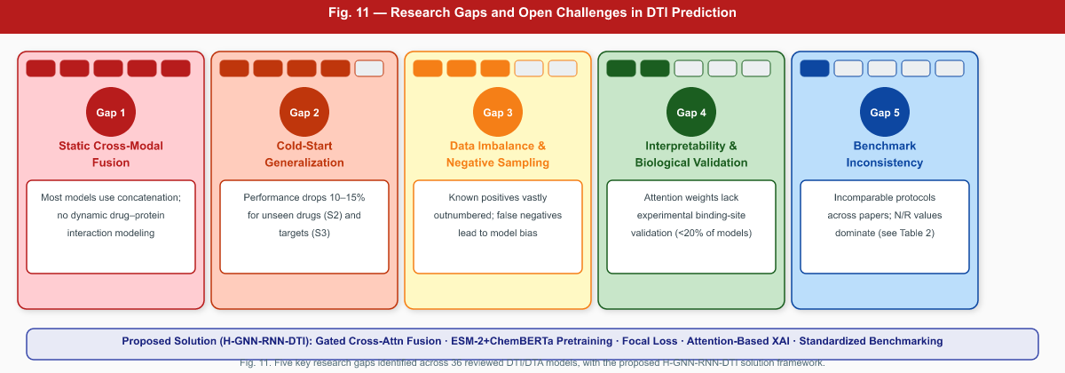
Figure 11. Summary of five primary research gaps identified across 36 reviewed DTI/DTA models, with severity indicators. The bottom bar indicates how the proposed H-GNN-RNN-DTI framework addresses each gap through gated cross-attention fusion, pretrained embeddings, focal loss, attention-based XAI, and standardized evaluation.

8. Future Research Directions

8.1 Dynamic Gated Cross-Modal Fusion
The proposed H-GNN-RNN-DTI Gated Cross-Attention (Eq. 24–28) provides a principled foundation for next-generation fusion. Future work should systematically benchmark gated fusion against bilinear attention (DrugBAN), mutual attention (MutualDTA), and hierarchical cross-attention (HMSA-DTI) using standardized evaluation. Extensions including iterative cross-modal refinement (multiple cross-attention rounds), graph-level and residue-level simultaneous fusion, and adaptive gate initialization from foundation model embeddings represent promising directions.

8.2 Foundation Model Integration and Multi-Modal Pretraining
The success of Top-DTI and ColdDTA demonstrates the transformative impact of foundation model pretraining. Future DTI models should adopt ESM-2 (650M-3B parameters) for protein encoding and ChemBERTa or MolFormer for drug encoding as standard initializations. Beyond initialization, multi-modal contrastive pretraining—learning jointly across drug and protein modalities on large-scale unlabeled data—represents an important open direction. Foundation models specifically pre-trained on drug–target interaction data (rather than general protein/chemical corpora) could provide substantially better downstream performance.

8.3 Structure-Sequence Co-Encoding
AlphaFold2 has made protein 3D structure prediction accessible at proteome scale. Future models should integrate sequence-based and structure-based protein encoding: RNN/Transformer over primary sequence combined with GNN over predicted 3D structure graph. EHIGN demonstrates the power of 3D geometric interaction modeling, but its requirement for experimental structures can now be relaxed using AlphaFold2 predictions. Drug 3D conformation generation (e.g., RDKit ETKDG, DiffSBDD) similarly opens opportunities for geometry-aware drug encoding beyond molecular graphs.

8.4 Principled Cold-Start Strategies
Beyond pretrained embeddings, future models should incorporate few-shot meta-learning for rapid adaptation to novel drugs and targets; prototypical network approaches that learn to generalize from chemical scaffold families; graph meta-learning on drug–target interaction networks; and data augmentation via molecular generation. Systematic benchmarking under the standardized S1/S2/S3 Yamanishi_08 protocol, extended to BindingDB and ChEMBL cold-splits, should be mandated for fair comparison.

8.5 Slice-Aware and Biologically Grounded Evaluation
Following Zhang et al. (2024), future evaluation should adopt slice-aware benchmarking that assesses performance across biologically meaningful subsets: target families (kinases, GPCRs, ion channels), chemical scaffold diversity levels, binding affinity ranges, and disease indications. This would reveal model weaknesses invisible in aggregate metrics and guide development of more robust architectures.

8.6 Quantitative Interpretability Validation
Interpretability mechanisms should be validated quantitatively against experimental data. Atom-level attributions should be compared against pharmacophore databases and mutagenesis data. Residue-level attributions should overlap with crystallographic binding contacts (PDB). Automated pipelines for systematic XAI validation—running model attribution against known pharmacophore databases for thousands of drug–target complexes—would establish interpretability as a measurable model property rather than a qualitative claim.

8.7 Data Imbalance and Negative Sampling Strategies
Future work should develop principled negative sampling strategies that explicitly model the probability of a "negative" pair being an unconfirmed true positive. Approaches including positive-unlabeled (PU) learning, generative negative sampling via molecular generation, and self-supervised pseudo-negative identification represent promising directions beyond the current unknown-negative assumption.

8.8 GAN-Based Data Augmentation for Cold-Start Mitigation
Generative Adversarial Networks (GANs) offer a promising approach to generating synthetic drug and protein sequence data to augment sparse training sets. As shown in Figure 10, a dual-path GAN architecture generates realistic drug and protein sequences via independent generators, validated by discriminators, with the authenticated features combined through co-processing for DTI prediction. This approach can substantially reduce cold-start degradation by generating plausible interaction partners for novel entities.
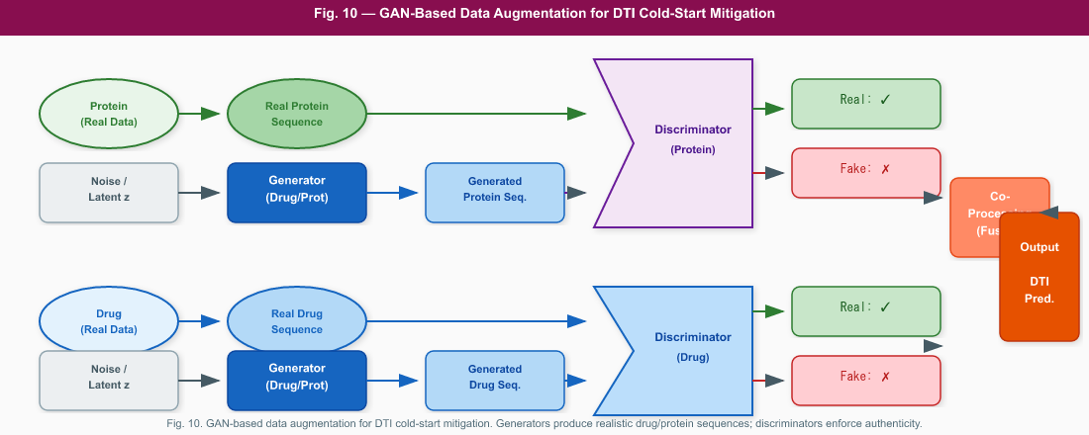
Figure 10. GAN-based data augmentation framework for DTI cold-start mitigation (adapted from literature paradigm). Independent generators synthesize drug and protein sequences from noise; discriminators enforce authenticity; co-processing fuses drug and protein features for DTI output.

9. Conclusion
This review has provided a comprehensive, critical analysis of 36 DTI/DTA prediction models spanning the full evolution of the field from CNN-based baselines to advanced hybrid multimodal deep learning frameworks. Through systematic model reviews, mathematical formulation, conceptual architecture sketches, and four comparative tables, we have synthesized the state of the art and identified persistent limitations.
The central finding is that hybrid multimodal architectures pairing GNNs for drug molecular graph encoding with RNNs, CNNs, or Transformers for protein sequence encoding represent the current best approach to DTI prediction. However, most hybrid models are limited by static concatenation-based fusion, inadequate cold-start generalization strategies, insufficient interpretability mechanisms, and inconsistent evaluation protocols. Advanced fusion mechanisms—cross-attention, bilinear attention, gated attention—and foundation model pretraining are the two highest-impact areas for near-term improvement.
The proposed H-GNN-RNN-DTI architecture directly addresses four identified gaps: (1) a novel Gated Cross-Attention fusion module (Eq. 24–28) overcomes static concatenation; (2) ChemBERTa and ESM-2 pretrained embeddings improve cold-start generalization; (3) focal loss and weighted BCE address data imbalance (Eq. 29–30); and (4) attention-based interpretability with biological validation provides actionable XAI. The model represents a principled next-generation framework that integrates methodological innovation with translational applicability.
Future DTI research should prioritize: standardized slice-aware evaluation protocols; dynamic gated cross-modal fusion; structure-sequence co-encoding leveraging AlphaFold2; multi-modal contrastive pretraining; principled cold-start generalization strategies; and quantitative interpretability validation against experimental binding data. Addressing these directions will advance DTI prediction toward the reliability, interpretability, and scalability required for real-world drug discovery applications.

References
Abbasi, K., Razzaghi, P., Poso, A., Ghanbari-Ara, S., & Masoudi-Nejad, A. (2020). Deep learning in drug target interaction prediction: Current and future perspectives. Current Medicinal Chemistry, 28(11), 2100–2113. https://doi.org/10.2174/0929867327666200907141016
Bae, H., & Nam, H. (2023). GraphATT-DTA: Attention-based novel representation of interaction to predict drug-target binding affinity. Biomedicines, 11(1). https://doi.org/10.3390/biomedicines11010067
Bagherian, M., Sabeti, E., Wang, K., Sartor, M. A., Nikolovska-Coleska, Z., & Najarian, K. (2021). Machine learning approaches and databases for prediction of drug-target interaction: A survey paper. Briefings in Bioinformatics, 22(1), 247–269. https://doi.org/10.1093/bib/bbz157
Bian, J., Lu, H., Dong, G., & Wang, G. (2024). Hierarchical multimodal self-attention-based graph neural network for DTI prediction. Briefings in Bioinformatics, 25(4). https://doi.org/10.1093/bib/bbae213
Bian, J., Lu, H., Wei, L., Li, Y., & Wang, G. (2025). Relational similarity-based graph contrastive learning for DTI prediction. Briefings in Bioinformatics, 26(2). https://doi.org/10.1093/bib/bbaf122
Cao, J., Chen, Q., Qiu, J., Wang, Y., Lan, W., Du, X., & Tan, K. (2024). NGCN: Drug-target interaction prediction by integrating information and feature learning from heterogeneous network. Journal of Cellular and Molecular Medicine, 28(7), 1–11. https://doi.org/10.1111/jcmm.18224
Chen, X., Yan, C. C., Zhang, X., Zhang, X., Dai, F., Yin, J., & Zhang, Y. (2016). Drug-target interaction prediction: Databases, web servers and computational models. Briefings in Bioinformatics, 17(4), 696–712. https://doi.org/10.1093/bib/bbv066
Chen, Y., Liang, X., Du, W., Liang, Y., Wong, G., & Chen, L. (2024). Drug–target interaction prediction based on an interactive inference network. International Journal of Molecular Sciences, 25(14). https://doi.org/10.3390/ijms25147753
Chun, Y., Li, H., & Wang, S. (2025). SS-DTI: A deep learning method integrating semantic and structural information for drug-target interaction prediction. Journal of Bioinformatics and Computational Biology. https://doi.org/10.1142/S0219720025500027
Dai, W., Wang, Y., Yan, S., Yu, Q., & Cheng, X. (2025). Heterogeneous network drug-target interaction prediction model based on graph wavelet transform and multi-level contrastive learning. Scientific Reports, 15(1), 1–17. https://doi.org/10.1038/s41598-025-16098-y
Debnath, K., Rana, P., & Ghosh, P. (2025). A survey on deep learning for drug-target binding prediction: models, benchmarks, evaluation, and case studies. Briefings in Bioinformatics, 26(5). https://doi.org/10.1093/bib/bbaf275
Deng, G., Shi, C., Ge, R., Hu, R., Wang, C., Qin, F., Pan, C., Mao, H., & Yang, Q. (2025). Efficient substructure feature encoding based on graph neural network blocks for drug-target interaction prediction. Frontiers in Pharmacology, 16, 1–15. https://doi.org/10.3389/fphar.2025.1553743
Dhannoon, A. K., & Dhannoon, B. N. (2024). Comprehensive review on drug-target interaction prediction—Latest developments and overview. Current Drug Discovery Technologies, 21(2), 56–67. https://doi.org/10.2174/1570163820666230901160043
Elbasani, E., Njimbouom, S. N., Oh, T. J., Kim, E. H., Lee, H., & Kim, J. D. (2021). GCRNN: Graph convolutional recurrent neural network for compound–protein interaction prediction. BMC Bioinformatics, 22, 1–13. https://doi.org/10.1186/s12859-022-04560-x
Gao, X., Yan, M., Zhang, C., Wu, G., Shang, J., Zhang, C., & Yang, K. (2025). MDNN-DTA: A multimodal deep neural network for drug-target affinity prediction. Frontiers in Genetics, 16, 1–16. https://doi.org/10.3389/fgene.2025.1527300
Hamilton, W. L., Ying, R., & Leskovec, J. (2017). Inductive representation learning on large graphs. Advances in Neural Information Processing Systems, 30, 1024–1034.
He, H., Chen, G., & Chen, C. Y. C. (2023). NHGNN-DTA: A node-adaptive hybrid graph neural network for interpretable drug-target binding affinity prediction. Bioinformatics, 39(6). https://doi.org/10.1093/bioinformatics/btad355
He, T., Heidemeyer, M., Ban, F., Cherkasov, A., & Ester, M. (2017). SimBoost: A read-across approach for predicting drug-target binding affinities using gradient boosting machines. Journal of Cheminformatics, 9(1), 1–14. https://doi.org/10.1186/s13321-017-0209-z
Hua, Y., Feng, Z., Song, X., Wu, X.-J., & Kittler, J. (2025). MMDG-DTI: Drug–target interaction prediction via multimodal feature fusion and domain generalization. Pattern Recognition, 157, 110887. https://doi.org/10.1016/j.patcog.2024.110887
Huang, K., Xiao, C., Glass, L. M., & Sun, J. (2021). MolTrans: Molecular interaction transformer for drug–target interaction prediction. Bioinformatics, 37(6), 830–836. https://doi.org/10.1093/bioinformatics/btaa880
Jin, Z., Wu, S., Chen, J., Shi, J., & Wu, X. (2021). EmbedDTI: Enhancing the molecular representations via sequence embedding and graph neural network for the prediction of drug–target interaction. Biomolecules, 11(12). https://doi.org/10.3390/biom11121783
Khojasteh, H., Pirgazi, J., & Sorkhi, A. G. (2023). Improving prediction of drug-target interactions based on fusing multiple features with data balancing and feature selection techniques. PLOS ONE, 18(8), 1–25. https://doi.org/10.1371/journal.pone.0288173
Kipf, T. N., & Welling, M. (2017). Semi-supervised classification with graph convolutional networks. International Conference on Learning Representations (ICLR).
Lee, J., Jun, D. W., Song, I., & Kim, Y. (2024). DLM-DTI: A dual language model for the prediction of drug-target interaction with hint-based learning. Journal of Cheminformatics, 16(1), 1–12. https://doi.org/10.1186/s13321-024-00808-1
Li, M., Guo, Z., Wu, Y., Guo, P., Shi, Y., Hu, S., Wan, W., & Hu, S. (2024). ViDTA: Enhanced drug-target affinity prediction via virtual graph nodes and attention-based feature fusion. Proceedings—2024 IEEE International Conference on Bioinformatics and Biomedicine (BIBM 2024), 42–47. https://doi.org/10.1109/BIBM62325.2024.10822490
Li, N., Yang, Z., Wang, J., & Lin, H. (2024). Drug–target interaction prediction using knowledge graph embedding. iScience, 27(6). https://doi.org/10.1016/j.isci.2024.109393
Liao, J., Chen, H., Wei, L., & Wei, L. (2022). GSAML-DTA: An interpretable drug-target binding affinity prediction model based on graph neural networks with self-attention mechanism and mutual information. Computers in Biology and Medicine, 150, 106145. https://doi.org/10.1016/j.compbiomed.2022.106145
Liao, Q., Zhang, Y., Chu, Y., Ding, Y., Liu, Z., Zhao, X., Wang, Y., Wan, J., Ding, Y., Tiwari, P., Zou, Q., & Han, K. (2025). Application of artificial intelligence in drug-target interactions prediction: A review. NPJ Biomedical Innovations, 2(1). https://doi.org/10.1038/s44385-024-00003-9
Liu, B., Wu, S., Wang, J., Deng, X., & Zhou, A. (2024). HiGraphDTI: Hierarchical graph representation learning for drug-target interaction prediction. Lecture Notes in Computer Science, 14946 LNAI, 354–370. https://doi.org/10.1007/978-3-031-70365-2_21
Lu, Z., Song, G., Zhu, H., Lei, C., Sun, X., Wang, K., Qin, L., Chen, Y., Tang, J., & Li, M. (2025). DTIAM: A unified framework for predicting drug-target interactions, binding affinities and drug mechanisms. Nature Communications, 16(1). https://doi.org/10.1038/s41467-025-57828-0
Luo, Y., Duan, G., Zhao, Q., Bi, X., & Wang, J. (2024). DTKGIN: Predicting drug-target interactions based on knowledge graph and intent graph. Methods, 226, 21–27. https://doi.org/10.1016/j.ymeth.2024.04.010
Mienye, I. D., Swart, T. G., & Obaido, G. (2024). Recurrent neural networks: A comprehensive review of architectures, variants, and applications. Information, 15(9), 1–34. https://doi.org/10.3390/info15090517
Minh, N. T., Thin, N., & Truyen, T. (2022). Mitigating cold-start problems in drug-target affinity prediction. Briefings in Bioinformatics, 23(July), 1–13. https://doi.org/10.1093/bib/bbac269
Nguyen, T., Le, H., Quinn, T. P., Nguyen, T., Le, T. D., & Venkatesh, S. (2021). GraphDTA: Predicting drug target binding affinity with graph neural networks. Bioinformatics, 37(8), 1140–1147. https://doi.org/10.1093/bioinformatics/btaa921
Ouyang, X., Feng, Y., Cui, C., Li, Y., Zhang, L., & Wang, H. (2025). Improving generalizability of drug–target binding prediction by pre-trained multi-view molecular representations. Bioinformatics, 41(1), 1–9. https://doi.org/10.1093/bioinformatics/btaf002
Öztürk, H., Özgür, A., & Ozkirimli, E. (2018). DeepDTA: Deep drug–target binding affinity prediction. Bioinformatics, 34(17), i821–i829. https://doi.org/10.1093/bioinformatics/bty593
Panahandeh, F., & Mansouri, N. (2025). A comprehensive review of neural network-based approaches for drug–target interaction prediction. Molecular Diversity. https://doi.org/10.1007/s11030-025-11303-6
Quan, N., Ma, S., Zhao, K., Bi, X., & Zhang, L. (2025). MFCADTI: Improving drug-target interaction prediction by integrating multiple features through cross attention mechanism. BMC Bioinformatics, 26(1). https://doi.org/10.1186/s12859-025-06075-7
Shi, H., Liu, S., Chen, J., Li, X., Ma, Q., & Yu, B. (2019). Predicting drug-target interactions using lasso with random forest based on evolutionary information and chemical structure. Genomics, 111(6), 1839–1852. https://doi.org/10.1016/j.ygeno.2018.12.007
Suruliandi, A., Idhaya, T., & Raja, S. P. (2024). Drug target interaction prediction using machine learning techniques—A review. International Journal of Interactive Multimedia and Artificial Intelligence, 8(6), 86–100. https://doi.org/10.9781/ijimai.2022.11.002
Sun, Y., Li, Y. Y., Leung, C. K., & Hu, P. (2024). iNGNN-DTI: Prediction of drug-target interaction with interpretable nested graph neural network and pretrained molecule models. Bioinformatics, 40(3). https://doi.org/10.1093/bioinformatics/btae135
Talo, M., & Bozdag, S. (2025). Top-DTI: Integrating topological deep learning and large language models for drug-target interaction prediction. Bioinformatics, 41, i133–i141. https://doi.org/10.1093/bioinformatics/btaf183
Tanoli, Z., Schulman, A., & Aittokallio, T. (2025). Validation guidelines for drug-target prediction methods. Expert Opinion on Drug Discovery, 20(1), 31–46. https://doi.org/10.1080/17460441.2024.2430955
Tran, H. N. T., Thomas, J. J., & Malim, N. H. A. H. (2022). DeepNC: A framework for drug-target interaction prediction with graph neural networks. PeerJ, 10, 1–24. https://doi.org/10.7717/peerj.13163
Vaswani, A., Shazeer, N., Parmar, N., Uszkoreit, J., Jones, L., Gomez, A. N., Kaiser, Ł., & Polosukhin, I. (2017). Attention is all you need. Advances in Neural Information Processing Systems, 30.
Vefghi, A., Rahmati, Z., & Akbari, M. (2025). Drug-target interaction/affinity prediction: Deep learning models and advances review. Computers in Biology and Medicine, 196, 1–64. https://doi.org/10.1016/j.compbiomed.2025.110438
Veličković, P., Cucurull, G., Casanova, A., Romero, A., Liò, P., & Bengio, Y. (2018). Graph attention networks. International Conference on Learning Representations (ICLR).
Wu, Z., Li, W., Liu, G., & Tang, Y. (2018). Network-based methods for prediction of drug-target interactions. Frontiers in Pharmacology, 9, 1–14. https://doi.org/10.3389/fphar.2018.01134
Xuan, P., Sun, C., Zhang, T., Ye, Y., Shen, T., & Dong, Y. (2019). Gradient boosting decision tree-based method for predicting interactions between target genes and drugs. Frontiers in Genetics, 10, 1–11. https://doi.org/10.3389/fgene.2019.00459
Yang, H., Chen, Y., Zuo, Y., Deng, Z., Pan, X., Shen, H., Choi, K. S., & Yu, D. J. (2024). MINDG: A drug–target interaction prediction method based on an integrated learning algorithm. Bioinformatics, 40(4). https://doi.org/10.1093/bioinformatics/btae147
Yang, Z., Zhong, W., Lv, Q., Dong, T., Chen, G., & Chen, C. Y.-C. (2024). Interaction-based inductive bias in graph neural networks: Enhancing protein-ligand binding affinity predictions from 3D structures. IEEE Transactions on Pattern Analysis and Machine Intelligence, 46(12), 8191–8208. https://doi.org/10.1109/TPAMI.2024.3400515
Yuan, Y., Chen, S., Hu, R., & Wang, X. (2025). MutualDTA: An interpretable drug-target affinity prediction model leveraging pretrained models and mutual attention. Journal of Chemical Information and Modeling, 65(3), 1211–1227. https://doi.org/10.1021/acs.jcim.4c01893
Zeng, X., Li, S., Lv, S., & Wen, M. (2024). A comprehensive review of the recent advances on predicting drug-target affinity based on deep learning. Frontiers in Pharmacology, 15, 1–15. https://doi.org/10.3389/fphar.2024.1375522
Zhang, Q., Sun, Z., Zhong, Z., Yang, H., Wei, Y., & Xu, J. (2025). SaeGraphDTI: Drug–target interaction prediction based on sequence attribute extraction and graph neural network. BMC Bioinformatics, 26(1). https://doi.org/10.1186/s12859-025-06195-0
Zhang, X. M., Liang, L., Liu, L., & Tang, M. J. (2021). Graph neural networks and their current applications in bioinformatics. Frontiers in Genetics, 12, 1–22. https://doi.org/10.3389/fgene.2021.690049
Zhang, X., Wu, J., Xie, J., Chen, T., & Zhou, K. (2024). Benchmark on drug target interaction modeling from a structure perspective. ArXiv. https://arxiv.org/abs/2407.0
Zhang, Y., Wang, Q., Baoming, Z., Junliang, F., & Li, S. (2025). IHDFN-DTI: Interpretable hybrid deep feature fusion network for drug–target interaction prediction. Interdisciplinary Sciences: Computational Life Sciences. https://doi.org/10.1007/s12539-025-00712-8
Zhao, Q., Zhao, H., Zheng, K., & Wang, J. (2022). HyperAttentionDTI: Improving drug-protein interaction prediction by sequence-based deep learning with attention mechanism. Bioinformatics, 38(3), 655–662. https://doi.org/10.1093/bioinformatics/btab715
Zhijian, L., Shaohua, J., Yigao, L., & Min, G. (2022). GDGRU-DTA: Predicting drug-target binding affinity based on GNN and double GRU. CSIT, 120703, 25–37. https://doi.org/10.5121/csit.2022.120703
Zhu, Y., Ning, C., Zhang, N., Wang, M., & Zhang, Y. (2024). GSRF-DTI: A framework for drug-target interaction prediction based on a drug-target pair network and representation learning on a large graph. BMC Biology, 22(1). https://doi.org/10.1186/s12915-024-01949-3
Zuo, Y., Wu, X., Ge, F., Yan, H., Fei, S., Liang, J., & Deng, Z. (2025). Research progress on drug-target interactions in the last five years. Analytical Biochemistry, 697, 115691. https://doi.org/10.1016/j.ab.2024.115691

