ResNet for ASL Classification
By: Jameson Adams
12/8/2025
GitHub
This report explores utilizing a pretrained ResNet model to translate ASL letters to written letters. It explores unfreezing different parts of the pretrained model starting with the fully connected layer and ending with completely training a base model. This report investigates manual hyper parameter tuning for four different models and selected the best performing model to test using one held out test set and one test set created from scratch.
The results are that the T-C model (fully connected, layer4 and layer 3 unfrozen) performed the best with a macro f1 score of 0.9943 on the validation set. The T-C model received a f1 score of 1.0 on the given test set and 0.1392 on the created test set.

Before any model could be trained, the data had to be collected from Kaggle. Google Collab has multiple ways to read in and store data. Data can be stored then mounted from Google Drive, from local file upload, and finally directly into the context window. Google Collab’s context window has drastically faster read/write times. This report decided to load the data in two ways. The train data was directly loaded into the context while both testing datasets were mounted from Google Drive then loaded into the context.
Next, the data had to go through transformations. Aside from the standard transformation to make the size of the image match the ImageNet images, the training data underwent augmentation, so that it could better generalize to the created test set. This involved jittering the color, saturation, hue and contrast and random cropping/small rotations. To deal with compute issues, 10% of the training dataset was dropped and a further 20% was held out as a validation set.
Finally, the four models were trained under three different manually selected hyper parameter condition sets. The conditions were:
- batch size of 64, Adam optimizer, and .001 learning rate
- batch size 128, SGD optimizer and .01 learning rate
- batch size 256, Adagrad optimizer and .1 learning rate

Figure 1 shows the plot of cross entropy loss for the training set and validation set for each of the models starting with T-A, T-B, T-C and finally S-A model compared with the number of epochs.
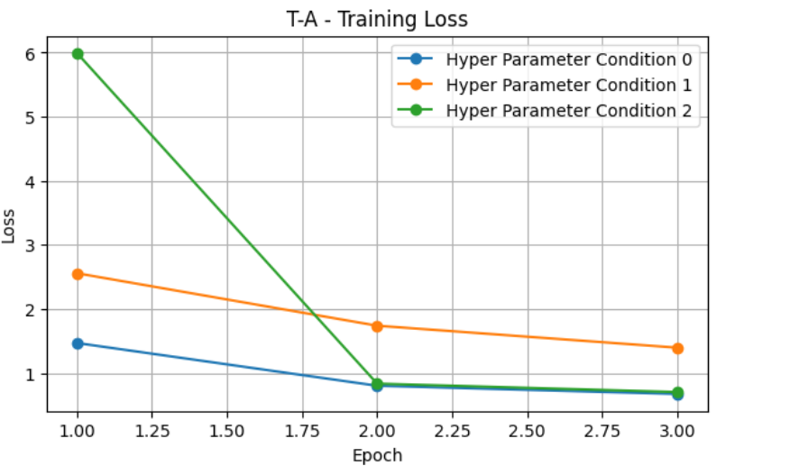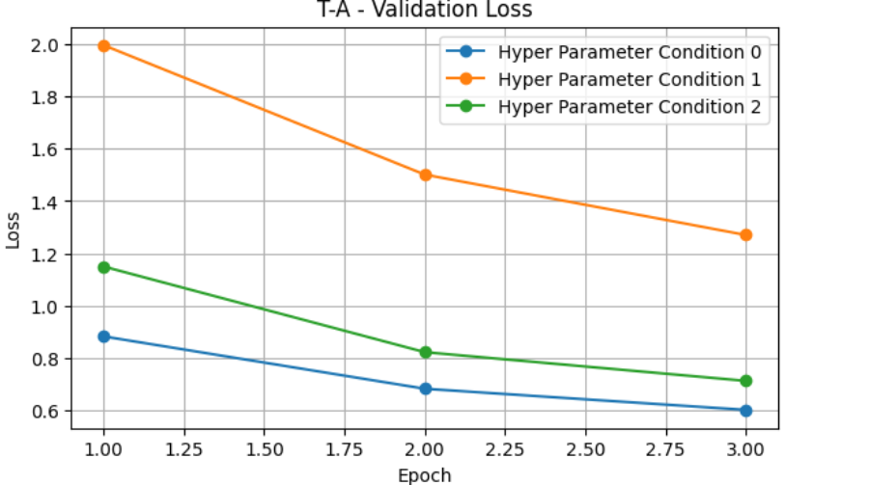

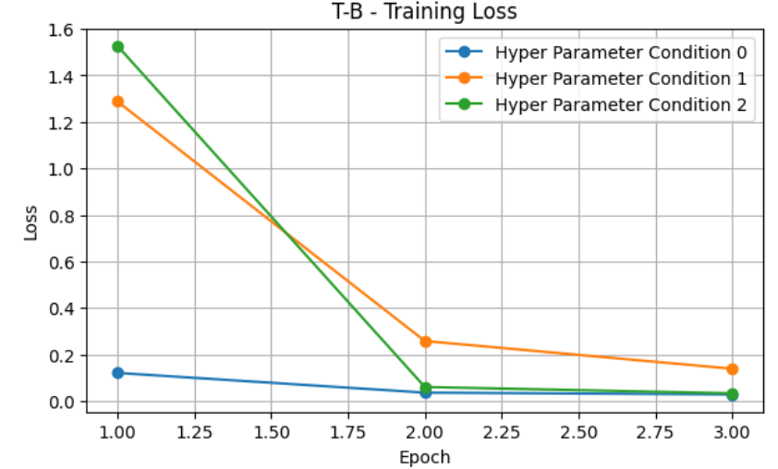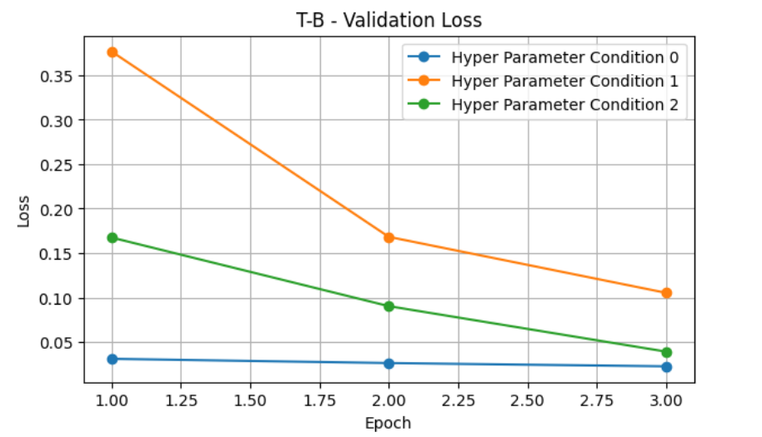
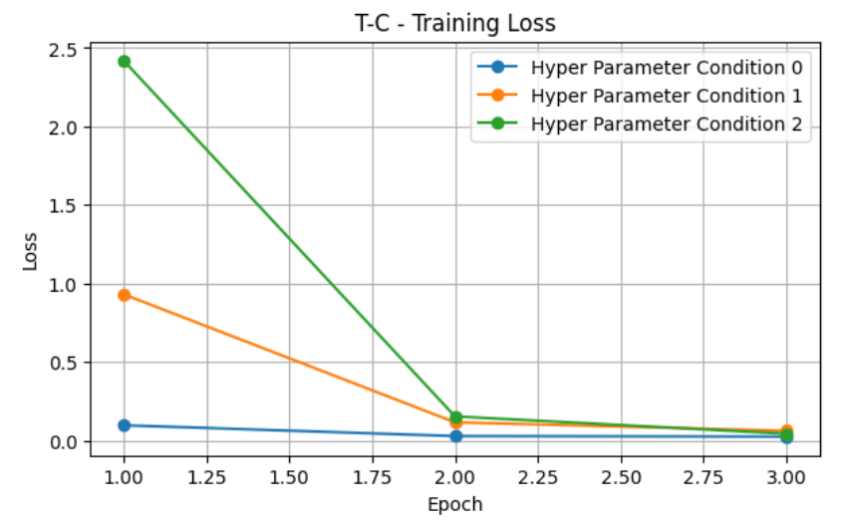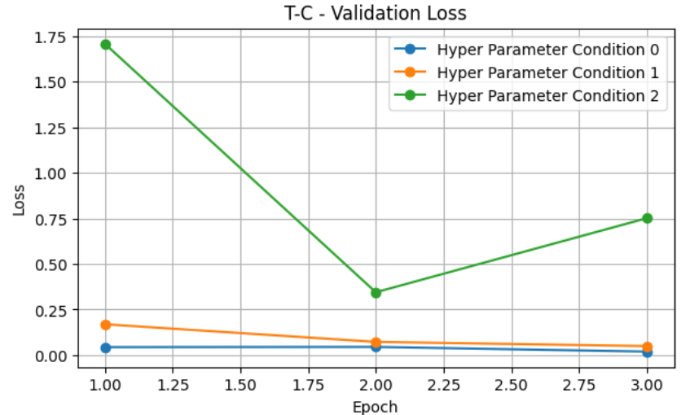
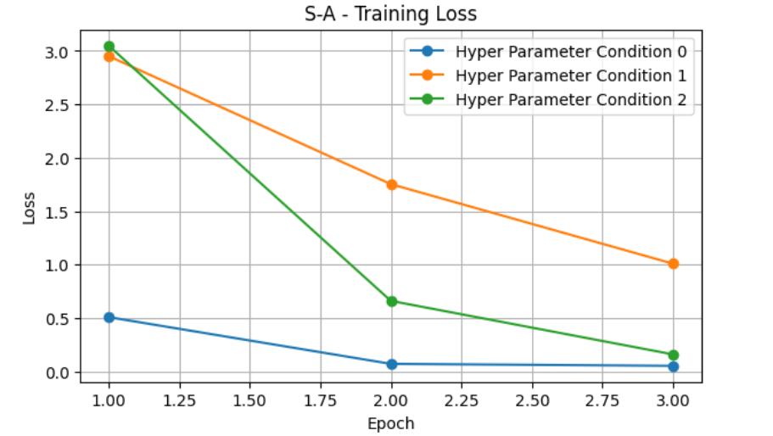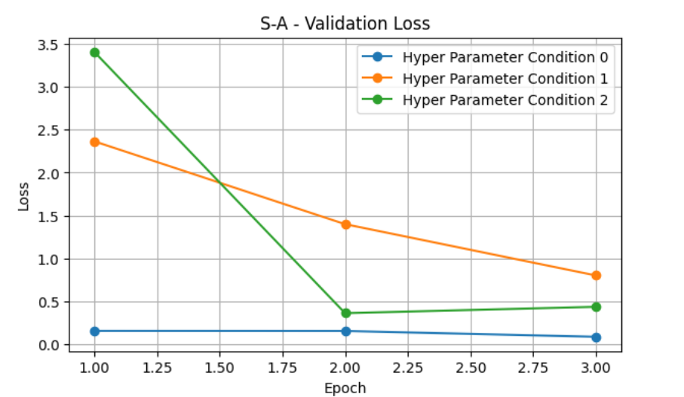
Figure 1: Shows the Training and Validation Loss for the Hyper Parameter Conditions for All Models

With two exceptions, the trend for all three condition sets was that as the epochs increased both the training and validation loss decreased. This intuitively makes sense and is the expected outcome. It is also expected that there are diminishing returns of training with more epochs. Due to compute, this report stopped training after three epochs. A more comprehensive report should train each model with more epochs.
Condition set 0 performed the best for all three models at all evaluation times. This could be due to the smaller batch size, or the learning rate being a good choice for the training data. A more comprehensive study should use algorithms to algorithmically find the optimal hyper parameter set.

Table 1 shows the accuracy and macro f1 scores on the validation set for all models and their hyper parameter variations.
 | Condition Set 0 |  | Condition Set 1 |  | Condition Set 2
 | Accuracy | F1 | Accuracy | F1 | Accuracy | F1
T-A | 0.830 | 0.8296 | 0.74 | 0.7394 | 0.787 | 0.7863
T-B | 0.992 | 0.9925 | 0.979 | 0.9794 | 0.988 | 0.9881
T-C | 0.994 | 0.9943 | 0.99 | 0.9898 | 0.903 | 0.8977
S-A | 0.971 | 0.9716 | 0.772 | 0.7757 | 0.878 | 0.8796

It is interesting to see from table 1 that the T-C model and T-B had very similar accuracy and F1 scores for the first two hyper parameter variations. T-A performed the worst. This report hypothesis that the general knowledge in the model from the ImageNet pre-training introduced noise into the model and as less of the model was frozen to use the pretrained weights, the model had more layers to focus on just discerning the different hand signs. S-A performed well under condition set 0, but worse than T-B and T-C. A possible explanation is that S-A comparatively struggled due to not having any frozen layers with the general ImageNet knowledge causing overfitting which becomes more apparent when comparing the results on condition set 1 and condition set 2.
This report selected T-C as the model to utilize the test set on because it slightly overperformed T-B on the best performing condition set, condition one.

The results from the given test set are an accuracy of 1.0 and an F1 of 1.0. Comparing this with the result from the created test set of an accuracy of 0.23 and an F1 of 0.1392. There is quite a large difference. This report hypothesis that the difference arises due to the difference of image quality and structure. This report attempted to mitigate these issues by utilizing various data augmentation techniques to mild success. The model was trained on over 56,160 training samples, but they were all the same variety. So even though the model generalizes to the given test set incredibly well, when confronted with ASL that does not follow the same format it struggles to classify accurately. If this project was going to be used commercially it is recommended to use a larger training dataset with more varied people, camera angles and quality.
A confusion matrix was created to identify the possible reasons why signs were misclassified -found in the GitHub repository. Multiple signs were misclassified as “s”. Looking at the base image for those signs, it makes sense as for example “n” and “s” look alike as seen in figure 2.
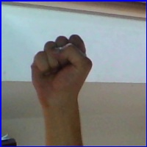
Figure 2: Left Image is "n" in Created Test Set. Right Image is "s" From Given Test Set

In conclusion, comparing the best fine-tuned model based on the pretrained ImageNet dataset T-C with S-A, T-C performed better on the validation set for both accuracy and f1 score (Table 1). This report hypothesis that because the T-C model retained one layer of the general knowledge from the ImageNet database, it was able to generalize more effectively to the validation set. On the other hand, the increased adaptability by unfreezing multiple layers allowed the model to better learn the idiosyncrasies of the ASL dataset outperforming T-A and T-B. T-C also had faster convergence compared to S-A, making it the definitive optimal model.

