James Daniels
TINFO 200
Debugger Lab (L-dbg)
Winter 2026

DEBUGGER LAB Exercise
You might find it useful to reformat the code that the authors supply with the book (from Github) for this exercise. The authors use a 3 space tab and the VS default is a 4 space tab. This will mean that some of the line numbers below in the questions may not line up exactly, but if you read the lab exercise carefully and follow along with the software, you’ll quickly identify the correct locations in the code that are being referred to.
Proceed through the cshtp6_Debugger.pdf document, following all instructions and try to duplicate the same pictures that are presented in the document, with your own running software. When you come to the point in the procedure where there is a Figure G.2 of the VS software in the PDF, you are to take a screen shot showing exactly the same thing, or as close to it as you can get, and paste that image snip into this document below each label.
Do not insert any full desktop screen shots.
Do not insert any full Visual Studio window screen shots.
I expect your screen shots to be reasonably similar to the figure in the lab document.
Also, do not skew the width and height aspect ratio of your screen shots – only resize them by the corners if needed, DO not change the width or height independently and “skew” the image
I must be able to read the details of what your windows are showing in your images.
Fig G.2 – Creating and manipulating an Account object
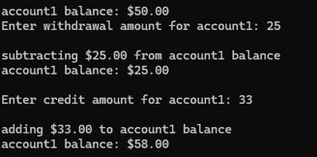
The Account program is running normally without the debugger (F5). An Account object is created with an initial balance of $50.00, and the program correctly processes withdrawal and credit input, displaying updated balances.
Fig G.3 – Setting Breakpoints
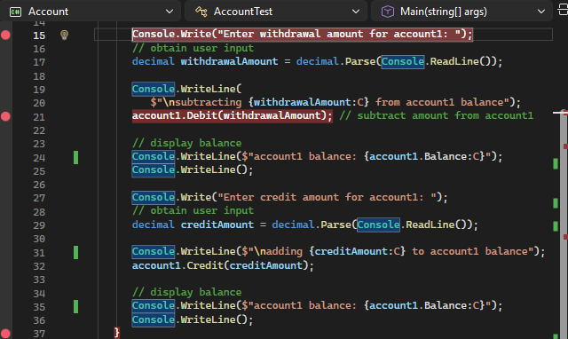
AccountTest.cs shows three breakpoints set at lines 15, 21, and 37. Line numbers differ slightly from the tutorial due to formatting differences, but the breakpoints correspond to the same logical execution points.
Fig G.4 – Account program running
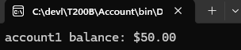
Account program is running in debug mode with the debugger attached before any breakpoints are reached.
Fig G.5 – Program execution suspended at the first breakpoint
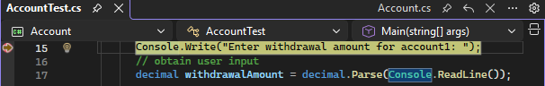
AccountTest.cs program is paused in debugger at the first breakpoint prior to reaching the next breakpoints.
Fig G.6 – Quick Info box displays value of variable withdrawalAmount
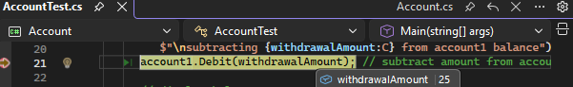
The quick info box is displaying the value of the variable withdrawnAmount while the program is paused at a breakpoint.
Fig G.7 – Sample execution of Account.exe in debug mode
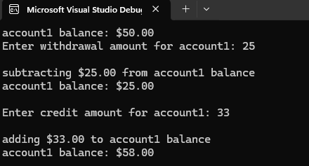
This figure shows the execution of Account.exe in debug mode with user input and correct output after fixing formatting and logic issues.
Fig G.8 – Disabled breakpoint
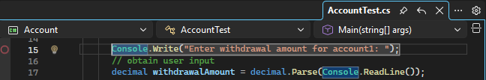
Line 15 breakpoint disabled so it will not pause program executions.
Fig G.9 – A Data Tip displayed for the account1 variable
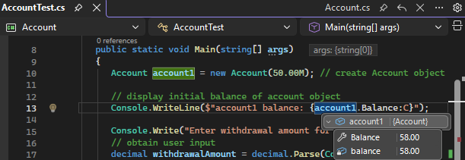
This shows a Data Tip displaying information about the account1 object while execution is paused in the debugger.
Fig G.10 – Setting breakpoints at lines 24, 27,and 28
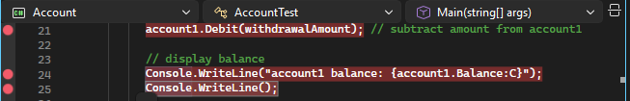
This shows three breakpoints set on consecutive lines to pause execution during the debit operation.
Fig G.11 – Entering the withdrawal amount before the breakpoint is reached
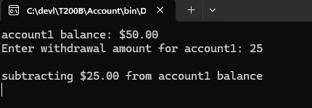
This shows user input entered prior to program execution pausing at a breakpoint.
Fig G.12 – Program execution pauses when debugger reaches the breakpoint at line 24
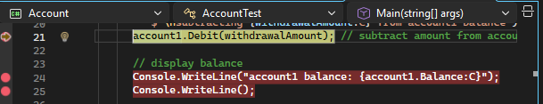
The debugger suspends execution after the withdrawal operation, pausing at the breakpoint before the updated account balance is displayed.
Fig G.13 – Examining local variables
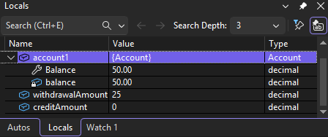
The account1 object is expanded in the Locals window to display its Balance property, along with the local variables withdrawalAmount and creditAmount while the program is paused in the debugger.
Fig G.14 – Examining the values of expressions
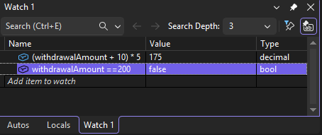
The Watch window displays the evaluated results of arithmetic and boolean expressions, allowing expressions to be tested without modifying the values of program variables.
Fig G.15 – Displaying the value of local variables
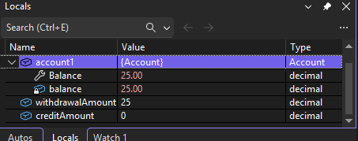
The Locals window shows withdrawalAmount = 25 and the updated account1.Balance = 25.00 after the debit operation.
Fig G.16 – Stepping into the Debit method.
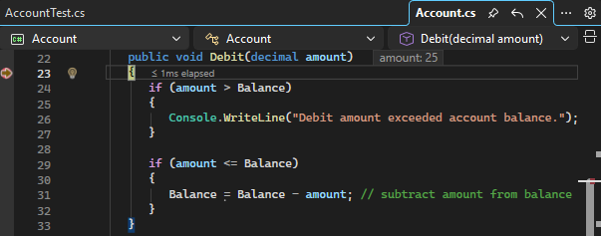
The debugger is applied and at the Debit(decimal amount) method in Account.cs, allowing the withdrawal to be examined.
Fig G.17 – Enabling the Just My Code debugging feature.
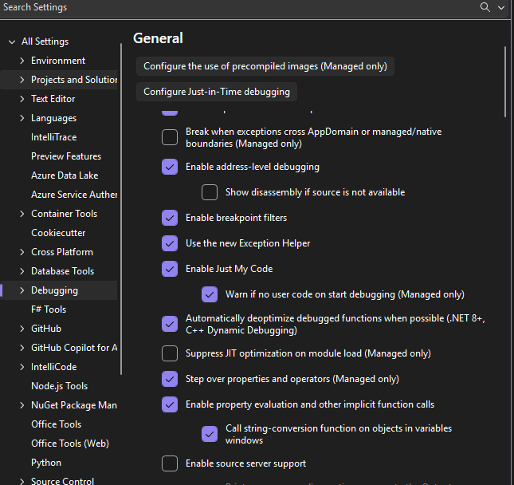
The Just My Code option is enabled in Visual Studio’s debugging settings, ensuring the debugger steps only through user written code and skips framework methods during execution.
Answer the following questions:
- What does the “just my code” feature do when selected. Give a complete explanation of the difference it makes in what the debugger traces.
If my program calls Console.WriteLine(), with just my code enabled, the debugger will execute that line but does not step into Microsoft’s internal Console or .Net framework code as explained in class. Instead, it skips that system code and moves directly to the next line in my program. Without just my code enabled, the debugger would step into the underlying methods, showing code I did not write.

- Why do you think the designers of Visual Studio have the F10 function key mapped to the Step Over command and the F11 function key mapped to the Step In command (by default)?
F10 is mapped to “Step Over” because it helps beginners-advanced users to visually navigate complex code. It lets programmers watch the program move line by line while keeping the focus on the main logic. This acts as a safety feature because it prevents stepping into methods or framework code that may be confusing or unnecessary at the moment. F11 is mapped to “Step Into” for when programmers intentionally want to learn how or see how a specific method works internally. Stepping into methods requires deliberate actions, which help prevent accidental deep debugging and keeps the process more controlled.
- What does the debugger do if you press and hold down the F10 function key for a few seconds?
If I press and hold down the F10 button, the debugger repeatedly steps over each line of code automatically. This allows users or programmers to move through the code line by line much faster, making it easier to visually follow the programs flow without stopping inside methods.
- What kind of code control statement do you think that feature might come in useful with?
It’s extremely useful with loops, but even in this lab it helped when stepping over methods calls like the account1.Debit(withdrawalAmount). Holding the F10 let the debugger move past that line without entering the “Debit” method, so I can continue to follow the main flow of the “AccountTest.cs” instead of jumping into the logic inside of Account.cs.
- List 5 VS windows that have useful debugging information for the programmer?
1. The Locals Window. It showed the current values of variables while in the program.
2.Immediate Window allowed me to evaluate expressions or run small commands while debugging.
3. Breakpoint Window displayed all the breakpoints and let me enable or disable them easily.
4. Call Stack Window showed which methods have been called and the order they were called in.
5.Watch Window let me track specific variables or expressions as the program ran.

