Michele Speidel

3/18/2023

Module 1.2 Assignment

GitHub Repository Setup

CSD340-309O_2235_DD

Web Development with HTML and CSS

Instructor Cristy Cross

1. **Link to GitHub Repository**

Link to GitHub repository

<https://github.com/jamdmmsfreese/csd-340-309O>

1. **Screenshot of Local Directory**

Named the directory csd-340-309O to differentiate cohorts

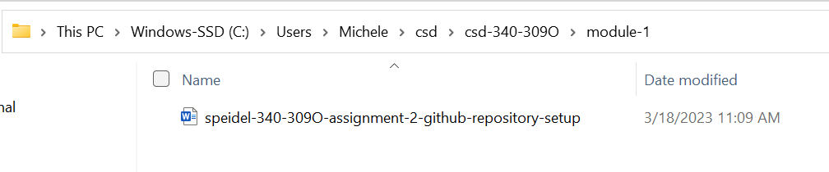

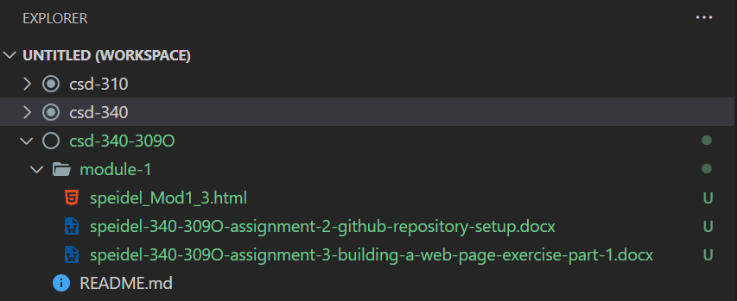

1. **Screenshot of GitHub repository**

Named the repository csd-340-309O to differentiate cohorts

