Michele Speidel

3/19/2023

Module 1.3 Assignment

Building a Web Page Exercise, Part 1

CSD340-309O_2235_DD

Web Development with HTML and CSS

Instructor Cristy Cross

1. **Markup Validation Service Check Copied from Starter Code**

No errors were received when using the starter code.

I did include some of the errors received when I was with Cohort 340-330H (item **4**. Below)

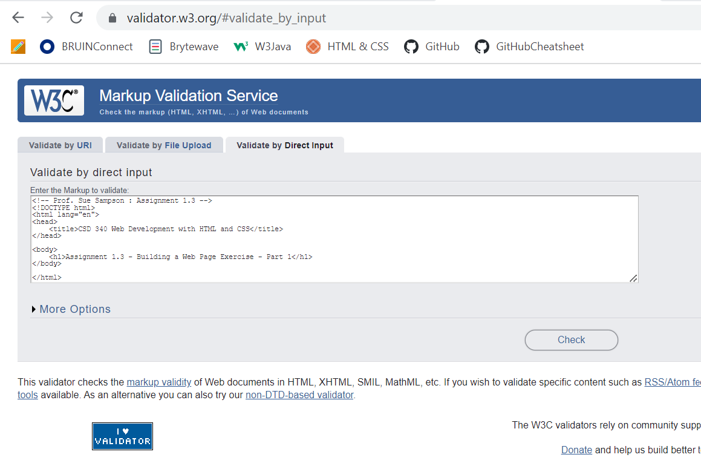

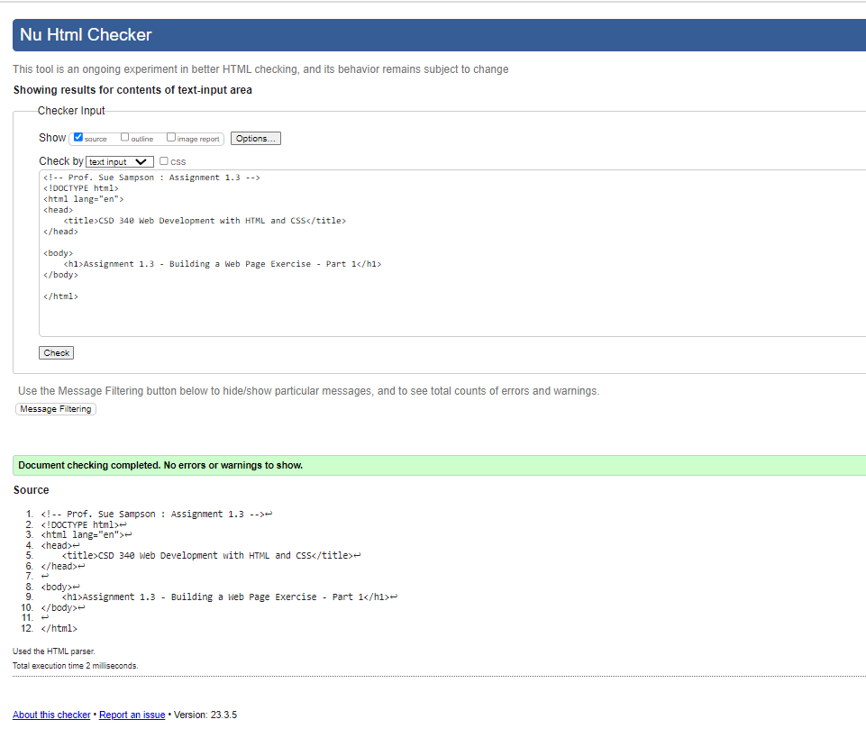

1. **Markup Validation Service Check Modified Starter Code**

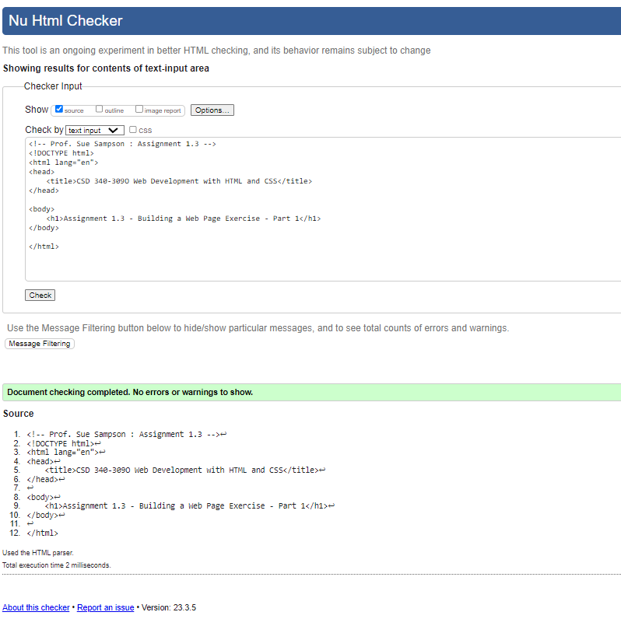

**3. Web Page in Browser**

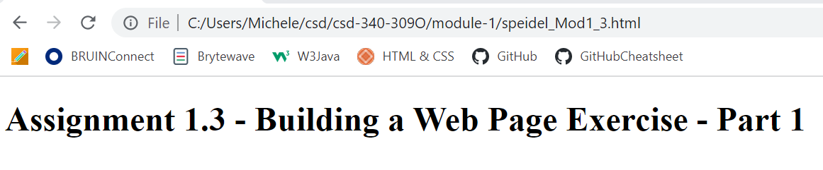

1. **Markup Validation Service Check Previous Cohort 340-330H Results**

Try 1 of 3

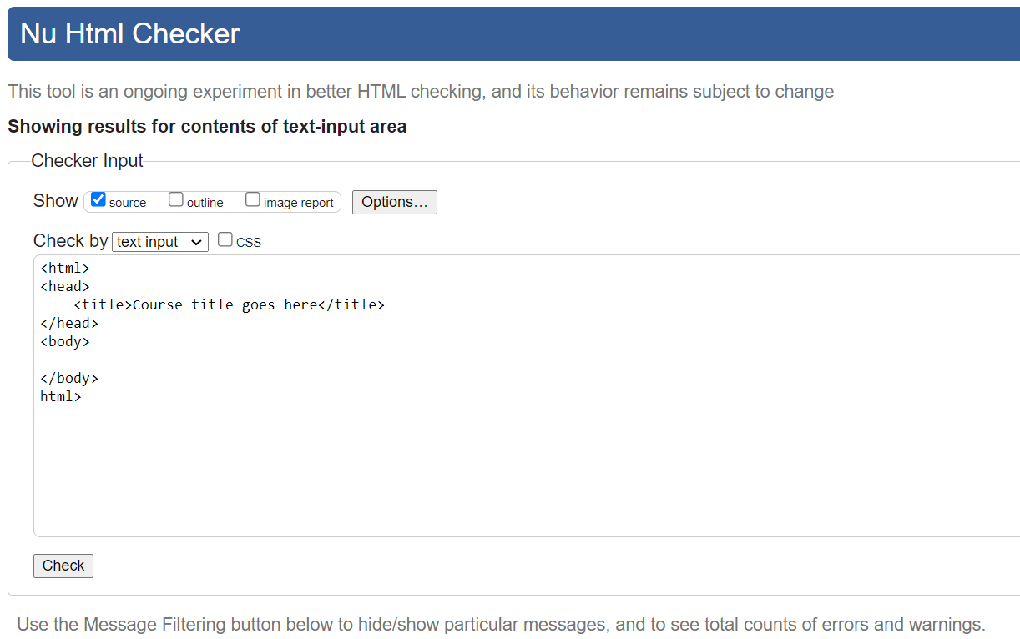

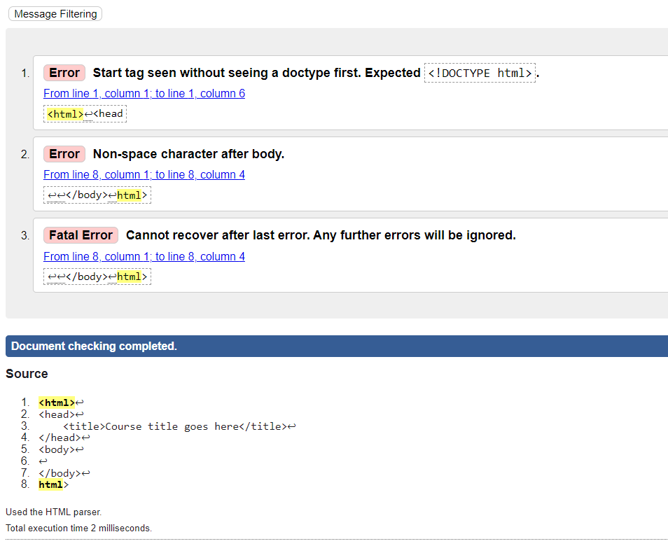

Try 2 of 3

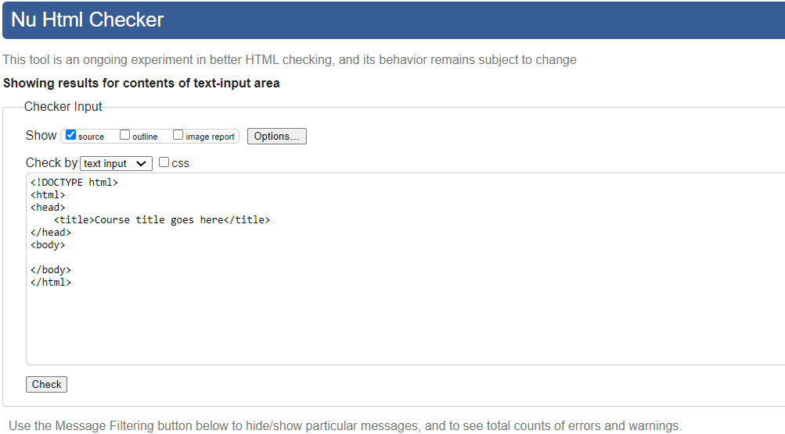

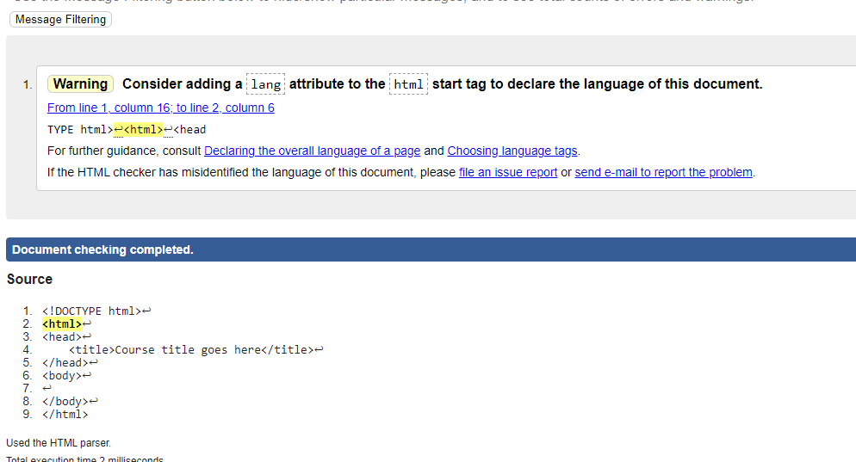

Try 3 of 3

