Michele Speidel

3/19/2023

Module 2.2 Assignment

Building a Web Page Exercise, Part 2

CSD340-309O_2235_DD

Web Development with HTML and CSS

Instructor Cristy Cross

1. **Set Up**

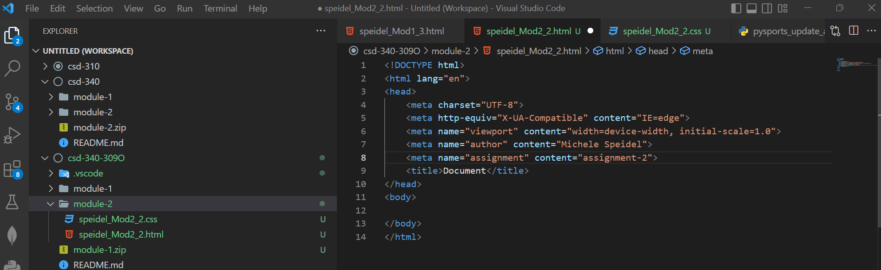

1. **Markup Validation Service Check**

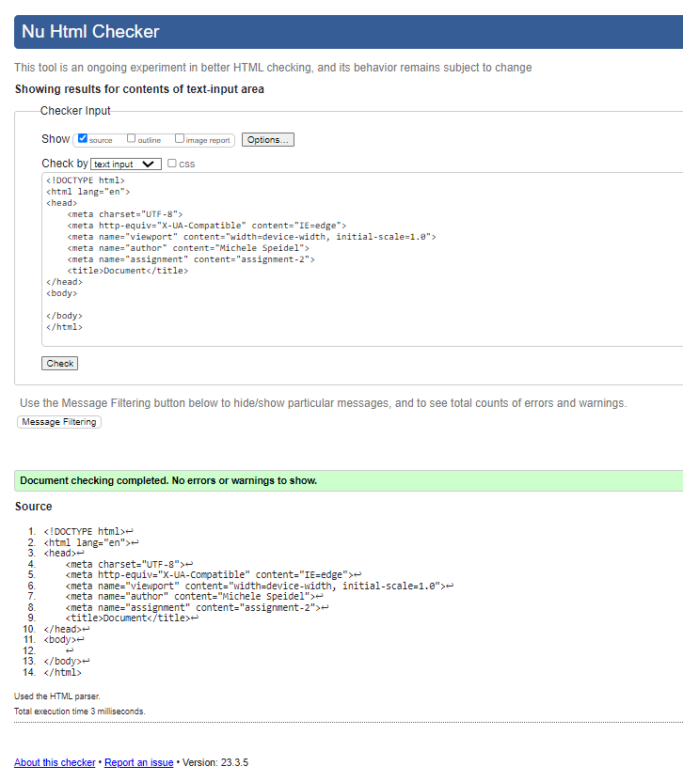

1. **Assignment HTML**

<! -- Michele Speidel -- >

<! -- Assignment 2.2 -- >

<! -- March 19, 2023 -- >

<! -- Instructor Cristy Cross -- >

<!DOCTYPE html>

<html lang="en">

<head>

    <meta charset="UTF-8">

    <meta http-equiv="X-UA-Compatible" content="IE=edge">

    <meta name="viewport" content="width=device-width, initial-scale=1.0">

    <meta name="author" content="Michele Speidel">

    <meta name="assignment" content="Assignment 2.2 Building a Web Page Exercise - Part 2 ">

    <meta name="description" content="demonstration of HTML and CSS functionality">

    <meta name="keywords" content="my story, school, college, bellevue">

    <meta name="robots" content="nofollow">

    <meta name="pragma" content="no-cache">

    <title>CSD 340-309O Development with HTML and CSS</title>

    <link href="speidel_Mod2_2.css" rel="stylesheet" type="text/css">

    <! -- start of css class style -- >

    <style type="text/css">

        .intro{

            text-indent: 2em;

        }

        .sentence{

            font-style: italic;

        }

    </style>

    <! -- end of css class style -- >

</head>

<body>

    <! -- start of main text -- >

    <div id="container">

        <h1>My Story</h1>

        <h2>Chapter 1: About Me</h2>

        <p class="intro">

            I grew up in the city.  I now live in a suburban area.  The city has grown a lot in the past several years.

        </p>

        <p>

            I went to small private schools growing up.  After high school, I went to work before trying college.  I finally started college 5-years after high school.  <span class="sentence">I finally graduated six years later!</span>

        </p>

        <p>

            As a child, I enjoyed dancing and running.  In high school, I was on the track team.  I was also a cheerleader.

        </p>

        <p>

            I grew up in a house with two siblings and my parents.  I have many other relatives but they do not live close by.  There are a few that I now pretty well, some a know a little bit, and many I have never met.

        </p>

        <! -- end of main text -- >

        <! -- line break -- --------------->

        <hr />

        <! -- start of address -- >

        <address>

            <p><a href="https://www.bellevue.edu" target="_blank"> Bellevue University</a><br />

            1000 Galvin Rd S<br />

            Bellevue, NE 68005</p>

        </address>

        <! -- end of address -- >

    </div>

</body>

</html>

<! -- references -- >

<! -- https://www.w3schools.com/ -- >

<! -- Duckett, Jon.  (2022).  HTML & CSS; design and build websites. John Wiley & Sons, Inc. -- >

1. **Assignment CSS**

body {

    font-size: 16px;

  }

p {

    font-weight: 400;

    line-height: 1.4em;

}

h1 {

    font-weight: 700;

    text-transform: uppercase;

    text-align: center;

}

h2 {

    font-weight: 500;

    text-align: left;

    padding: 15px;

}

address {

    text-align: center;

}

a:link {

    text-decoration: none;

    font-weight: bold;

    font-size: 1.25em;

    color:#4f3674;

}

a:visited {

    color:black;

}

a:hover {

    text-decoration: underline;

    color:#d6a800;

}

1. **Web Page**

