Michele Speidel

3/26/2023

Module 3.2 Assignment

GitHub Page

CSD340-309O_2235_DD

Web Development with HTML and CSS

Instructor Cristy Cross

Subject: Michele Speidel Module 3 Assignment 2

Document: speidel-304-309O-assignment-2-github-page

zip file: module-3

GitHub Repository: [https://github.com/jamdmmsfreese/csd-340-309O/tree/main/module-](https://github.com/jamdmmsfreese/csd-340-309O/tree/main/module-1)3

HTML Validator W3C

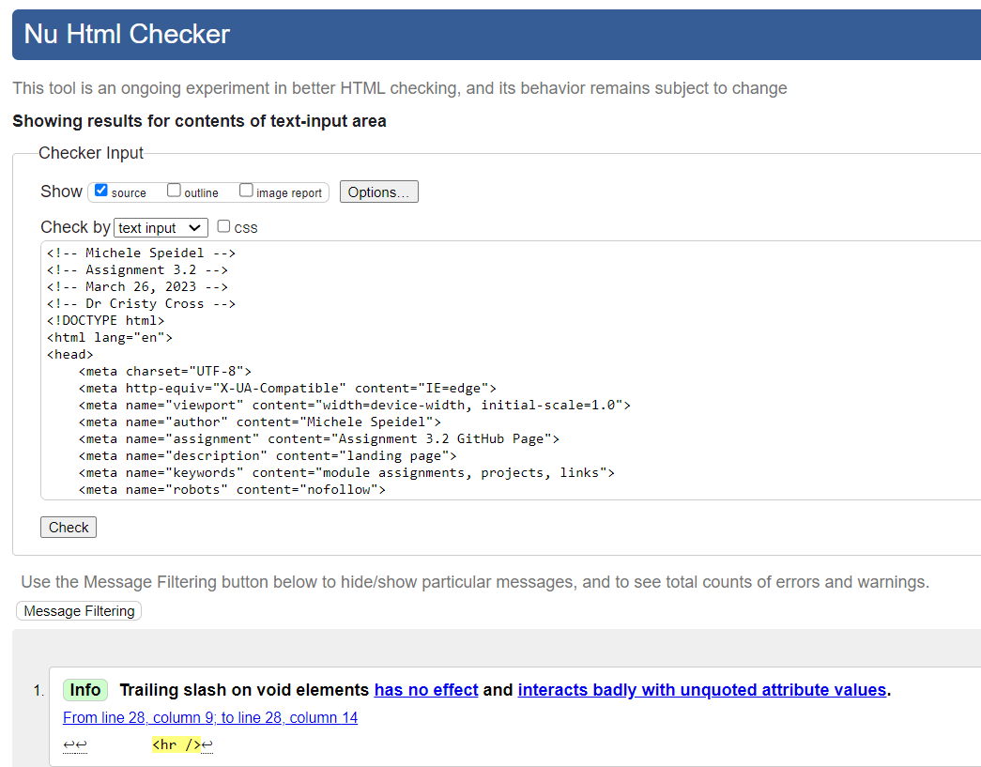

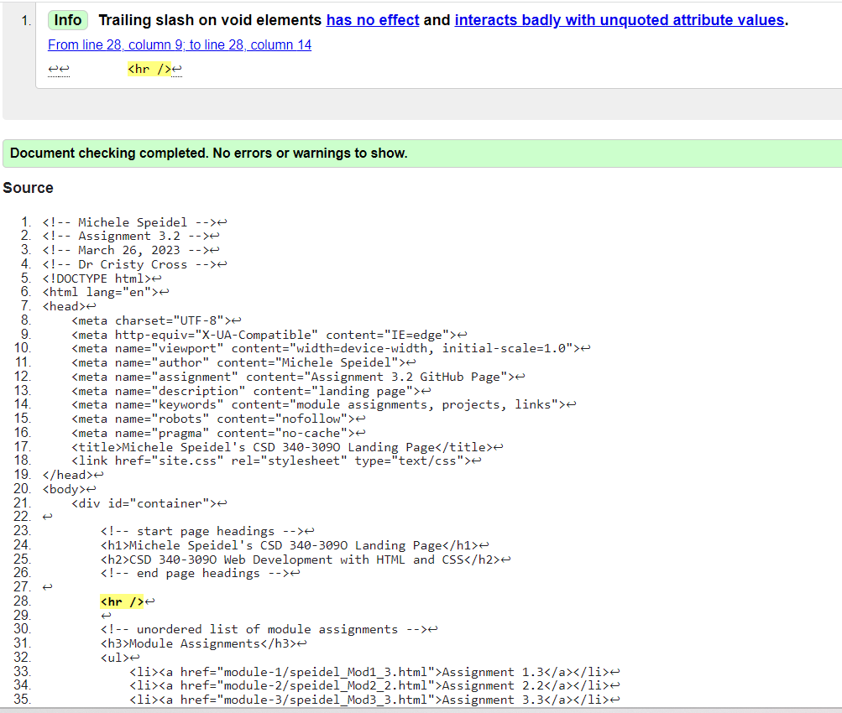

CSS Validator W3C

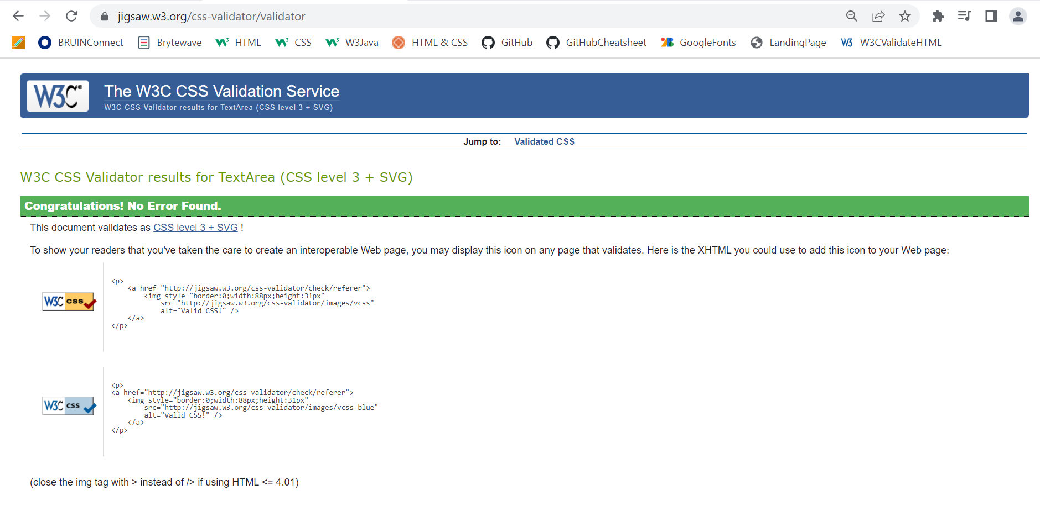

Index Page

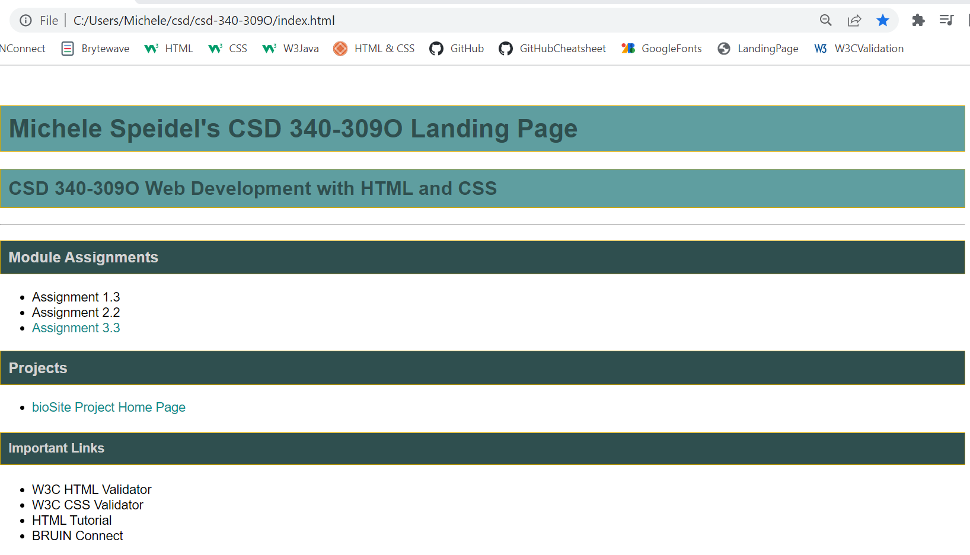

HTML Code

<!-- Michele Speidel -->

<!-- Assignment 3.2 -->

<!-- March 26, 2023 -->

<!-- Dr Cristy Cross -->

<!DOCTYPE html>

<html lang="en">

<head>

    <meta charset="UTF-8">

    <meta http-equiv="X-UA-Compatible" content="IE=edge">

    <meta name="viewport" content="width=device-width, initial-scale=1.0">

    <meta name="author" content="Michele Speidel">

    <meta name="assignment" content="Assignment 3.2 GitHub Page">

    <meta name="description" content="landing page">

    <meta name="keywords" content="module assignments, projects, links">

    <meta name="robots" content="nofollow">

    <meta name="pragma" content="no-cache">

    <title>Michele Speidel's CSD 340-309O Landing Page</title>

    <link href="site.css" rel="stylesheet" type="text/css">

</head>

<body>

    <div id="container">

        <!-- start page headings -->

        <h1>Michele Speidel's CSD 340-309O Landing Page</h1>

        <h2>CSD 340-309O Web Development with HTML and CSS</h2>

        <!-- end page headings -->

        <hr />

        <!-- unordered list of module assignments -->

        <h3>Module Assignments</h3>

        <ul>

            <li><a href="module-1/speidel_Mod1_3.html">Assignment 1.3</a></li>

            <li><a href="module-2/speidel_Mod2_2.html">Assignment 2.2</a></li>

            <li><a href="module-3/speidel_Mod3_3.html">Assignment 3.3</a></li>

        </ul>

        <!-- unordered list of projects -->

        <h3>Projects</h3>

        <ul>

            <li><a href="bioSite_Project_Home_Page.html" target="_blank">bioSite Project Home Page</a></li>

        </ul>

        <!-- unordered list of important links -->

        <h4>Important Links</h4>

        <ul>

            <li><a href="https://validator.w3.org" target="_blank">W3C HTML Validator</a></li>

            <li><a href="https://jigsaw.w3.org/css-validator/" target="_blank">W3C CSS Validator</a></li>

            <li><a href="https://www.w3schools.com/html/" target="_blank">HTML Tutorial</a></li>

            <li><a href="https://bruinconnect.bellevue.edu/" target="_blank">BRUIN Connect</a></li>

        </ul>

    </div>

</body>

</html>

<!-- references -->

<!-- Duckett, Jon. (2022). HTML & CSS; design and build websites. John Wiley & Sons, Inc. -->

<!-- Hankin, Bob. (2016). GD230_font-family; YouTube. Bob Hankins. Retrieved March, 24, 2023, from https://www.youtube.com/watch?v=z9LIHs6w530&t=98s&ab_channel=BobHankin -->

CSS Code

#container {

    margin-top: 50px;

    margin-left: 100px;

    margin-right: 100px;

    font-family: Arial, Helvetica, sans-serif, serif;

}

h1, h2, h3, h4 {

    background-color:cadetblue;

    color:darkslategray;

    border: 1px solid #d6a800;

    padding: 10px;

}

h3 {

    background-color:darkslategray;

    color:lightgrey;

}

h4 {

    background-color:darkslategray;

    color:lightgrey;

}

a:link {

    text-decoration: none;

    color:darkcyan;

}

a:visited {

    color:black;

}

a:hover {

    text-decoration: underline;

    color:peru;

}

GitHub Repository

<https://github.com/jamdmmsfreese/csd-340-309O>

Additional References:

(N/A). (2013). HTML Markup Validation Service. W3C. Retrieved March 25, 2023, from

<https://validator.w3.org/#validate_by_input>

(N/A). (2009). CSS Markup Validation Services. W3C. Retrieved March 25, 2023, from

<https://jigsaw.w3.org/css-validator/#validate_by_input>