Michele Speidel

3/26/2023

Module 3.3 Assignment

Building A Web Page Exercise – Part 3

CSD340-309O_2235_DD

Web Development with HTML and CSS

Instructor Cristy Cross

Subject: Michele Speidel Module 3 Assignment 3

Document: speidel-340-309O-assignment-3-building-a-web-page-exercise-part-3

zip file: module-3

GitHub Repository: <https://github.com/jamdmmsfreese/csd-340-309O/tree/main/module-3>

GitHub Landing Page Website: <https://jamdmmsfreese.github.io/csd-340-309O/>

HTML Validator W3C

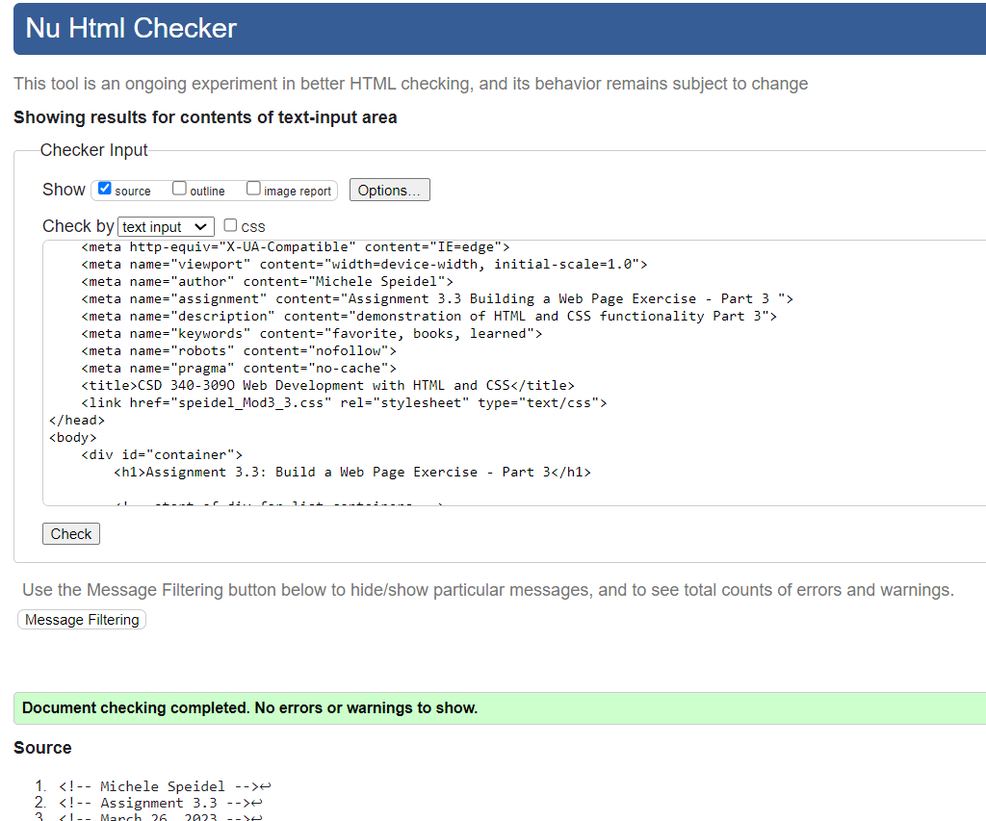

CSS Validator W3C

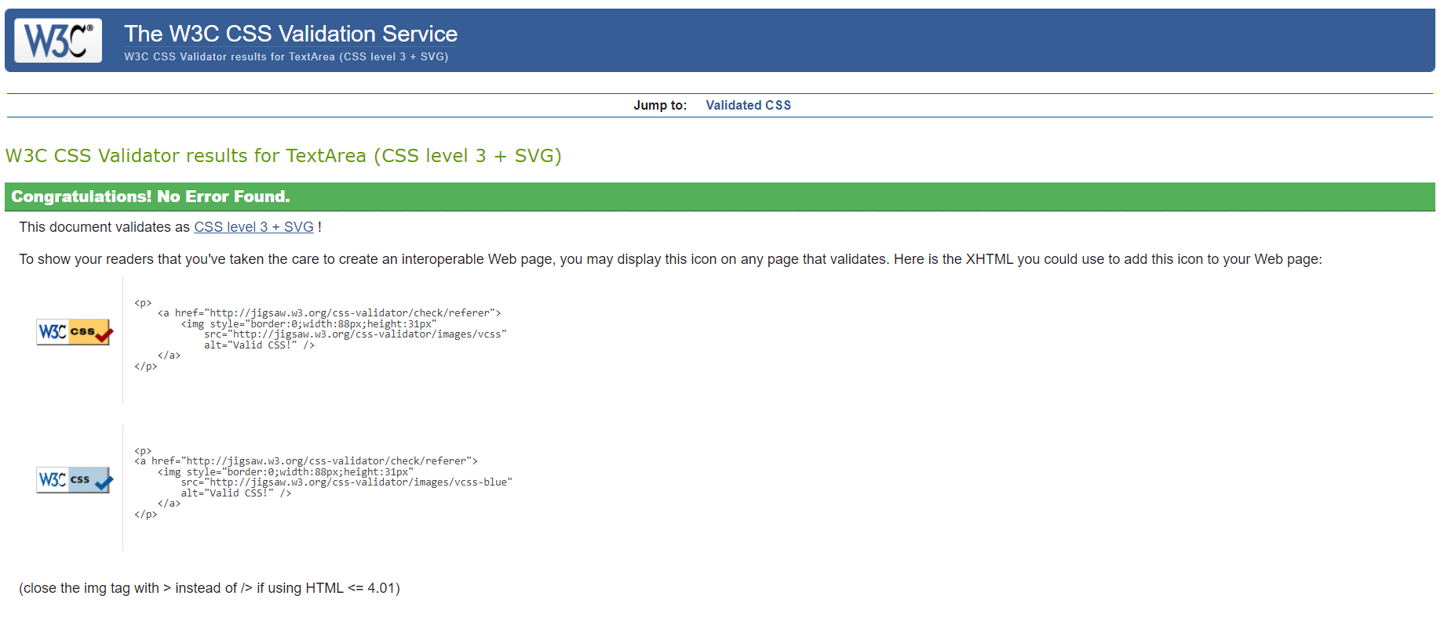

Index Page

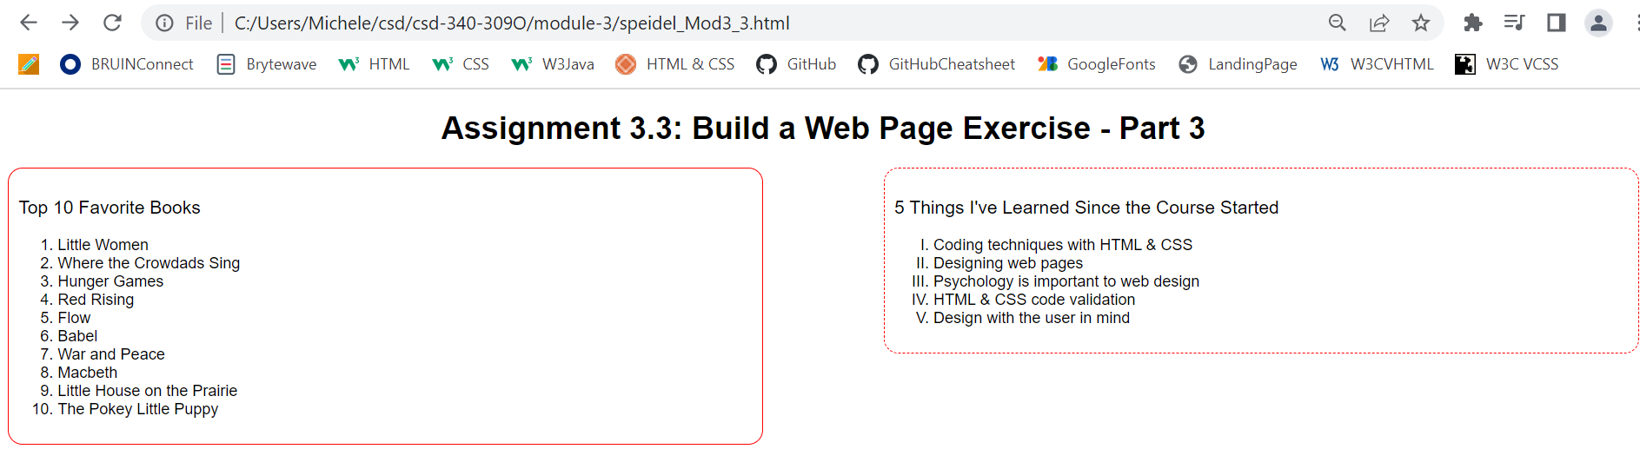



HTML Code

<!-- Michele Speidel -->

<!-- Assignment 3.3 -->

<!-- March 26, 2023 -->

<!-- Dr Cristy Cross -->

<!DOCTYPE html>

<html lang="en">

<head>

    <meta charset="UTF-8">

    <meta http-equiv="X-UA-Compatible" content="IE=edge">

    <meta name="viewport" content="width=device-width, initial-scale=1.0">

    <meta name="author" content="Michele Speidel">

    <meta name="assignment" content="Assignment 3.3 Building a Web Page Exercise - Part 3 ">

    <meta name="description" content="demonstration of HTML and CSS functionality Part 3">

    <meta name="keywords" content="favorite, books, learned">

    <meta name="robots" content="nofollow">

    <meta name="pragma" content="no-cache">

    <title>CSD 340-309O Web Development with HTML and CSS</title>

    <link href="speidel_Mod3_3.css" rel="stylesheet" type="text/css">

</head>

<body>

    <div id="container">

        <h1>Assignment 3.3: Build a Web Page Exercise - Part 3</h1>

        <!-- start of div for list containers -->

        <div class="boxContainer">

            <!-- start of left list container -->

            <div class="divLeft">

                <h3>Top 10 Favorite Books</h3>

                <ol>

                    <li>Little Women</li>

                    <li>Where the Crowdads Sing</li>

                    <li>Hunger Games</li>

                    <li>Red Rising</li>

                    <li>Flow</li>

                    <li>Babel</li>

                    <li>War and Peace</li>

                    <li>Macbeth</li>

                    <li>Little House on the Prairie</li>

                    <li>The Pokey Little Puppy</li>

                </ol>

            </div>

            <!-- end of left list container -->

            <!-- start of right list container -->

            <div class="divRight">

                <h3>5 Things I've Learned Since the Course Started</h3>

                <ul>

                    <li>Coding techniques with HTML & CSS</li>

                    <li>Designing web pages</li>

                    <li>Psychology is important to web design</li>

                    <li>HTML & CSS code validation</li>

                    <li>Design with the user in mind</li>

                </ul>

            </div>

            <!-- start of right list container -->

        </div>

        <!-- end of div for list containers -->

        <!-- page space and link back to landing page-->

        <div class="pageSpace">

        </div>

        <div class="LinkLanding">

            <a href="../index.html">Back to Landing Page</a>

        </div>

     </div>

</body>

</html>

<!-- references -->

<!-- Duckett, Jon.  (2022).  HTML & CSS; design and build websites. John Wiley & Sons, Inc. -->

<!-- (N/A). (2020). 3 Ways to Display Two divs Side by Side (Float, Flexbox, CSS Grid). Coder-Coder. Retreived March 25, 2023, from https://coder-coder.com/display-divs-side-by-side/

  -->

CSS Code

#container {

    font-family: Arial, Helvetica, sans-serif, serif;

}

h1 {

    text-align: center;

}

h3 {

    font-weight: 500;

}

li{

    font-weight: 300;

}

.divLeft {

    border: 1px solid;

    border-color:red;

    border-radius: 15px;

    float: left;

    width: 45%;

    padding: 10px

}

.divRight {

    border: 1px dashed;

    border-color:red;

    border-radius: 15px;

    float: right;

    width: 45%;

    padding: 10px;

}

ul{

    list-style-type: upper-roman;

}

.pageSpace {

    width: 100%;

    margin-top: 60%;

}

.LinkLanding {

    float: right;

    margin-bottom: 20px;

}

a:hover {

    text-decoration: underline;

    color:peru;

}

GitHub Repository

<https://github.com/jamdmmsfreese/csd-340-309O>

Additional References:

(N/A). (2013). HTML Markup Validation Service. W3C. Retrieved March 25, 2023, from

<https://validator.w3.org/#validate_by_input>

(N/A). (2009). CSS Markup Validation Services. W3C. Retrieved March 25, 2023, from

<https://jigsaw.w3.org/css-validator/#validate_by_input>