Michele Speidel

4/2/2023

Module 4.2 Assignment

Build A Web Page Exercise Part 4

CSD340-309O_2235_DD

Web Development with HTML and CSS

Instructor Cristy Cross

Subject: Michele Speidel Module 4 Assignment 2

Document: speidel-340-309O-assignment-2-build-a-web-page-exercise-part-4

zip file: module-4

GitHub Repository: [https://github.com/jamdmmsfreese/csd-340-309O/tree/main/module-](https://github.com/jamdmmsfreese/csd-340-309O/tree/main/module-1)4

GitHub Landing Page Website: <https://jamdmmsfreese.github.io/csd-340-309O/>

This document also shows the following: A fix to book titles from speidel_Mod3_3.html

**W3C HTML Validator**

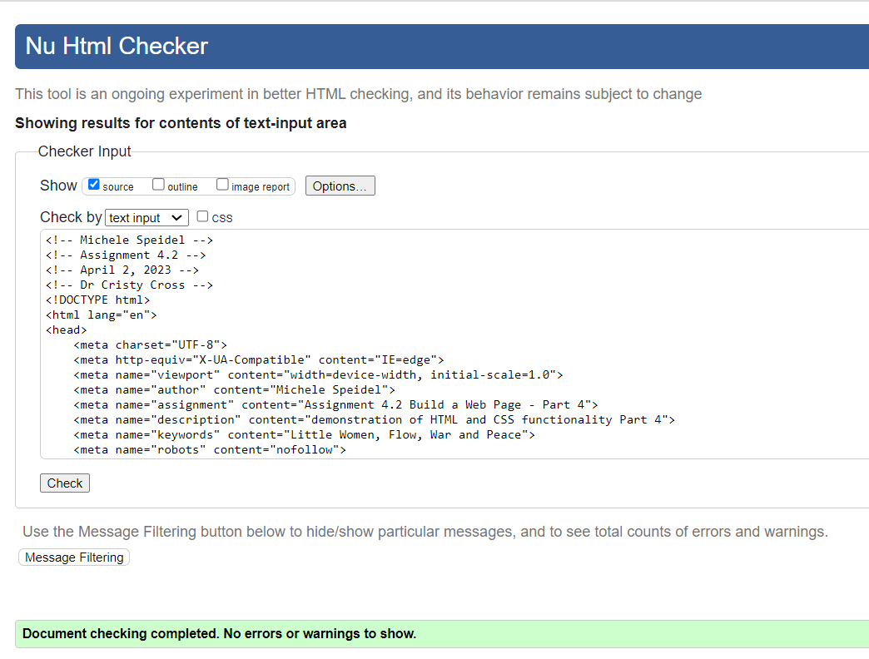

**W3C CSS Validator**

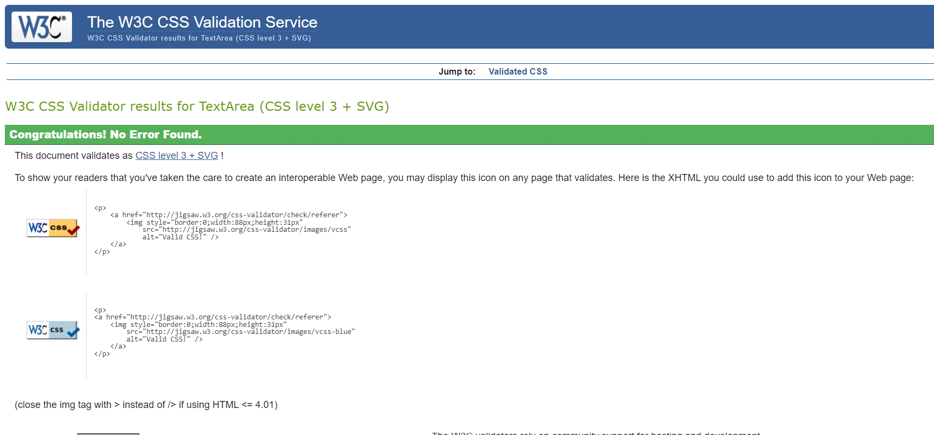

**Assignment 4.2 Web Page**

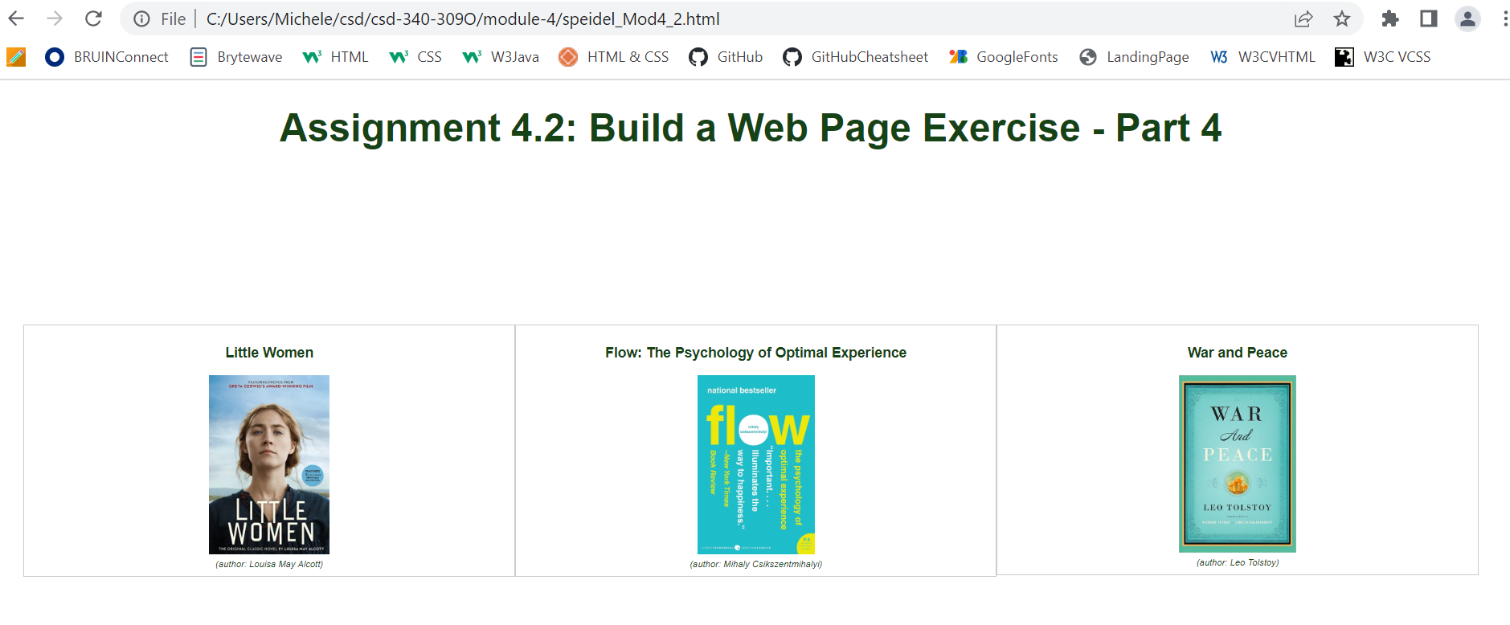



**Fixed Book Titles in Module 3.3**

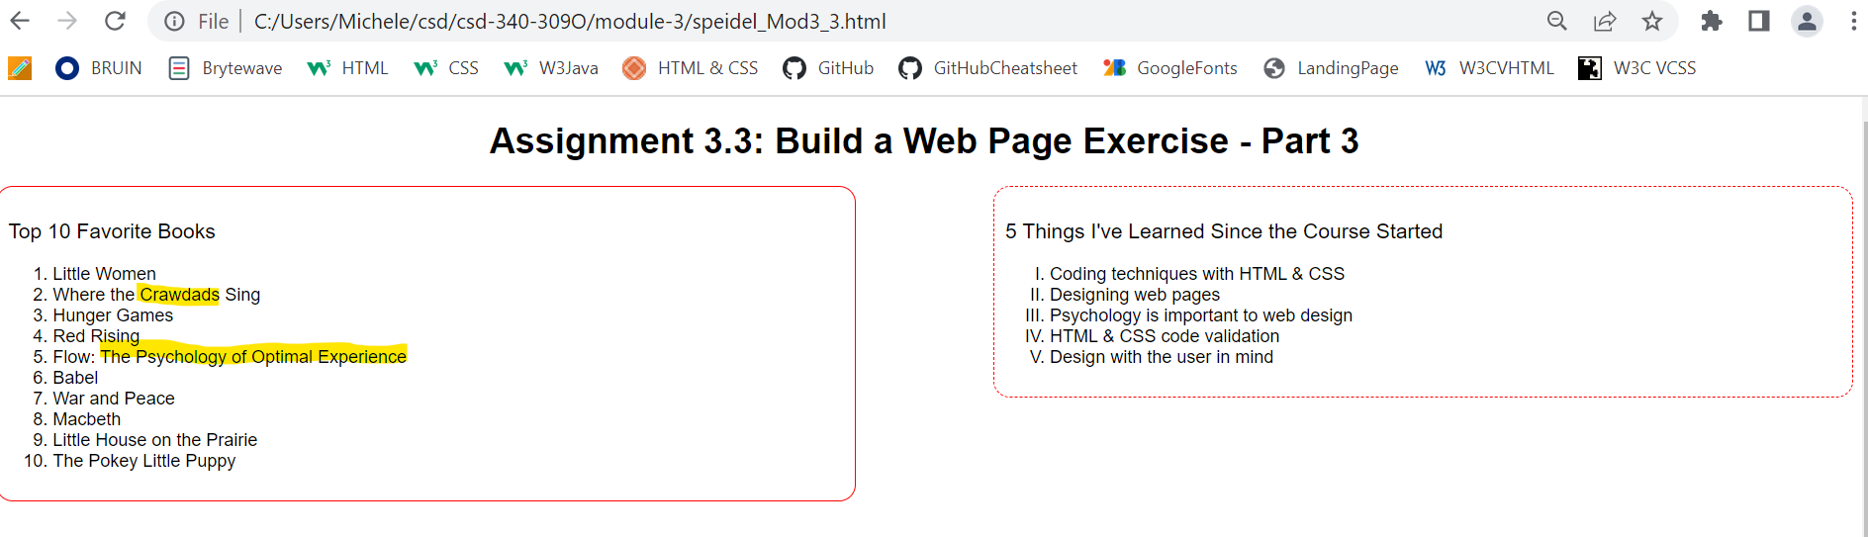

HTML Code

<!-- Michele Speidel -->

<!-- Assignment 4.2 -->

<!-- April 2, 2023 -->

<!-- Dr Cristy Cross -->

<!DOCTYPE html>

<html lang="en">

<head>

    <meta charset="UTF-8">

    <meta http-equiv="X-UA-Compatible" content="IE=edge">

    <meta name="viewport" content="width=device-width, initial-scale=1.0">

    <meta name="author" content="Michele Speidel">

    <meta name="assignment" content="Assignment 4.2 Build a Web Page - Part 4">

    <meta name="description" content="demonstration of HTML and CSS functionality Part 4">

    <meta name="keywords" content="Little Women, Flow, War and Peace">

    <meta name="robots" content="nofollow">

    <meta name="pragma" content="no-cache">

    <title>CSD 340-309O Web Development with HTML and CSS</title>

    <link href="speidel_Mod4_2.css" rel="stylesheet" type="text/css">

    <!-- start of css class style -->

    <style>

        .grid-container {

            display: grid;

            grid-template-columns: auto auto auto;

            padding: 20px;

        }

            .grid-item {

                font-size: 10px;

                text-align: center;

                font-family: Arial, Helvetica, sans-serif, serif;

            }

        figure {

            border: 1px #cccccc solid;

            padding: 4px;

            margin: auto;

          }

        figcaption {

            background-color: white;

            color: rgba(22, 67, 22);

            font-style: italic;

            font-size: .75em;

            padding: 2px;

            text-align: center;

        }

    </style>

    <!-- end of css class style -->

</head>

<body>

    <div id="container">

        <h1>Assignment 4.2: Build a Web Page Exercise - Part 4</h1>

    <!-- start image-gallery containing 3-images -->

    <div id="image-gallery">

        <div class="grid-container">

            <!-- start image 1 -->

            <div class="grid-item">

                <figure>

                    <h3>Little Women</h3>

                    <img src="images/img-book-little-women.jpeg" alt="Book Little Women" style="width:25%">

                    <figcaption>(author: Louisa May Alcott)</figcaption>

                </figure>

            </div>

            <!-- end image 1 -->

            <!-- start image 2 -->

            <div class="grid-item">

                <figure>

                    <h3>Flow: The Psychology of Optimal Experience</h3>

                    <img src="images/img-book-flow-the-psychology-of-optimal-experience.jpg" alt="Book Flow: The Psychology of Optimal Experience" style="width:25%">

                    <figcaption>(author: Mihaly Csikszentmihalyi)</figcaption>

                </figure>

            </div>

            <!-- end image 2 -->

            <!-- start image 3 -->

            <div class="grid-item">

                <figure>

                    <h3>War and Peace</h3>

                    <img src="images/img-book-war-and-peace.jpg" alt="Book War and Peace" style="width:25%">

                    <figcaption>(author: Leo Tolstoy)</figcaption>

                    <!-- Book Translators -->

                    <!-- (Translator: Richard Pevear) -->

                    <!-- (Translator: Larissa Volokhonsky) -->

                </figure>

            </div>

            <!-- end image 3 -->

        </div>

        <!-- page space and link back to landing page-->

        <div class="pageSpace"></div>

        <div class="LinkLanding">

            <a href="../index.html">Back to Landing Page</a>

        </div>

    </div>

    <!-- end image-gallery-->

    </div>

</body>

</html>

<!-- references -->

<!-- CSS Tutorial; CSS Grid Layout Module. (2023). W3Schools. Retrieved March 31, 2023, from https://www.w3schools.com/css/tryit.asp?filename=trycss_grid_grid-row-gap -->

<!-- Duckett, Jon.  (2022).  HTML & CSS; design and build websites. John Wiley & Sons, Inc. -->

<!-- HTML Tutorial; HTML <figcaption> Tag. (2023). W3Schools. Retrieved March 31, 2023, from https://www.w3schools.com/tags/tag_figcaption.asp -->

<!-- image references -->

<!-- Flow: The Psychology of Optimal Experience Book Image. (2023). Barns & Noble Booksellers, Inc. Retrieved March 31, 2023, from

https://www.barnesandnoble.com/w/flow-mihaly-csikszentmihalyi/1103371187?ean=9780061339202 -->

<!-- Little Woman Book Image. (2023). Barns & Noble Booksellers, Inc. Retrieved March 31, 2023, from

https://www.barnesandnoble.com/w/little-women-louisa-may-alcott/1132798825?ean=9781419751615 -->

<!-- War and Peace Book Image. (2023). Barns & Noble Booksellers, Inc. Retrieved March 31, 2023, from

https://www.barnesandnoble.com/w/war-and-peace-pevear-volokhonsky-translation-leo-tolstoy/1106029184?ean=9781400079988 -->

CSS Code

#container {

    font-family: Arial, Helvetica, sans-serif, serif;

}

#image-gallery {

    margin-top: 10%;

}

h1, h3 {

    text-align: center;

    color: rgb(22, 67, 22);

}

.pageSpace {

    width: 100%;

    margin-top: 60%;

}

.LinkLanding {

    float: right;

    margin-bottom: 20px;

    font-size: 12px;

}

a:hover {

    text-decoration: underline;

    color:peru;

}

Additional References:

HTML Markup Validation Service. (2013). W3C. Retrieved March 31, 2023, from

<https://validator.w3.org/#validate_by_input>

CSS Markup Validation Services. (2009). W3C. Retrieved March 31, 2023, from

<https://jigsaw.w3.org/css-validator/#validate_by_input>