Power Supply Controller Automated Test Equipment (PSC ATE) User’s Guide
D. Bergman
Rev 1.2 11/10/25

Introduction

The Power Supply Controller Automated Test Equipment (PSC ATE) is a system for performing automated testing of an ALS-U-type PSC. The system consists of a 4-channel tester PCB with embedded firmware, cable connections to a PSC under test for channel control and DCCT current feedback, and application software for carrying out automated testing. Additional test equipment is included in the test rack for supporting calibration of the PSC channels.

The PSC ATE connects via an ethernet socket connection to a host computer running the test application program. The host computer also has an EPICS IOC for communicating with the PSC.

The picture below shows the PSC ATE PCB with its cable connections to a 4CH PSC and ethernet connection.

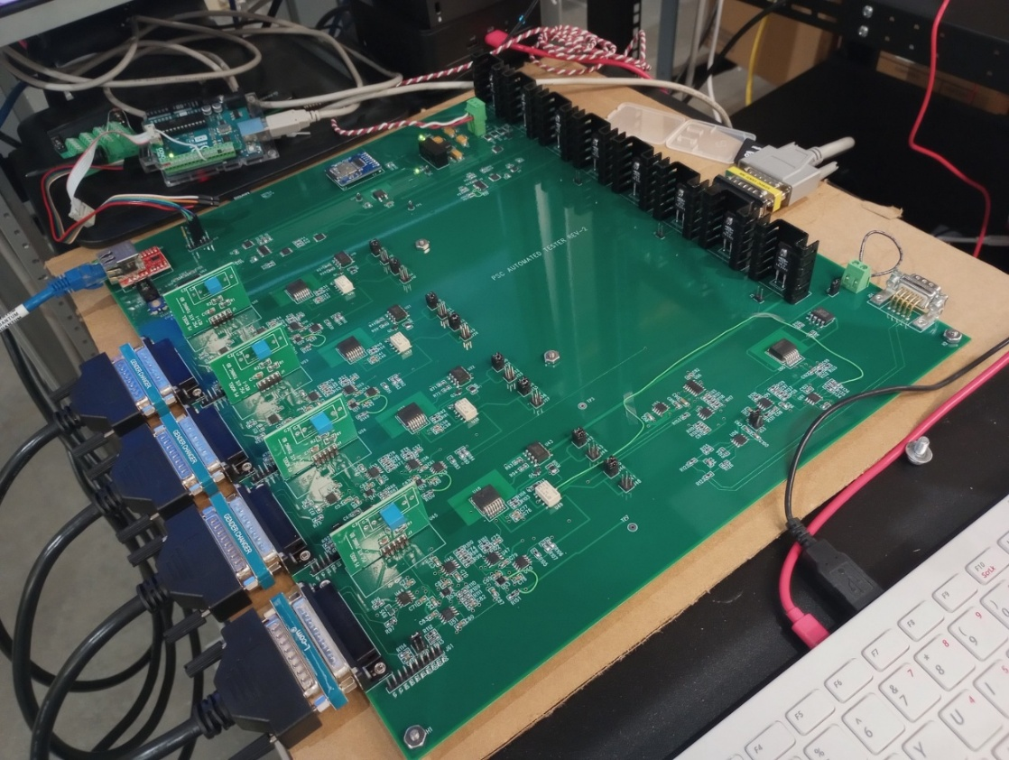

PSC ATE Features

The PSC ATE emulates the analog and digital signals that go between a power supply and a PSC at the channel control connectors. Additionally, plug-in tuning boards allow the PSC ATE to emulate the PID control loop dynamics of a power supply and magnet load without the need for an actual power converter or magnet. The plug-in tuning boards provide the dc transfer gain, magnet time constant, and power converter bandwidth limit of any power converter and magnet combination.

The PSC ATE provides a dummy UDP data packet like the one used by the bipolar power converters.

The PSC ATE also includes an on-board calibrated current reference with a range of -0.2 A to 0.2 A for performing a calibration operation on each channel of the PSC. The programming resolution of the current source is 20-bits. Each channel of the PSC ATE includes a relay that selects between test mode and calibration mode.

The PSC ATE does not have the capability to test the fast orbit feedback or EVR functions of the PSC, nor does it explicitly test the PSC snapshot functions.

Programmable Functions

The PSC ATE provides the following programmable functions. The functions are controlled through ascii messaging over a UDP socket connection.

- Set Ft1/SumFlt (DI1), Flt2/HB (DI2), Flt3/Klixon (DI-Spare)
- Set DCCT Fault
- Read DCCT ±15 V levels
- Set channel Ignd level
- Set gains for Vmon and Imon readback signals
- Select channel Test or Cal mode.
- Calibration current source On/Off
- Set value of calibration 20-bit DAC

In addition to the programmable functions, the PSC ATE also verifies PSC DO signals by providing appropriate responses to the ON1, ON2, and Reset digital output bits.
Programming Command Syntax
- Set DI bits:
DIxyz\n where x is channel number, y is fault DI bit, and z is 0 (low) or 1 (high).

Example: DI111\n set channel 1 DI-1 (FLT1) high
DI320\n set channel 3 DI-2 (FLT2) low
DI201\n set channel 2 DI-0 (ACon) high

- Set DCCT Faults:
Dx\n where x is 0, 1, 2, 3, 4

Example: D1\n set channel 1 DCCT fault
D4\n set channel 4 DCCT fault
D0\n set no DCCT fault

- Read DCCT +15V14, -15V14, +15V58, -15V58 voltage levels:
D15?\n
Receive four floats (8 bytes) over ethernet

- Set channel Ignd level:
Igndxd.ddd\n where x is channel number and d.ddd is number between -4.999 and 4.999.

Example: Ignd12.250\n set channel 1 Ignd level to 2.250 V
Ignd2-1.234\n set channel 2 Ignd level to -1.234 V

- Set channel Vmon and Imon gains:
First set Imon gain:

Ix0.ddd\n where x is channel and 0.ddd is decimal between 0 and 0.999.
Example: I10.333\n set CH1 Imon gain to 0.333

The value for Imon gain should be equal to

G = 0.02 * N / I_{max} where N is the DCCT turns ratio (typically 1000), and I_{max} is the Current Rating in Amps of the TDK/Lambda power converter being emulated.

Then set Vmon gain:

Vx0.ddd\n where x is channel and 0.ddd is decimal between 0 and 0.999.

Example: V10.0.500\n set CH1 Imon gain to 0.500

The value for Vmon gain should be 0.5.

Sending the V command will update the digipots for both the Imon and Vmon signals.

Note that the spare analog readback serves as Imon for unipolar power converters and as DC bus for bipolar power converters. Jumper pairs J16/J17, J27/J28, J38/J39, and J49/J50 select between Imon and DC bus for channels 1 through 4 respectively.

When testing a unipolar power converter, use jumpers J16, J27, J38, and J49.

When testing a bipolar power converter, use jumpers J17, J28, J39, and J50.

The Imon digipot changes the gain only for the Imon readback, not the DC bus readback.

- Set channel mode Test or Calibrate

Txd\n where x is channel number and d is 0 (Test) or 1 (Calibrate)

Example: T10\n set channel 1 to Test mode
T31\n set channel 3 to Calibrate mode
Note that only one channel may be calibrated at a time. To calibrate a channel, turn the channel off, select Calibrate mode for the channel, then turn on the calibration source.

- Calibration source ON/OFF:
CALd\n where d is 0 (Cal source OFF) or 1 (CAL source ON)

Example: CAL0\n Cal source OFF

- Set Calibration source value

CALDACd.ddddd\n where d.ddddd is decimal between -9.99999 and 9.99999

Example: CALDAC1.00000 set CALDAC to 1 V = 20 mA

- Set Power Converter Fault:
Fx\n where x is channel number
Example: F1\n set CH1 power converter fault
The fault is a latched condition in the ATE. Reset is required to clear the fault.

- Select power converter emulation mode:
P0\n for Bipolar Power Converter
P1\n for Unipolar Power Converter

Software

A simple python utility program has been written to facilitate sending commands to the PSC ATE. The user interface is shown in the figure:

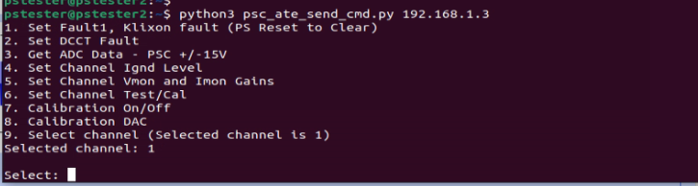

A GUI version of this program has also been developed. These programs allow for manual control of PSC ATE functions. For this purpose, a custom automation program is needed.

Addendum

The following two pictures show the PID tuning board.

