Title page

Tree censuses of the Barro Colorado Island 50-ha plot, Panama, 1982–2023
David Mitre¹, Rolando Pérez¹, Salomón Aguilar¹, Suzanne Lao¹, Stuart J. Davies¹, and José A. Medina-Vega¹
¹ Smithsonian Tropical Research Institute, Apartado 0843-03092, Balboa, Ancón, Republic of Panama
ORCID iDs
David Mitre: https://orcid.org/
Rolando Pérez: https://orcid.org/
Salomón Aguilar: https://orcid.org/
Suzanne Lao: https://orcid.org/
Stuart J. Davies: https://orcid.org/0000-0002-8596-7522
José A. Medina-Vega: https://orcid.org/0000-0001-5468-5605
Corresponding author: José A. Medina-Vega, medinaja@si.edu

Keywords
Barro Colorado Island; census; demography; forest dynamics plot; ForestGEO; long-term monitoring; Panama; tropical moist forest

Acknowledgments
Funding. The Barro Colorado Island (BCI) forest dynamics research project was made possible by National Science Foundation grants to Stephen P. Hubbell: DEB-0640386, DEB-0425651, DEB-0346488, DEB-0129874, DEB-00753102, DEB-9909347, DEB-9615226, DEB-9405933, DEB-9221033, DEB-9100058, DEB-8906869, DEB-8605042, DEB-8206992 and DEB-7922197. Since the 2015 census, the project’s primary funder has been the Smithsonian Institution. We acknowledge additional support from the HSBC Climate Partnership, the John D. and Catherine T. MacArthur Foundation, the Andrew W. Mellon Foundation, the Frank H. Levinson Family Foundation, the Small World Institute Fund and numerous private individuals. In its first two decades the project was also supported by the Smithsonian Scholarly Studies Program, the World Wildlife Fund, the Earthwatch Center for Field Studies, the National Geographic Society, the Geraldine R. Dodge Foundation, the W. Alton Jones Foundation, the Pew Charitable Trusts and the Guggenheim Foundation. The plot is part of ForestGEO, a global network of large-scale forest dynamics plots.
Field stations, marine laboratories and related research institutions. The data were collected in the Barro Colorado Nature Monument, Panama, at the Barro Colorado Island (9.15° N, 79.85° W). We thank the Smithsonian Tropical Research Institute for logistical support.
Additional acknowledgments. We thank Robin B. Foster, who co-founded the plot with Stephen P. Hubbell and led its botany through the first censuses; Richard Condit, data manager from 1991 and head of the project from 1995 to 2010; Steven Dolins for designing the tree census database; and Allen Herre, Jeff Klahn, Sue Williams and Zenith Batista, who led field work in the 1980s and the 1990 census. We also thank the hundreds of field assistants, botanists and data managers who have censused the plot since its establishment, and the field team that completed the ninth census in 2022–2023: Richar Martínez, Victor Rojas, Luis Navarro, Luis Alfredo Martínez, Roni Saenz, Guillermo Aguilar, Luis Aguilar, Biancolini Castro, Anayansi Cerezo, Luis Cedeño, Tamara Ubarte, Reina Bermudez, and Eliecer Alvarado.

Contributor Roles
David Mitre: project management, data curation. Rolando Pérez and Salomón Aguilar: data curation (taxonomy). Suzanne Lao: data curation. Stuart J. Davies: funding acquisition, project administration, resources, supervision. José A. Medina-Vega: methodology (stem reconstruction), data curation (R tables), validation, writing – original draft. All authors: writing – review and editing.

Conflict of Interest
The authors declare no conflicts of interest.

Abstract
The 50-ha Forest Dynamics Plot on Barro Colorado Island (BCI), Panama, is the oldest plot of the Forest Global Earth Observatory (ForestGEO) and one of the most studied tropical forests in the world. In each census, every free-standing woody stem at least 1 cm in diameter at breast height (DBH) in the 1000 × 500 m plot of lowland moist forest is tagged, mapped, identified and measured. We present nine censuses (1982, 1985, 1990, 1995, 2000, 2005, 2010, 2015 and 2022–2023), describing the fate of 460,211 individuals from 327 taxa in 62 families. In the most recent census (2022–2023), the plot held 203,489 living individuals with a stem at 1.3 m, with a mean of 4,070 [4,023–4,114] ind. ha⁻¹, of 300 species, 179 genera and 59 families, and a mean basal area of 31.35 [30.38-32.37] m² ha⁻¹ from the diameters as recorded. Abundance was uneven: 212 species (70.7%) fell below half the community-wide mean abundance (< 339 individuals), of which 67 (22.3% of all species) were represented by ten or fewer individuals and 22 occurred as singletons. The three most abundant species by individual count were Pombalia prunifolia (12.15% of all individuals), Faramea occidentalis (10.62%), and Trichilia tuberculata (4.95%). The greatest contributions to stand basal area were made by Quararibea stenophylla (5.48% of total plot-level basal area), Prioria copaifera (5.1%), and Alseis blackiana (5.1%). At the family level, the most individual-rich families were Rubiaceae (18 genera, 29 species; 18.46% of all standing individuals), Violaceae (2 genera, 2 species; 13.26%), and Fabaceae (19 genera, 36 species; 8.42%). The families contributing most to stand basal area were Malvaceae (15 genera, 16 species; 15.41% of total plot-level basal area), Fabaceae (11.31%), and Rubiaceae (10.17%). Fabaceae and Rubiaceae were notable for ranking highly in both metrics, while Violaceae dominated by individual count despite negligible basal area (0.99%), and Malvaceae dominated basal area with comparatively few individuals (1.82% of all individuals). This long-term dataset supports studies of tree demography and species coexistence, of biomass and carbon dynamics, and of forest responses to climate.

Overview
Large forest dynamics plots, in which every stem above a small size is mapped, identified and remeasured at regular intervals, underpin much of what is known about tropical forest diversity and dynamics (Anderson‐Teixeira et al. 2015; Davies et al. 2021). The 50-ha plot on Barro Colorado Island (BCI), Panama, was the first. Stephen Hubbell and Robin Foster established it in 1980; its first census, the 1982 census, ran from 1981 to 1983 (Hubbell & Foster 1983; Hubbell et al. 2024). It became the model for the Forest Global Earth Observatory (ForestGEO), now more than 85 plots (Davies et al. 2021). Its censuses have been used to study density dependence and coexistence (Hubbell et al. 1990, 1999; Comita et al. 2010), habitat associations (Harms et al. 2001), immigration (Condit et al. 2012), demographic trade-offs (Rüger et al. 2018, 2020), compositional change and climate (Feeley et al. 2011; Condit et al. 2017), and biomass dynamics (Chave et al. 2003; Piponiot et al. 2022, 2024; Rutishauser et al. 2020).
The last public release (Condit et al. 2019a, b) held eight censuses, 1982–2015. This release adds the ninth census, taken in 2022–2023. It updates the species names, documents the names that changed since the previous release, and makes stems comparable across censuses. Before 2010 the database followed individuals, not stems: the tag of the individual was on the main stem, and the other stems of an individual often received a new database identifier at each census, which cut their histories. Since 2010 every stem has carried its own tag. We reconstructed the earlier stem histories, with their uncertainty.
The data are for ecologists who study tropical forest demography and diversity, for carbon-cycle scientists, and for modellers who calibrate or test vegetation models with plot data.

Data Availability
The data, metadata (Metadata.md), README and code are archived at repository, https://doi.org/xxxx under license: XXXX. The data are R data files (Rtables; Tables 1, 2,…,9). The package code loads the files and reproduces every table and number of this paper. The code that builds Rtables from the raw export of the ForestGEO database, including the stem reconstruction, is at https://github.com/jamedina09/BCI50ha_StemReconstruction_Rtables, archived at Zenodo with DOI. Please cite this paper and the data package. Questions go to the corresponding author; copies of publications to ForestGEO (forestgeo@si.edu).

Data Description
Extent and resolution. The plot is a 1000 × 500 m rectangle (50 ha) of 1,250 quadrats of 20 × 20 m. The nine censuses span 1981 to 2023 (Figure 1); 95% of the records of a census were taken within 8–10 months, except in 1981–1982 (19 months) and 2022–2023 (15 months). Consecutive censuses of an individual were about 5 years apart, except 3.4 years (censuses 1–2) and 7.5 years (8–9).
Taxa. The censuses include every free-standing woody plant: trees, shrubs, palms, tree ferns and strangler figs. The 327 taxa of the species table belong to 191 genera and 62 families. Four are morphospecies, and 74 individuals are not identified.
Sampling unit. Each row is a stem in one census. An individual (treeID, with its field tag) has one or more stems, and treeID and stemID together identify a stem.
Tables. The data package holds nine census tables, a species table and the posterior samples of the stem reconstruction. The census tables (bci.stem1 to bci.stem9) each have 646,813 rows and 17 columns (Table 1): one row for every stem ever recorded, in the same order in all tables (by treeID, then stemID), including the censuses before the stem appeared and after it died. The species table (328 rows, 17 columns; Table 2) gives for each species code the taxonomy, authority, synonyms, growth forms, common name, herbarium collections and, for the 50 species with updates in the taxonomy since the previous release (Condit et al. 2019b), the previous name and the kind of change. The posterior file contains one row per distinct reconstruction sampled for each multi-stemmed individuals whose stem identities were reconstructed and can be joined to the census tables using treeID and StemPaths (Table 4).
Sample sizes. Individuals with a living stem at 1.3 m ranged from 244,252 (1990) to 203,489 (2022–2023; Figure 1); another 5,884–14,498 individuals per census were alive but broken below 1.3 m and generally small (median largest diameter recorded in earlier censuses 10–15 mm; 95–98% never reached 50 mm) with no stem at breast height (13,536 in 2022–2023).
Census 9. The individuals of 2022–2023 (4,070 ind. ha⁻¹, mean across 1,250 quadrats of 20 × 20 m; 95% highest-density interval of bootstrap means: 4,023–4,114 ind. ha⁻¹) belonged to 300 species, 179 genera and 59 families and had a basal area of 31.35 [30.38-32.37] m² ha⁻¹, from the diameters as recorded. Of the species, 212 (70.7%) had fewer than 339 individuals (half the mean abundance), 67 had ten or fewer, and 22 were singletons. Pombalia prunifolia, Faramea occidentalis and Trichilia tuberculata made up 27.7% of the individuals, and Quararibea stenophylla, Prioria copaifera and Alseis blackiana had the largest basal areas. Rubiaceae, Violaceae and Fabaceae had the most individuals, and Malvaceae, Fabaceae and Rubiaceae the largest total basal areas.
Records and status. Each row keeps the field record unedited: diameter (dbh, mm), height of measurement (hom, m), date (ExactDate), codes and field status (DFstatus); these are empty in a census without a record. Rstatus gives every stem a status in every census (Table 3), date gives every row a date, and gx and gy give one location per individual.

Summary of Methods
Site. Barro Colorado Island (BCI; 9.15° N, 79.85° W) is a 15.6-km² island in Gatun Lake, Panama, isolated when the lake was formed during the construction of the Panama Canal (1910–1914) and protected since 1923. It is part of the Barro Colorado Nature Monument, where the Smithsonian Tropical Research Institute runs a field station. The plot lies on the central plateau of the island, at 120–160 m above sea level, in old-growth lowland tropical moist forest that includes a small area of younger forest (Harms et al. 2001). From 1982 to 2023, annual rainfall averaged 2,621 mm (SD = 510 mm), ca. 9.3% of it in the dry season from January to April, and the mean air temperature was 25.9 °C (SD = 0.49 °C; mean and SD calculated using data from complete years only; data provided by the Physical Monitoring Program of the Smithsonian Tropical Research Institute).
Census protocol. Every free-standing woody stem with a DBH of at least 10 mm is mapped within its 20 × 20 m quadrat, identified and measured at 1.3 m or, where the trunk is buttressed or deformed there, above the irregularity, and the height of measurement is recorded. Each individual carries a numbered tag; since 2010 every stem has also carried its own (stem) tag, whereas before 2010 the other stems of an individual were measured untagged. Each census revisits every individual recorded before and adds the stems and new individuals that have reached 10 mm (or 1 cm). The plot’s botanists identify the plants in the field—see Condit (1998) for more details.
Stem reconstruction prior to 2010. The individuals with a single database stem needed no reconstruction. In the multi-stemmed individuals, the identities fixed in the field were kept (i.e., every stem tagged). An exact dynamic program then assigned the remaining measurements to stems, finding the most probable stem histories under a model of stem growth, stem mortality and stem ingrowth estimated from the stems tagged in 2010–2023 (two census intervals). Palm clumps, strangler figs and individuals too large for the exact program were solved by a probabilistic matcher under the same model. The reconstruction of each multi-stemmed individual was sampled 200 times, and the Rtables carry the most probable one.

Limitations and Challenges
Reconstructed stems. Before 2010 the stems of multi-stemmed individuals are inferred, not observed. Individual identity (treeID, tag) is observed, so analyses that treat an individual as the sum (or group) of its stems do not depend on the reconstruction.
Diameter classes. In 1982 and 1985 diameters below 55 mm were recorded in 5-mm classes, so DBH increments of small stems over the first two intervals is coarse.
Height of measurement. On buttressed or damaged trunks the point of measurement was raised over time; those individuals with measurements taken away from 1.3 m are not comparable with those at 1.3 m. Therefore, for assessments of basal area and/or biomass change over time, they should be corrected to 1.3 m, for example, with the taper model of Cushman et al. (2014).
Missing diameters. An alive stem without a diameter is a missed measurement, which can be interpolated from the stem’s own measurements.
Census timing. Censuses took up to 19 months, and intervals differ among quadrats. Intervals should be computed from date, not from census years.
Recruitment and ingrowth. New stems of established individuals (ingrowth) are not new individuals (recruitment) and should be counted separately.
Taxonomy. Names may change again; species codes are stable within this release, and the names were checked against World Flora Online (Kindt 2020; The World Flora Online Consortium et al. 2026).

Scientific Opportunities
The ninth census, after an interval that spans the 2015–2016 El Niño drought, extends tests of directional change in composition, growth and mortality (Feeley et al. 2011; Condit et al. 2017) and of the stability of biomass (Rutishauser et al. 2020; Piponiot et al. 2024). The species table, with growth forms and documented name changes, supports trait-based and phylogenetic analyses of demographic trade-offs (Rüger et al. 2018, 2020) and coexistence (Hubbell et al. 1999; Comita et al. 2010). The provided data can also calibrate remote sensing of canopy change and test vegetation models.

Tables and Figures
Table 1. Columns of the census Rtables bci.stem1 to bci.stem9: one row per stem and census, 646,813 rows in each table, the same stems in the same order.
Column | Content
CensusID | Census 1–9
treeID | Individual (a tree, shrub, palm, tree fern or strangler fig); the same in every census
stemID | Stem number within its individual (1, 2, …); treeID and stemID together identify a stem
tag | Field tag of the individual
StemTag | Field tag of the stem, used since 2010; earlier records may show the tag the stem received later
sp | Species code; joins the species table
quadrat | 20 × 20 m quadrat, XXYY: column (gx/20) and row (gy/20)
gx | Location of the individual, in m east of the western edge (0–1000); one value per individual
gy | Location of the individual, in m north of the southern edge (0–500); one value per individual
dbh | Diameter as recorded, in mm, at height hom; empty when not measured
hom | Height of measurement as recorded, in m
ExactDate | Date of the field record; empty without a record
date | Date of every row, in days since 1 January 1960: the recorded date, else the most common date of the individual, the quadrat or the census
codes | Field codes as recorded, separated by “;”
DFstatus | Field status as recorded: alive, broken below, dead, stem dead, missing; empty without a record
Rstatus | Analytical status: P, A, G or D (Table 3)
StemPaths | Key of the record in the reconstruction, unique within its individual; the posterior samples list the measured records up to the individual's anchor census (2010 for most individuals); empty for individuals not reconstructed

Table 2. Columns of the species table bci.spptable: one row per species code (328 rows).
Column | Content
sp | Species mnemonic code; joins the census tables
Order | Order
Family | Family
Genus | Genus
SpeciesName | Species epithet; for a morphospecies, its label
Latin | Scientific name: genus and epithet, then the infraspecific name when there is one
InfraspecificRank | Rank below species (var. or subsp.); empty when none
InfraspecificEpithet | Epithet below species; empty when none
Authority | Authors of the name
Synonyms | Synonyms and earlier names, separated by commas
Lifeform_RFoster | Growth form after R. B. Foster
Lifeform_RPerez_SAguilar | Growth form and height class after R. Pérez and S. Aguilar (in Spanish)
CommonName | Common names
Herbarium | Herbarium collections
NameCondit2019 | Name of the species in Condit et al. (2019a, 2019b), only when it differs from Latin
NameChange | Kind of change from that name
Notes | Additional notes; what no other column says

Table 3. Analytical status of a stem in a census (Rstatus). Evidence of life is an alive record, a broken-below record (with a diameter, a measured resprout; without one, a stump: the stem broke below 1.3 m and is alive, with no stem at breast height), or a diameter on a missing or status-less record. A dead record is dead or stem dead.
Code | Meaning | Rule
P | prior | Before the stem's first record; placeholder for new individuals and stems in appearing in later censuses.
A | alive | From the first record to the last evidence of life (an alive or broken-below record, or a diameter). An alive cell without a diameter is a missed measurement; a stump, broken below 1.3 m and alive with no stem at breast height.
G | dead stem | Dead, while another stem of its individual is A in that census or later.
D | dead individual | Dead, and every stem of its individual dead.

Table 4. Columns of the posteriors table posterior_sampled_paths (1’554,448 rows).
Column | Content
tag | Field tag of the tree
treeID | Tree
path_sig | Stem label of each sampled record of the tree in this sample, in census order. Labels joined by “-“.
path_count | Number of the tree's 200 samples with this reconstruction. 1–200; sums to 200 per tree. Weight of the row: path_count / 200
path_prob | Reference value of the engine
recon | The stem of each record in this sample. Pairs StemPaths:label separated by ";"

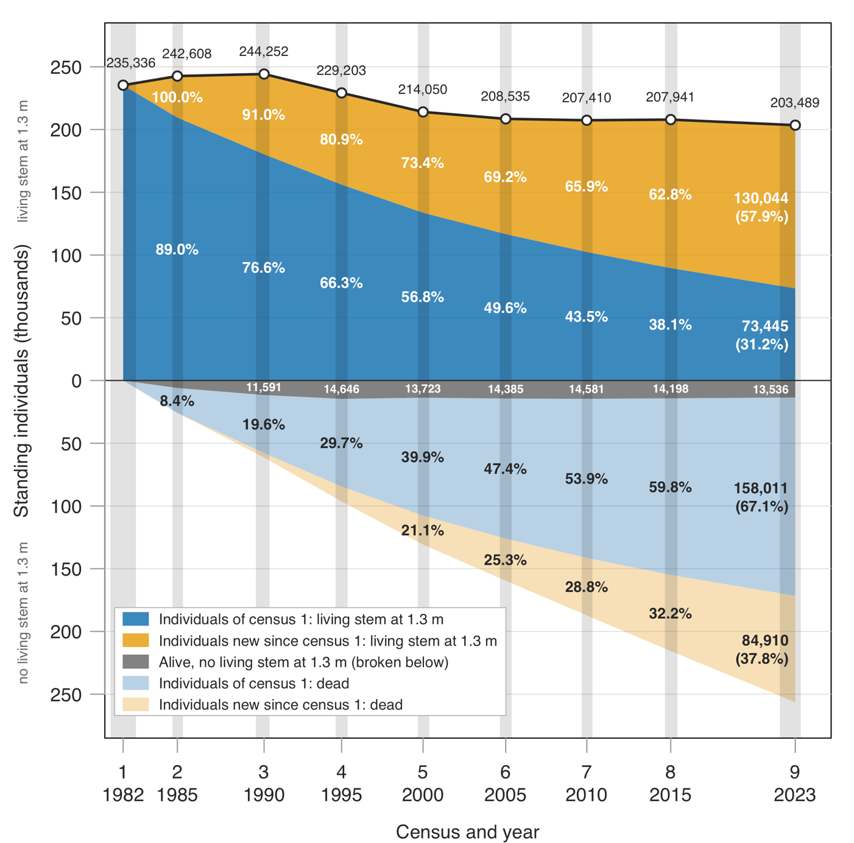
Figure 1. Figure 1. Number of standing individuals of the Barro Colorado Island (BCI) 50-ha plot through nine censuses, 1982–2023. An individual is one free-standing woody plant (a tree, shrub, palm, tree fern or strangler fig), whatever its number of stems. In each census, every individual recorded alive up to then is in one of three groups, from the census tables: with a living stem at 1.3 m, that is, a stem with Rstatus A on a record that is not a stump (above zero; total written above the line; these are the individuals counted in a census); alive without a living stem at 1.3 m (grey, next to zero): broken below 1.3 m, with a record whose field record is broken below and that has no diameter (a stump), or, for a few individuals, missing; and dead (pale colours, cumulative): recorded dead in the field, with no living stem at 1.3 m, and no broken-below record in that census or in any later one. Blue: the 235,336 individuals of census 1; orange: individuals first recorded alive after census 1. Percentages: share of the individuals of the same group, recorded alive up to that census, that have a living stem at 1.3 m (above zero) or are dead (below zero); the rest of each group is in the grey band, whose number of individuals is written in it. Shaded vertical bands: period in which 95% of the records of each census were taken (2.5% to 97.5% quantiles of the record dates); each census is placed at its median record date.

References
Anderson‐Teixeira, K.J., Davies, S.J., Bennett, A.C., Gonzalez‐Akre, E.B., Muller‐Landau, H.C., Joseph Wright, S., et al. (2015). CTFS‐ForestGEO: a worldwide network monitoring forests in an era of global change. Glob. Change Biol., 21, 528–549.
Chave, J., Condit, R., Lao, S., Caspersen, J.P., Foster, R.B. & Hubbell, S.P. (2003). Spatial and temporal variation of biomass in a tropical forest: results from a large census plot in Panama. J. Ecol., 91, 240–252.
Comita, L.S., Muller-Landau, H.C., Aguilar, S. & Hubbell, S.P. (2010). Asymmetric Density Dependence Shapes Species Abundances in a Tropical Tree Community. Science, 329, 330–332.
Condit, R. (1998). Tropical Forest Census Plots. Springer, Berlin, Heidelberg.
Condit, R., Chisholm, R.A. & Hubbell, S.P. (2012). Thirty Years of Forest Census at Barro Colorado and the Importance of Immigration in Maintaining Diversity. PLOS ONE, 7, e49826.
Condit, R., Pérez, R., Aguilar, S., Lao, S., Foster, R. & Hubbell, S. (2019a). Complete data from the Barro Colorado 50-ha plot: 423617 trees, 35 years.
Condit, R., Pérez, R., Aguilar, S., Lao, S., Foster, R. & Stephen, H. (2019b). BCI 50-ha Plot Taxonomy.
Condit, R., Pérez, R., Lao, S., Aguilar, S. & Hubbell, S.P. (2017). Demographic trends and climate over 35 years in the Barro Colorado 50 ha plot. For. Ecosyst., 4, 1–13.
Davies, S.J., Abiem, I., Abu Salim, K., Aguilar, S., Allen, D., Alonso, A., et al. (2021). ForestGEO: understanding forest diversity and dynamics through a global observatory network. Biol. Conserv., 253, 108907.
Feeley, K.J., Davies, S.J., Perez, R., Hubbell, S.P. & Foster, R.B. (2011). Directional changes in the species composition of a tropical forest. Ecology, 92, 871–882.
Harms, K.E., Condit, R., Hubbell, S.P. & Foster, R.B. (2001). Habitat associations of trees and shrubs in a 50-ha neotropical forest plot. J. Ecol., 89, 947–959.
Hubbell, S. & Foster, R.B. (1983). Diversity of Canopy Trees in a Neotropical Forest and Implications for Conservation. In: Tropical Rain Forest: Ecology and Management. Oxford: Blackwell Scientific Publications.
Hubbell, S.P., Condit, R. & Foster, R.B. (1990). Presence and absence of density dependence in a neotropical tree community. Philos. Trans. R. Soc. B Biol. Sci., 330, 269–281.
Hubbell, S.P., Foster, R.B., O’Brien, S.T., Harms, K.E., Condit, R., Wechsler, B., et al. (1999). Light-Gap disturbances, recruitment limitation, and tree diversity in a neotropical forest. Science, 283, 554–7.
Hubbell, S.P., Foster, R.B. & Rubinoff, I. (2024). Early History of the Barro Colorado Island Forest Dynamics Project.
Kindt, R. (2020). WorldFlora: An R package for exact and fuzzy matching of plant names against the World Flora Online taxonomic backbone data. Appl. Plant Sci., 8, e11388.
Piponiot, C., Anderson-Teixeira, K.J., Davies, S.J., Allen, D., Bourg, N.A., Burslem, D.F.R.P., et al. (2022). Distribution of biomass dynamics in relation to tree size in forests across the world. New Phytol., 234, 1664–1677.
Piponiot, C., Condit, R., Hubbell, S.P., Pérez, R., Lao, S., Aguilar, S., et al. (2024). Woody Biomass Stocks and Fluxes in the Barro Colorado Island 50-ha Plot.
Rüger, N., Comita, L.S., Condit, R., Purves, D., Rosenbaum, B., Visser, M.D., et al. (2018). Beyond the fast–slow continuum: demographic dimensions structuring a tropical tree community. Ecol. Lett., 21, 1075–1084.
Rüger, N., Condit, R., Dent, D.H., DeWalt, S.J., Hubbell, S.P., Lichstein, J.W., et al. (2020). Demographic trade-offs predict tropical forest dynamics. Science, 368, 165–168.
Rutishauser, E., Wright, S.J., Condit, R., Hubbell, S.P., Davies, S.J. & Muller-Landau, H.C. (2020). Testing for changes in biomass dynamics in large-scale forest datasets. Glob. Change Biol., 26, 1485–1498.
The World Flora Online Consortium, Elliott, A., Hyam, R., Watson, M., Wrankmore, E., Hartley, H., et al. (2026). World Flora Online Plant List June 2026.

