Understanding American Integrity Insurance Group (AII)
Ticker: AII | Price: $16.60| Shares: 20M | MC: 325M | Cash: $226M | Debt: ~$1M | EV: $99M

Primary Thesis
AII writes ~94% of its policies in Florida making hurricanes sweeping through the Gulf or Atlantic the primary risk to the business. The company maintains a reinsurance program protecting up to $1.9B for the first catastrophe event and $1.5B for a second. The true tail risk however is not the first or second event as both are well protected, but rather the third. Using historical hurricane season data, my estimate suggests the annual probability of a third Florida landfall event given two have already occurred is approximately 0.018% or roughly a 1-in-5,591-year scenario. The last recorded instance was 2004 when Charley, Frances, and Jeanne all made Florida landfall within a single season. In that third event scenario, AII’s reinsurance drops dramatically from ~$1.5B to $85M with the captive not reinstating, which is a structural vulnerability that warrants ongoing monitoring despite its remote probability.

Absent a multi storm catastrophe season the business is exceptionally well positioned. A 63.7% combined ratio (2025), consistent favorable reserve development across 10 accident years of triangle data, a short-tail claims payout pattern (86% paid within two years), and a strategically significant NCQSR reduction from 40% to 25% cession in 2026 all support a constructive view

At a current price of $16.60 against book value per share of $17.1, AII currently trades at 0.97x book value a discount to intrinsic value. A conservative DCF applying flat 2025 earnings through 2035, a -1% terminal decay rate, and discount rates of 15-18% to account for catastrophe tail risk produces NPV estimates of $543M-$644M, representing a 43-70% upside to current market cap. These assumptions are deliberately punitive: zero revenue growth, negative terminal value, and discount rates that would be considered extreme for any non-catastrophe exposed business.
Scenarios
Flat I/S @ 15% Discount Rate; -1% Maturity for 20yrs, NPV: $644M, +70%
Flat I/S @ 16% Discount Rate; -1% Maturity for 20yrs, NPV: $607M, +60%
Flat I/S @ 17% Discount Rate; -1% Maturity for 20yrs, NPV: $574M, +51%
Flat I/S @ 18% Discount Rate; -1% Maturity for 20yrs, NPV: $543M, +43%

The market appears to be pricing AII as if a catastrophe is imminent, backing into a ~$15/shr price by subtracting the $35M first event retention from current book value of ~$337M and divided by ~20M shares. But the event has not occurred, and book value will continue to grow with each passing clean quarter. The alternative explanation is simpler; with limited analyst coverage post IPO the market is not yet paying attention. Extrapolating Q1’26 revenue of ~$91M implies approximately $364M for full year 2026, which is meaningfully above the $277M used in the flat DCF, making the modeling conservative by construction. The market appears to be pricing in either a near term catastrophe or terminal stagnation while the data supports neither.

Overview
American Integrity Insurance Group (AII) was founded in 2006 and is headquartered in Tampa, Florida. AII has six subsidiaries and under one subsidiary in particular, American Integrity Insurance Company (AIIC), AII provides residential property insurance for single family homeowners, condominium owners, vacant dwellings, and investment properties in the state of Florida. The business operates in the “voluntary Market”, directly underwriting and selling residential property insurance coverage though at times may assume policies from Citizens when it meets certain underwriting and profitability criteria.

As of 2025, AII had 421,866 Policies in Force (PIF) (22.5% assumed from Citizens), with 395,134 or 94% of the policies being in Florida alone. Of the Florida portion, there’s at-least ~95,000 policies exposed to hurricanes on the gulf side, at-least ~90,000 policies exposed to hurricanes on the Atlantic side, and at-least ~43,000 policies located in central Florida, which would be exposed to indirect hits though rainfall, wind, and flooding are still a factor. In 2025, AII ceded 40% of their gross premiums written under their Non-Catastrophe Quota Share Reinsurance (“NCQSR”) arrangements, but as a part of their 2026 strategy, this was renegotiated and the business will now only cede 25% of all gross premiums written allowing AII to retain more profit but also assume more risk (a key catalyst going into 2026).

Catastrophe Tower
There are two catastrophe event towers at play. Try to think of AII reinsurers program as layers of safety nets stacked on top of each other. AII holds the bottom layer themselves and each layer above that is paid for by someone else.
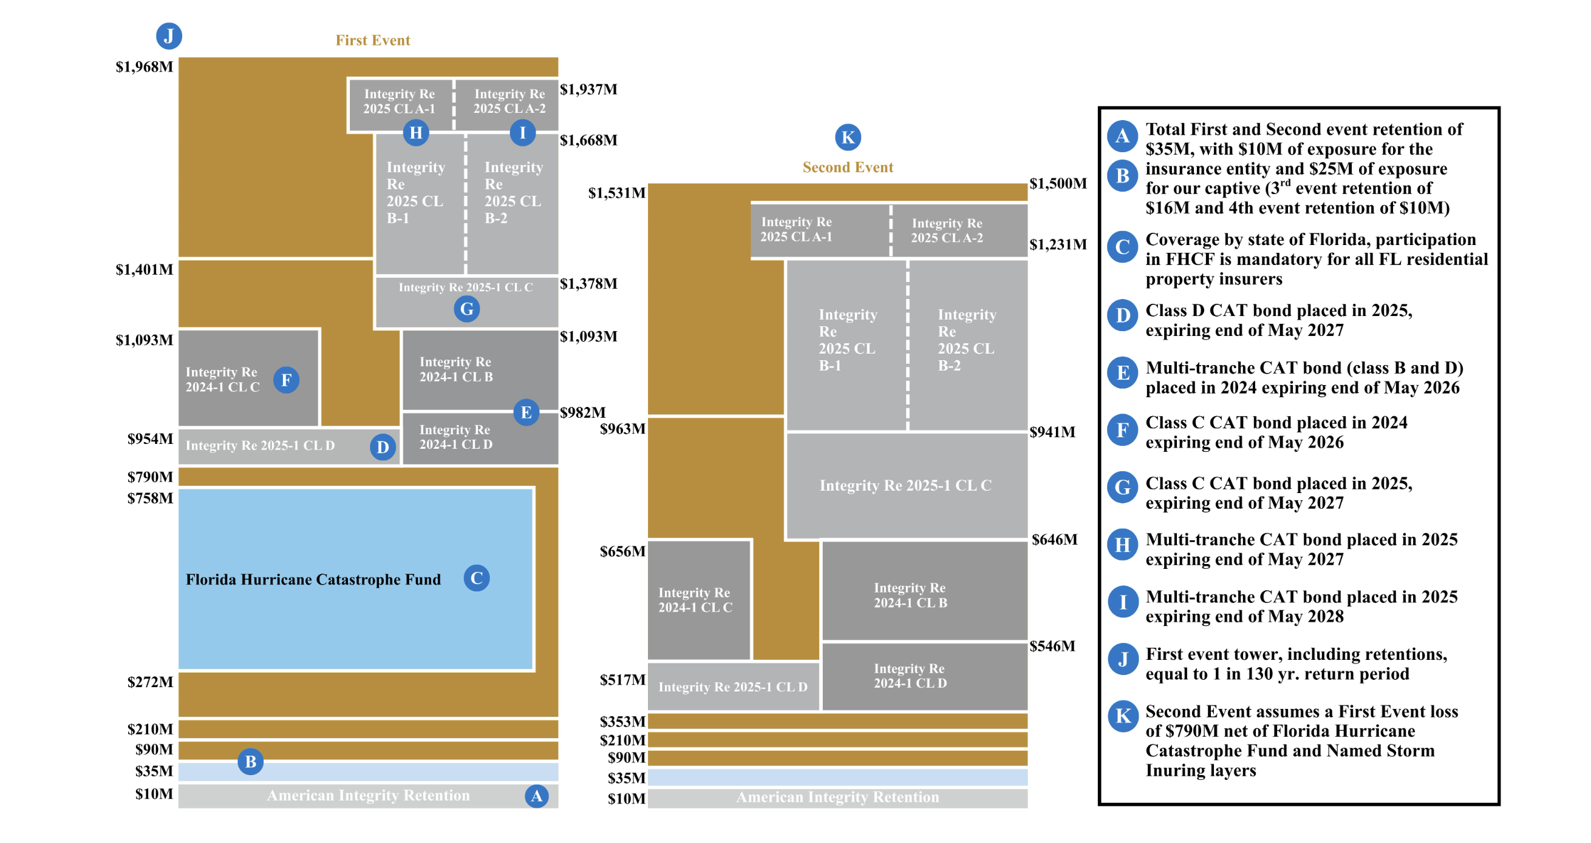

In the first event, AII absorbs the first $35M ($10M = Insurance exposure; $25M = Captive Exposure) which represented 10.4% of shareholders’ equity on December 31, 2025. This $35M is essentially the “skin in the game” for AII, which breaks down as $10M of direct exposure plus $25M held inside their own captive reinsurer, which is a subsidiary they own and funded themselves (Think of the captive as AII’s self-insuring a portion of their own risk through a vehicle they own). Above $35M, a panel of traditional reinsurers takes over up to ~$1.9B. In context, the largest modeled historical loss for AII’s current book (repeat of 2017 Irma C4) would cost $565M which their tower covers more than 3x that amount. For the first event, AII is effectively bulletproof below a 1 in 130-year storm.

In the second event, coverage drops to $1.5B after the same $35M retention, which is still a massive amount but is meaningfully less than the ~$1.9B of the first event. The captive does reinstate for the second event providing an additional $25M layer.

In the third event, coverage drops drastically to $85M after a $10M retention. The captive does not participate in the third event; thus, if Florida gets hit by three significant storms in one season AII is more exposed on the third than the first two storms which could present a massive liquidity event.

The Florida Hurricane Catastrophe Fund (FHCF) sits inside the tower and is mandatory for all Florida residential insurers. This coverage provides up to $436.9M above a certain attachment point. One important point is that FHCF is not collateralized and is not rated by an agency, it’s simply backed by the state of Florida’s ability to issue bonds. If there is a situation where FHCF doesn’t have enough money after a catastrophic season it can legally pay less than promised. Since there were no major storms in 2025, AII currently has $0 in reinsurance recoverables from FHCF as of December 31, 2025.

AII has issued eight bonds since 2017. In February 2025 they placed a $565M multi-tranche catastrophe bond and in March 2024 a $305M bond. These are securities that are sold to investors in the capital markets (ie hedge funds, pensions, etc) who in return for loaning the money receive yields. If losses exceed a trigger the bond principal pays AII instead of returning it to investors. These bonds help diversify AII’s reinsurance counterparty risk away from traditional reinsurers and into the capital markets.

Conditional Probabilities
Of a sample of 43 seasons only four storms produced multiple Florida landfalls: 1950, 2004, 2005, and 2024. This implies a conditional probability of a second storm given a first of ~9.3%. More interesting is the third event conditional probability. Of the four multi-landfall seasons, only 2004 produced three Florida landfalls (Charley, Frances, and Jeanne). Given that 2004 represents the only three storm season in 173 years that puts the conditional probability of a third storm given two have already occured at 25%.

Applying these empirically derived probabilities to AII’s disclosed 1-in-130-year return period framework:
P(first tower exhausted) = 1/130 = 0.77%
P(second tower stressed) = 0.77% * 9.3% = 0.07%
P(third event scenario) = 0.07% * 25% = 0.018%

So then the annual probability of the third event tail materializing is approximately 0.018%, which is roughly 1 in 5,600-year scenario on an expected value basis. Once Florida has been hit twice in a season the probability of a third hit isn’t remote, it’s one in four. This instance of a third event is where the reinsurance tower structure changes dramatically since the captive does not reinstate and coverage drops from ~$1.5B to $85M and net retention above the tower becomes existential relative to the $337M in book value.

Position of Reinsurance Recoverables
AII has $269M in total reinsurance recoverable, monies owed to them from reinsurers for claims already paid or reserved. The top 10 reinsurers owed $182M as of December 31, 2025, all of which are rated A or better by AM Best or fully collateralized meaning cash is held in a trust. Horshoe Re Ltd ($32M) and Ada Re ($14M) are both collateralized, meaning if they went bankrupt tomorrow AII can access that cash (no credit risk).

Key Operating Ratios
Insurance companies are evaluated differently than most businesses. Instead of focusing on margins and EBITDA, the industry uses a specific set of ratios that together tell you whether an insurer is making money from its core business before touching investment income.

Loss ratio
In 2025 for every dollar of net premium earned, AII paid 38.7 cents in claims and claim expenses. The lower this number the better. This is an improvement from 2024 driven by no major storm occurring in 2025 while Hurricane Helene drove $32.2M of catastrophe losses in 2024 alone.

Expense ratio
In 2025 for every dollar of net premium earned, AII spent 25 cents running the business (ie agent commissions, salaries, technology, overhead). This is an improvement from 2024 (33 cents), which was primarily driven by a Citizens take out effect. Policies assumed from Citizens carry zero acquisition cost (no commissions paid to an agent); thus, as the Citizens take out tailwind fades this ratio should increase.

Combined ratio
In insurance, this number is one of the most important. This is the loss ratio plus the expense ratio and anything less than 100% implies the company is profitable purely from underwriting. In 2025, AII’s combined ratio was 63.7% vs 80.9% in 2024 meaning AII generated ~36.3 cents of underwriting profit on every dollar of net premium

Underlying Loss Ratio
The underlying ratio strips out two things, (1) current year catastrophe losses and (2) prior year reserve development in order to reveal the true attritional loss trend. Essentially, the goal is to reveal, ignoring storms and reserve adjustments, what is the true cost of everyday claims. For AII, this ratio worsened year over year, going from 32.6% to 39.4%. It seems combined ratio improved year over year, but at the same time the underlying trend worsened.

Gross Underlying Non-Catastrophe Loss ratio
This ratio removes reinsurance and tries to answer the question of: for every dollar of gross premium written, what do non catastrophe claims actually cost before reinsurance? For AII, 17% in the past two years which shows that the everyday non-catastrophe risk is pretty stable.

Ceded Reinsurance Ratio
AII cedes 72.5% of every gross premium dollar to reinsurers. In 2025, AII wrote $944M in gross premiums but only kept ~$243M showing that AII is fundamentally a reinsurance purchasing operation with an underwriting engine attached to it.

AII’s Non-Catastrophe Quota Share Reinsurance (NCQSR) Shift
In 2025, AII ceded 40% of non-catastrophe gross premiums written to quota share reinsurers. Starting December 2025, they renegotiated that down to 25%. This is akin to AII previously splitting its lemonade stand revenue 60/40 with a partner and now keeping 75 cents of every dollars instead of only 60. More retained premium means higher net premiums earned, but this also means more retained losses when claims come in. The net effect on 2026 earnings depends solely on one key variable, the 2026 attritional loss. If 2026 comes in clean, the decisions to reduce the NCQSR would have proved to be a good decision as management would have retained a more profitable book. However, if 2026 sees elevated non-catastrophe losses (ie roof claims, water damage, litigation) the losses AII would have ceded to reinsurers under the old structure will now sit on AII’s income statement.

Additionally, the 17% gross underlying non-catastrophe loss ratio holding flat year over year does suggest that management has confidence in their attritional loss profile, which is likely what drove the underlying decision To assess whether management's confidence in their attritional loss profile is justified, we turn to the loss development triangles disclosed in Note 8 of the 2025 10-K.

Analysis of AII’s Incurred and Paid Loss Development Triangles
Disclosed in note 8 of the 2025 10K, the incurred and paid loss development triangles showcase a pattern of favorable reserve development across nearly every accident year. The 2017 accident year, which captures hurricane Irma losses was initially reserved at $57.3M and has since developed to $19.4M in 2025, which is a ~$38M development improvement over eight years. More recent accident years show the same pattern: 2024 incurred losses were initially estimated at ~$94M and already show ~$10M of favorable development in just one year.

Additionally AII’s average payout curve is 55% in year one, 31% in year two, 3% in year three, 4% in year 4 and 1% in year five. By year three the payouts are essentially complete, this confirms that AII manages a short tail book with low reserving uncertainty. If we apply the paid to incurred ratio to accident year 2024 for example, we see AII is carrying $11M of disclosed Incurred But Not Reported (IBNR) against an implied balance of $6.9M ($84.4M- $77.5M), a cushion of ~$4M above what the development pattern would suggest. This conservative behavior is consistent with management’s stated philosophy.

Updated for Q1’26 Results
Q1’26 results confirm the predicted mechanical impact of decreased cession, with the combined ratio expanding from 42.9% to 75.0%, which management attributes to two causes: (1) the absence of the Citizens take out windfall that artificially suppressed Q1’25 expenses and (2) the mechanical reduction in ceding commissions resulting from the NCQSR restructuring; neither of which point to operational deterioration. Furthermore, the gross underlying non-catastrophe loss ratio (the metric most insulated from reinsurance structure changes) went from 16.2% to 19.1%, which does warrant monitoring but doesn’t alter the underlying thesis. Likewise, the core underwriting engine is performing, showcased by new voluntary policies increasing 21.6% Y/Y, policy retention improved from 78.1% to 83.6% and in force premium grew to $974.8M.

Analysis of Florida named storm landfall data compiled by Wikipedia's List of Florida Hurricanes (sourced from NOAA's HURDAT database, spanning 173 years from 1851 to 2024) and identifies 43 seasons with at least one Florida landfall. Of those 43 seasons, four produced multiple landfalls (1950, 2004, 2005, 2024) and only one (2004) produced three or more. All probability calculations herein are derived from this empirical dataset.
P(third event) = P(first tower exhausted) × P(second storm | first) × P(third storm | two have occurred) = (1/130) × (4/43) × (1/4) = 0.000179 or approximately 0.018%. Return period = 1/0.000179 ≈ 5,591 years.
“Citizens Property Insurance Corporation plays a crucial role in Florida’s property insurance marketplace by providing property insurance protection to people who are in good faith entitled to obtain coverage through the private market but are unable to do so” https://www.citizensfla.com/who-we-are
Page 9 FY25 10K: https://www.sec.gov/Archives/edgar/data/2007587/000200758726000016/aii-20251231.htm#i98f67cc23ee149cc93f4f0924f29adae_13
Page 8 in FY25 10K: https://www.sec.gov/Archives/edgar/data/2007587/000200758726000016/aii-20251231.htm#i98f67cc23ee149cc93f4f0924f29adae_13

