PROJECT:REPORT

Submitted by: Muhammad Jameel Khalid(200901082)

Hasnat Shaid(20901036)

Submitted to:

Mam Madiha.

Subject:

DATA BASE SYSTEM.

CRIMINAL RECORD

Table of Contents

BREAKDOWN 1

SQL file: 2

LOGIN PAGE: 2

FUNCTIONS 3

SEARCH 4

ADD NEW: 4

PRINT: 5

DELETE: 5

UPDATE: 6

RESET: 6

EXIT: 7

BREAKDOWN:

Admin login :

* Username
* Password

CRMINAL RECORD:

* Search
* Add new
* Print
* Delete
* Update
* Reset
* Exit

# SQL file:

|  |
| --- |
| create database criminaldata  use criminaldata  create table data (CID int, Cname varchar(120), CCNIC varchar(59), CSec varchar(50), CCellno int) |

This our MySQL Code in which we have created data base and created table

# LOGIN PAGE:

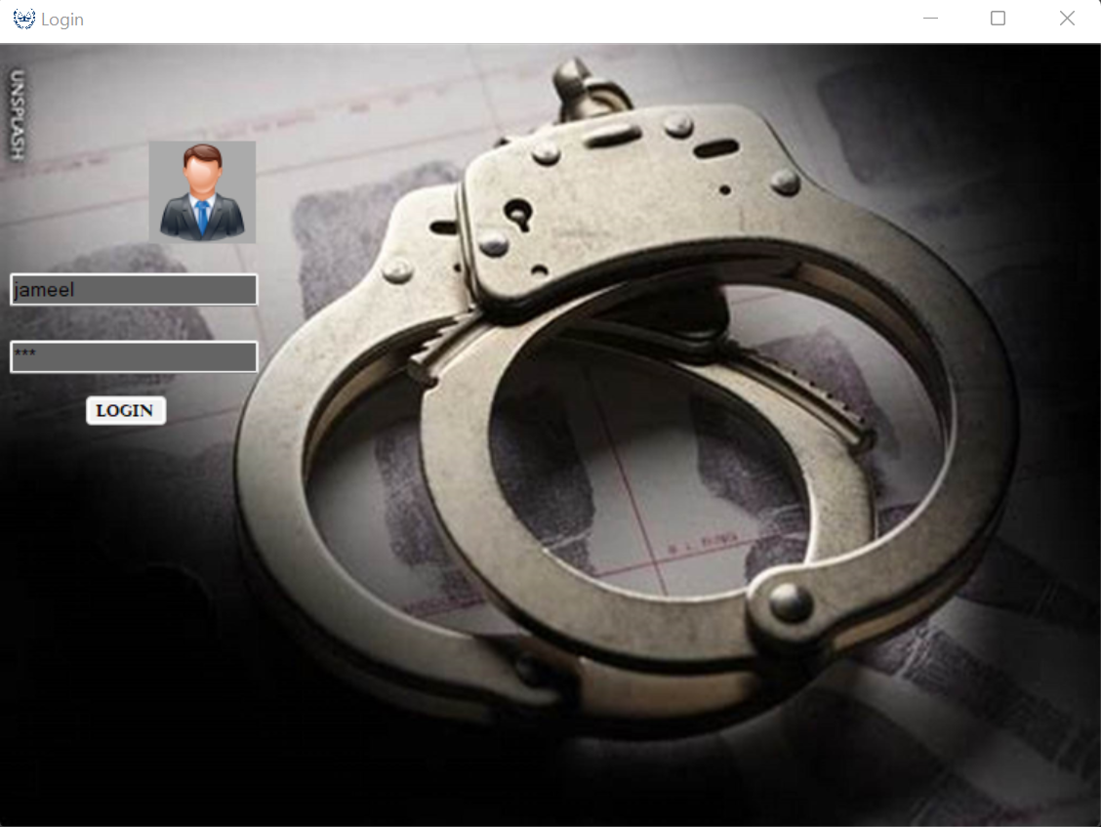

In login page we have added a panel for adding username and password and put a checker for accepting terms and conditions and then attach a LOGIN button in order to enter the blood bank

FUNCTION:

After login new form opens in which we can perform function which are following.

* Search
* Add New
* Print
* Delete
* Update
* Reset
* Exit

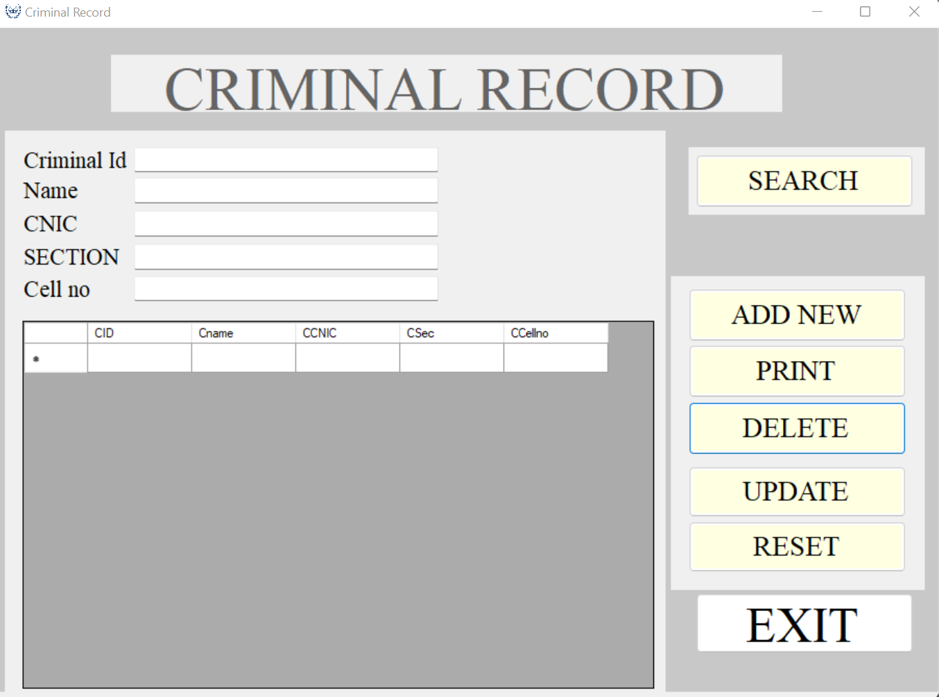

SEARCH:

This function Searches value through entering criminal id in text box and will show all other attributes in all other text box as you can see in attached image.

# Table Description automatically generatedADD NEW:

In this function you can add data in Criminal Record. We can Add Criminal Id, Name, CNIC, Section, Cell no. After pressing on Add New button Dialog box will pop which shows “Data entered successfully” As show in picture and then new record will be upgraded in the list as show in picture 2.

# PRINT:

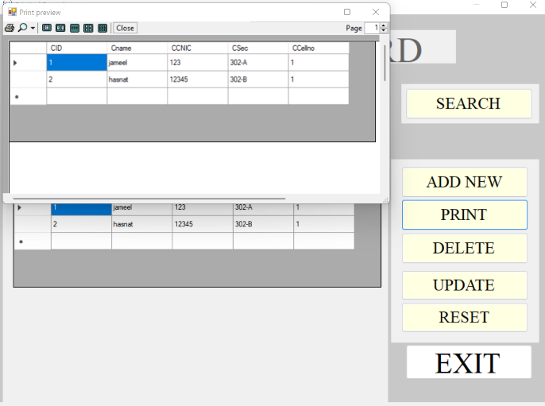

In this function we can print whole record present in table. By pressing Print button new window will pop displaying the record which have printed.

.

# DELETE:

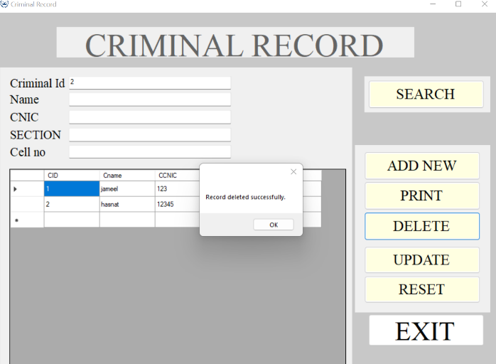

In this function we can delete row by entering Criminal Id in text box and then after pressing Delete button the desired row will be deleted, and a dialog box will pop displaying “Record Deleted Successfully”. After this table will be updated automatically as shown in picture.

# UPDATE:

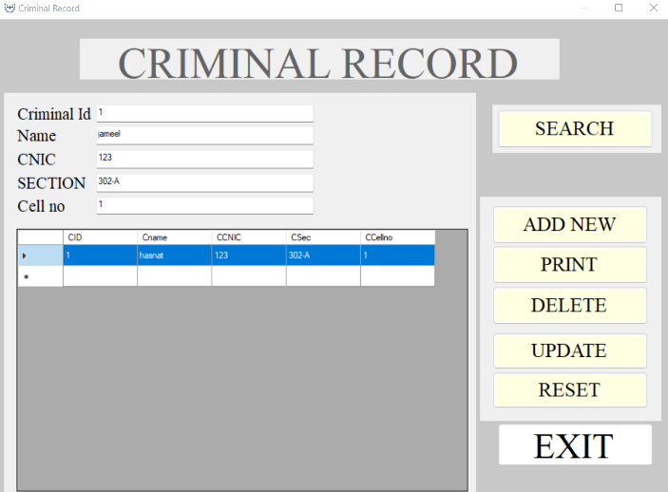

In this function we can update attributes of row by entering Criminal Id and write new attribute we want to change of that Criminal Id and then by pressing UPDATE button our record will be updated sucessfully as shown in picture.

# RESET:

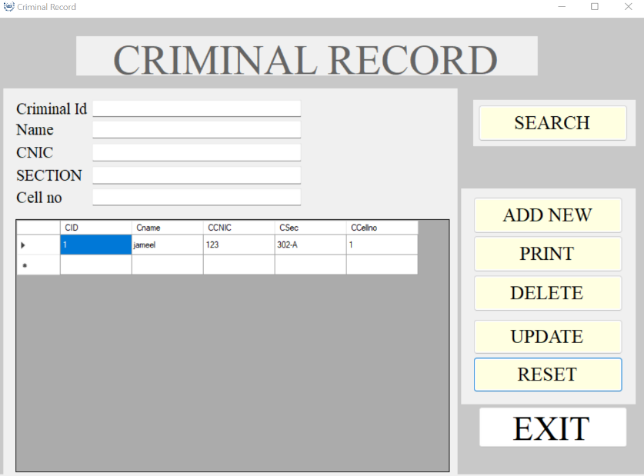

By pressing RESET button all the text box will become empty.

# EXIT:

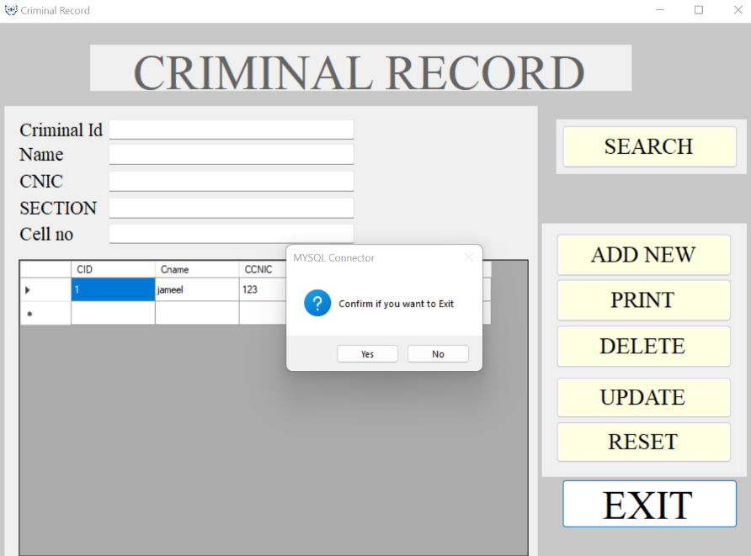

By pressing Exit button, program will stop debugging and foram will be closed.