Version Used: dhtmlx-gantt": "6.1.3"

**Issue**: Unable to put the chart based on the child node start and end date.

**Requirement**:

We are rendering the hierarchy tree structure in gantt and the time line against each node in the tree, each parent time line combination of all child time line.

**Use case:**

**Expected**

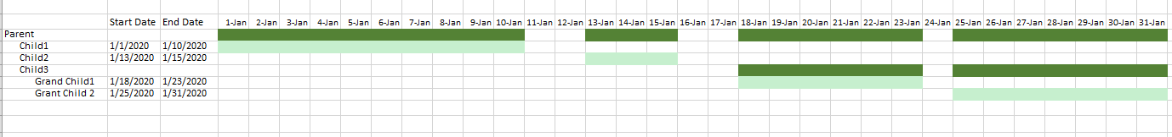

**Actual**

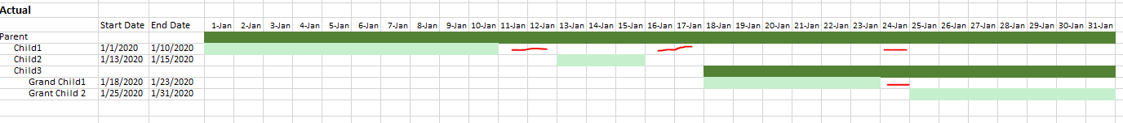

**Working Excel model :** 

**JSON Object:**

[{id: 1, text: "Priliminary Activities", start_date: "2017-08-01 00:00", end_date: "2017-08-15 00:00"},

      {id: 2, text: "Audit Planning", start_date: "2017-08-01 00:00", end_date: "2017-08-15 00:00",parent: 1},

      {id: 17, text: "Pre-Engagement", start_date: "2017-08-01 00:00", end_date: "2017-08-08 00:00",parent: 2},

      {id: 18, text: "Strategy", start_date: "2017-08-10 00:00", end_date: "2017-08-15 00:00",parent: 2},

      {id: 19, text: "Audit plan", start_date: "2017-08-10 00:00", end_date: "2017-08-15 00:00",parent: 2},

      {id: 3, text: "Independance", start_date: "2017-08-03 00:00", end_date: "2017-08-04",parent: 1},

      {id: 4, text: "Risk Assessment", start_date: "2017-08-04 00:00",end_date: "2017-08-05"},

      {id: 5, text: "Components of Internal", start_date: "2017-08-03 00:00", end_date: "2017-08-04",parent: 4},

      {id: 6, text: "Materiality", start_date: "2017-08-05 00:00", end_date: "2017-08-06",parent: 4},

      {id: 7, text: "Risk Assessment", start_date: "2017-08-03 00:00", end_date: "2017-08-05",parent: 4},

      {id: 8, text: "Planning", start_date: "2017-08-02 00:00", end_date: "2017-08-04", type: 1},

      {id: 9, text: "Audit Planning", start_date: "2017-08-01 00:00", end_date: "2017-08-02",parent:8, type: 1},

      {id: 10, text: "Inetrim Responds", start_date: "2017-08-02 00:00", end_date: "2017-08-03", type: 1},

      {id: 11, text: "Risk Assessment", start_date: "2017-08-03 00:00", end_date: "2017-08-04",parent: 10, type: 1},

      {id: 12, text: "Assessment", start_date: "2017-08-01 01:00", end_date: "2017-08-13",parent: 10, type: 1},

      {id: 13, text: "Final Response", start_date: "2017-08-02 00:00", end_date: "2017-08-03", type: 1},

      {id: 14, text: "Audit Planning", start_date: "2017-08-03 00:00", end_date: "2017-08-04",parent: 13, type: 1},

      {id: 15, text: "Risk Assessment", start_date: "2017-08-04 00:00", end_date: "2017-08-05",parent: 13, type: 1},

      {id: 16, text: "Completion", start_date: "2017-08-05 00:00", end_date: "2017-08-06", type: 1},

    ]