# 1. Project Title

FitFlex: Your Personal Fitness Companion

# 2. Introduction

Team ID : NM2025TMID31418

Team Leader : A Suraiya Banu & Mail id [asuraiyabanu2427@gamil.com](mailto:asuraiyabanu2427@gamil.com)

Team members

Name: K Ajitha Banu &Mail id [ajithabanu2427@gmail.com](mailto:ajithabanu2427@gmail.com)

Name: A Anisha &Mail id [a.anisha2427@gmail.com](mailto:a.anisha2427@gmail.com)

Name: J Ameera Jasmine &Mail id [j.ameera2427@gamil.com](mailto:j.ameera2427@gamil.com)

# 3. Project Overview

Purpose:

FitFlex aims to transform the workout experience by offering an intuitive, user-friendly platform that helps users discover, organize, and track their fitness routines with ease.

Features:

• User-friendly experience with easy navigation

• Comprehensive exercise management and organization

• Access to exercises from reputable fitness APIs

• Visual exercise exploration through curated galleries

• Advanced search options for personalized fitness experiences

# 4. Architecture

• Frontend: React.js with Tailwind CSS/Bootstrap

• API Integration: RapidAPI for fitness and YouTube data

• State Management: React Hooks

• HTTP Client: Axios

# 5. Setup Instructions

Prerequisites:

• Node.js and npm: Download from https://nodejs.org/en/download/

• Git: https://git-scm.com/downloads

• Code Editor: VS Code, Sublime Text, or WebStorm

Steps:

1. Download code from the Google Drive link provided.

2. Extract the folder and open it in VS Code.

3. Run `npm install` to install dependencies.

4. Start the server with `npm start`.

5. Access the app at http://localhost:3000

# 6. Folder Structure

FITNESS APP  
  
node_modules/  
public/  
src/  
 ├── assets/  
 ├── components/  
 ├── pages/  
 ├── styles/  
  
App.css  
App.js  
App.test.js  
index.css  
index.js  
logo.svg  
reportWebVitals.js  
setupTests.js  
.gitignore  
package-lock.json  
package.json

# 7. Running the Application

• Run `npm start` to start the development server.

• Access the app at http://localhost:3000 in the browser.

# 8. API Documentation

• Exercises API: Fetch body parts, equipment, and exercise details from RapidAPI.

• YouTube API: Fetch related workout videos from RapidAPI YouTube Search.

# 9. Authentication

This project does not currently implement authentication. Future updates may include user login and personalization features.

# 10. User Interface

• Hero Section: Showcases trending workouts or challenges

• About Page: Highlights FitFlex’s mission and purpose

• Search Bar: Allows advanced search for exercises

• Category Page: Displays workout categories with visual tiles

• Exercise Page: Displays exercise instructions, visuals, and related videos

# 11. Testing

• Manual testing during milestones

• Tools: Postman for API testing, Chrome Dev Tools for debugging

# 12. Screenshots

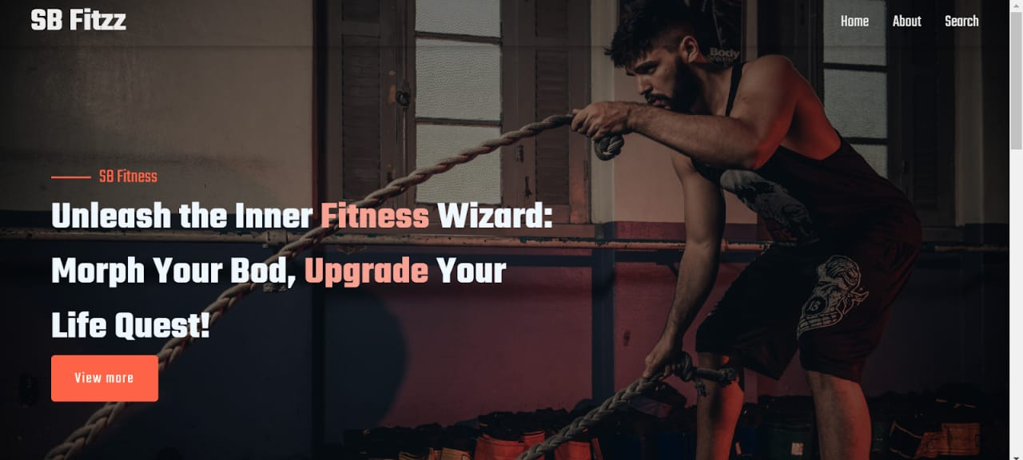Screenshots: Hero component, About page, Search functionality, Category page, Exercise page

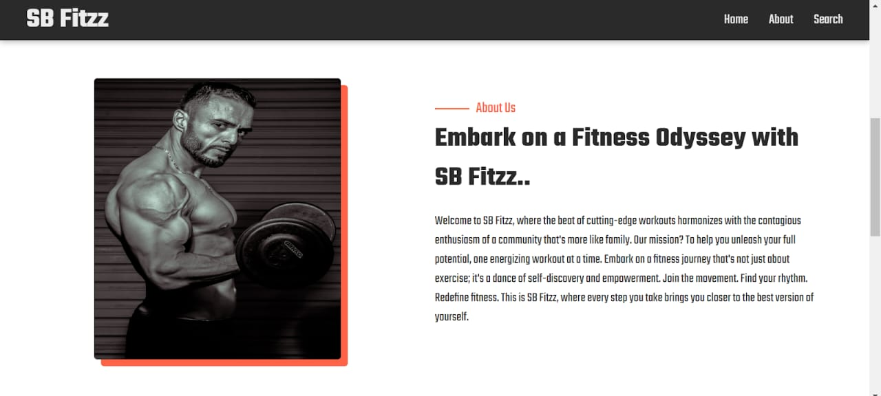

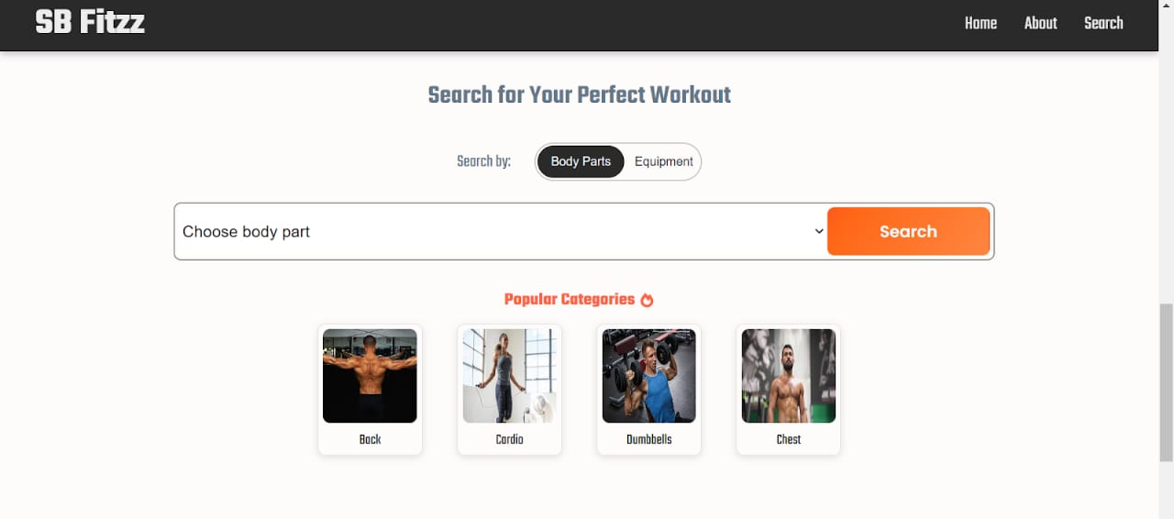

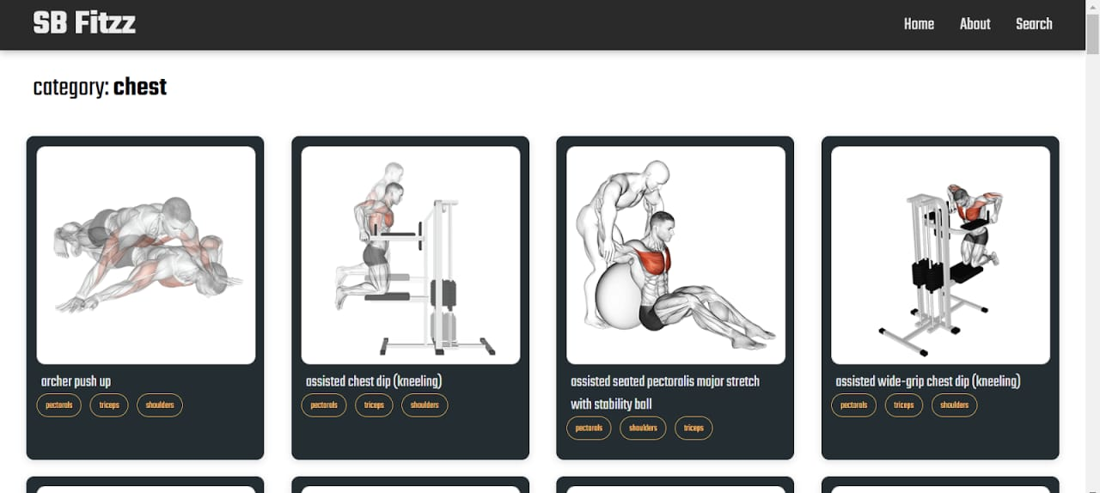

# 13. Future Enhancements

• Implement user authentication and personalization features

• Add progress tracking and analytics dashboard

• Support for community features like challenges and leaderboards

• Mobile app version with React Native