Group Members:
Angelica O. Encarnacion
Hershey T. Edoloverio
Fritz Andrei C. Danoco
Jobert Jamelo
Post-Order Traversal
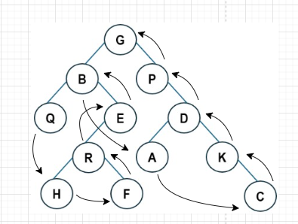
Post Order: Q, H, F, R, E, B, A, C, K, D, P, G
First Five Letters: Q, H, F, R, E = [17, 8, 6, 18, 5]
Bubble Sort [17, 8, 6, 18, 5]
Pass 1
17>8 swap [8, 17, 6, 18, 5]
17>6 swap [8, 6, 17, 18, 5]
18>5 swap [8, 6, 17, 5, 18]
Pass 2
8>6 swap [6, 8, 17, 5, 18]
17>5 swap [6, 8, 5, 17, 18]
Pass 3
8>5 swap [6, 5, 8, 17, 18]
Pass 4
6>5 swap [5, 6, 8, 17, 18]
Bubble Sort: [5,6,8,17,18]
Insertion Sort [17, 8, 6, 18, 5]
Insert 8 place before 17 [8,17,6,18,5]
Insert 6 place before 8 [6,8,17,18,5]
Insert 18 already place [6,8,17,18,5]
Insert 5 go to front [5,6,8,17,18]
Insertion Sort: [5,6,8,17,18]
Selection Sort [17,8,6,18,5]
Smallest = 5 swap with index 1 [5,8,6,18,17]
Next smallest = 6 index 2 [5,6,8,18,17]
Next smallest = 8 already correct [5,6,8,18,17]
Next smallest = 17 swap with 18 [5,6,8,16,17]
Selection Sort [5,6,8,17,18]
Quick Sort
Pivot = 17 Partition 1 [ 17, 8, 6, 18, 5]
Pivot = 8 Partition 2 [ 8, 6, 5] [ 18]
Pivot = 6 Partition 3 [ 5, 6]
No more partitions [5]
Quick Sort: [5,6,8,17,18]
Merge Sort [17,8,6,18,5]
Split:
[17,8,6,18,5]
[17,8] and [6,18,5]
Sort
[17,8] to [8,17]
[6,18,5] to [6], [18,5] to [5,18] sort [5,6,18]
Merge both
[8,17] + [5, 6, 18]
[5, 6, 8, 17, 18]

Merge Sort: [5,6,8,17,18]
Pre-Order Traversal
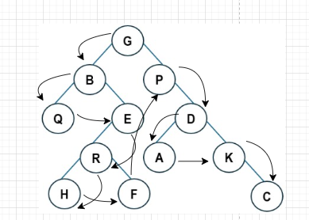
Pre Order: G, B, Q, E, R, H, F, P, D, A, K, C
First Five Letters: G, B, Q, E, R, = [7, 2, 17, 5, 1]
Bubble Sort [7, 2, 17, 5, 18]
Pass 1
7 > 2 swap [2, 7, 17, 5, 18]
7 < 17 no change
17 > 5 swap [2, 7, 5, 17, 18]
17 < 18 no change
Pass 2
7 > 5 swap [2, 5, 7, 17, 18]
The rest is sorted.
Bubble Sort Result: [2, 5, 7, 17, 18]
Insertion Sort [7, 2, 17, 5, 18]
Step 1: Insert 2
[2, 7, 17, 5, 18]
Step 2: Insert 17
Already in place [2, 7, 17, 5, 18]
Step 3: Insert 5
Moves left [2, 5, 7, 17, 18]
Step 4: Insert 18 already sorted.
Insertion Sort Result: [2, 5, 7, 17, 18]
Selection Sort [7, 2, 17, 5, 18]
Pass 1
Smallest = 2 swap with 7
[2, 7, 17, 5, 18]
Pass 2
Remaining: 7, 17, 5, 18
Smallest = 5 swap with 7
[2, 5, 17, 7, 18]
Pass 3
Remaining: 17, 7, 18
Smallest = 7 swap with 17
[2, 5, 7, 17, 18]
Selection Sort Result: [2, 5, 7, 17, 18]
Quick Sort [7, 2, 17, 5, 18]
Choose pivot = 18
Partition:
Left side (≤ 18): [7, 2, 17, 5]
Right side: []
Sort left pivot = 5
Left of 5 [2]
Right of 5 [7, 17]
Sort [7, 17] already sorted.
Now combine:
[2] + [5] + [7, 17] = [2, 5, 7, 17]
Add the final pivot 18:
Quick Sort Result: [2, 5, 7, 17, 18]
Merge Sort [7, 2, 17, 5, 18]

Step 1: Split
Left: [7, 2, 17]
Right: [5, 18]
Step 2: Sort Left
Split [7] and [2, 17]
Sort [2, 17] already sorted
Merge [2, 7, 17]
Step 3: Sort Right
[5, 18] already sorted
Step 4: Final Merge
Merge [2, 7, 17] and [5, 18]
[2, 5, 7, 17, 18]
Merge Sort Result: [2, 5, 7, 17, 18]

