CAMEL PLAYGROUND
ER Diagram and Future Development Plan
SENG 691 — Group 3, Phase 1

1. Project Overview
The CAMEL Playground is a web-based demonstration of multi-agent collaboration. Users can submit a task, assign or generate roles for two AI agents, run the conversation in small turn-based bursts, guide the agents with instructions, and view plain-English summaries from a Narrator agent. The project also supports multiple language-model providers and an offline stub mode for testing.
The analysis is based on the project files shown in the demo folder, particularly playground.py and role_playing_demo.py. The current implementation keeps session data in Python/Gradio state and does not demonstrate a persistent database. Therefore, the ER diagram below is a proposed logical design for a future version, not a representation of existing tables.

2. Proposed Entity-Relationship (ER) Diagram
The proposed schema supports users, tasks, agent sessions, model configurations, assigned agents, conversation messages, and human guidance. It provides a foundation for persistent session history and later analytics.
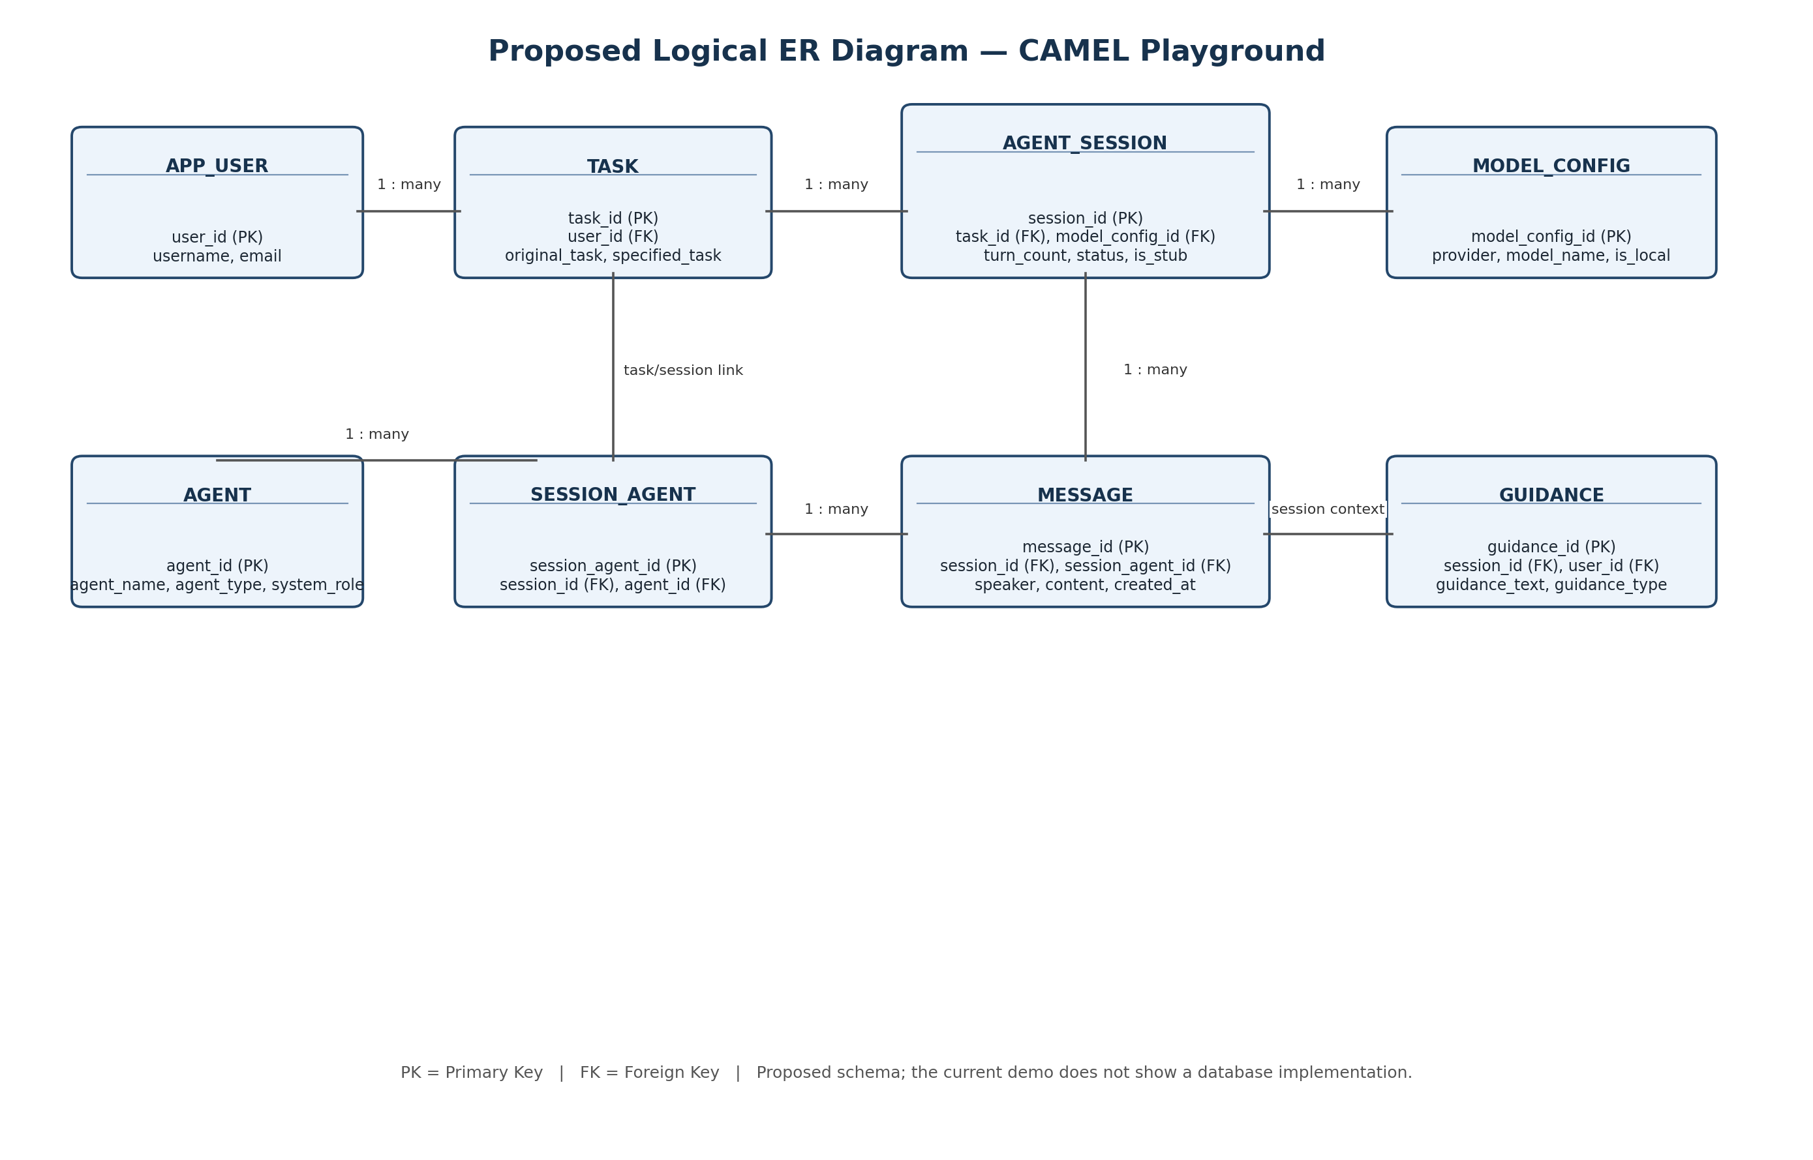
Figure 1. Proposed logical ER diagram for the CAMEL Playground.

2.1 Entity Descriptions
Entity | Purpose | Key fields
APP_USER | Stores user account details. | user_id (PK), username, email
TASK | Stores the original task and refined task description. | task_id (PK), user_id (FK), original_task, specified_task
AGENT_SESSION | Represents one run of a task. | session_id (PK), task_id (FK), model_config_id (FK), status, turn_count
MODEL_CONFIG | Records the provider and model used. | model_config_id (PK), provider, model_name, is_local
AGENT | Defines reusable agent roles. | agent_id (PK), agent_name, agent_type, system_role
SESSION_AGENT | Links agents to individual sessions. | session_agent_id (PK), session_id (FK), agent_id (FK)
MESSAGE | Stores transcript messages and speakers. | message_id (PK), session_id (FK), session_agent_id (FK), content
GUIDANCE | Stores human instructions and guidance notes. | guidance_id (PK), session_id (FK), user_id (FK), guidance_text, guidance_type

2.2 Main Relationships
- One user can create many tasks.
- One task can have multiple execution sessions.
- Each session uses a model configuration; one configuration can be reused by many sessions.
- A session can contain multiple agents, linked through SESSION_AGENT.
- Each session can contain many messages and receive multiple guidance entries.
Design notes: The AGENT entity can represent the Assistant, AI User, and Narrator. MESSAGE.speaker can also represent Human or System messages. API keys should remain in secure environment variables or a secrets manager and should not be stored in this schema.

3. Future Development Plan

Phase 1 — Foundation (High priority)
Implement the proposed database schema, persist transcripts and session metadata, and add automated tests for session creation, task completion, and offline stub mode.

Phase 2 — Reliability and security (High priority)
Improve error handling, validate inputs, protect hosted deployments with authentication, and provide clear session status and recovery mechanisms.

Phase 3 — Intelligent collaboration (Medium priority)
Add session analytics, configurable stopping conditions, reusable task templates, and evaluation metrics such as task completion, repetition, and estimated model cost.

4. Three Enhancements to Existing Features

Enhancement 1: Persistent session history
Save the original and specified task, role assignments, transcript, human guidance, model configuration, and completion status. Allow users to reopen previous sessions after restarting the application.
Expected benefit: Prevents loss of work and supports repeatable demonstrations.

Enhancement 2: Smarter progress and termination controls
Improve the Narrator to flag repeated responses, stalled progress, goal drift, and possible completion. Add configurable turn limits and clear pause/resume controls.
Expected benefit: Makes sessions easier to supervise and helps reduce unnecessary model calls.

Enhancement 3: Model configuration and error recovery
Centralize provider settings, validate model availability and credentials before a run, and provide useful retry guidance for rate limits, timeouts, and temporary provider errors.
Expected benefit: Improves reliability across supported cloud and local model providers.

5. Two New Features

New Feature 1: Visual Multi-Agent Workflow and Team Configuration
Allow users to build a custom team of agents with roles such as Planner, Researcher, Reviewer, and Executor. Display the workflow, responsibilities, handoffs, and progress. Users could configure the number of agents, choose sequential or review-based workflows, and require human approval before important steps.
Expected value: Extends the current two-agent role-playing demonstration into a configurable multi-agent platform.

New Feature 2: Session Evaluation and Model Comparison
Provide a dashboard that evaluates saved runs and compares model configurations on the same task. Track completion status, number of turns, execution time, and estimated cost; let users rate output quality and export a session report.
Expected value: Helps the team measure whether multi-agent collaboration improves results and which configuration performs best.

6. Recommended Implementation Order
Order | Deliverable | Success criterion
1 | Database and session persistence | A session can be saved and reopened with its transcript intact.
2 | Reliability and recovery | Errors are handled clearly and sessions stop safely at configured limits.
3 | Progress monitoring | Repeated responses and potential goal drift are surfaced to the user.
4 | Multi-agent workflow | Users can configure and run a team with more than two agents.
5 | Evaluation dashboard | Saved runs can be compared using consistent metrics.

7. Conclusion
The recommended next step is to implement persistent session storage and improve reliability. These changes provide a stable foundation for configurable multi-agent workflows and session evaluation. The proposed ER model organizes the data needed for these improvements, while the future plan gives the team a practical sequence of deliverables and measurable success criteria.

