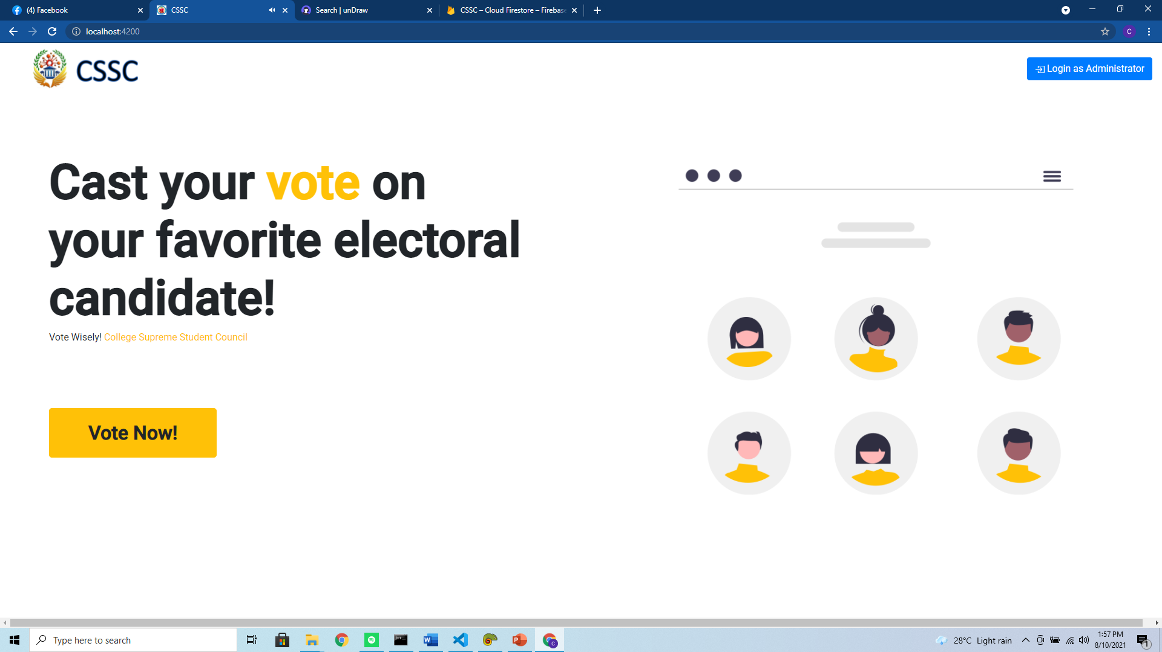

***Figure 1.0.*** *Landing Page of CSSC Cloud Based System-wide Voting System Wen Application*

The Figure above shows the landing page of the said system where voters and administrators land when valid Uniform Resource Locator (URL) is detected on the address bar.

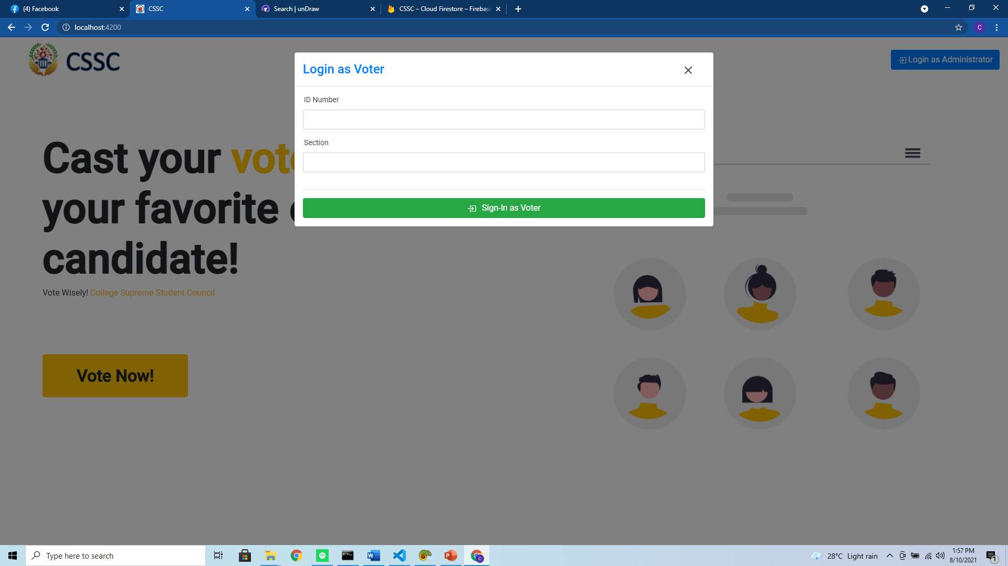

***Figure 2.0.*** *Sign-in Form for the Voter*

The Figure above shows the sign-in form for the voters when they click the “vote now” button in the landing page. The said voter should key-in his ID Number and section to access the voter’s interface and perform voters’ duties. The developer decided to put a section in the form to prevent brute force attack since the ID Number has been designed chronologically.

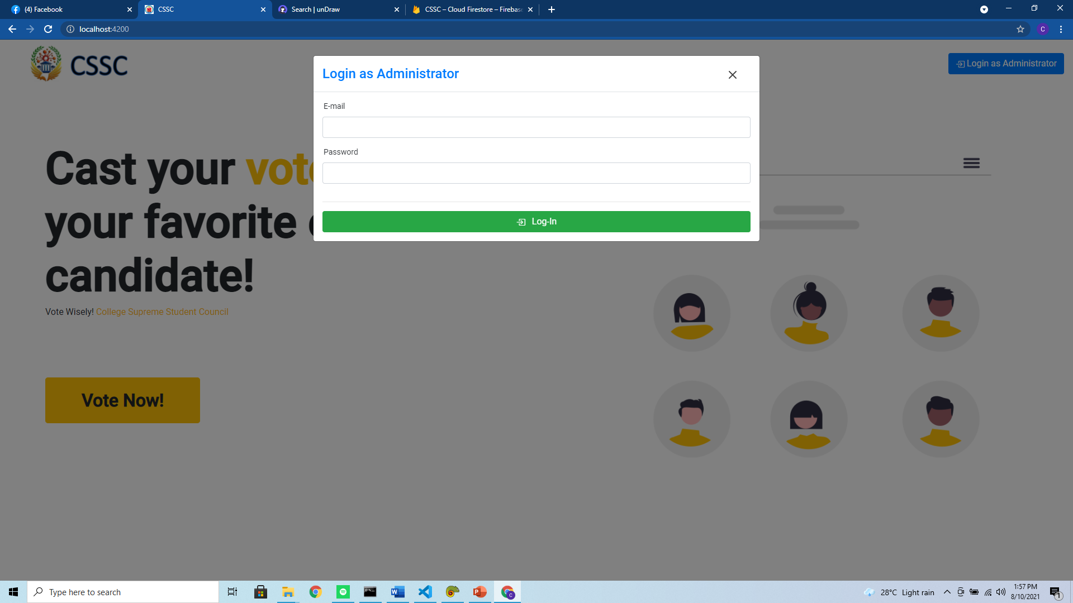

***Figure 3.0.*** *Log-in form of Super Administrator and Administrator*

The Figure above shows the log-in form of the said administrators to perform important functions like registering a fellow administrator, encoding voters, registering parties and its candidates. The said Administrators also could perform an update and delete of the data designated to them. The “Super Administrator” is the person who manages administrators from different campuses while the “Administrators” only manages data on the campus it is assigned.

***Voter’s User Interface***

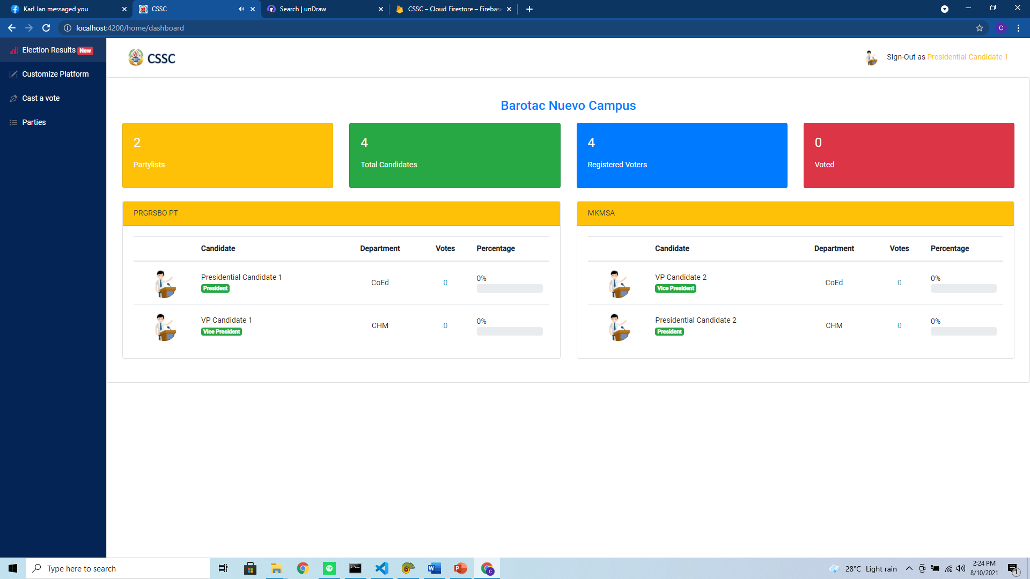

***Figure 4.0.*** *Realtime election results*

The Figure above shows the real-time election results of parties. Every time voters voted on their candidates the data on the User Interface (UI) above will change. The data you will see in this page is the party where the candidate belongs, candidate name, its position, department, number of votes, and percentage of the vote that is cast on him/her based on the number of registered voters.

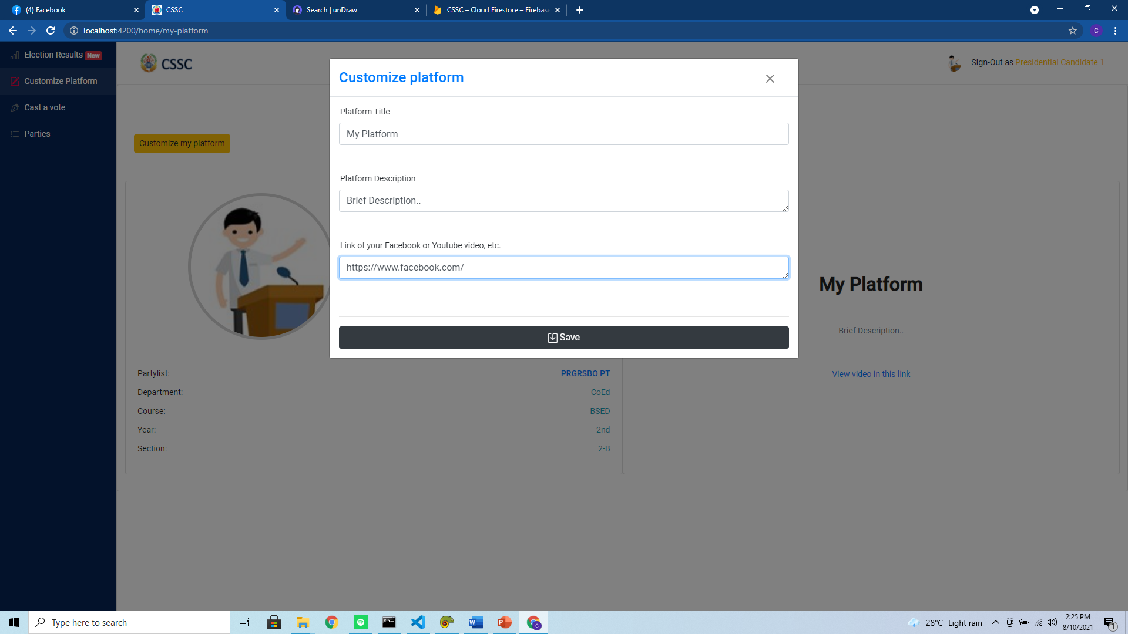

***Figure 5.0.*** *Platform Customization*

The Figure above shows platform customization in the voter UI if the said voter is a candidate for a given party. This page will not show if the voter is not a candidate.

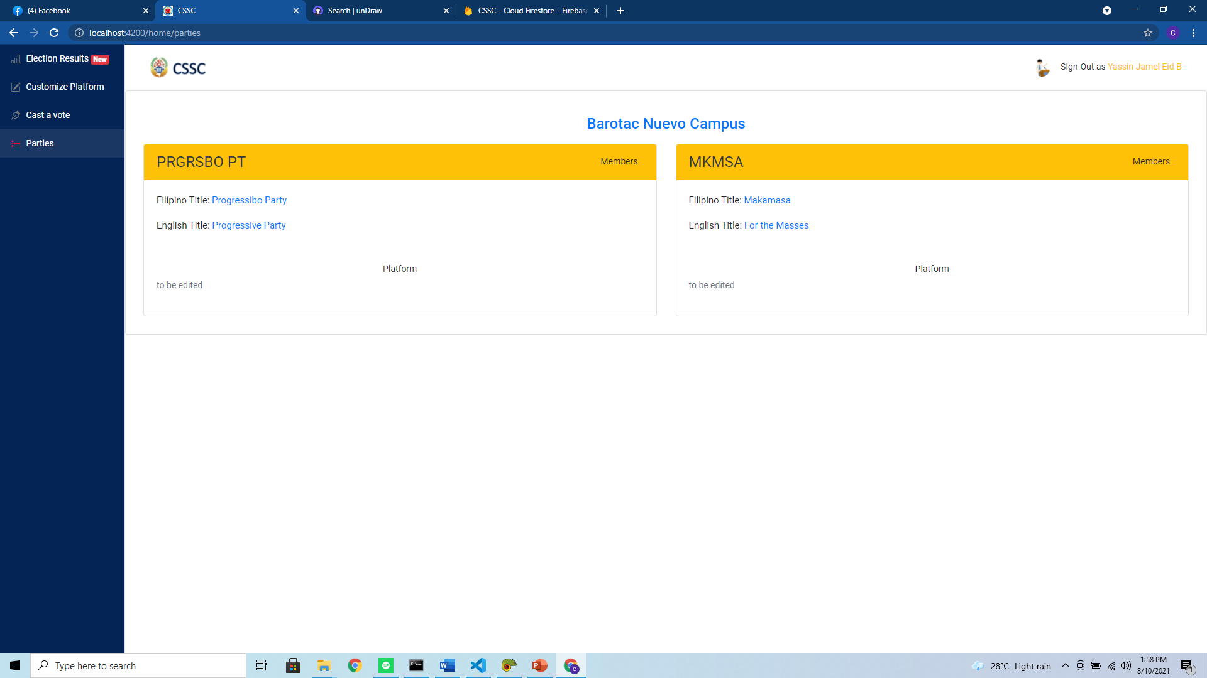

***Figure 6.0.*** *Party list*

The Figure above shows the party list that has been registered on the campus of the voter. It displays the party’s acronym, Filipino title, English title and the platform of the party.

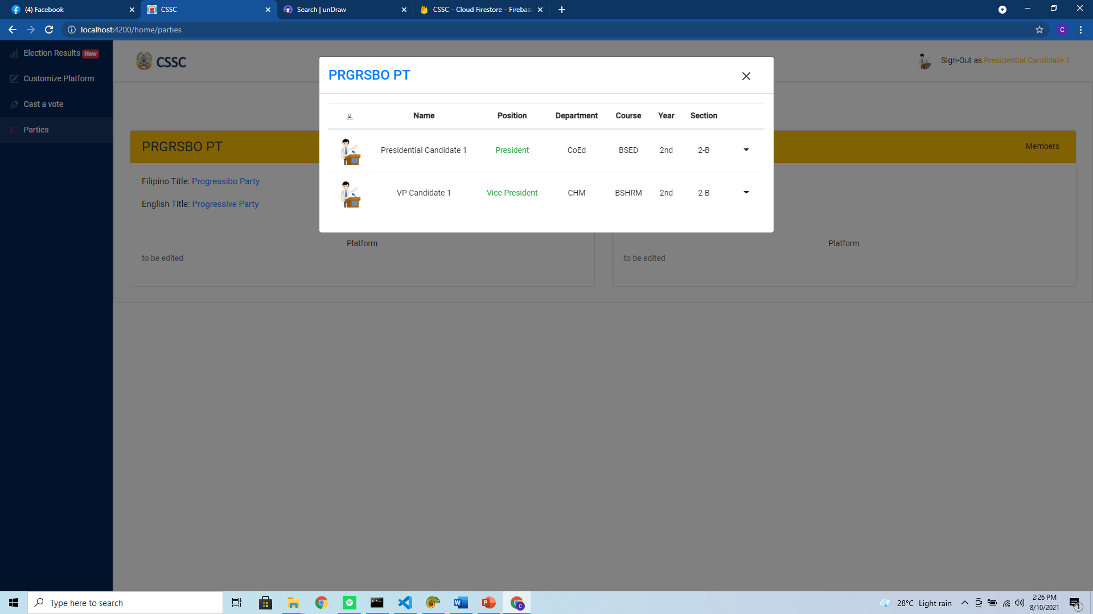***Figure 7.0.*** *Party Candidates*

The Figure above shows all the candidates of a given party if you click the “members” button next to the party’s acronym.

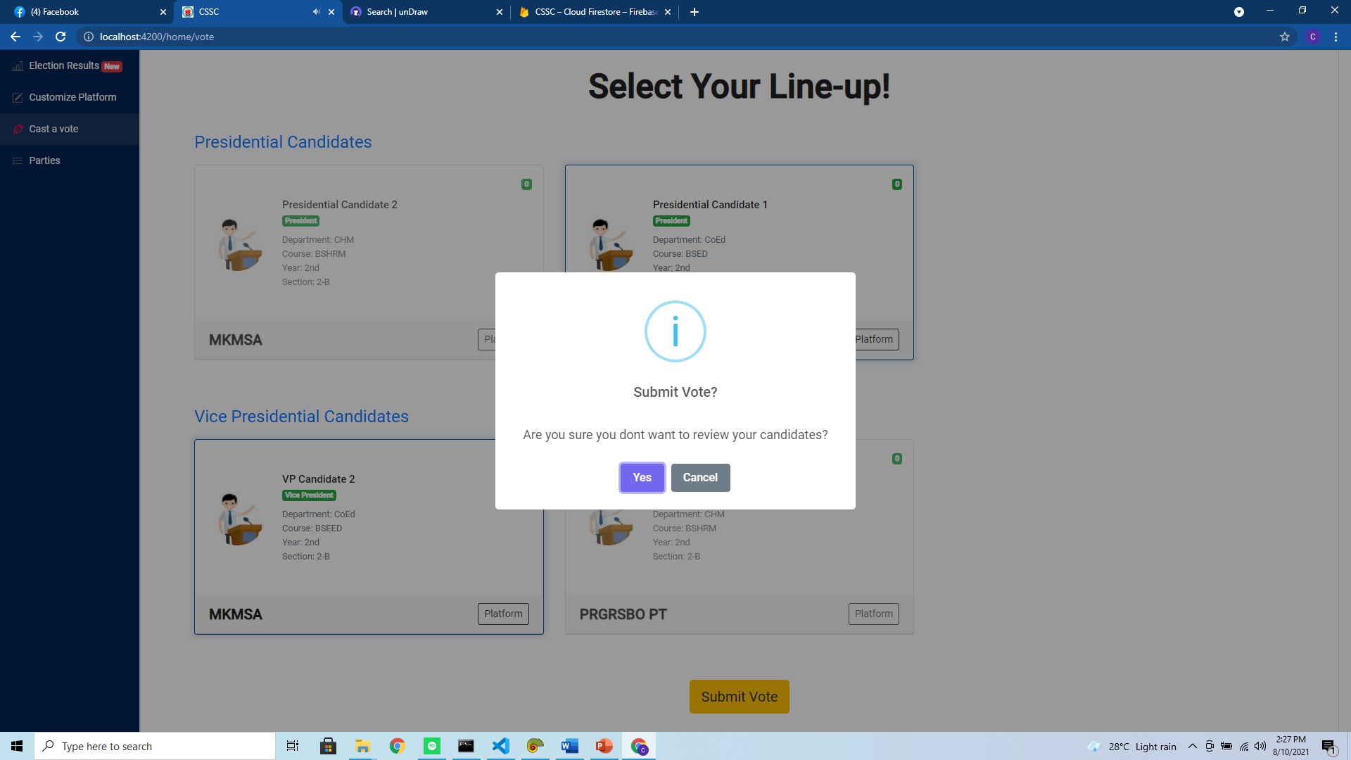***Figure 8.0.*** *Vote User Interface*

The Figure above shows the user interface when the user would like to cast a vote. They will just click for their candidate of choice and click “submit” button when it is done.

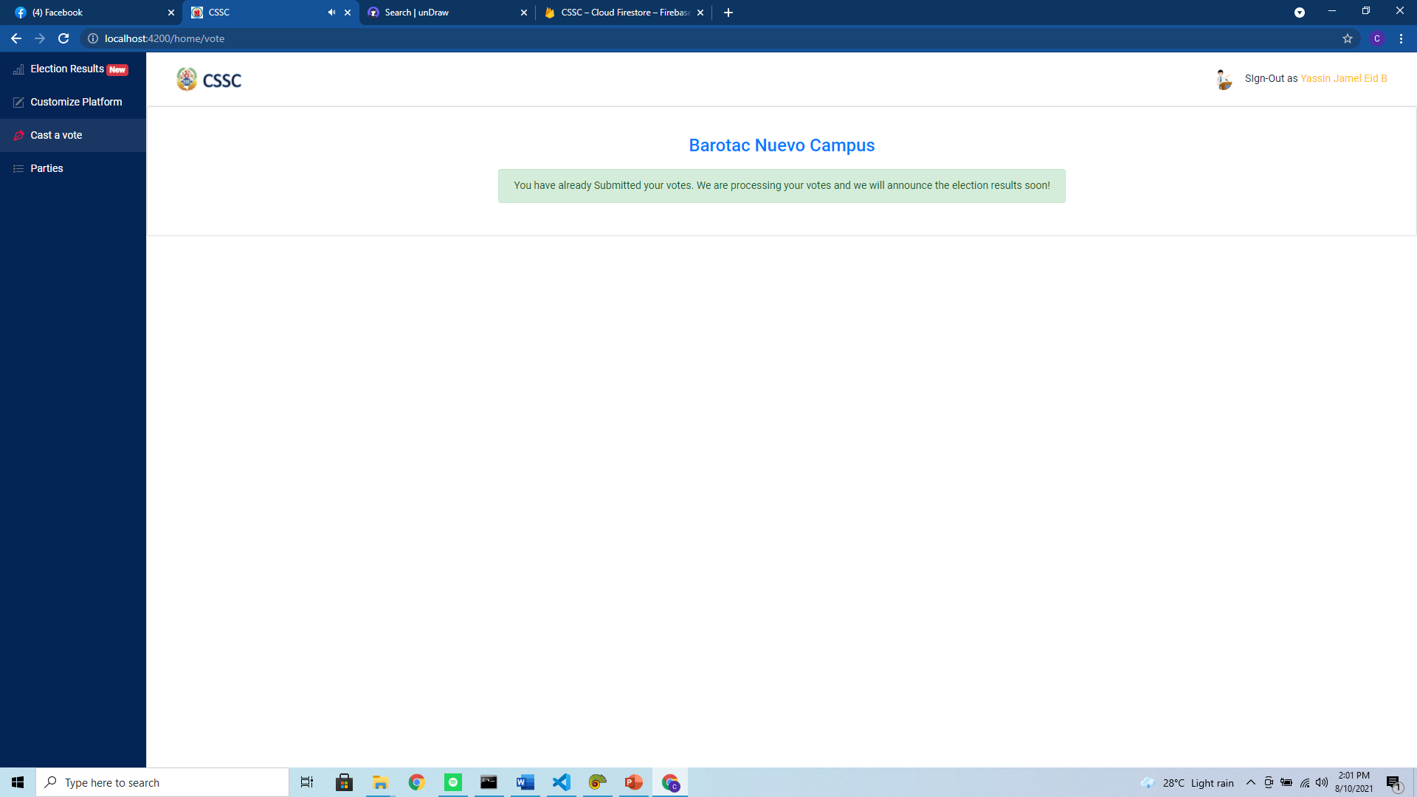

***Figure 9.0.*** *Vote User Interface when Done voting*

The Figure above shows this user interface when the user has already cast its votes.

***Super Administrator’s User Interface***

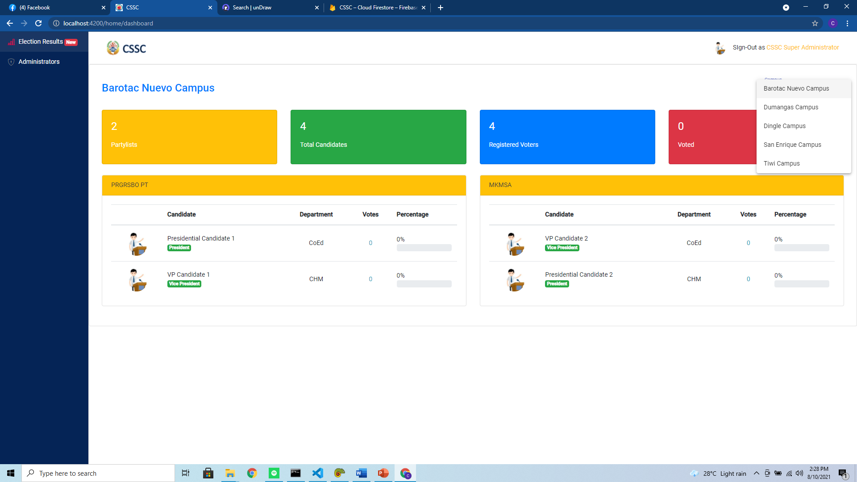***Figure 10.0.*** *Election Results*

The Figure above shows the election results for a chosen campus. The Super Administrator has the capability to see results on any campus.

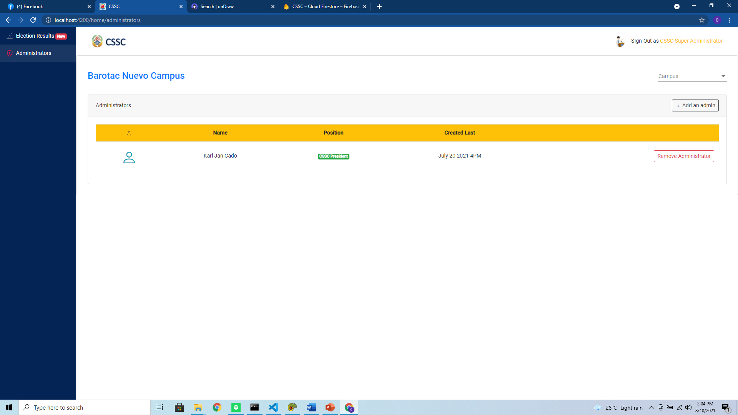***Figure 11.0.*** *List of Administrators Based on Selected Campus*

The Figure above shows the list of administrators based on the selected campus. The data that is displayed are: its name, the position of the said administrator and the date and time that he/she is registered.

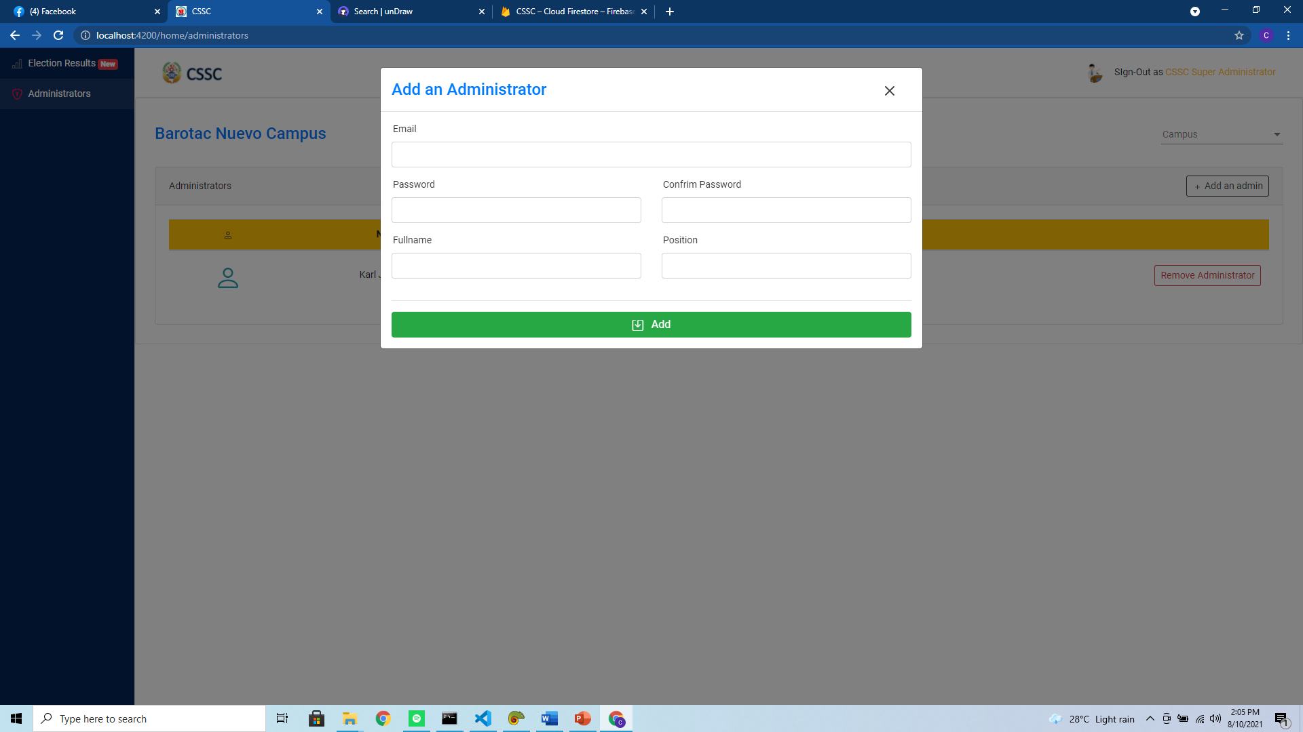***Figure 12.0.*** *Adding of an Administrator form*

The Figure above shows the form when adding an administrator. The inputs consist of: email, password, confirm password, full name of the administrator and its position.

***Administrator’s User Interface***

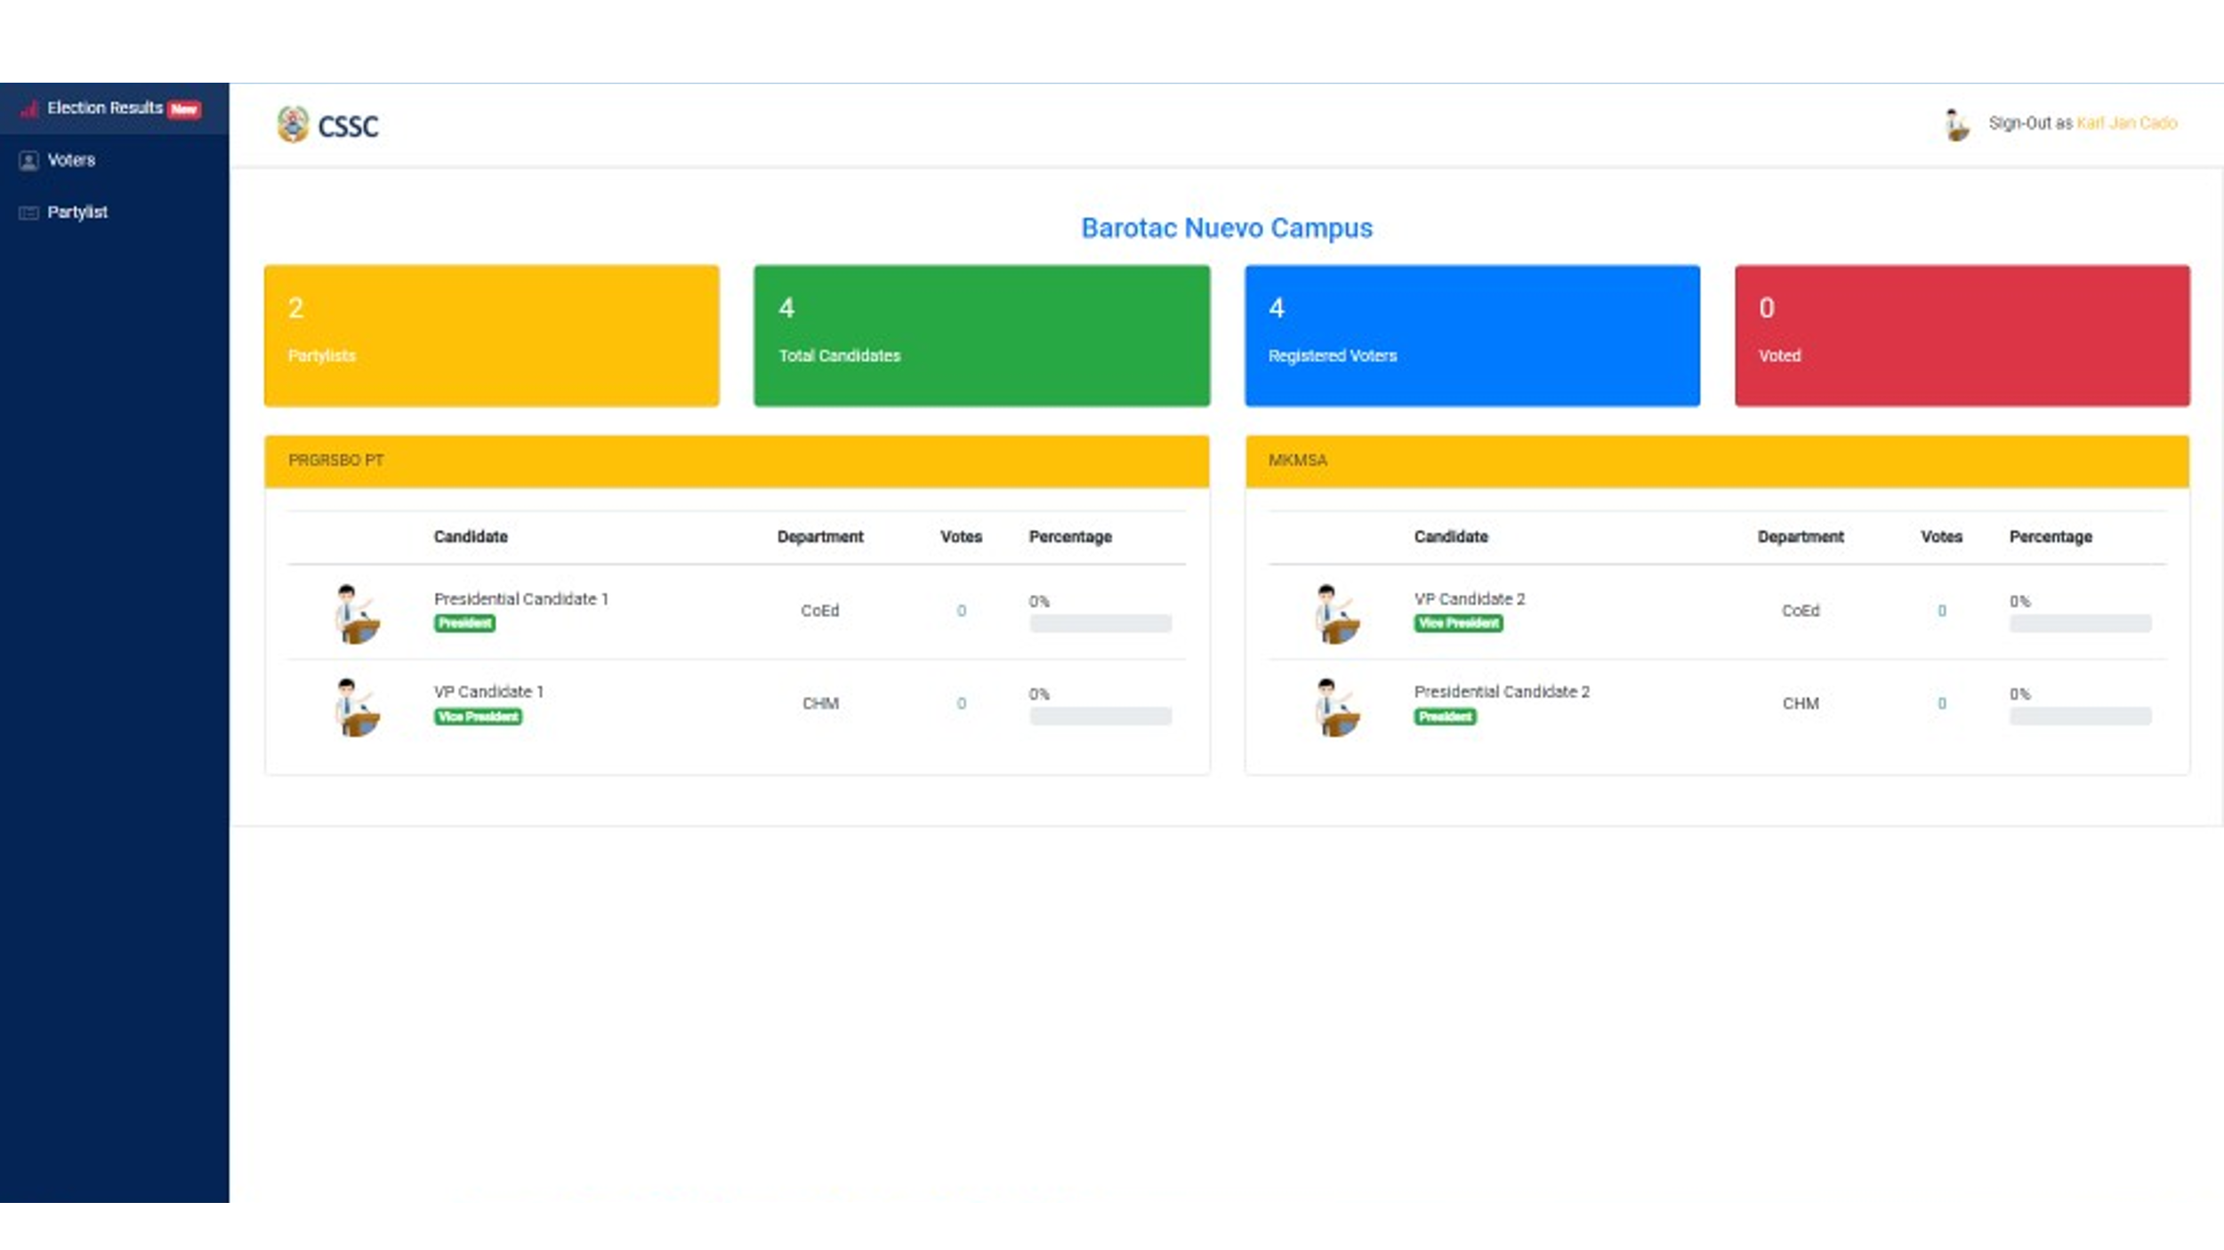

***Figure 13.0.*** *Election Results*

The Figure above shows the election results of the campus where the administrator is assigned.

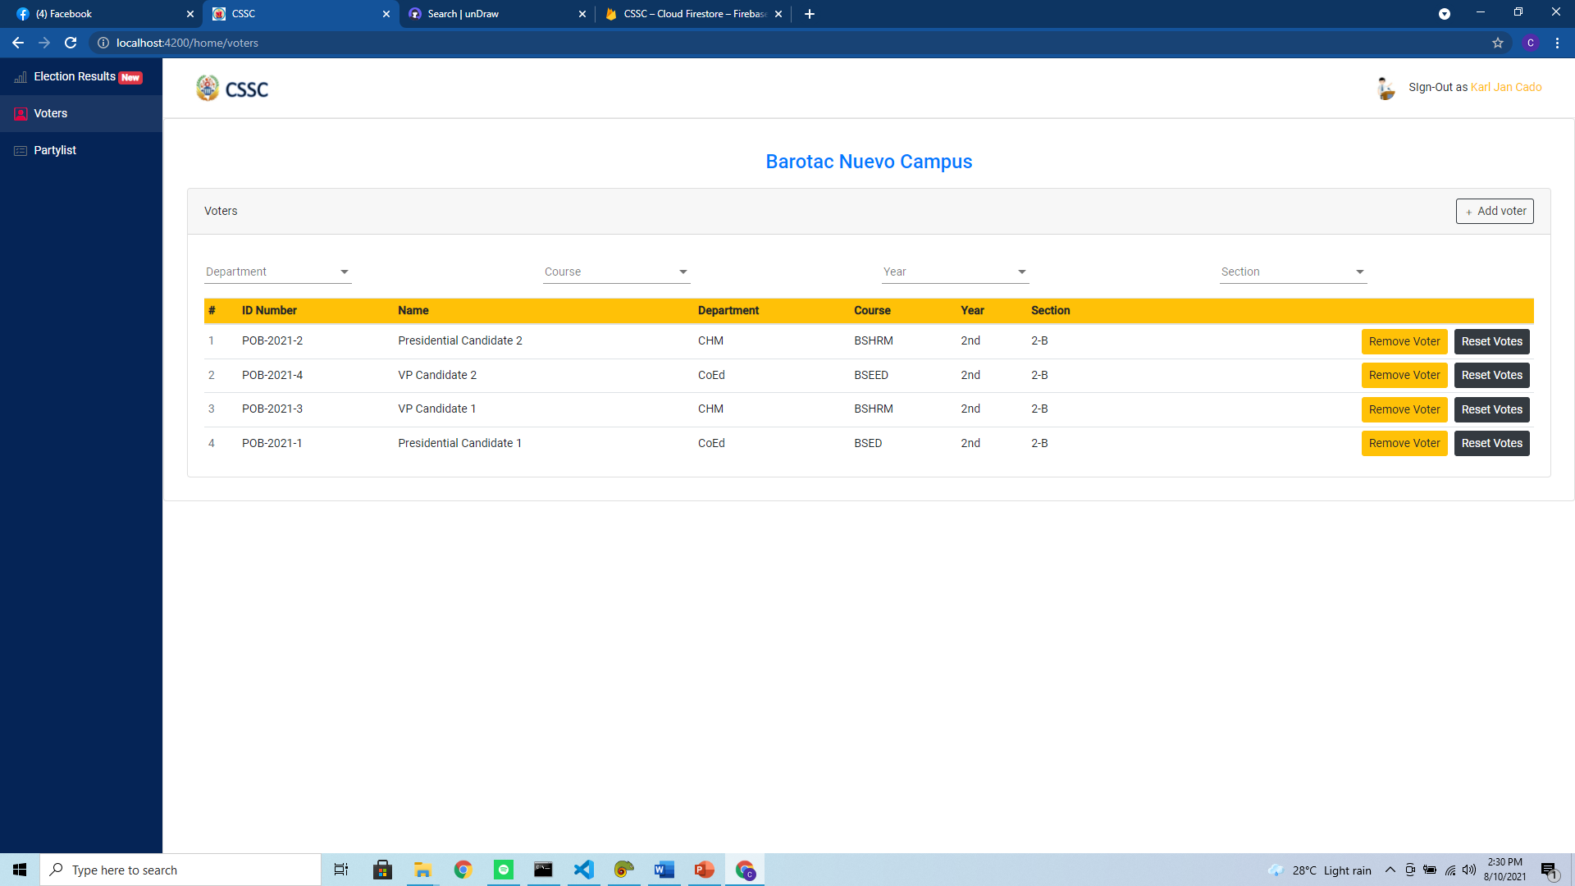***Figure 14.0.*** *List of Voters*

The Figure above shows the list of voters in a particular campus. The administrator could use the filters above to easily see the student that he/she would like to perform an operation like, removing the student or resetting its votes when there are security compromises. The said filters are: department, course, year and section.

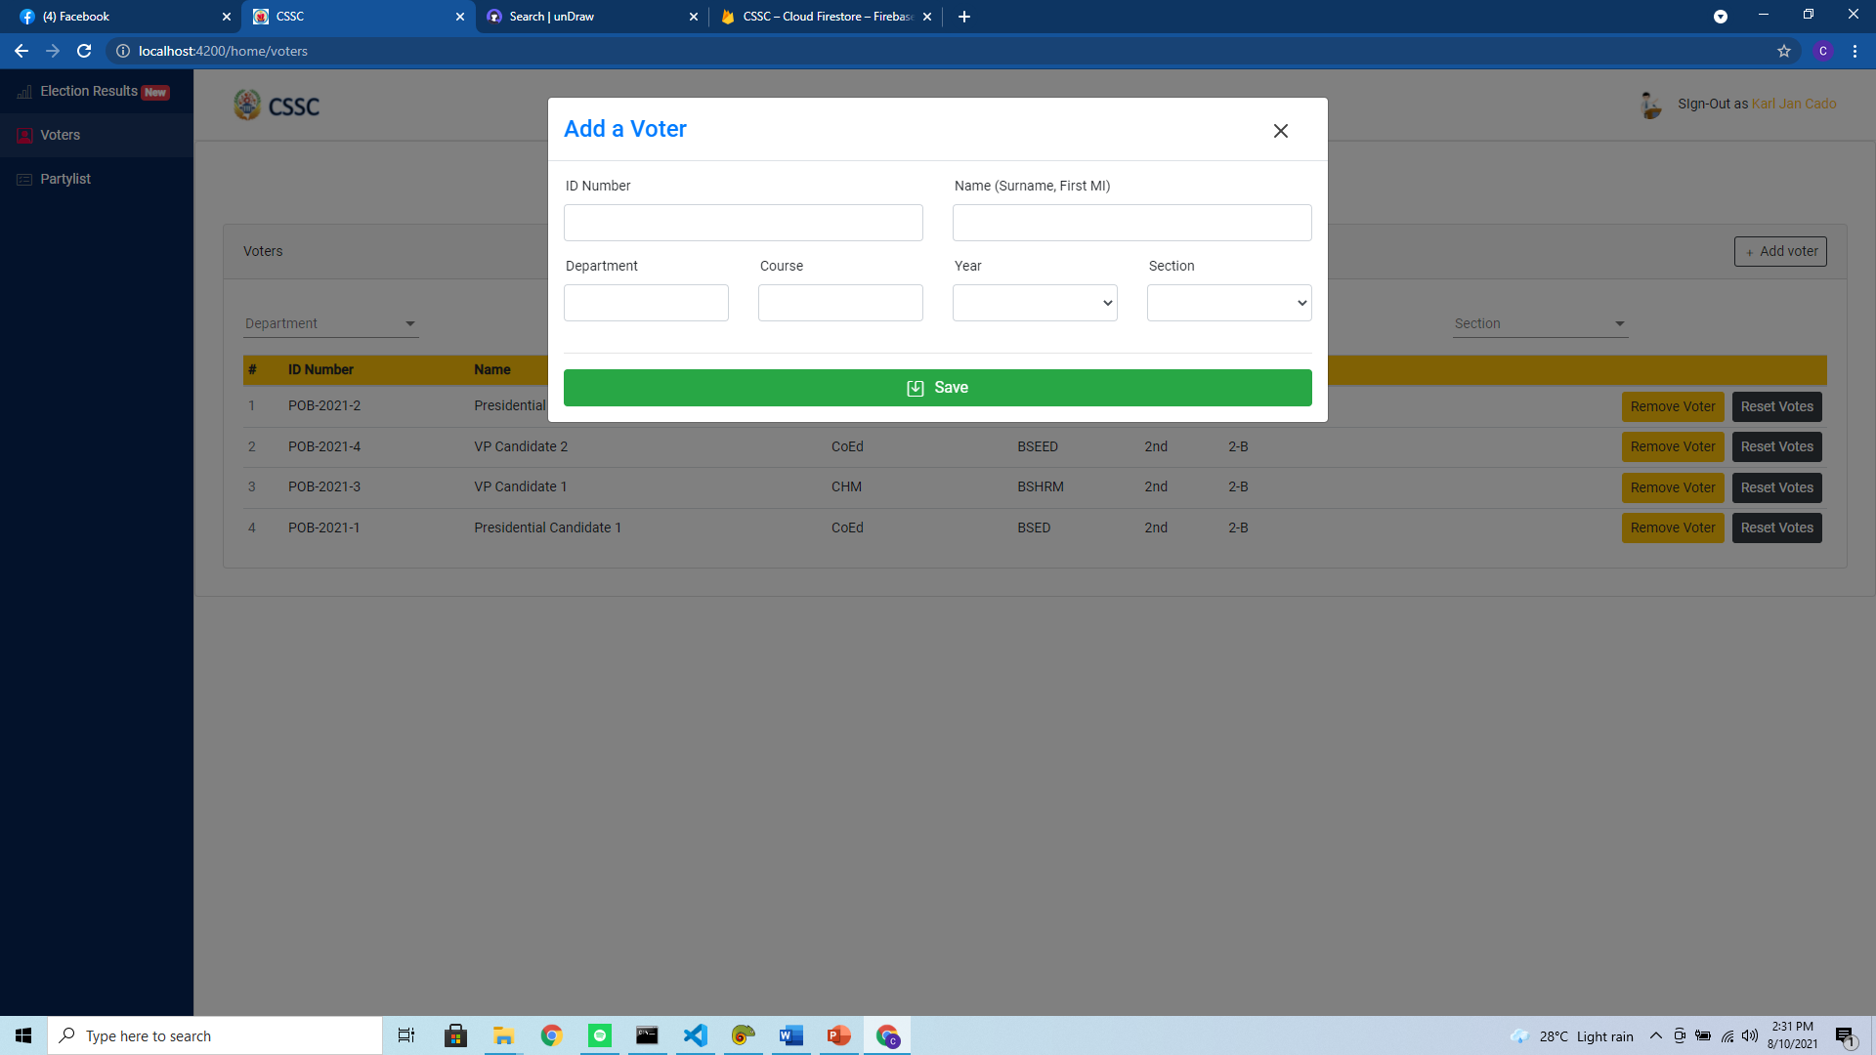***Figure 15.0.*** *Adding a Voter*

The Figure above shows the voter form. It consists of inputs of ID Number, name of the voter (Note: *the specified format should be followed for uniformity*), its department, course, year and section.

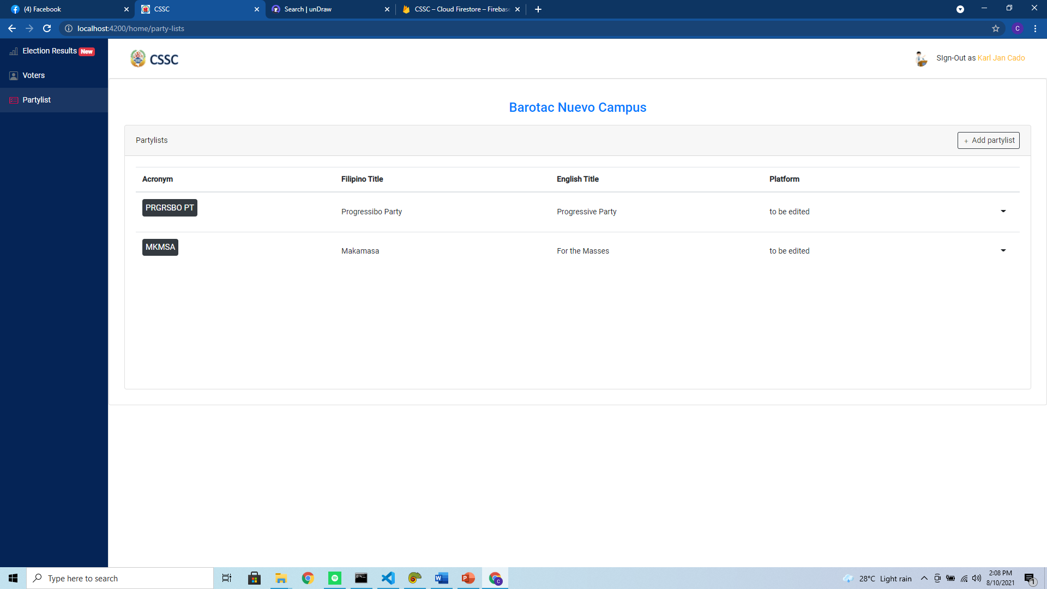***Figure 16.0.*** *Parties*

The Figure above shows the list of parties that is present in the campus of the administrator.

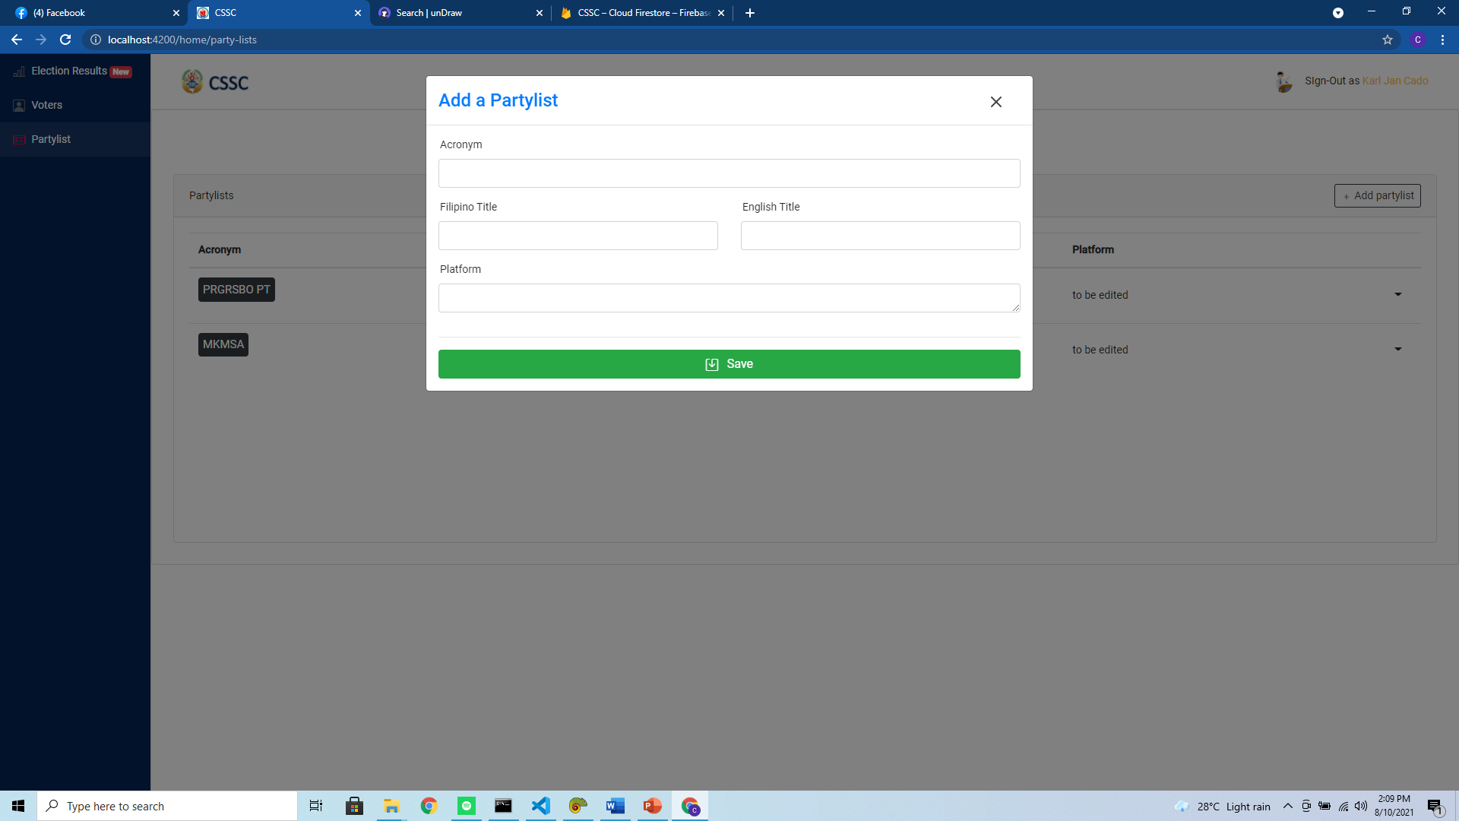***Figure 17.0.*** *Adding a Party*

The Figure above shows the form when adding a party. The inputs consist of the party’s acronym, Filipino title, English title, and its platform.

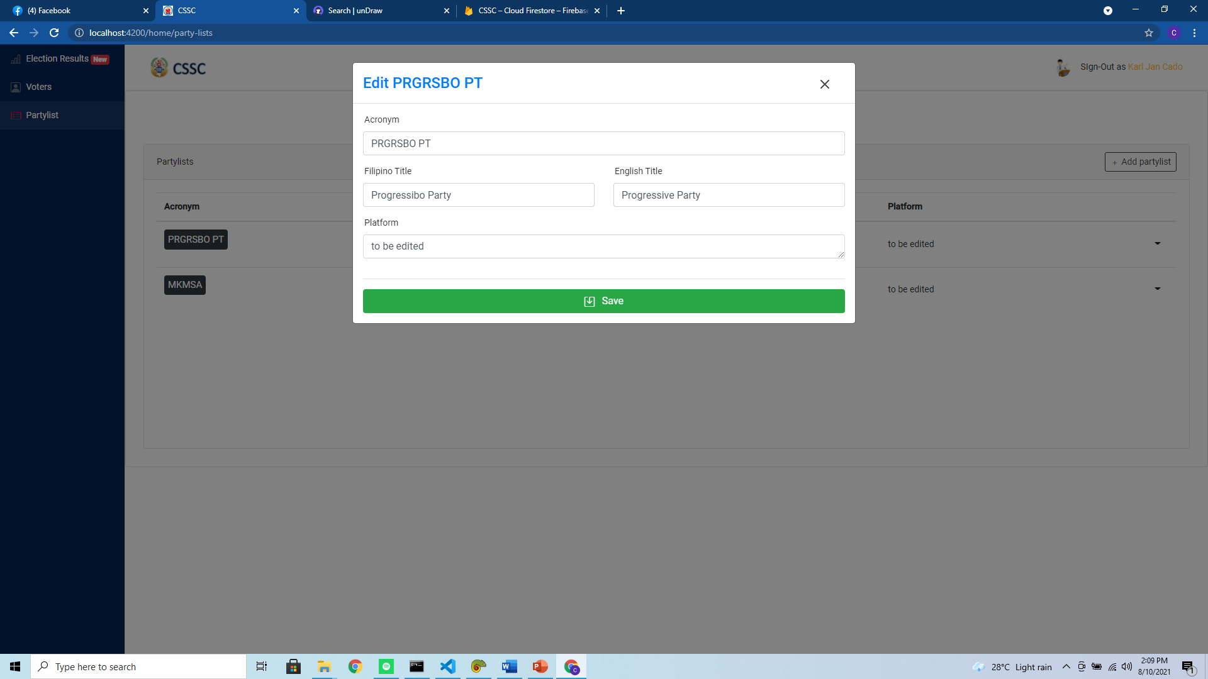***Figure 18.0.*** *Editing a Party*

The Figure above shows the form when editing a party. The same inputs were given when adding a party (See***Figure 13.0***).

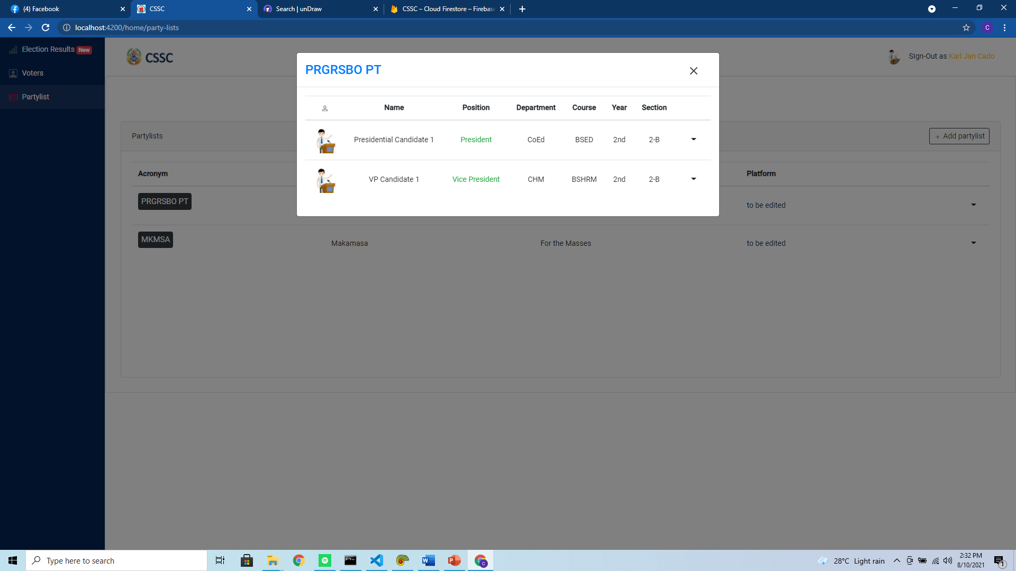***Figure 19.0.*** *Viewing Candidates of a party*

The Figure above shows the candidates of a party that the administrator would like to view. They will just click the dropdown button and navigate to view members to see the UI above.

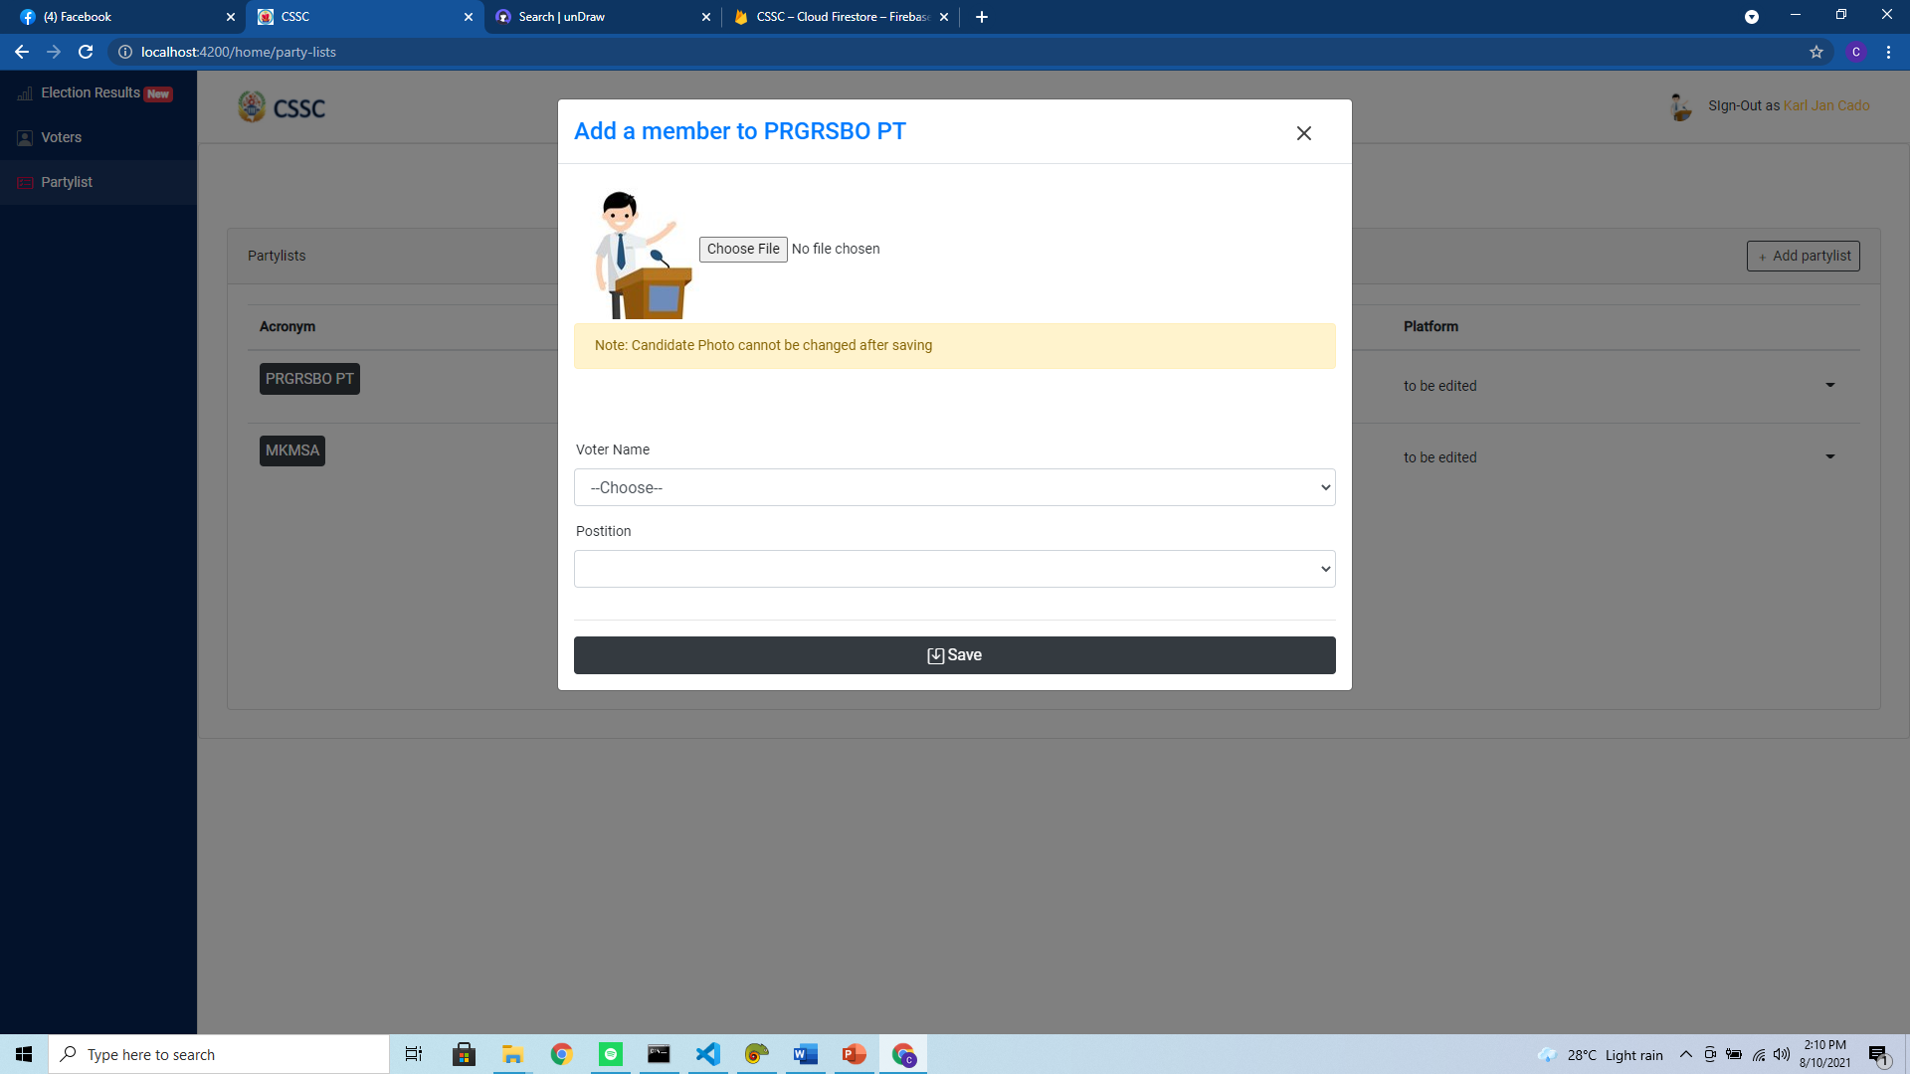***Figure 20.0.*** *Adding a Party Member*

The Figure above shows form when adding a party member. The inputs consist of the member’s photo, its name, and position. When adding a member of the party the administrator should make sure that the said member that he/she will add is already registered as a voter.