James Pinkston
November 26, 2025
D6: Deploying a Model – Link to Repo Here
Progress 1
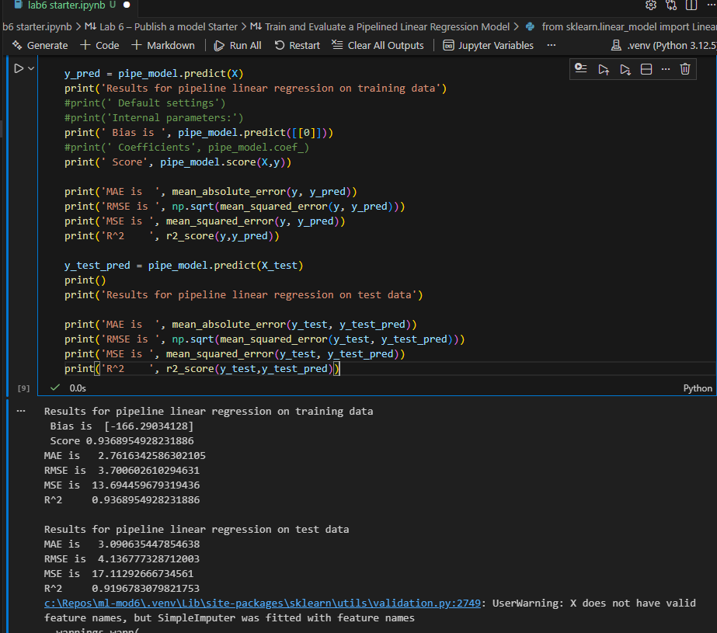
Analysis 2
The linear regression model achieved an R^2 of about 0.889 on training data and 0.868 on test data, showing a moderately strong linear relationship between height and weight. The polynomial pipeline performed better, increasing the R^2 to 0.937 on training data and 0.92 on test data, and reducing MAE and RMSE on both sets. Overall, the polynomial regression provides noticeably more accurate predictions than the simple linear model.
Progress 3
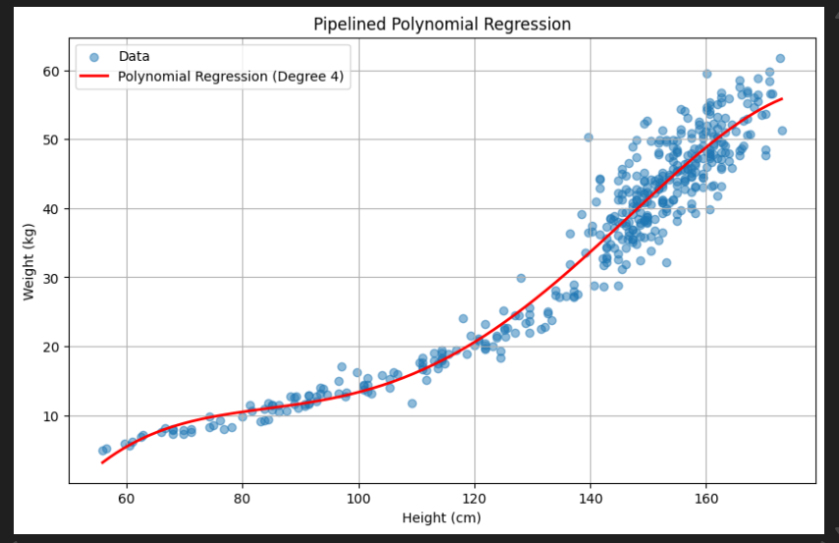
Progress 4
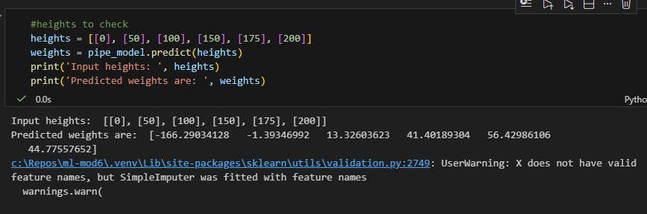
Analysis 5
The appropriate limits for input height should be based on the range of values seen in the training data. For this dataset, heights roughly between 50 cm and 180 cm produce reasonable weight predictions. Beyond this range, the model’s predictions begin to increase or decrease rapidly and become unrealistic.

Progress 6
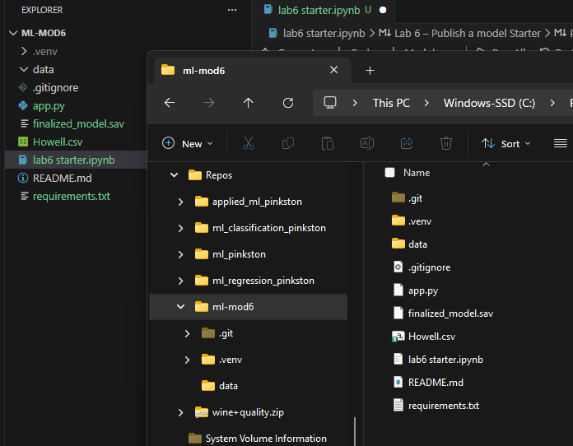
Progress 7
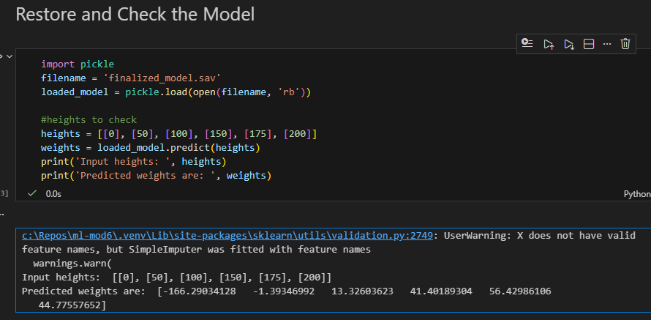
Progress 8
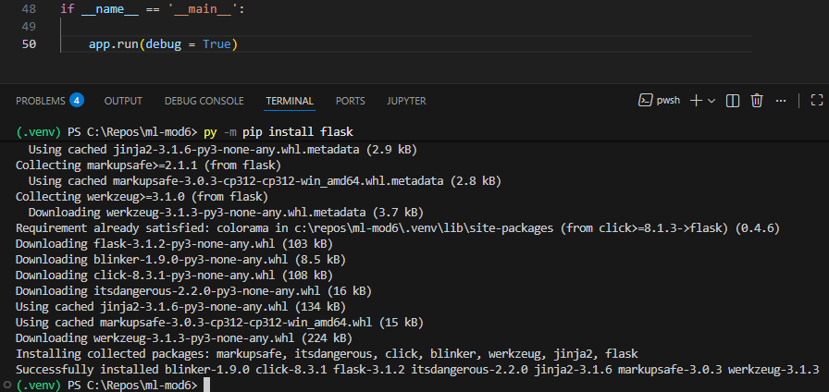
Progress 9
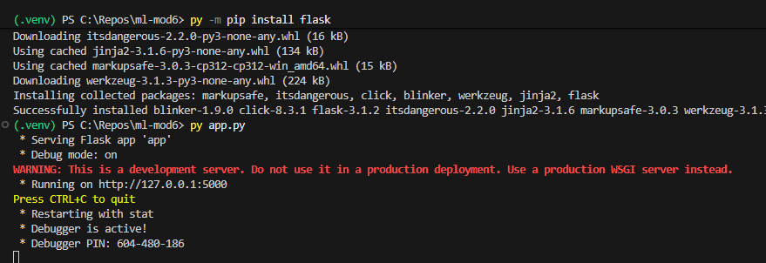
Progress 10
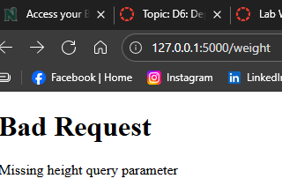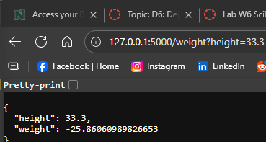
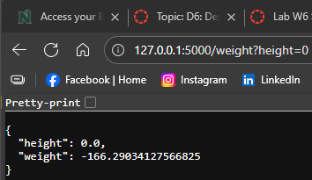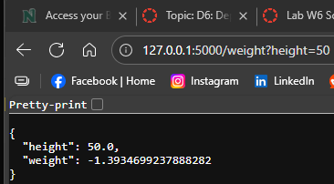
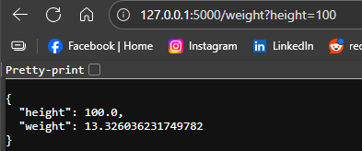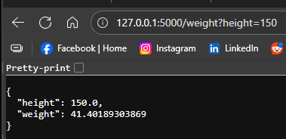
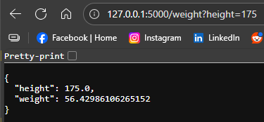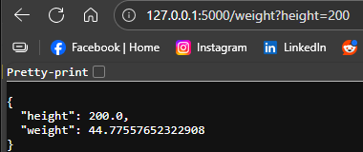
Analysis 11
The predicted weights from the Flask app match the lab notebook predicted values exactly. There are no discrepancies.

