Ticket Vendor Machine

3. Use Case Modelling

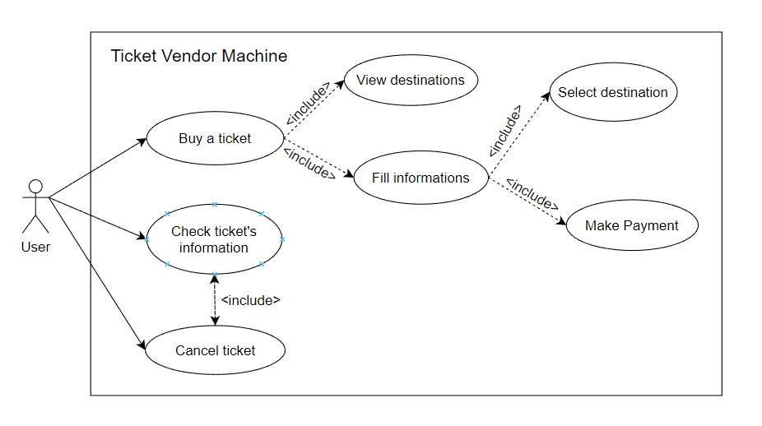

4.1. Activity diagram to present the process of user’s buying ticket from the machine

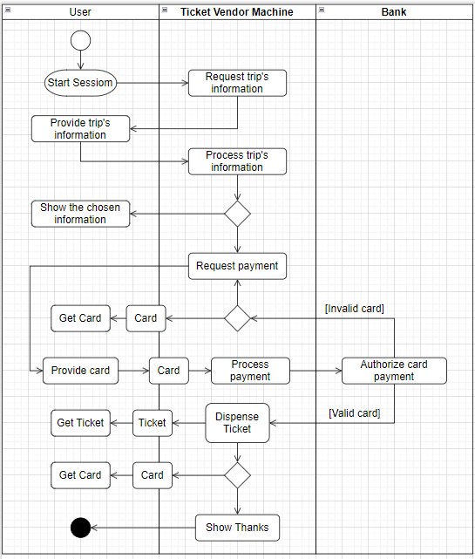(look like ATM)

4.2. Activity diagram for communication among systems if your system is intergrated with other system like Momo, VNPay, ZaloPay, ...etc

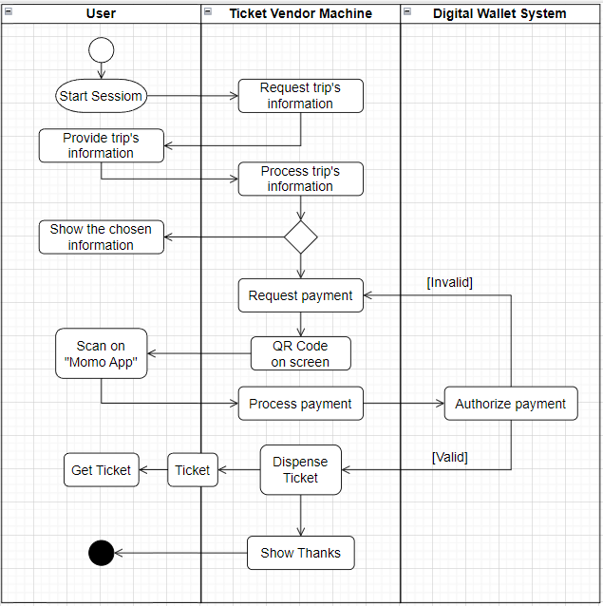

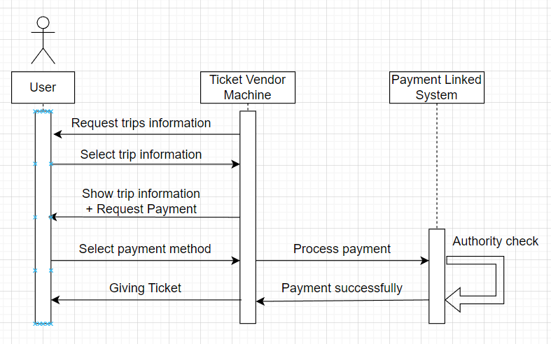5.1. Sequence Diagram

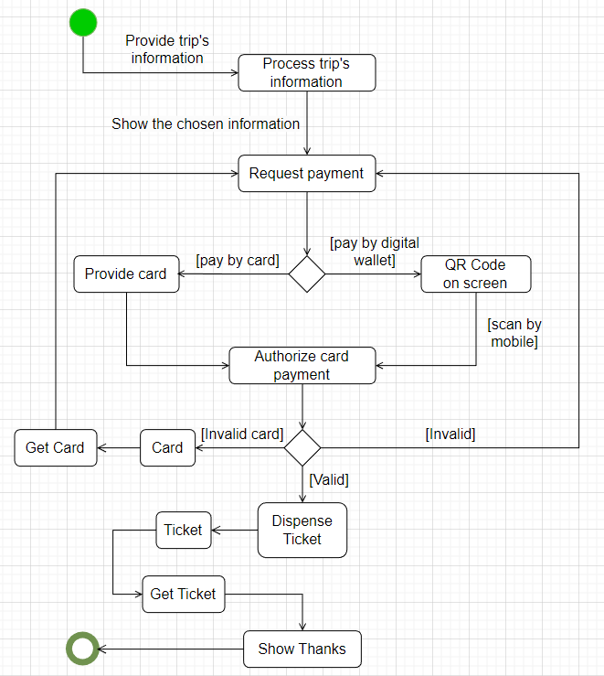5.2. State chart diagram

7. Architecture design

