**MECS4510 Evolutionary Computation, Fall 2023**

**HW1: Traveling Salesman Problem**

Name: Bole (James) Pan

UNI: bp2632

Instructor: Prof. Hod Lipson

Date Submitted: September 27, 2023

Grace Hours Used: 0 hours

Grace Hours Remaining: 96 hours

**Summary Result Table**

**Table 1. Results Summary**

|  |  |  |  |
| --- | --- | --- | --- |
| **File Name** | **Category** | **Evaluations** | **Length** |
| cities.txt | The shortest path | 76010 | 523.7312659268067 |
| cities.txt | The longest path | 92641 | 616.6014859186349 |

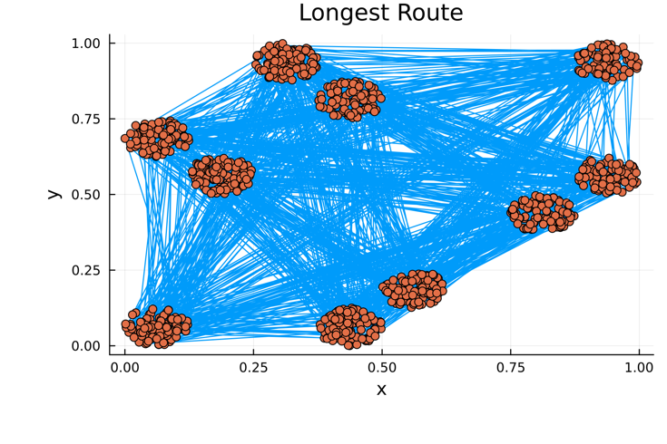 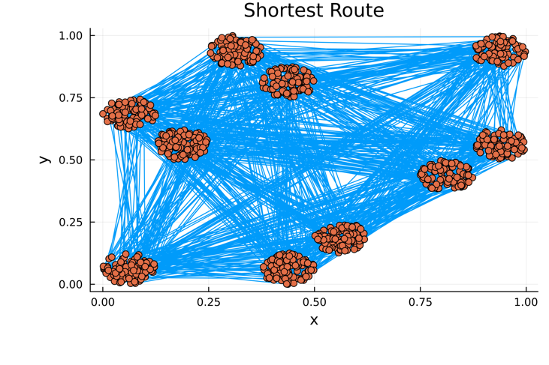

Figure. The shortest path (left) and the longest path (right) found

**Theoretical Shortest Path:** 12.775068874879208

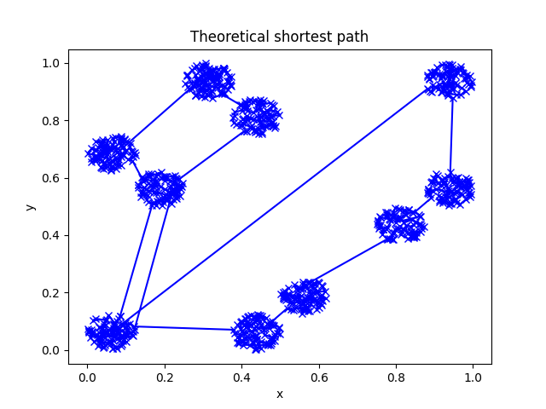

Figure. The theoretical shortest path found using Christofides’ algorithm.

**Methods**

* **Fitness:** we define fitness as the inverse of the total distance of a route. Therefore, the shorter the route, the higher the fitness.
* **Representation Used:** We represent each city as a tuple with two elements. A route, as called an individual, is an ordered array of all the cities. A population is an array of routes, or individuals. We are using direct representation, and more specifically, index representation.
  + **Mutation:** we use the swap mutation method. For an individual route, we loop through each city, and with a certain mutation rate we probabilistically swap this city with another random city.
  + **Crossover:** we use the order crossover method. For two parent routes, we randomly select a subset of cities from one parent, and make the child's corresponding segment the same as that of the parent, then fill in the rest of the cities in the order of the other parent.
* **Random Search:** Randomly generate a permutation of the cities and calculate the total distance. Repeat this process for a number of times and record the best result.
* **Random Mutation Hill Climbing:** Randomly generate a permutation of the cities and calculate the total distance. Then, for a number of times, apply mutation on the route and calculate the fitness of that route. If the new fitness is higher, keep the new route. Repeat this process for a number of times and record the best result.
* **EA variation and selection methods used:** We use the roulette selection method. From the initial population, we first select a small population of elites. The higher the fitness, the more likely an individual would be selected for this group. We put all our elites in the new population. Then, until the new population reaches the predetermined population size, we randomly select two individuals from the elites and apply crossover to produce a child, apply mutation on the child, and put it into the new population. This process, going from the initial population to the new population, is repeated for a number of times (called generations).
* **Analysis of Performance:** In terms of finding the longest path, in 100k generations, with mutation rate of 5%, selection rate of 30%, and population size of 100, we found that evolutionary algorithm performs the best. Random search follows with significantly lower performance, while random mutation hill climbing performing the worst. Hill climber also has the greatest error of the mean at each generation.
* **Methods compared:** we compare the performance of random search, random mutation hill climbing, and EA.

**Performance Curves**

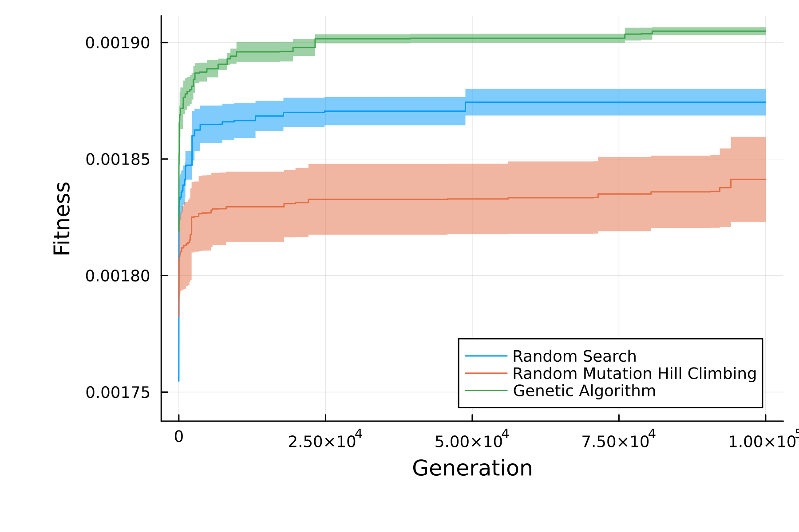

Figure. The shortest path learning curves of random search, hill climber, and EA (ribbons represent the error of the mean in each generation, averaged on four runs)

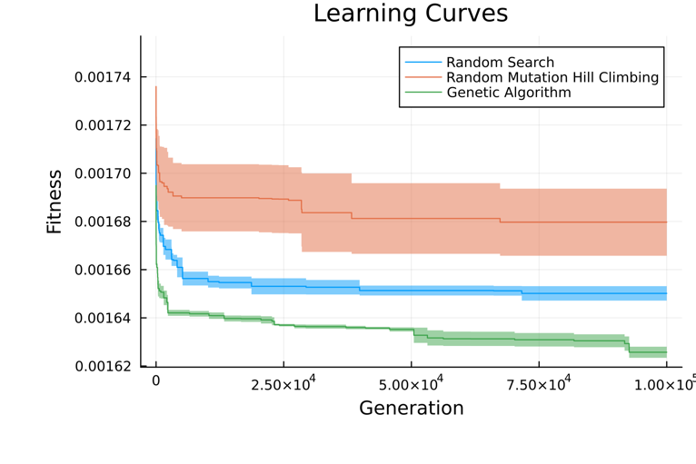

Figure. The longest path learning curves of random search, hill climber, and EA

**Appendix: Code**