**Embedded Systems Development Group Meeting 1**

**Meeting Details:**

* Time: 1:00pm – 2:10pm
* Date: 31/10/13
* Location: Project room

**Minute’s taker:** Thomas West

**Meeting Agenda:**

* A discussion of previous experience areas
* A discussion of the areas of a project that interest or are applicable to individuals
* Assign weekly research between group members
* Discuss source control and methods of storing code/documents
* Decide on when the next meeting will be

**In Attendance:**

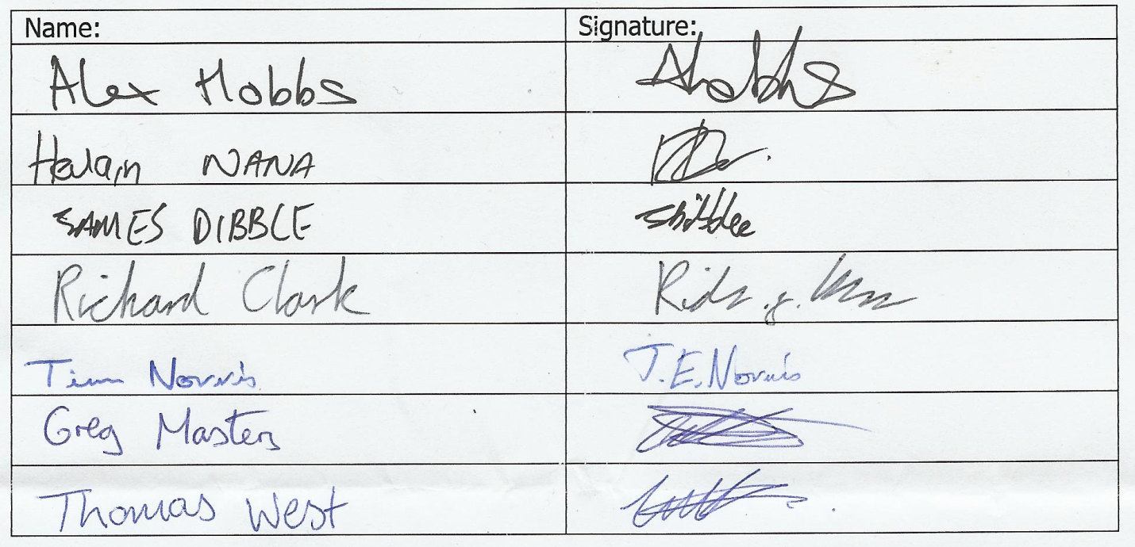

**Members not present:** None (All attended)

**Discussion of previous experience and project interests:**

The group collectively discussed what they have done over the past years at University including any personal or work tasks that could be relevant. This helped everybody to see the skills that the group possessed and where we may need to research. After this we divided implementation areas between us to look at.

**Research:**

The team each decided on an important area to research and discuss in the next meeting. This was something relevant to the area that they are likely to be working on though this was agreed to be finalised in the next meeting.

|  |  |
| --- | --- |
| Name | Research area |
| Thomas West | The caching of audio files to a device |
| Greg Masters | Wi-Fi beacon identification for getting an approximate location |
| Alex Hobbs | The control panel we are to use and how best to communicate with it |
| Hevlain Nana | Security issues and best practices with the project |
| James Dibble | Entity relational mapping and research into the use of API’s |
| Richard Clark | The use of pulse audio for audio streaming including synchronisation |
| Tim Norris | Research possible extension ideas |

**Source Control:**

There were a number of source control methods discussed including GIT, SVN and TFS. After some debate on the topic, taking into consideration past experience, extensibility and compatibility the group decided to use GIT. There was also some discussion on continuous integration. There was some interest in the use of [Travis CI](https://travis-ci.org/). The group decided that this would be one of the areas that we will need to research further.

**Hardware:**

The group discussed which board they thought would be most suitable for use and decided to use one of the suggested boards, the IGEP. Some of the group members had done some work on this board before and the built in Wi-Fi and other technical specifications met the requirements.

**Follow up meeting:**

* Time: 1:00pm
* Date: 07/11/13
* Location: TBD