## The application

The aim is to implement a new mobile distribution system for museum art galleries. The system shall include microcontrollers to operate audio receiver and playback unit. This shall accept track control commands through keypads, and show timing and track numbering on a small display. The portable shall use WIFI to connect through to the central data distributer which shall be equipped with a WIFI router box. The central database shall hold audio tracks and user information to check on authorisation, payment and any other details. The system shall also support the routine needs of the administrators. Before the release of the system, a prototype shall be implemented to support the system, below is a list of the prototype chosen and its functionalities.

## Prototype

The prototype that we have chosen to demonstrate is the audio streaming device, the audio streaming the team decided to use was the QT. The client shall send request for audio track the server shall respond with a URL to the audio track. The server shall respond with the correct audio track based on the information it holds on the current user - e.g. Age. The client shall then be able to use the URL to stream the audio from the server, the client buffers the audio locally so that it shall be paused, rewineded and fast forwarded. The

### Scenario

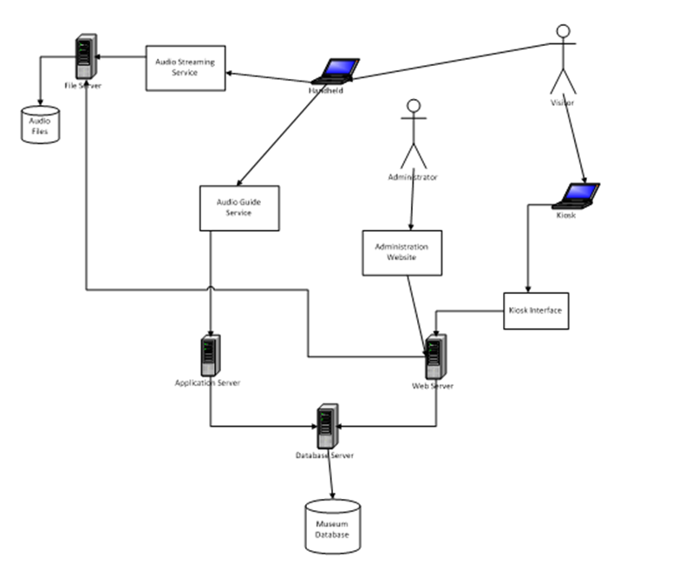

The diagram above provides an overview of how our program will run; the diagram describes how each device will play a part in how the audio device will work. As you can see the diagram shows the visitor approaching the payment kiosk, while at the kiosk the customer registers and hire a mobile audio playback unit. The customer shall give their information such as name, address, mobile and language which shall be stored on the database server. In order to access any information you would have to go through to the database server because that is where everything will be stored. When the information is successfully added to the database the client shall then be provided with a 4 digit pin for the audio file to be streamed down (this shall not be done for the demonstration).

From the following diagram you can see how we will go about implementing the new mobile distribution system. We decided to have our system as a cohesive system as it enables each essential part of this device to do one thing e.g. the database server will store all of the users information such as name, date of birth, payment details ect…

Prototype functuntionality

The hardware IGEPV2

The IGEPV2 provides much functionality such as built in Wi-Fi and other technical specifications met the requirements. Some of the team members have already has some experience with IGEPV2 as they had done some previous work with this. Some of the basic functionalities are:

x 95mm

Processor =

• •CPU: Cortex A8 at 1GHz

• •DSP: TMS320DM C64+ 800Mhz

• •Graphics: 2D/3D POWERVR SGX530 @200MHz

• •Industrial range (-40 to 85ºC)

Peripheral=

• •Ethernet controller: 1 x 10/100 MB BaseT (RJ45)

• •UART: 3 x UART (2 x RS232 and 1 x RS485)

• •USB: ◦1 x USB 2.0 OTG (miniAB receptable)

• ◦1 x USB 2.0 Host (Type A receptable)

• •Video: 1 x DVI-D programmable panel size (HDMI connector)

• •Audio: ◦1 x Stereo Audio In (Stereo minijack)

• ◦1 x Stereo Audio Out (Stereo minijack)

• •1 x MicroSD Card Reader

• •RTC

• •Wireless connectivity:

• ◦Wifi: 802.11 b/g

• ◦Bluetooth: BC4 - Class 2.0

• ◦Antenna: Internal Wifi/BT Antenna

available signal

• •3 x SPI

• •2 x I2C

• •1 x MMC

• •1 x I2S / McBSP / SSI (digital audio)

• •1 x Digital Video / TFT interface

• •1 x Camera Interface

• •1 x Keypad matrix