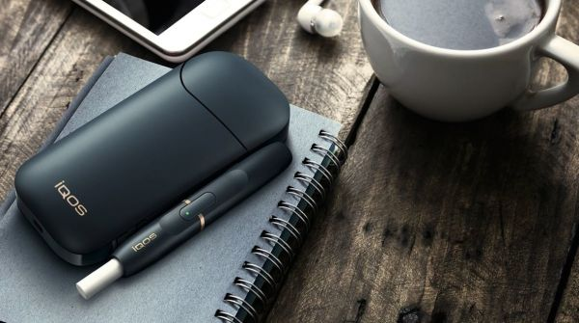

IQOS

Marketing Research

james mahfouz – Rick Azzi

[Year]

**Table of contents**

**1. Introduction**

1.1 The Need for the research

1.2 The Purpose of the research

1.3 Research Questions

1.4 Research Hypotheses

1.5 Limitations

**2. Procedures and Methodology**

2.1 Population Selection

2.2 Sample Selection

2.3 Research designs

2.4 Instrumentation

2.5 Field Work

2.6 Data Collection

**3. Findings of the research**

**4. Conclusions and recommendations**

4.1 Conclusion

4.2 Recommendations

**5. References**

**6. Appendix**

**Introduction**

**The need of the research:**

By collecting this data, IQOS can better understand the target market, the strengths and weaknesses, and how to improve the customer experience. The data can also be used to identify any patterns among customers, and to evaluate the effectiveness of their marketing campaigns. This information can help IQOS make decisions about product development, pricing strategies, and promotional activities.

**The purpose of the research:**

The purpose of this form is to gather information about customers’ perceptions of IQOS and be used by IQOS to make decisions about their products and marketing strategies. It will gather information about customers' familiarity with IQOS, usage patterns, sources of information about IQOS, reasons for trying it, satisfaction levels, areas for improvement, likelihood of recommendation, demographic information, and occupation.

**The research questions:**

Here are some sample research questions that could be answered using the marketing research form for IQOS:

* What are customers perceptions of the convenience of using IQOS compared to traditional smoking methods?
* What factors influence customers decisions to try IQOS for the first time?
* How satisfied are customers with the design and appearance of IQOS products?
* What are the main sources of information that customers use to learn about IQOS?
* How likely are customers to recommend IQOS to others and what factors influence their recommendation behavior?
* What are the most common reasons for switching to IQOS from traditional smoking methods?
* Are there any areas for improvement identified by customers in their experience with IQOS?
* Does customer occupation impact their perception and usage of IQOS?

**The research hypotheses:**

* Hypothesis 1: IQOS users will have a higher level of satisfaction with the product compared to traditional smoking methods.
* Hypothesis 2: IQOS users will be more likely to recommend the product to others compared to those who have not used IQOS.
* Hypothesis 3: IQOS users will have a lower rate of switching back to traditional smoking methods compared to those who have tried IQOS in the past.
* Hypothesis 4: IQOS users will report a better taste and more enjoyable smoking experience compared to traditional smoking methods.
* Hypothesis 5: IQOS users will report a reduction in the cost of smoking compared to those who continue to smoke traditional cigarettes

**Limitations:**

* Self-reported data: The form relies on customers to truthfully answer the questions, which may not always be the case. Some customers may exaggerate their satisfaction with IQOS.
* Limited scope: The form only gathers information from customers who have used IQOS and may not be representative of the entire potential customer base.
* Single source of information: The form only gathers information from customers and does not take into account other important factors that may influence customer satisfaction, such as the quality of customer service or the availability of IQOS in different locations.
* Limited demographic information: The form only collects basic demographic information, such as age and gender, which may not be enough to fully understand the customer motivations.
* Limited data analysis: The form does not provide a comprehensive analysis of the data collected and may only provide basic insights into customer perceptions and experiences with IQOS. Further analysis and research may be required to fully understand the data collected.

**Procedures and Methodology**

**Population and sample selection:**

The population selected for the marketing research form for IQOS are Lebanese individuals who have used IQOS. The sample is selected based on the people aged between 18 and 24.

**Research design:**

The research design is the Exploratory Research design.

**Instrumentation:**

The instrumentations are, survey questionnaire done with google form, Microsoft word and Microsoft PowerPoint for the report, Microsoft Excel for the data.

**Field work:**

We collected the data using the survey questionnaire done by google form.

**Data Collection:**

The questionnaire was created using the internet, especially the IQOS articles, google, and the course. The questions of the questionnaire contain questions related to customers perceptions and experiences with the product. The questions are in the appendix of the report.

**Findings of the Research**

**The age range**

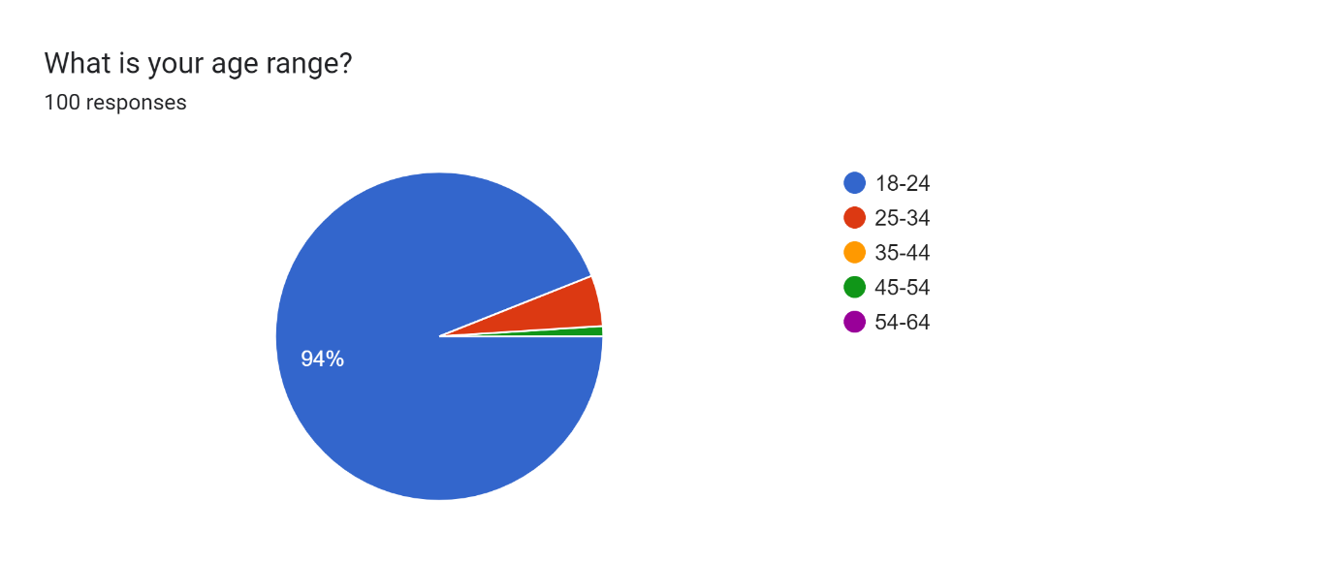

In this part, 94% of the responses came from people aged between 18 and 24 years old.

**The Gender**

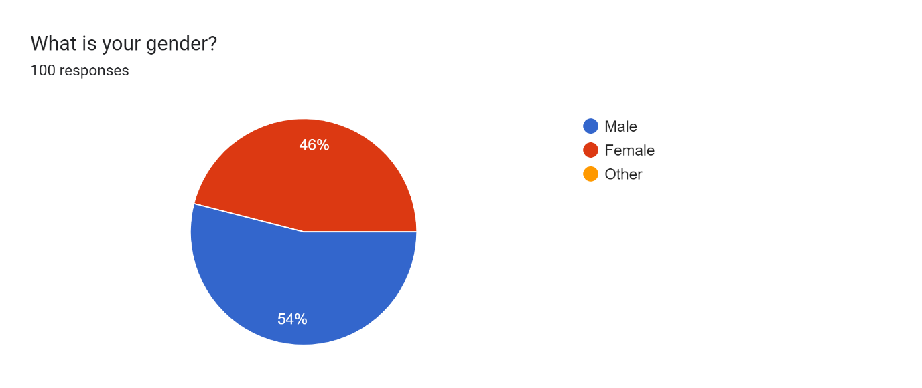

In this part, 54% of the responses came from men and 46% of the responses came from women, there exist no one who chose the other option.

**The Occupation**

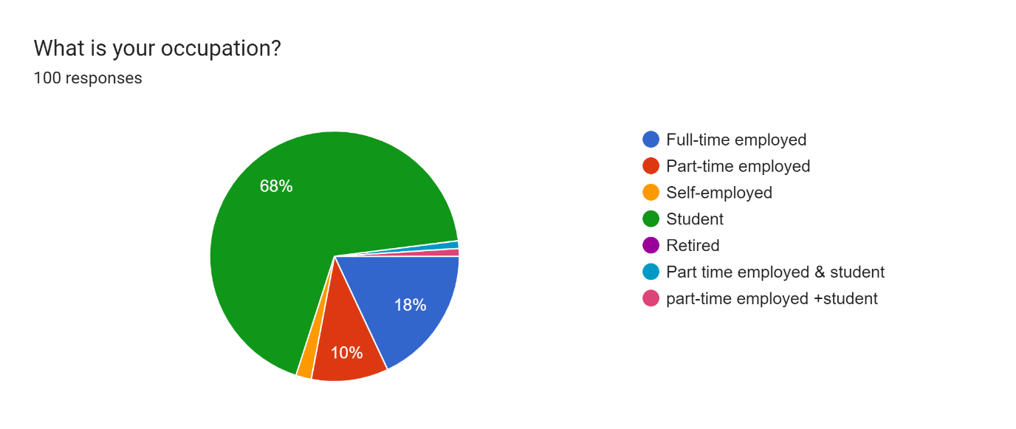

In this part, 68% of the responses came from people who are Students. 18% are full-time employed, and 10% are part-time employed, the rest are divided between part-time and student, self-employed.

**The familiarity with the product**

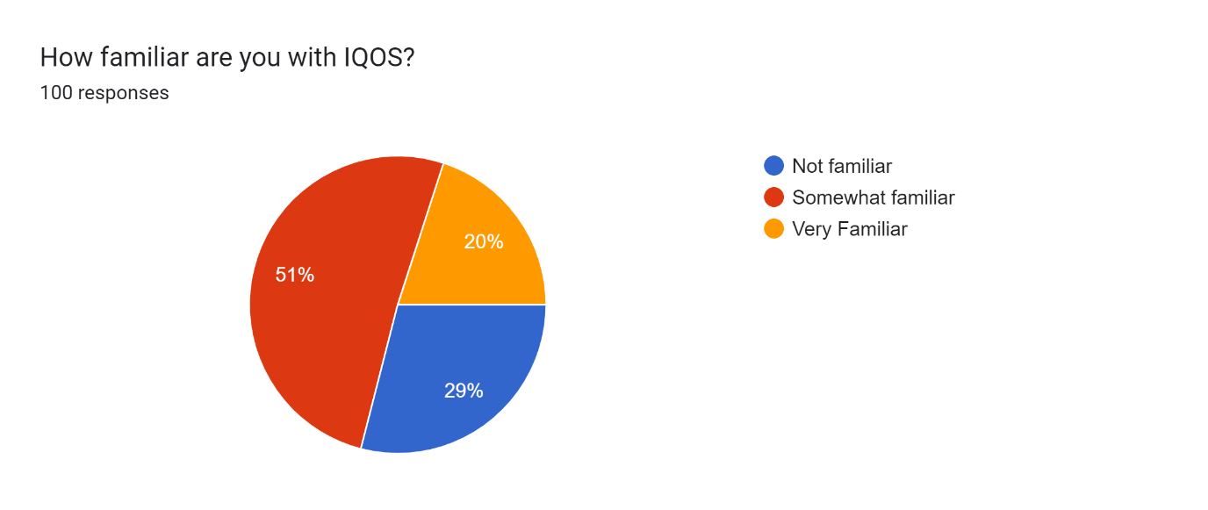

In this part, 51% of the responses were that people are somewhat familiar with IQOS, 29% were not familiar and 20% are very familiar.

**Percentage of people who tried IQOS**

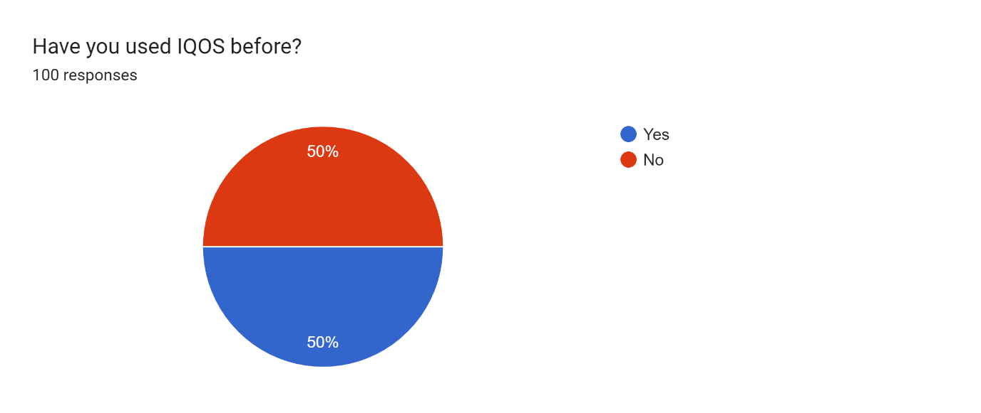

In this part, 50% used the product before and 50% didn’t.

**Usage of IQOS by customers**

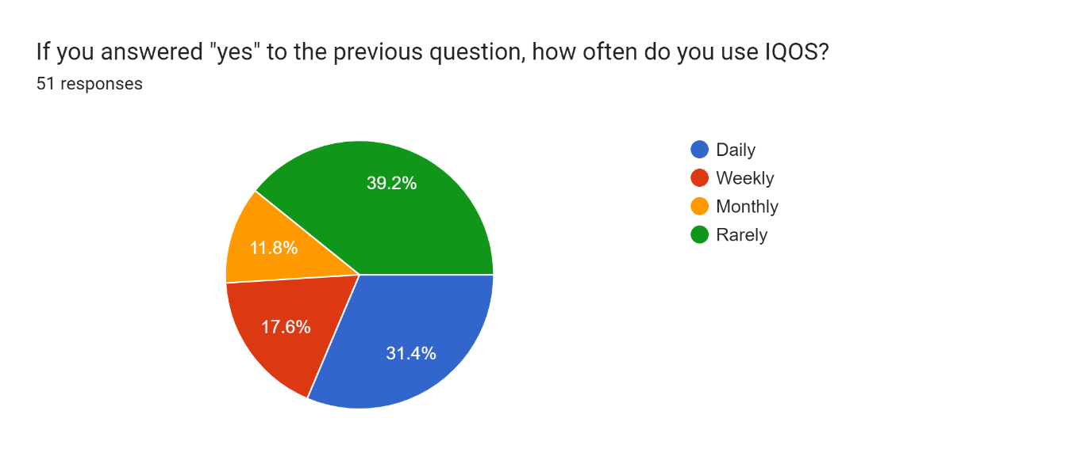

In this part, 39.2% of the responses were from people who rarely use the product, 31.4% use the product daily, 17.6% weekly and 11.8% monthly.

**How they heard about IQOS**

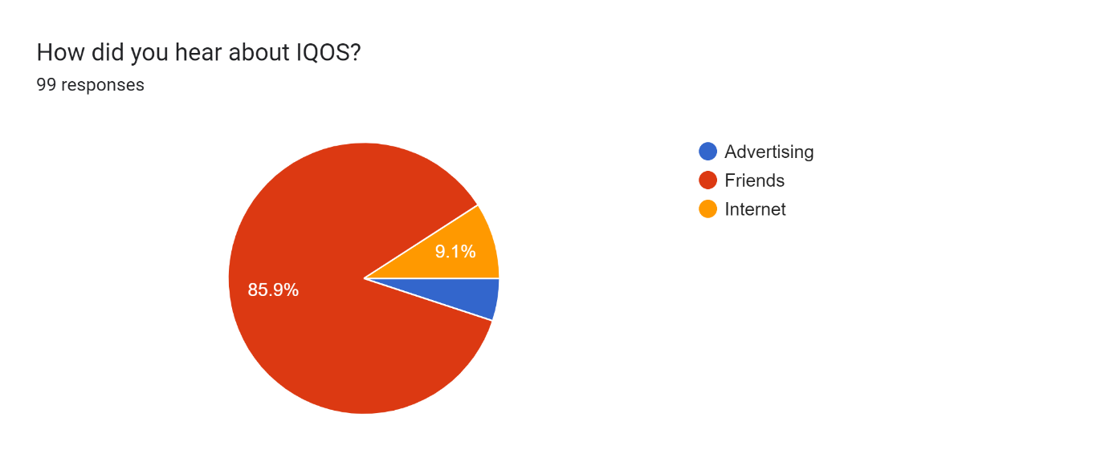

In this part, 85.9% heard about the product from their friends, 9.1% from the internet and the rest from advertising.

**Factors to try the product**

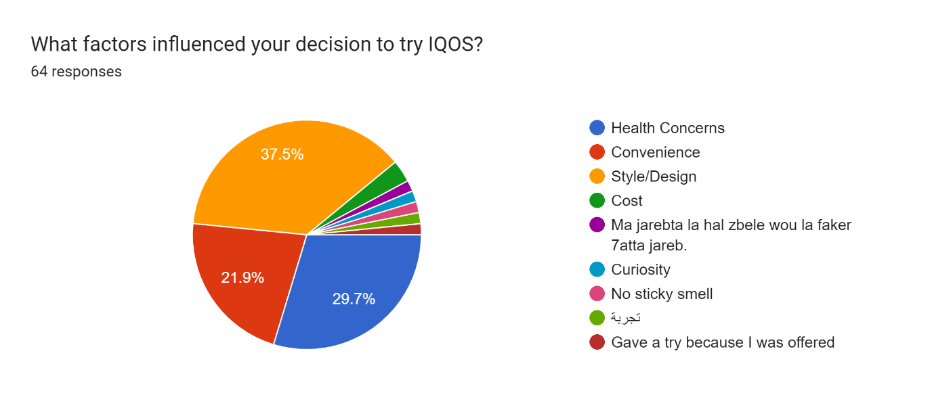

In this part, 37.5% say that they tried it because of the style or design, 29.7% because of health concerns, 21.9% from convenience, this was the most answered, the rest are divided into small percentages.

**Satisfaction with the product**

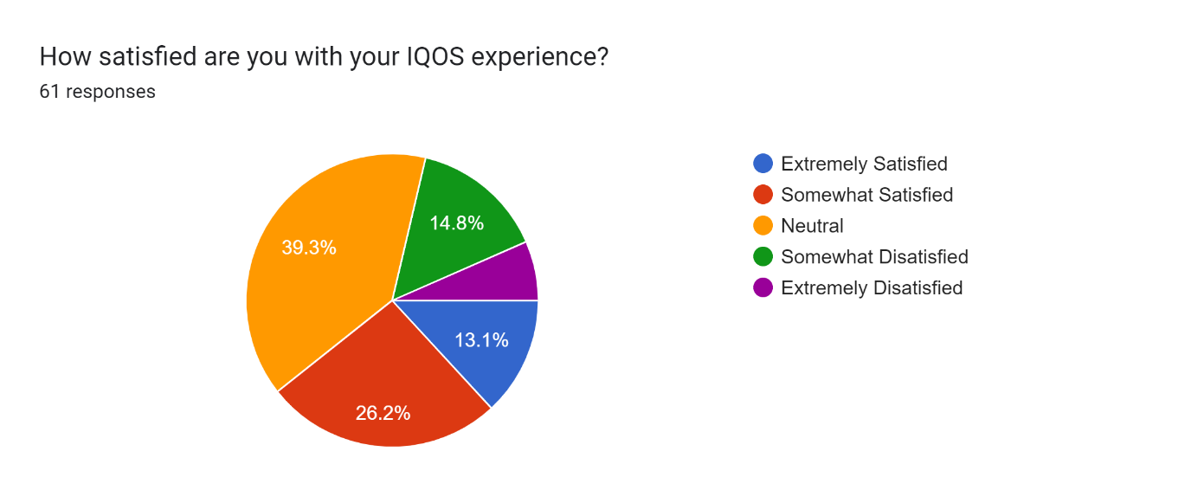

In this part, 39.3% of the answers were neutral, 26.2% were satisfied, 14.8% were dissatisfied, 13.1% are extremely satisfied.

**Improvement recommendations**

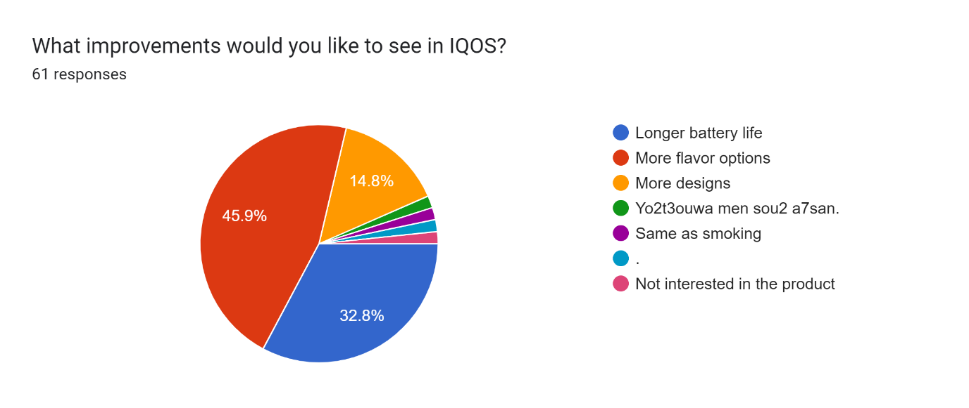

45.9% recommended more flavor options, 32.8% said they wanted a longer battery life, 14.8% said more designs, and the rest are divided.

**Likeliness to recommend**

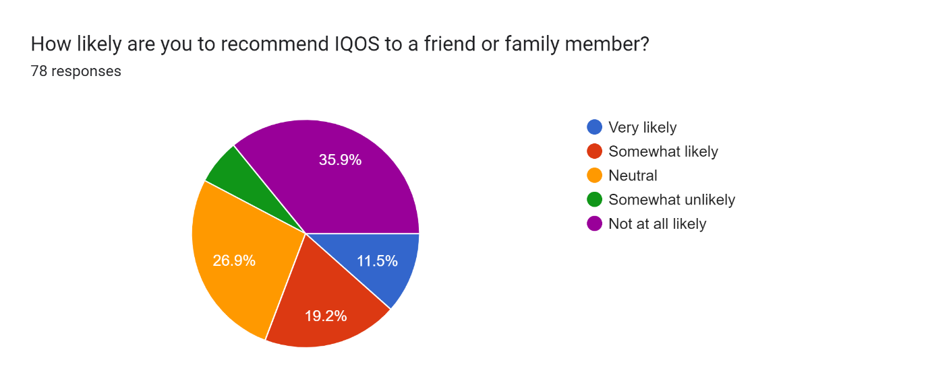

In this part, 35.9% said that they won’t recommend it, 26.9% said that it is neutral, 19.2% said that it is likely, and 11.5% said that they will very likely recommend it.

**How likely when someone try will he like the product?**

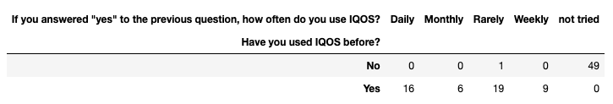

We can notice from this contingency table that when someone tries IQOS there is approximatively 30% that they will like and continue using it daily and the other majority will rarely retry it.

**Why do daily user switched to IQOS**

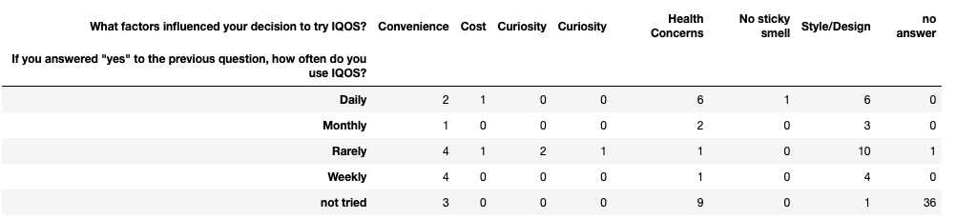

We can notice here that IQOS daily user mainly switched to it for health concerns which isn’t proven totally yet but there is some truth to it that can be mentioned in the marketing strategies. Other reasons for switching to IQOS are the design, so the company can create new design to make new customer’s switch to IQOS.

**What are the daily user’s recommendation**

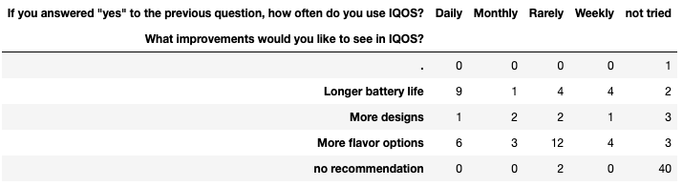

Here we can see that most of daily user want a longer battery life and more flavor as of non daily user they want mostly more flavors which can be an area to improve to acquire more customers.

**The unsatisfied customer’s**

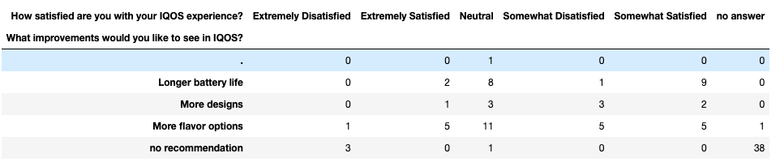

Most of the customer’s that have a neutral or dissatisfied opinion about IQOS mostly want more flavor option and there are some of them who wants a longer battery life as the daily customer’s.

**Conclusions and recommendations**

**Conclusion**

After sending the form and getting the responses, we can conclude that IQOS isn’t that popular yet. Most of the people who use it or have heard of this product are probably young aged. People aren’t a lot familiar with it yet and there exist a big number who didn’t even try it. Even the IQOS users, most of them use it rarely and not daily compared to the use of smokes for example. It is not that popular because it can’t have advertisement, it is a product who is banned from doing advertisements as cigarettes, tobacco, argile, vapes, it is well known that they can’t do this because this type of product contains nicotine and can harm people, so their marketing is mostly based on people saying good stuff about it.

**Recommendations**

To make IQOS more popular and make people know about it more, the company should find ways to show it to people or make them hear about it. Because as we said in the conclusion, this product can’t have advertisement as it is considered a not-recommended item to buy as it harms the human body. The company can do interviews, articles, videos, posts, that says the positive side of its use. The positive side is that it can make people stop smoking because it is considered less harmful. Adding more flavors may bring new daily customer’s and augmenting the battery life will satisfy even more loyal customer’s.

We recommend that other researches should be studied in the future, because the product is still new to the market, in the future it will definitely have more popularity so the research will be more important.

**References**

<https://harmreductionjournal.biomedcentral.com/articles/10.1186/s12954-021-00490-8>

<https://en.wikipedia.org/wiki/Iqos>

<https://www.ncbi.nlm.nih.gov/pmc/articles/PMC7572488/>

<https://truthinitiative.org/research-resources/emerging-tobacco-products/6-important-things-know-about-iqos-new-heated>

**Appendix**

The question used in the forms are

What is your age range?

a. 18-24

b. 25-34

c. 35-44

d. 45-54

e. 55+

What is your gender?

a. Male

b. Female

c. Other

What is your occupation?

a. Full-time employed

b. Part-time employed

c. Self-employed

d. Student

e. Retired

f. Other (please specify) ____

How familiar are you with IQOS?

a. Not at all familiar

b. Somewhat familiar

c. Very familiar

Have you used IQOS before?

a. Yes

b. No

If you answered "yes" to the previous question, how often do you use IQOS?

a. Daily

b. Weekly

c. Monthly

d. Rarely

How did you hear about IQOS?

a. Advertising

b. Word of mouth

c. Online search

d. Other (please specify) ____

What factors influenced your decision to try IQOS?

a. Health concerns

b. Convenience

c. Style/design

d. Cost

e. Other (please specify) ____

How satisfied are you with your IQOS experience?

a. Extremely satisfied

b. Somewhat satisfied

c. Neutral

d. Somewhat dissatisfied

e. Extremely dissatisfied

What improvements would you like to see in IQOS?

a. Longer battery life

b. More flavor options

c. More compact design

d. Other (please specify) ____

How likely are you to recommend IQOS to a friend or family member?

a. Very likely

b. Somewhat likely

c. Neutral

d. Somewhat unlikely

e. Not at all likely

What is your gender?

a. Male

b. Female

c. Other

What is your occupation?

a. Full-time employed

b. Part-time employed

c. Self-employed

d. Student

e. Retired

f. Other (please specify) ____

The sheet of response to the survey

