STAINED GLASS

The project in progress should be kept tight by gently tapping the pieces together and holding them there by tacking a horseshoe nail into place. Small sections of lead should be used here to prevent damage to the glass. See photograph (2).

Make sure that each piece of glass is clean especially from cutting oil, and then wrap the outside of each piece of glass in foil. Position the glass on the centre of the foil as you do this press the foil down tight and smooth the edges with your All Nova tool. See photograph (4).

Photograph (3)

It is important to make sure that all the lead joints are cut accurately and meet correctly, with no gaps showing between the lead and the glass.

When the panel has been completed, the next stage is soldering. Every joint is soldered on both sides of the panel. The leads must be clean, and then a flux (tallow) is used to help the solder run and adhere to the lead. The joints are now soldered, care being taken not to allow the iron to become too hot and melt the lead as well.The solder should then flow into a gently rounded bend. If your joint has peaks, the iron needs to be a bit hotter or should be held in place longer. See photograph (3).

The final stage is to cement the panel to make it weather proof. Using a scrubbing brush, the The object is to produce a raised bead; it is a cement is forced into the gap between the leaf good idea to practice this technique on scraps of the lead and the glass.

Photograph (4)

When each piece of glass has been foiled, lay them all down on the workbench. If the panel is rectangular, use wooden laths as for leading.

The first soldering to be done is to tack the pieces together with blobs of solder: this is done before attempting to run a bead along the whole length.

Soldering is the most important step when using foil, as this affects the strength and final appearance of your project. All exposed copper must be soldered, as the joint relies upon the solder for its strength. Flux all the toil and, using a soldering iron and solder, run a bead along the seam between the pieces of glass.

of glass foiled together, as good soldering will enhance the appearance of the final object. The leaf of the lead may have to be opened a See photo (5).
little to help this. When the cementing has been completed, whiting is spread over the panel to
'k-k - --- ~ _;[ ---1 k&' '1- - th. ------1m
Finally, brush the panel clean on both sides and then stand back and admire your work.

COPPER FOIL

The copper foil is made in different widths VJ, AJ, YC and Y' - in roll lengths of 36 yards, and it has adhesive on one side. The narrower the foil, the smaller the final line of solder between the glass, but the technique will become more difficult as greater accuracy of cutting is called for.

Before foiling, all the glass pieces should have been cut and checked on the cutline to see that they fit together accurately.

STRUCTURAL

REINFORCEMENT

Leaded light panels, on exceeding a size, which will be determined by their location, ie:- if in a door or ventilator (constantly being open and shut) or in an exposed situation, require extra support.This can be achieved by:
a Saddle bar 3MBI
b Reinforcing bar (Rebar) 3MB2
c Steel core or Steels 3LE4 or 3MB3
el Zinc section 3MB4

0-<

Photograph (1)

a SADDLE BARS are the strongest method of support and are used in large external windows for preventing panels from sagging, and for resisting wind pressure in exposed situations. See photograph (1)

b REBAR is used to prevent the panel from bowing, but does not give the support where multiple panels are assembled. Saddle bars are preferable in these cases. See photo (2)

Photograph (5)

The final stage is to ensure you thoroughly clean the finished object, removing all the flux residue from the glass.The solder may then be stained to either a black or copper finish by using a liquid patina.

3

c STEEL CORE either steel cored lead, or steel strips fitted in the lead cames when leading. Mainly used in domestic glazing, where support is desirable, especially in leaded lights with diamond panes, in the continuous diagonal leads.

d ZINC SECTION used to frame a panel which is not glazed into a window or frame. Also to give a panel strength for ease of handling.
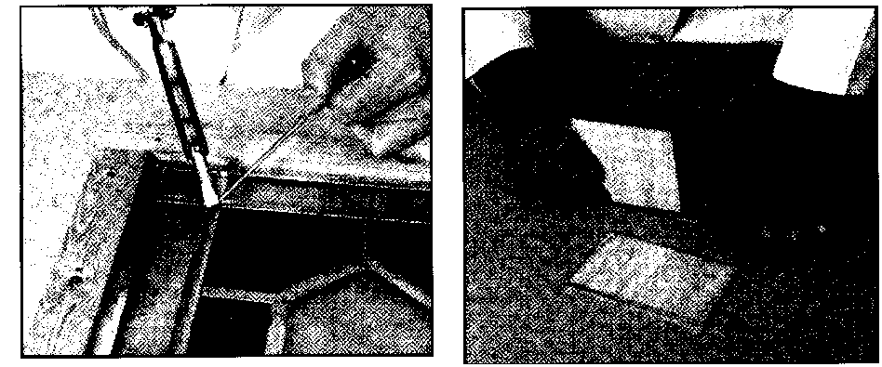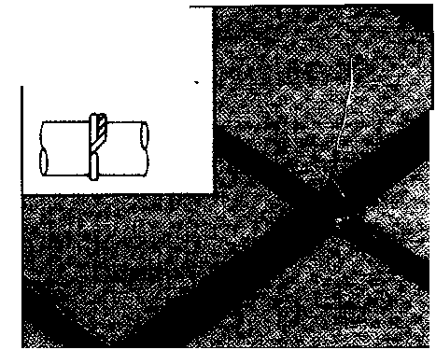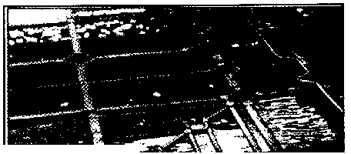
BEGINNERS KIT FOR COPPER FOILING

It is often said that copper foil work is simpler for the beginner to learn when compared to lead work.

Although this may be true in some respects -copper foil projects are usually smaller scale -greater accuracy of cutting and soldering is necessary. Hetleys kit has all the tools and materials required to get you started in copper toiling.

STAINED GLASS

A cutline is taken from the cartoon, this giving
the shapes of all the pieces of glass that have
to be cut.

In many cases, where painting is not required,
the first drawing may well be the cutline.

The accuracy of the cutline is crucial in that by
keeping to it the glass will be cut to the correct
size. The thickness of your line will represent
the space between the pieces of glass.

For lead the width of this line would be
between 2mrn and 3mrn depending upon the
width of the heart, and for foil it will be
The excellent manual Muick Success Stained 1 mm. After the glass has been cut the cutline
Glass" by Wardell, is included with the kit, and is used again when leading the panel together
contains step-by-step instructions for your first by keeping strictly to the drawing, the final
copper foil projects. panel or object will be made to the correct size.

The kit contains the following items: GLASS CUTTING

Acrylic Oil Cutter - for cutting glass.
Breaking & Grazing Pliers for gripping the glass when breaking after a score has been made.
75w Soldering Iron Kit - for melting solder when joining foil joints
Cutting Oil 200mi - to lubricate the cutter
All Nova Tool - a multi -purpose tool used for smoothing down the copper foil
Safety Glasses Copper Foil YJ Copper Foil 1/0 Liquid Safety Flux - applied to the foil before soldering to assist adhesion
3 Solder 40160 Sticks
Black on Solder- a patina used to improve the appearance of the copper foil joints
Flux Brush - for applying the flux to the foi
Quick Success Stained Glass - instruction manual
4 Hobby Cuts glass (112'x 12) - easy-to-cut glass from Spectrum or Armstrong (colours may vary)

CREATING A DESIGN

The first stage, for either method, is to make a full size drawing of the window or object you want to produce.

If a lot of detail is to be included by painting onto the glass, this drawing will be the cartoon and is the important original from which the the final window is to be copied.

LEADING A PANEL

Cutting glass successfully is a matter of using the correct technique and having confidence; it is certainly not something to be afraid of. There are many different cutters available today, the ones we sell having either inexpensive steel or carbide wheel, or oil cutters. The oil cutters have a reservoir of oil inside the handle that lubricates the wheel automatically; lubrication is the secret of easy glass cutting.

When scoring the glass the cutting wheel should always be held perpendicular to the surface. Apply firm downward pressure so that a slight scratching noise may be heard. Too much pressure will result in very small glass chippings being visible along the score line; too little pressure will produce no score at all. Never go back along a scored fine for a second time.

To break the glass, hold it firmly in your fists between the thumb and index finger of each hand, and twist your wrists to obtain an even outward pressure. Alternatively the cut running pliers may be used: these are designed to exert the same even pressure as described by gently squeezing the pliers.

Our beginners' books give good instructions for beginners learning to cut glass. We suggest that you practice on scraps of 3mm clear glass obtainable from your local glass merchant before making a project. When cutting glass you can see through, place the glass over the cutline on your workbench. If you are using opalescent glass, which is often too dense to see through, it will be necessary to cut the cutline into templates and draw the shape around these onto the glass. It the entire panel is in opalescent glass, a duplicate will be needed: one to cut up and one to be used on the workbench.

2

Lead came is made by extruding or milling lead into an'H' section of different widths.

When using lead came it is important that the lead is fully stretched before use: the lead from Hetleys is supplied ready to use, but som other leads may be supplied twisted and eve crumpled.

The heart of the lead should be opened t accept the glass, using an All Nova tool.

Photograph (1)

The cutline is then placed on the workben (preferably made from chipboard or plywooc and two wooden lath strips are nailed over it 902 to form the bottom and one side border the panel.

The outside leads are then placed inside theE laths, and the pieces of glass and surroundir leads are built up from this corner. See photograph (1).

Each piece of lead is cut to the correct len using a lead knife, the length being sligh short to allow for the overlap of the adj . oin lead. Depending upon the angle of the adjac lead, a mitre cut may be necessary.

Photograph (2)
