Northwind Database Queries

Name: James Kim

The relationships for the Northwind Database are shown below.

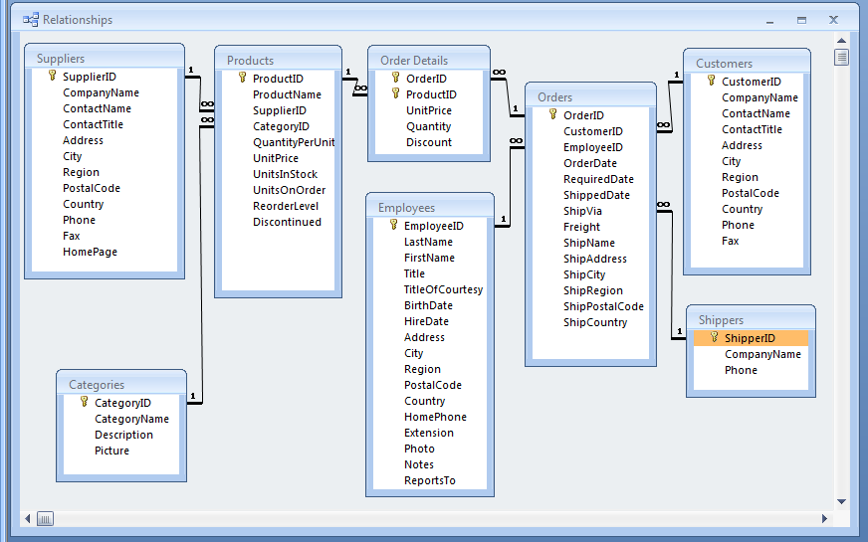

Paste the SQL statements for the queries below the query statements.

- OutOfStockProducts: Make a list of products that are out of stock. (My query yielded 5 records.)
SELECT *
FROM products
WHERE UnitsInStock=0

- OutOfStockProductsNotDiscontinued: Make a list of products that are out of stock and have not been discontinued. Include the suppliers’ names. (My query yielded 1 record.)
SELECT ProductID, ProductName, CompanyName, ContactName
FROM products INNER JOIN suppliers
ON products.SupplierID = suppliers.SupplierID
where UnitsInStock=0 AND Discontinued = 0

- ReorderProducts: Make a list of products that need to be re-ordered i.e. where the units in stock (the number you have) and the units on order (the number you have coming) is less than the reorder level (the number that prompts you to order more). (My query yielded 2 records.)
SELECT ProductID, ProductName, UnitsInStock, UnitsOnOrder, ReorderLevel
FROM products
where UnitsInStock+UnitsOnOrder < ReorderLevel

- ProductPopularity: Make a list of products and the number of orders in which the product appears. Put the most frequently ordered item at the top of the list and so on to the least frequently ordered item. (My query yielded 77 records; Raclette Courdavault (54 orders) was at the top and Mishi Kobe Niku (5 orders) was at the bottom.)
SELECT products.ProductID, ProductName, COUNT(DISTINCT(OrderID)) as 'Number of Orders'
FROM `order details` INNER JOIN products
ON products.ProductID = `order details`.ProductID
GROUP BY ProductID
ORDER BY COUNT(DISTINCT(OrderID)) DESC

- ProductPopularity2: Make a list of products and total up the number of actual items ordered. Put the most frequently ordered item at the top of the list and so on to the least frequently ordered item. (My query yielded 77 records; Camembert Pierrot (1577) was at the top and Mishi Kobe Niku (95) was at the bottom.)
SELECT products.ProductID, ProductName, SUM(Quantity) as 'Total Ordered'
FROM `order details` INNER JOIN products
ON products.ProductID = `order details`.ProductID
GROUP BY ProductID
ORDER BY SUM(Quantity) DESC

- CategorySuppliers: Make a list of categories and suppliers who supply products within those categories. (My query yielded 49 records.)
SELECT DISTINCT CategoryName, CompanyName
FROM categories
INNER JOIN products ON products.CategoryID = categories.CategoryID
INNER JOIN suppliers ON products.SupplierID = suppliers.SupplierID
ORDER BY CategoryName DESC

- CustomerOrders: Make a complete list of customers, the OrderID and date of any orders they have made. Include customers who have not placed any orders. (My query yielded 832 records.)
SELECT orders.CustomerID, CompanyName, OrderID, OrderDate
FROM customers LEFT OUTER JOIN orders
ON orders.CustomerID = customers.CustomerID

- CustomerNumberOfOrders: Make a complete list of customers along with the number of orders they have placed – including if they have made 0 orders. Sort it from the customer with the most orders to the one with the least. (My query yielded 91 records.)
SELECT CompanyName, COUNT(OrderID) as 'Number of Orders'
FROM customers LEFT OUTER JOIN orders
ON orders.CustomerID = customers.CustomerID
GROUP BY CompanyName
ORDER BY COUNT(OrderID) DESC

- CustomerWithMaxNumberOfOrders: Create a query that determines the customer who has placed the maximum number of orders. You can use SQL’s TOP key word and the above query as a subquery. (My query yielded Save-a-lot Markets with 31 orders.)
SELECT CompanyName, COUNT(OrderID) as 'Number of Orders'
FROM customers LEFT OUTER JOIN orders
ON orders.CustomerID = customers.CustomerID
GROUP BY CompanyName
ORDER BY COUNT(OrderID) DESC
LIMIT 1

- CustomerAndSuppliersParameterizedByCity: Create a parameterized query that has the user enter a city and then list the customers or suppliers from that city. You might want to use their union query as a starting point. (London had 6 customers and 1 supplier.)
import mysql.connector

try:
cnx = mysql.connector.connect(user='root', password='root123',
host='localhost',
database='assignment9',
use_pure=True)

except mysql.connector.Error as err:
print(err.msg)
else:
print('connected...')
cursor= cnx.cursor()
city=input('search for a city: ')

query = "SELECT CompanyName AS 'Customer' FROM customers WHERE City LIKE '%"+city+"%' UNION SELECT CompanyName AS 'Supplier' FROM suppliers WHERE City LIKE '%"+city+"%'"

try:
cursor.execute(query)

except mysql.connector.Error as err:
print(err.msg)
else:
for (CompanyName) in cursor:
print(CompanyName)

cursor.close()
cnx.close()

