Cameron Avellani

Integrate and configure

SQlite is already supported by python so it will be the easiest to integrate. Python allows you to access databases fairly easy, making it simple to pull the data needed and manipulate it

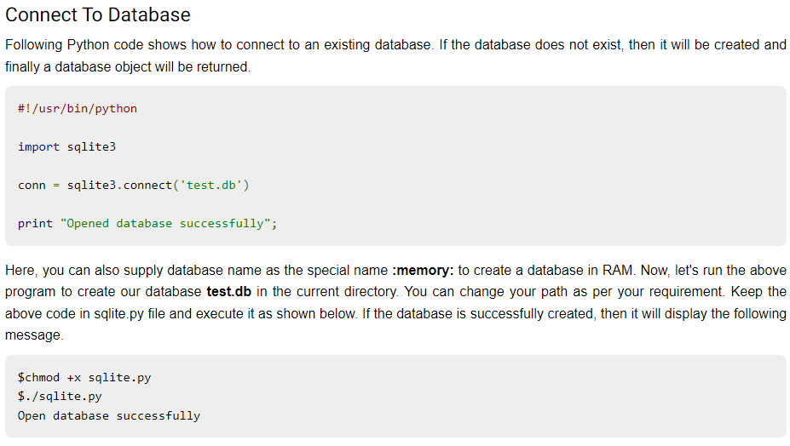

Figure 1. From [*https://www.tutorialspoint.com/*](https://www.tutorialspoint.com/)showing how simple it is to connect to data with python

For SQlite in Java you need to download the latest SQLITE JDBC Drive and Java set up. After that is downloaded Java allows you to connect to existing databases, if one does not exist, then Java will automatically create one for you.

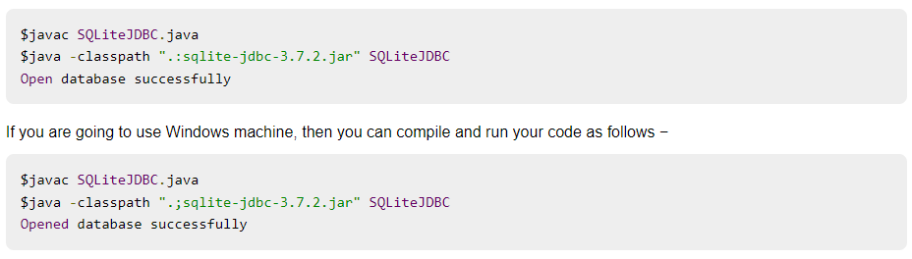

Figure 2. From [*https://www.tutorialspoint.com/*](https://www.tutorialspoint.com/) *showing how to connect to a database with java*

C++ is very similar to Java, you need to install the SQLite library, and you will then be able to connect to existing databases. Similarly, if a database doesn't exist, then one will be created for you

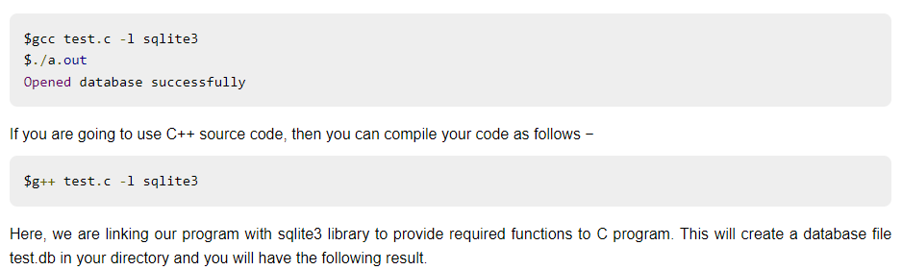

Figure 3. From [*https://www.tutorialspoint.com/*](https://www.tutorialspoint.com/) showing how to connect to a database with C++

**This is good, make sure to look into implementing the java and cpp code into the programs after the databases are created.**

Reference: <https://study.com/academy/lesson/integration-configuration-model-definition-purpose.html>

<https://www.tutorialspoint.com/python_network_programming/python_databases_and_sql.htm#:~:text=Python%20supports%20various%20databases%20like,is%20the%20Python%20DB%2DAPI>.

<https://www.tutorialspoint.com/sqlite/sqlite_c_cpp.htm>

<https://www.tutorialspoint.com/sqlite/sqlite_java.htm>