Working with Foundation 6 - the Basic Template, Underscores and WordPress

Udemy

**Contents**

Download and Install Underscores, the WP Developer Plugins, and the Foundation 6 Basic Template (Gulp). 1

Tools Used 1

Underscores 1

WP Developer Plugins 1

Theme Test Unit 1

Developer 2

Show Current Template 3

Download Foundation 6 Basic Template and place into the WordPress folder 4

Install BrowserSync 5

Enqueue Foundations Styles 7

Enqueue Scripts 7

Add Custom.scss to the Project. 8

Initialize, Add and Commit to Git 9

Add to Git Desktop so it Keeps Track of the Project 9

# Download and Install Underscores, the WP Developer Plugins, and the Foundation 6 Basic Template (Gulp).

## Tools Used

Windows command line, Foundation’s command line tool (CLI), Node.js and Npm, Bower, Gulp, Browser Sync, Underscores, WordPress, Git, Git Desktop and GitHub.

## Underscores

After downloading and setting up WordPress on the localhost:

* Go to underscores.me, fill out the theme options keeping the theme name the same as the name that you gave to the WP folder. The theme slug will be the same but all lower-case, the author is me, the author uri is https://github.com/james20381, give a description, don’t click sassify! we’ll be using Foundations Gulp Template for sass, then click Generate.
* Go to your WordPress site, go to the back-end, go to Appearance then Themes, click Add New then Upload Theme. Click Activate and go to the front-end to see it.

## WP Developer Plugins

### Theme Test Unit

* Go to codex.wordpress.org/theme_unit_test. Right click on it and select save link as, then save it to the desktop.
* Then go to WordPress, back-end (dashboard), tools and import, Wordpress and click on Install now. This will download and install the Wordpress importer plug-in, (which once installed can be found under the Plug-ins section).
* Click Run Importer and choose the xml file we just downloaded to the desktop. Open it and click Upload file and import. Now the file is uploaded into WordPress and we can start working with the content.
* Click the Import Attachments box then the Submit button. (The Import might take several attempts), click on the Have Fun button when it’s in.

### Developer

* Go to Plugins, Add new and enter Developer into the search box,

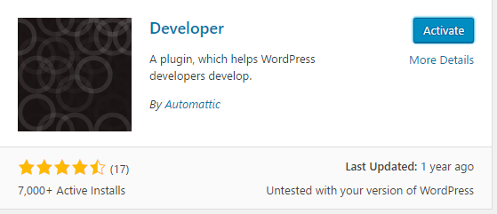

* Click on install, then Activate. the plugin will now suggest a long list of optional plugins you can install to help with development. This is the whole purpose of the Developer plugin. Developer is a helper plugin that assists you in installing useful plugins so you don't have to source them out yourself one at a time.
* From the options choose Debug Bar, Monster Widget, Regenerate Thumbnails and Theme Check. The Debug Bar adds debugging to the WordPress tool bar at the very top. The Monster Widget makes it easy to add a lot of widgets to a sidebar very quickly. Regenerate Thumbnails allows me to regenerate any featured images, once I have changed the default settings. Theme Check runs a basic test on my theme to make sure it meets the basic WordPress standards.
* WP_debug enables debug mode which will identify and try to resolve issues in your code. And save queries logs the database queries in an array so you can review them. That means if something weird is happening and you need to see what the communication is between WordPress and the database, that is all saved and you can review it later. For this course, we only need WP_debug, so we're going to set that right now.
* Open up WP-config from inside the local install of WordPress.

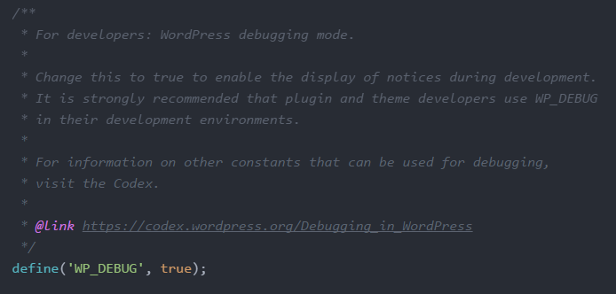

* Scroll down to WP_DEBUG and set it to true.
* Save, go back to WordPress and reload the developer page, and you'll see the WP debug constant is now set.

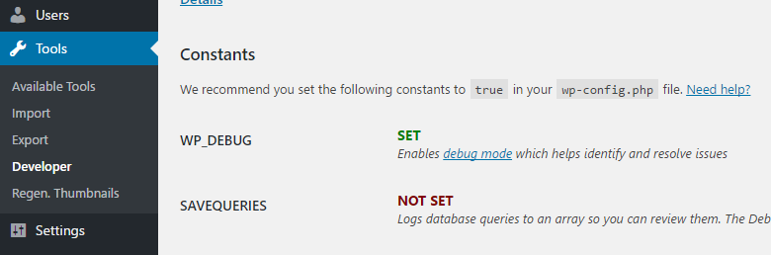

### Show Current Template

* Go back to Plugins and install Show Current Template.

(Configure Underscores Base Settings and Functions)

## Download Foundation 6 Basic Template and place into the WordPress folder

* Cd to the directory where you want to create the new project.
* If Foundation’s CLI isn’t already installed from previous projects, install it using $ (sudo) npm install –global foundation-cli.
* $ foundation new.
* Name the new project folder (name it anything for now, we’ll be moving the contents into the WordPress folder anyway)
* Select the Basic Template.

All the Foundation files, Gulp with Sass compiler and Autoprefixer are downloaded using Bower? and Npm.

* Move to the WordPress folder:

bower_components

bower.json

gulpfile.js

app.js into the WP js folder

node_modules

package.json

scss

* Delete from the Foundation folder:

CHANGELOG.md

etc

index.html

Below are snapshots of the two folders before the files have been moved

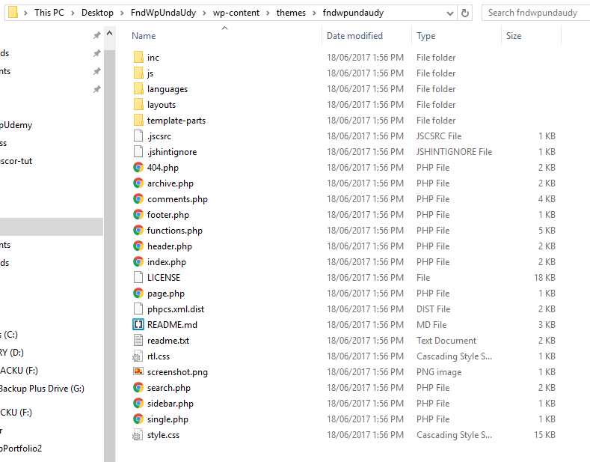

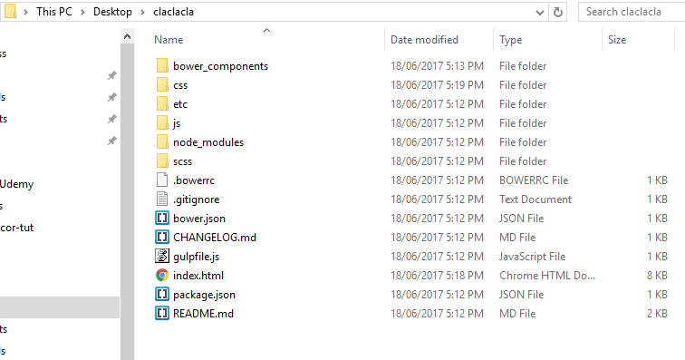

## Install BrowserSync

* $ cd to inside the WP themes/theme folder where Gulp now lives.
* $ npm install --save-dev browser-sync (save saves it to our project and adds it to our package.json file, dev says we just need it for development not for the production version of the website)

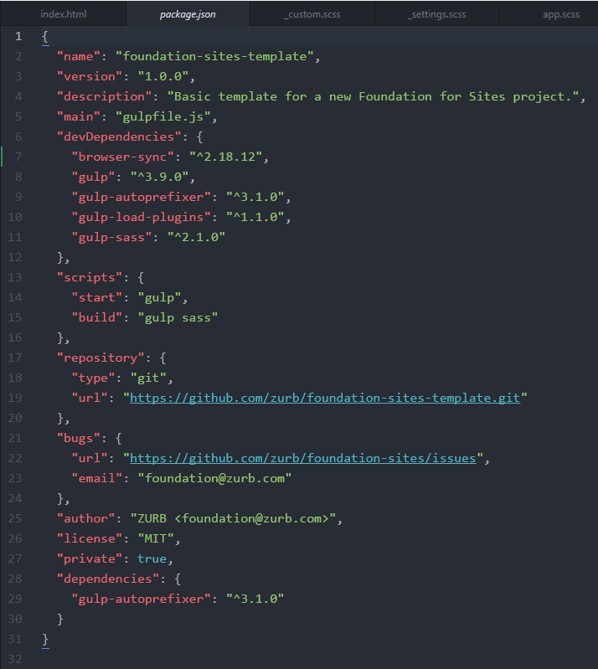

On install, BrowserSync gets added to the package.json file

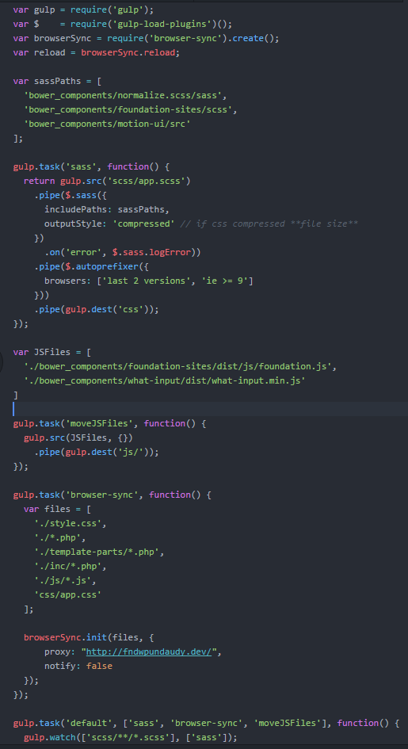

Add this code to gulpfile.js, enter and test browserSync first, then move the js files.

# Enqueue Foundations Styles

Open up functions.php from the themes/theme folder and enqueue Foundations styles.

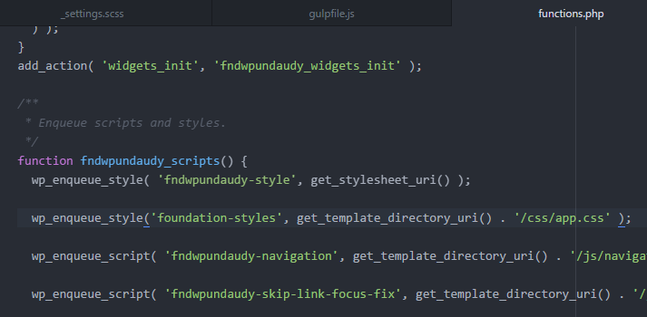

Remove this enqueue, it references style.css and it causes problems. WordPress needs style.css so we cant delete the file, we just don’t enqueue it.

# Enqueue Scripts

Underneath the enqueued styles is where you enqueue scripts.

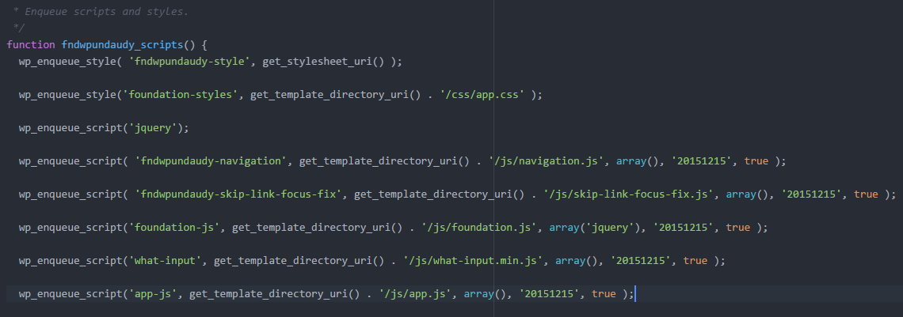

Open up app.js and change the $ sign to jQuery.

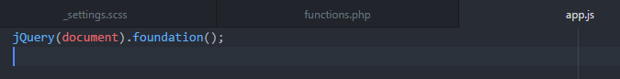

# Add Custom.scss to the Project.

Inside the scss folder, create a new file called custom.scss, then inside app.scss @import the file at the bottom of the @includes list.

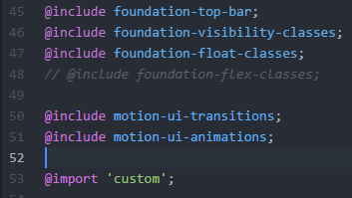

* $ cd into the new project folder.
* $ foundation watch
* $ Ctrl C, Terminate batch job (Y/N) y

## Initialize, Add and Commit to Git

* $ git init (the stack comes with a .gitignore file already filled out)
* $ git add .
* $ git commit –m “add initial Foundation basic template commit”

## Add to Git Desktop so it Keeps Track of the Project

* Add local repository